MINISTRY OF NATURAL RESOURCES AND ENVIRONMENT OF   
THE RUSSIAN FEDERATION

**FEDERAL   
ENVIRONMENTAL, INDUSTRIAL   
AND NUCLEAR SUPERVISION SERVICE**

APPROVED by Order of the Federal Environmental, Industrial and Nuclear Supervision Service of Russia dated June 8, 2010, No. 465

**Provision**

**for forecast estimate precision enhancement  
 of environmental radioactive contamination  
 and personnel/public radiation exposures**

**RB-053-10**

Effective   
from June 8, 2010.

**Moscow 2010**

**Provision for forecast estimate precision enhancement of environmental radioactive contamination and personnel/public radiation exposures RB-053-10**

**Federal Environmental, Industrial and Nuclear Supervision Service**

**Moscow, 2010**

This Provision for forecast estimate precision enhancement of environmental radioactive contamination and personnel/public radiation exposures (hereinafter referred to as the Provision) serves as a guide and is not a normative legal act.

This Provision contains guidelines for the use of calculation forecast methods of environmental radioactive contamination and personnel/public radiation exposures.

This Provision is intended for individuals and organizations that deal with the design and engineering of ARSMS at NPP and other NF.

This Provision has been developed based on Federal Laws No. 170-FZ "On atomic energy use" dated November 21, 1995, No. 3-FZ "On radiation safety of population" dated January 9, 1996, No. 7-FZ "On Environmental protection" dated January 10, 2002; of the Federal Rules and Regulations: "Radiation safety standards" (NRB-99/2009) approved by Decree No. 47 of the Chief State Sanitary Doctor of the Russian Federation dated July 2009, "Main sanitary regulations for ensuring radiation safety" (OSPORB-99) approved by the Decree of the Chief State Sanitary Doctor of the Russian Federation dated December 27, 1999, considering the guidelines contained in the IAEA document: "Consideration of dispersion atmosphere parameters in siting for nuclear power plants" (Safety Guide No. 50-80-83. International Atomic Energy Agency, Vienna, 1982).

Issued for the first time[1].

**CONTENTS**

I. General provisions 4

II. Recommendations on the scope and operating conditions of the ARSMS 5

III. Identifying meteorological parameters for the assessment of conditions that lead to   
the generation of a radiation situation at site 5

IV. Recommendations for the use of models for radioactive impurity transfer in   
the atmosphere 6

V. Model parameters 7

VI. Forecast methods 7

VII. Conditions for an adequate and sufficient quantity of ARSMS sensors located   
at the site and in the NF SPZ 8

VIII. Deployment principle of ARSMS photon radiation detectors at the site and in   
the NF SPZ 8

IX. Clarification of *P*В value 9

X. Selecting a sensor for the clarification of *P*В value 9

Appendix No. 1. ARSMS composition block diagram 10

Appendix No. 2. Criteria conforming to the conditions of radiation control posts deployment   
at the site and in the nuclear facility SPZ 11

Appendix No. 3. Methodology for processing of gradient observations 15

Appendix No. 4. The model of the boundary layer of atmosphere 18

Appendix No. 5. Dry deposition rate 22

Appendix No. 6. Roughness of underlying surface 23

Appendix No. 7. Constant of washout of radioactive impurity with precipitation 24

Appendix No. 8. Constant of radioactive impurity decay 27

Appendix No. 9. Gravitational sedimentation rate 29

Appendix No. 10. Recommendations for sensors of meteorological parameters 30

Appendix No. 11. ST "RECASS" 31

Appendix No. 12. ST "SULTAN" 35

Appendix No. 13. ST "NOSTRADAMUS" 38

Appendix No. 14. ST "DOZA" 42

Appendix No. 15. ST "GENGAUS" 44

Appendix No. 16. Physical basis for impurity transfer in the atmosphere 45

Appendix No. 17. Analysis of mathematical models of impurity transfer in the atmosphere 49

Appendix No. 18. Differential model of radionuclide propagation in the atmosphere 53

Appendix No. 19. Unconventional assessment methods for radioactive   
contamination of the environment 19

Appendix No. 20. Determination method for the adequate and sufficient quantity of   
ARSMS sensors located at the site and in the NF SPZ 60

Appendix No. 21. Deployment principle of ARSMS photon radiation detectors   
at the site and in the NF SPZ 64

Appendix No. 22. Discharge rate clarification method 73

Appendix No. 23. Method for selecting the optimum sensor for specification 77

Appendix No. 24. Terms and definitions 79

**I. General provisions**

1. This Provision for forecast estimate precision enhancement of environmental radioactive contamination and personnel/public radiation exposures (hereinafter - the Provision) serves as a safety guide, is non-regulatory and is not a normative legal act.

2. This Provision contains guidelines of the for the use of calculation forecast methods of the Federal Environmental, Industrial and Nuclear Supervision Service for use of environmental radioactive contamination and personnel/public radiation exposures, including the following recommendations:

* to justify that the use of readings of photon radiation detectors along with design data allows the forecast estimate precision of the environmental radioactive contamination to be significantly enhanced and to reduce the error of calculations to the error of the detector;
* to formulate the main principles and select criteria for the optimum deployment of radiation control posts at the site and in the sanitary protection zone (hereinafter - the SPZ) of a nuclear power plant (hereinafter - the NPP) that enable to minimize the consequences of radiation accidents;
* to select an algorithm that contributes to a higher precision of forecast estimates of environmental radioactive contamination for determination of the coordinates of a radiation photon detector located at the site and in the NPP SPZ.

3. The use of the recommendations in this Provision is aimed at solving the following main tasks:

* to improve financial costs for the development of automated radiation situation control systems (hereinafter - the ARSMS) of NPPs and nuclear facilities (hereinafter - NF);
* to forecast results of radiation contamination of the environment in the absence of information on the radionuclide composition of radioactive impurity discharged to the atmosphere in radiation emergencies at NPPs or any other NF, which uses an ARSMS considering the recommendations of this Provision;
* to enhance the precision of forecast results of environmental radioactive contamination and the exposure of the personnel and public during radiation accidents at NPPs or other NF.

**II. Recommendations on the scope and operating conditions of the ARSMS**

4. The base of the ARSMS consists of: system of photon radiation dose rate control posts, deployed at site, a total number of sensors that measure meteorological parameters, the readings of which are used to determine the condition of atmospheric stability; process sensors of NPP, designed to determine atmospheric radioactive impurity discharge parameters; lower and upper level software, of which the former processes data (sensor readings) with a view to converting them to a special format to be used as input data in forecast calculations. The upper level software is based on calculation models of radioactive impurity transfer in the atmosphere and water medium, as well as mathematical methods for the estimate of radiation exposure of the personnel and the public. It is directly used to carry out forecast calculations of environmental radioactive contamination. The ARSMS composition block diagram is shown in Fig. 1, Appendix No. 1.

5. The ARSMS should be operated in real time, which is achieved by automating data collection on radiation and meteorological parameters, which uses mathematical models of radioactive propagation in the air and water environment that occur during discharges at NPPs in order to carry out forecast calculations.

6. The ARSMS shall be designed so as to address economic, environmental, physical and technical criteria, as well as demographic features of the region where the NPP is deployed. The above criteria conforming to the conditions of radiological control posts deployment at the working site and in the nuclear facility SPZ are presented in the Appendix No. 2.

7. The error of the forecast estimate of environmental radioactive contamination and the radiation exposure of the personnel and the public obtained by means of calculation models can be minimized by clarifying atmospheric meteorological parameters, using the readings of ARSMS photon radiation detectors and clarifying the discharge rate of the gas aerosol radioactive impurity (*P*В), which enter the atmosphere during radiation accidents and during normal operation.

**III. Identifying meteorological parameters for the assessment of conditions that lead to the generation of a radiation situation at site**

8. Meteorological parameters that determine the atmosphere boundary layer play a special role in assessing its stability: wind speed, temperature, humidity etc. A change in one of these parameters will inevitably result in the change of stability of the boundary layer as a whole, and, this, in turn, will result in the change of concentration of radioactive impurity and radiation situation at site.

9. Meteorological parameters, as applied to the region where an NPP is located, shall be determined on special meteorological sites of external dosimetry laboratories.

10. The direction, speed of the wind, temperature and humidity shall be measured at several levels at a meteorological mast located at the meteorological site of the external dosimetry laboratory, applying the method of gradient observations. Measured parameters can further be used as benchmarks for calculating full profiles of these values in the atmosphere boundary layer in more advanced meteorological models or as constants – directly in equations, which are used to calculate the propagation of radioactive impurity in the atmosphere during its transfer. Method of gradient observations is given in Appendix No. 3, while Appendix No. 4 shows calculation methods for meteorological parameters.

**IV. Recommendations for the use of models for radioactive impurity transfer in the atmosphere**

11. The model for radioactive impurity transfer in the atmosphere shall be selected on the basis of:

1) the results of forecast calculations of environmental radioactive contamination and radiation exposure of the personnel and the public with the "satisfactory (minimum) error" at minimum distances of 30 km from the source of discharges at any effective elevation of a radiation contamination source, which does not exceed the elevation of the atmospheric boundary layer subject to:

* parameters of the underlying surface which determines the value of the dry deposition rate (the values of the dry deposition rate for various nuclide and surface types are presented in Appendix No. 5);
* roughness parameters (roughness parameter values for various underlying surfaces are presented in Appendix No. 6);
* washout of radioactive impurity with natural precipitations (rain, snow) and mist (constant washout of radioactive impurity with natural precipitations and mist are given in Appendix No. 7);
* radioactive decay of impurity during transfer (values of decay constant of radioactive impurity for the main radionuclides discharged to the atmosphere by NPPs and other NF are presented in Appendix No. 8);
* atmospheric humidity;
* dispersion composition of impurity or gravitational deposition rate (calculation formulas for particle gravitational deposition rate are given in Appendix No. 9);
* values of meteorological parameters (longitudinal and lateral wind speed, coefficient of turbulent diffusion, energy of turbulent pulsations) across the entire atmospheric boundary layer;
* rate of radioactive impurity discharge to the atmosphere.

2) use of qualified methods for identifying meteorological parameters of the model (main recommendations on meteorological parameters sensors are presented in Appendix No. 10).

3) carrying out of real-time forecast estimates of environmental radioactive contamination and the radiation exposure of the personnel and the public (calculation by the model with all functionalities, which determine radiation exposure of the personnel and the public and the extent of environmental pollution in stationary conditions cannot exceed the time required to obtain averaged values of measured rates of meteorological parameters ~10 min).

4) economic factor the essence of which as applied to this case consists of the fact that preference shall be given to such a model, which reduces equipment costs without deteriorating the system parameters and the forecast precision.

**V. Model parameters**

12. One of the main model parameters is the discharge rate of radioactive impurity *PВ,*which enters the atmosphere from openings (slots, cracks, valves, ruptures) during NPP accidents.

13. In order to determine the specified parameters in real time, design organizations shall use new developments of instruments measuring *PВ* not only the activity of the gas aerosol impurity, but also partial values during the discharge of an impurity consisting of several radionuclides, and, if no such instruments are available, shall perform SR and ED efforts for the purpose of their development.

14. In the absence of instrumentation to determine *PВ*, the latter shall be assessed by comparing the design and measured dose rate of external radiation created by the photon radiation flux of radionuclides of the radioactive impurity at a point closest to the axis of the discharge if its composition and radiation characteristics of radionuclides are a priori known. However, the precision of such estimates of *P*В  will be substantially lower than that measured by measurements.

**VI. Forecast methods**

15. Radiation properties of environmental radioactive contamination: dose rate from a volumetric source (a plume or cloud of discharges), surface activity of underlying surface, underlying surface dose rate, inhalation dose etc. are determined as functionalities of the obtained solution for concentrating the radioactive impurity the radionuclide composition of which has been assessed.

16. Integral methods should be used to assess such radiation characteristics as a dose rate of external radiation from a volumetric source (radioactive cloud) and underlying surface contaminated as a result of radioactive impurity deposition. It will help avoid the error in assessing the above values due to the violation of the radiation balance law at the air/ground division boundaries and find a number of specific features in the spatial distribution of these values determined by impurity transfer in the atmosphere under different meteorological conditions. In the meantime, the value of *PВ* helps to substantially adjust calculated estimates of spatial distributions of the dose rate, activities of the underlying surface and other radiation properties.

17. In order to assess the radiation situation in the area of an operating NPP it is recommended to use the mathematical methods set out in Appendices No. 11 - 15 the physical basis of which is given in Appendices No. 16 - 18, as well as hardware discussed in Appendix No. 19.

18. Monitoring based on using automated hardware is an alternative mathematic method of radiation situation forecasting. The awareness of such an automated system is directly dependent on the number of control posts equipped with sensors that record ionizing radiation.

**VII. Conditions for an adequate and sufficient quantity of ARSMS sensors located at the site and in the NF SPZ**

19. In order to determine an adequate and sufficient number of sensors capable of recording a plume or a cloud of the radioactive discharges propagating from a source at any wind directions and any condition of atmosphere stability it is recommended to use the algorithm set forth in Appendix No. 20.

**VIII. Deployment principle of ARSMS photon radiation detectors at the site and in the NF SPZ**

20. Radioactive contamination of the environment in case of an unauthorized release of radioactive impurity in the form of a reheated gas jet from openings, valves, vessel leaks, ragged holes or cracks occurring due to explosions or ruptures in high pressure and high temperature vessels or in case of a powerful pulse release of radioactive impurity through an opening (for example, when training exercises are carried out at NPPs, consideration is given to the hole in the ceiling slab of the reactor (RBMK) appearing due to a falling foreign object from the air) when no information is available on the radionuclide composition of the impurity or spectral composition of its photon radiation, assessments shall be carried out by the readings of process sensors that are installed in tanks and determine medium pressure and temperature, and ARSMS sensors that determine the dose rate of external cloud shine formed as a result of the discharge. The sensors at the site and in the SPZ shall be located so that the distance from a possible source of radiation hazard to any of the sensors is strictly different. For instance, the sequence of the values of the above distances (from minimum to maximum) could follow the Archimedean spiral formula. The deployment principle of ARSMS photon radiation detectors at the site and SPZ of the NF is discussed in more detail in Appendix No. 21.

21. In order to quickly assess the environmental radioactive contamination if no information is available on the radionuclide composition of the radioactive impurity, which forms a radioactive cloud, considering the layout of ARSMS photon radiation detectors uniformly in azimuth and at varying distances from a source, the spectral composition shall be determined for the photon radiation of radioactive impurity and its average energy. To this end, use should be made of the algorithm set out in Appendix No. 21.

**IX. Clarification of *PВ* value**

22. One of the main parameters of the transfer model of gas aerosol radioactive impurity in the atmosphere, as mentioned in item 12 herein, is *PВ* value of the radioactive impurity entering the atmosphere under radiation accidents at the NPP or any other NF. The clarification of this parameter enables all other characteristics of the environmental radioactive contamination to be adjusted (volumetric activity of the radioactive impurity propagation in the air basin and extent of the environmental radioactive contamination as a whole). The clarification method of *P*В value, as well as a more precise estimate of the *PВvalue* considering the photon values of the dose rate of natural or man-made origin is given in Appendix No. 22.

**X. Selecting a sensor for the clarification of the *P*В value**

23. In order to obtain a more precise *P*В value, it should be determined by the readings of the ARSMS detector provided that their number is sufficient in the SPZ closest to the release axis, Fig.1 Appendix No. 23

24. The sensor, closest to the release axis, shall be determined by the algorithm described in Appendix No. 23.

25. An example of the algorithm of prognostic calculations of environmental pollution with the estimate of radiation exposure on the personnel and the public is given in Fig. 2, Appendix No. 23.

26. Terms and definitions used herein are given in Appendix No. 24.

Appendix No. 1 to the Provision

for forecast estimate precision enhancement of environmental radioactive contamination and personnel/public radiation exposures approved by the Order of the Federal Environmental, Industrial and Nuclear Supervision Service

**ARSMS composition block diagram**

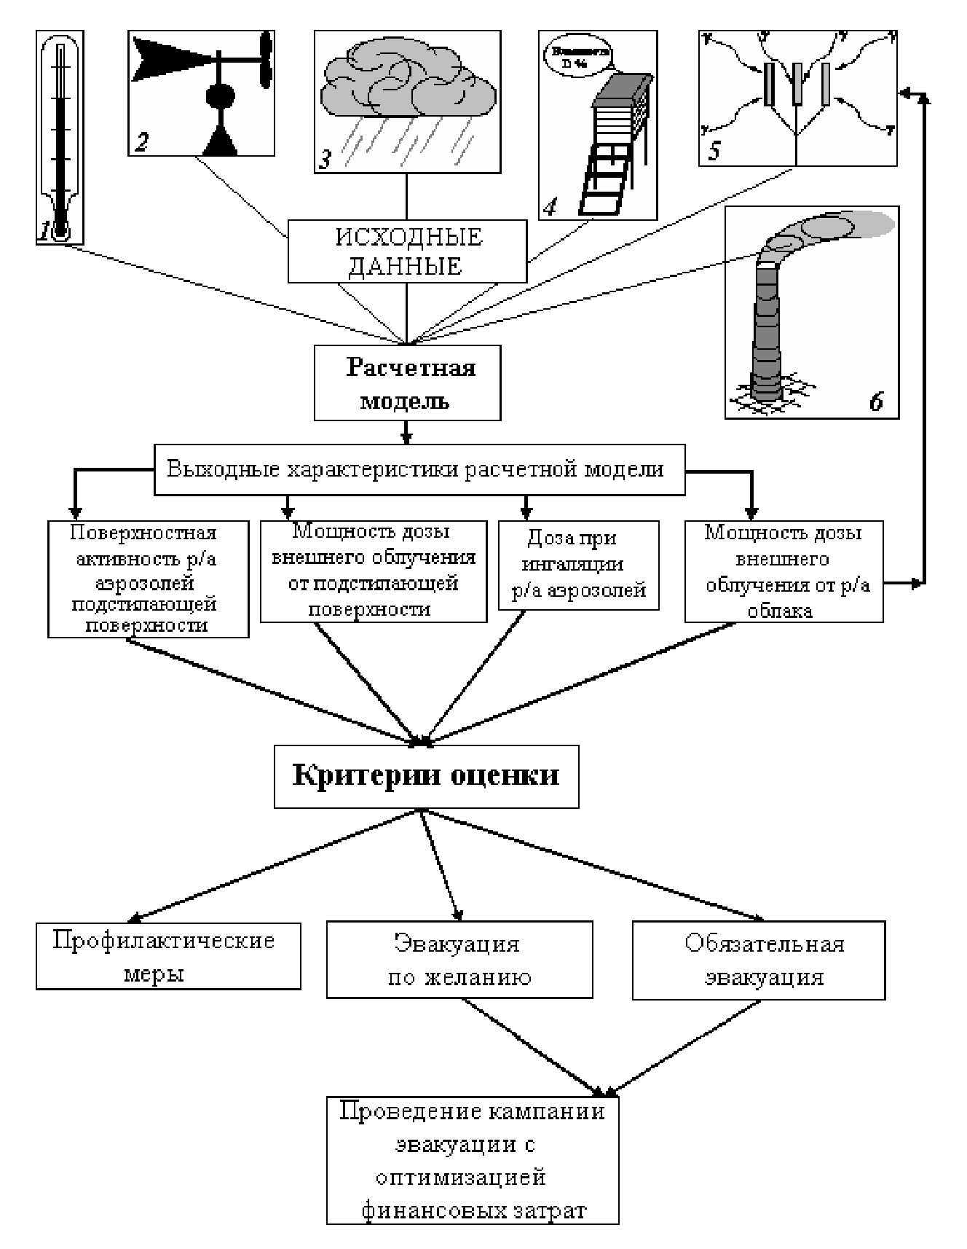

Fig. 1. ARSMS block diagram:

1 – environmental temperature sensors; 2 – wind direction and speed sensors; 3 – precipitation sensors; 4 – environmental humidity sensors; 5 – photon radiation sensors of monitoring posts; 6 *-* process sensors of parameters of release of radioactive impurity to the atmosphere

|  |  |
| --- | --- |
| Структурная схема состава АСКРО  Исходные данные  Расчетная модель  Выходные характеристики расчетной модели  Поверхностная активность р/а аэрозолей подстилающей поверхности  Мощность дозы внешнего облучения от подстилающей поверхности  Доза при ингаляции р/а аэрозолей  Мощность дозы внешнего облучения от р/а облака  Критерии оценки  Профилактические меры  Эвакуация по желанию  Обязательная эвакуация  Проведение кампании эвакуации с оптимизацией финансовых затрат | ARSMS block diagram  Input data  Design model  Output characteristics of the design model  Surface activity of radioactive aerosols of underlying surface  Dose rate of external exposure from the underlying surface  Dose on inhalation of radioactive aerosols  External exposure dose rates from radioactive cloud  Evaluation criteria  Preventive measures  Optional evacuation  Obligatory evacuation  Evacuation campaign with optimization of financial costs |

Appendix No. 2 to the Provision for forecast estimate precision enhancement of environmental radioactive contamination and personnel/public radiation exposures approved by the Order of the Federal Environmental, Industrial and Nuclear Supervision Service

**Criteria conforming to the conditions of radiation control posts deployment at the site and in the nuclear facility SPZ**

**1. Environmental criteria**

Development of the NPP and other atomic industry radiation hazardous enterprises radiation safety control systems is usually based on a concept. Any concept of development of such systems relies on the principle of radioactive contamination parameters measurement based on the selection of sensors measuring some characteristics of the impurity – its immediate concentration (with aspiration sensors [1]) or photon radiation dose rate [2], number of sensors and their positioning around the facility. Duration of the contamination levels averaging time determines the way of sensors positioning around the NPP as well – in the direction of the most likely propagation of discharges. The latter is determined based on the wind rose compiled on the basis of meteorological observations during a year [3, 4]. Such systems have shown good results particularly for contamination levels analysis during normal NPP operation, however, as pointed out in the references [1, 2, 5], they have a significant drawback, since all information on the radiation situation belongs to the past, which is absolutely unacceptable in case of emergency. It is also worth mentioning that seasonal wind roses can differ from annual, therefore, the most likely direction of NPP discharges propagation may be subject to changes in space and time. To eliminate the latter drawback, and to restore the required accuracy of radioactive substances concentration field in the atmosphere and on site according to the readings of sensors located in-situ, numerous sensors are required, which number increases with decreasing of the restored concentration field error [6]. For example, if the radionuclide concentration distribution near the ground surface is calculated as a Gaussian function, $q\left(x,y,t\right)=q_{max}exp\left[-\left(x^{2}+y^{2}\right)/2σ_{y}^{2}\right]$ where *q*max is the concentration value in the cloud center (*x* = 0, *y* = 0); σ*y* is the propagation dispersion, then to reproduce the function *q*(*x*, *y*, *t*) with admissible error δ = 50%, it is necessary to have 70 measurement points, and at δ = 30% - 200 points [7]. Taking into account that each instrument requires communication lines, maintenance, i.e. the dedicated personnel, in its turn, requiring social costs, etc., it is obvious that control systems based on this principle are rather expensive and inefficient in case of emergency, as they fail to support real time operation.

**2. Economic criteria**

For the optimal use of experimental data, an idea of measuring and model-based monitoring combining into a single system has been put forth in recent years for the one’s benefits to make up for the other’s drawbacks [8]. A system of such type shall ensure the continuous process of the environmental radiation contamination propagation model adaptation to the specific varying conditions based on the in-situ actual measurement results, which, in its turn, requires the improved accuracy of measurements. Improvement of measuring accuracy is possible due to reduction of the impact of cluttered background and background accumulated in the control points, exclusion of systematic errors, recording and automatic making up for detectors nonlinearity [9]. The important factors for systems development include economic constituents of their creation and operation. The system cost is mainly determined by the cost of its component parts, communication lines, installation and commissioning works. Tighter requirements to reliability, the precision of measurements (especially real-time), and fast response, expansion of functions together with the economic constituents determine the requirements and criteria for modern systems development. Solution of these tasks involves certain expenses, hence, the optimal solution option is sought for. One of the most important parameters of the control system is the quantity of telemetering systems, as the sensors installed on these systems give information on immediate environmental radioactive contamination and, besides, due to their number, communication lines and required maintenance have a significant impact on the overall system cost.

**3. Physical and technical criteria**

The estimate of the environmental radioactive contamination comes down to the estimate of the contamination of air and underlying terrain in the release direction, which, in their turn, depend on the amount of the volumetric activity of the radioactive impurity in the air, surface activity of the underlying terrain in case of radioactive impurity fallout, and the external dose rate and the dose via inhalation in the contaminated area. Should the radioactive impurity radionuclide composition be known at least approximately (e.g., it can be set within the technological regulations at the NPP or according to the emergency level criterion [7]), then external dose rate sensors of the ARSMS posts network located at the NPP site, in the sanitary protection zone and observation zone provide for specification of the discharge rate, and, therefore, the estimate of the extent of the environmental radioactive contamination. However, in this case, certain requirements are set to positioning of ARSMS sensors at the site and in the sanitary protection zone, consisting in uniform sensors positioning in azimuth, but at a varying distance from the discharge source. These requirements determine the physical criteria, and the principle of ARSMS sensors positioning in the specified NPP area.

**4. The demographic principle of ARSMS control posts deployment**

In case of the demographic principle of deployment actually defined in Governmental Decree No. 763 [10], ARSMS posts shall be installed in major settlements within the NPP observation zone. And the issue of their feasible positioning is closely related to the operational reliability of the entire system. The analysis of the NPP deployment areas (the so-called site plans) shows that such network of posts cannot ensure reliable recording of the emergency discharge, as at some wind directions its plume escapes the control posts. Reliability enhancement by means of installing additional posts will result in a sharp increase of the ARSMS cost. Besides, the demographic-based system is able only to register the situation, while it is also charged with the tasks of forecast of radioactive contamination propagation, and generation of summarized information required to make decisions on the public protection in case of an accident at the NPP. The only positive point in such ARSMS posts positioning is the social importance of the annunciation system – panels in the settlements. However, using conventional means of communication, e.g., local broadcast network, the same result can be achieved at a much lower cost. It means that the demographic principle of the ARSMS posts positioning in the region of NPP deployment is not always fit, hence, it cannot be recommended for universal application.

**5. Contradictions between ecological and economical principles of ARSMS control posts deployment**

Ecological and economical principles to be followed when the sensors positioning around the NPP obviously contradict with each other. The solution of the problem is achievable by using the hybrid monitoring principle [8, 11–13], where mathematical forecasting data are adjusted considering the readings of ARSMS posts. In Russia, an optimal solution was found subject to environmental, economic and demographic requirements imposed on such systems [14]. This development was patented to secure Russia’s priority in this sphere [15]. Solution optimization comes down to determination of the number of control posts (γ-radiation dose rate sensors) positioned according to the rule stating that the radioactive impurity cloud generated as a result of an accident at the NPP will be inevitably registered by at least one sensor. This development was supported within the scope of international cooperation during the preliminary design development, in particular, for the Novovoronezh NPP ARSMS, that provided for its further use at the Kalininskaya NPP, Balakovo NPP and Rostov NPP.

List of references to Appendix No. 2

1. Bondarev A.A., Dibobes M.K., Pyuskyulyan K.I. Radiation situation assessment in the NPP deployment area in case of an uncontrolled intake of radionuclides to the outdoor environment. Atomic energy, vol. 60, Ed. 2, 1986, p. 138–139.

2. Lightman D.L., Melkaya I. Yu Calculating turbulent flows by gradient measurements. Proceedings of Leningrad Hydrometeorological Institute. Some issues of the physics of the boundary layer of the atmosphere and sea. 1970. Ed. 40, p. 64–73.

3. Sedov L.I. Dimensional and similarity methods in mechanics. М.: Nauka, 1987, 430 p.

4. GOST 8.361-79. Liquid and gas flow rate. Method of measurements in one point of the pipe section. М.: Standard Publishing House, 1985, 23 p.

5. Volkov E.P., Glushenko A.M., Durnev V.N. etc. On creating automated environment radiation control systems at NPPs. Atomic Energy, vol. 57, ed. I, 1984, p. 32-34.

6. Teverovskiy E. N., Dmitriev A. S., Kirdin G. S., “Automated systems of atmospheric pollution forecast and control in case of accidental discharges from nuclear facilities,” М.: Energoatomizdat, 1983, p. 136.

7. International Nuclear and Radiological Event Scale (INES). INES User Guide. IAEA: Vienna (Austria), 1991.

8. Yeremeev M.S., Yeremenko V.A., Zhernov V.S. et al. Hybrid monitoring of radiation situation: a prospective approach to operational monitoring and forecasting environmental contamination with NPP discharges and effluents. Atomic energy, vol. 59, ed. 5, 1985, p. 370–372.

9. Denisov A.А., Zhernov V.S., Krashenninikov M.S., Matveev V.V., Ryzhov N.V., Skatkin V.M. NPP radiation control system with a microprocessor-based distributed configuration. Atomic energy, vol. 53, ed. 3, 1982, p. 131–138.

10. RF Government Decree No. 763 dated October 15, 1992. Territorial radiological control system – STRK.

11. Yeremeev I.O., Shernov V.S., Klimenko M.A., Kotzar Yu.Yu., Skatkin V.V. Tasks and objectives of environmental radioactive contamination monitoring. Atomic energy, vol. 65, ed. 6, 1988, p. 437–439.

12. Khamyanov L.P., Yelokhin A.P., Rau D.F., Chistokhin V.M. Automated radiological control system at NPPs. Teploenergetika, 1989, No. 12, p. 21–23.

13. A.P. Elokhin, D.F. Rau On issues of radiation situation control in the areas of operating NPPs. Energy: economy, engineering, ecology, 1996, p. 35–39.

14. Yelokhin A.P., Rau D.F., Ryzhov N.V., Skatkin V.M., Khalupkova G.I. Concept of creating an automated radiation situation control system in the area of location of Russian nuclear power plants. Abstracts of the International Radiation Safety Symposium. Moscow, 1994, vol. 1, p. 31.

15. Yelokhin A.P., Rau D.F. The control system of the radiation situation in the areas of nuclear facilities. RF Patent No. 2042157, Bulletin No. 23 dated August 20, 1995.

Appendix No. 3 to the Provision for forecast estimate precision enhancement of environmental radioactive contamination and personnel/public radiation exposures approved by the Order of the Federal Environmental, Industrial and Nuclear Supervision Service

**Methodology for processing of gradient observations**

The existing methods for determination of meteorological parameters are rather complicated as they require accurate measurements of wind speed profile, which is only possible at well-equipped meteorological stations. The methodology under consideration is based on a non-linear model of the surface layer and is less demanding to the precision of gradient observations. Computations of parameters are performed as follows [1]. The wind speed and the temperature are measured at two levels, where the values *z*1*=* 2 m and *z*2 *=* 0.5 m are generally used. The difference *Du = u*(*z*1) – *u*(*z*2), *D*θ *=* θ(*z*1) – θ(*z*2) is found.

Using the formula [2] and expressions for the wind speed and temperature through non-dimensional values (*u* = ν∗*un* κ*,* θ = - θ∗θ*n* κ*,* θ0 = *P*0*cp*ν∗), we obtain:

*P*0 /*cp* = | -κν∗*D*θ/*D*θ*n, Du* = ν∗*Dun* /κ ;

(*Du /Dun*)2=(*g/T*0)*L*(*D*θ/*D*θ*n*), (1)

where *un,* θ*n* are tabulated values of universal functions. computed for various *zn* (*zn = z/L),* and *Dun*, *D*θ*n* are their difference; κ is the Karman constant. Since *Du*, *D* θ are measurable values, and *Dun*, *D*θ*n* depend on *L,* then the expression (1) is implicit function *L*. To find *L* some value *Lmax* is set and it is varied, for instance, *Li* = *DLi*, *i* = 1, 2, 3,…*N*, *DL = Lmax*/*N* until the difference or relative error

|  |  |
| --- | --- |
|  | (2) |

is minimum (within ε = 0). This is the found value of *L\** at which ε is minimum that will determine the sought value of *L*: *L = DLi\**. Having determined *L* and having recalculated *zn* at fixed *z*1 and *z*2 , i.e., consequently, having recalculated *D*θ*n*, *Dun*, we find ν∗ :

|  |  |
| --- | --- |
| $$ν_{*}^{'}=κ\frac{Du}{{Du}_{n}}.$$ | (3) |

or

|  |  |
| --- | --- |
| $$v_{*}^{''}=κ\sqrt{(gl/T_{0})(Dθ/Dθ_{n})}.$$ | (4) |

As ε → 0 , ν′∗ → ν′∗′. The similar method of computation is the most expedient for calculation of meteorological parameters on a computer. Since the parameter *L* can be both *L >* 0 and *L <* 0 (at *L* = 0 mode of motion loses its turbulent character, [1], page 74), then all possible variations *Li* shall be carried out by the formula: *Li = DL*(*N + L - i*)*, i =* 1, 2, 3,..., *N*, *N +*1, *N +* 2,..., 2*N +* 1*.* The latter will enable to take into account stratification of the atmospheric layer determined by temperature conditions. To calculate *un*(*zn*)*, kn*(*zn*) with the found *L* it is practical to use the analytical value of *y* as a function *zn* [2] rather than the tables. Both *un* and θ*n* by the preset *zn* shall be selected as follows: if *zn* is known, *y* can be found, by which the values of the corresponding *un* or θ*n* are found from the table. Similarly, values *un*, θ*n* are found for another value of *zn* (another level), which is followed by calculation of difference ∆*un*, ∆θ*n*. Once the parameters *L,* ν* have been determined, the values *u*(*z*)*, k*(*z*) are found by the formulas (9), (10) Appendix No. 4. The constant *с*1 in [2] is found at *z = z*0 and *u*(*z*)*z = zo =* 0.

|  |  |
| --- | --- |
|  |  |
| Fig. 1. The dependence of the ground wind speed *U*(*z*) from the elevation of the underlying surface (atmosphere ground layer model): 1 – unstable condition (*L*= -18 *v*\* = 0,32 m/s), 2 – stable condition (*L* = 30, *v*\*= 0,26 m/s) | Fig. 2. The dependence of turbulent diffusion *K*(*z*) on the elevation from the underlying surface in varying atmosphere stability conditions:  1 – unstable state (*L* = –18),  2 – stable state (*L* = 30) |

The calculated values *u*(*z*)*, k*(*z*) for two cases (*L*> 0, *L*< 0) are presented in the form of graphs in Fig. 1, 2.

It shall be noted that for the methodology of gradient observations of wind speed and temperature to be used, one may not only use standard levels, but also any other levels, at which sensors are placed for measuring meteorological parameters [3, 4]. Moreover, in the conditions where the level of roughness of the underlying surface cannot be considered homogeneous throughout a rather extended area of *X* ~ 1.5 – 2.0 km, it is expedient to choose the sensor placement levels for observation of meteorological parameters not lower than at 20 m [5].

List of references to Appendix No. 3

1. Lightman D.L. Physics of boundary layer of atmosphere. L.: Gidrometizdat, 1970, 340 pp.

2. Yelokhin A.P. Optimization of methods and means of automated control systems of the environmental radiation situation. Thesis for degree of Doctor of Engineering. М.: MEPhI, 2001, 325 pp.

3. Zilitinkevich S.S. Dynamics of boundary layer of atmosphere. L.: Gidrometizdat, 1970, 296 pp.

4. Zilitinkevich S.S., Chalikov D.V. Determination of universal profiles of wind speed and temperature in the surface layer of atmosphere. Izv. the USSR AS, ser. “Physics of atmosphere and ocean” vol. 4, No. 3, 1968.

5. Yelokhin A.P., Kholodov E.A., Zhilina M.V. The impact of changes in the roughness of the underlying surface on the generation of a trace in case of its radioactive contamination. Meteorology and hydrology, No. 5, 2008, pp. 69-80.

Appendix No. 4 to the Provision for forecast estimate precision enhancement of environmental radioactive contamination and personnel/public radiation exposures approved by the Order of the Federal Environmental, Industrial and Nuclear Supervision Service

**The model of the boundary layer of atmosphere**

The layer turbulized under the effect of the underlying surface is referred to as the planetary boundary layer of atmosphere. Its thickness depends on the speed of the external flow (flow to a long distance from the ground surface in free atmosphere), on vertical stratification, on dimensions and shape of irregularities of the underlying surface. The boundary layer of atmosphere is not only characterized by continuous growth of speed from zero to a value corresponding to the flow in free atmosphere, but also by determined variation of the wind direction at any rotations. The latter is determined by effects produced by the Coriolis force (*f*К). The mechanism of clockwise rotation of wind can be understood from the following considerations.

Near the ground surface, the gradient of pressure is offset with the friction force (*f*ТР). With a rise of the elevation and a decrease of the slowing effect of the ground surface, the friction force is reduced, the speed rises, and in proportion to the rise of speed *fK* increases, in proportion to which the change of the wind direction will increase. As shown by experimental data, the dynamic effect is observed to the elevation of 1.5 - 2 km, which is also true for monotonous clockwise rotation of wind (the rotation angle at this elevation can reach 24°). Further variations of direction are less significant and no longer monotonous. Considering the problem of formation of meteorological parameters in the boundary layer of atmosphere, we will limit the scope of our interest to the case of stationarity and homogeneity along the axis [1]. The set of equations describing the boundary layer is made up of equations describing the vertical profiles of turbulent stresses (dynamic equations) at *u* = *v***∗***un /* κ and *v* = *v*\**vn* / κ :

|  |  |
| --- | --- |
| $$\left.\begin{matrix}\frac{d^{2}η_{n}}{dz_{n}^{2}}+\frac{σ_{n}}{k_{n}}=0 \\ \frac{d^{2}σ_{n}}{dz_{n}^{2}}+\frac{η_{n}}{k_{n}}=0\end{matrix}\right\},$$ | (1) |

*u* = ν∗*un* κ*,* ν = ν∗ν*n* κ*,* κ *–* the Karma's constant;

*u* is a longitudinal wind speed;

ν *is* a transversal wind speed, respectively;

η = *kdu/dz is* a longitudinal turbulent stress;

σ = *kd*ν/*dz* is a traverse turbulent stress.

The equation for the turbulence coefficient is:

|  |  |
| --- | --- |
| $k_{n}=l_{n}\sqrt{b_{n}}$. | (2) |

The equation for the balance of energy of turbulent pulsation is:

|  |  |
| --- | --- |
| $\frac{η_{n}^{2}+σ_{n}^{2}}{k_{n}}-\frac{L_{1}}{L}P_{n}\left(z_{n},\frac{L_{1}}{L}\right)-\frac{b_{n}^{2}}{k_{n}}+α\frac{d}{dz_{n}}k_{n}\frac{db_{n}}{{dz}_{n}}=0$, | (3) |

where

$α=κ^{2}α_{b}/\sqrt{C}$; α*b* = *const* ; *С* is an empirically defined numerical coefficient.

The equation for the scale of turbulent pulsations is:

|  |  |
| --- | --- |
| $l_{n}=\frac{\frac{η_{n}^{2}+σ_{n}^{2}}{k_{n}^{2}}-\frac{L_{1}}{L}P_{n}(z_{n},L_{n}/L)/k_{n}}{\frac{d}{{dz}_{n}}\left[\left(η_{n}^{2}+σ_{n}^{2}\right)/k_{n}^{2}-\frac{L_{1}}{L}P_{n}(z_{n},L_{n}/L)/k_{n}\right]}$. | (4) |

The equation for heat flux is:

|  |  |
| --- | --- |
| $$α_{T}k_{n}(dθ_{n}/{dz}_{n})=P_{n}(z_{n},L_{1}/L)=exp⁡(-α_{2}z_{n}/H_{n}),$$ | (5) |

where *L* is Monin-Obukhov scale, ν\**is* dynamic speed determined by data of observation in the surface layer, *Нn* is a dimensionless elevation of the boundary layer obtained from the following equation:

|  |  |
| --- | --- |
| $$η_{n}^{2}(H_{n},L_{1}/L)+σ_{n}^{2}(H_{n},L_{1}/L)=ε_{2},$$ | (6) |

where ε2 is a small quantity (ε2*=* 0.05).

Equations (1) ÷ (6) are supplemented with boundary conditions:

|  |  |
| --- | --- |
| as *zn* → 0: η*n* →1, σ*n* → 0; *kn* → 0, *bn* → 1; | (7) |
| as *zn* → ∞: η*n* → 0, σ*n* → 0; *bn* → 0. | (8) |

In the presented form the system contains only one parameter μ0 = *L*1/*L*. The numerical value of parameter α2 may be varied, which means consideration of different profiles of the radiant heat influx. In calculations, the value of α*2/H*Т is given, and based on the found value of *Нn* from (6), α2 is found. In calculations, it is supposed that α*b* = 0.73, *С* = 0.046, κ = 0.4, α = 0.54. The typical relationship between the elevation of the boundary layer of atmosphere and its stability conditions (parameter μ0) is presented in Fig. 1.

|  |  |
| --- | --- |
|  | Fig. 1. The elevation dependence of the boundary layer of the atmosphere on its stability condition characterized by the parameter μ0 |
| atmosphere stability parameter $μ_{0}$ |  |

The solution of the equation system (1) ÷ (8) has been found numerically, with iterations by *kn* as follows:

1. Setting *kn* as a linear dependence on *zn*(*kn* = *zn*).

2. The system (1) is solved for the given *kn* (by the matrix procedure method).

3. Equation (6) is solved (by Newton’s method).

4. *lп* is determined from (4).

5. The new value is calculated according to (2).

This cycle is repeated until |*ki+*1 – *ki*| becomes a small value (*i* is the number of iteration). Then it is analyzed at what value of *zn*, the condition (6) is met. This is the value to be taken for the dimensionless value of the elevation of the boundary layer, and *H = L*1*Нn*. Once the set of equations is solved, the sought values of *u*(*z*), ν(*z*), *k*(*z*), *b*(*z*) are found from equations:

|  |  |
| --- | --- |
| $$\left.\begin{matrix}u=\frac{ν_{*}u_{n}}{κ}=(ν_{0}/κ)\int_{z_{0n}}^{z_{n}}{(η_{n}/k_{n}){dz}_{n},} \\ ν=\frac{ν_{*}ν_{n}}{κ}=(ν_{*}/κ)\int_{z_{0n}}^{z_{n}}{(σ_{n}/k_{n}){dz}_{n}}\end{matrix}\right\};$$ | (9) |

|  |  |
| --- | --- |
|  | (10) |
| $$b=ν_{*}^{2}{(c)}^{-1/2}b_{n}=4,6625v_{e}^{2}b_{n}.$$ | (11) |

Typical dependences of longitudinal and traverse wind speeds as a function of altitude are presented in Fig. 2, 3.

With the determined parameter *u*(*z*)*,* ν*(z*) and *k*(*z*) turbulent diffusion equations (13–15) Appendix No. 16 are formulated as follows: it is assumed that the dilution of the impurity by axis *Y* is carried out by the Gauss law, thereby determining the impurity concentration by the equation [2]:

|  |  |  |
| --- | --- | --- |
| $$q\left(x,y,z,t\right)=\frac{S(x,z,t)}{\sqrt{2π}σ_{y}(x)}exp⁡(-y^{2}/2σ_{y}^{2}),$$ |  | (12) |

where σу(*х*) is mean square deviation. Integrating the turbulent diffusion equation (13) of Appendix No. 16, according to (13),

|  |  |
| --- | --- |
| $$S\left(x,z,t\right)=\int_{-∞}^{+∞}{q\left(z,y,z,t\right)dy=2\int_{0}^{∞}{q(x,y,z,t)dy}}$$ | (13) |

and, by using (12), we have:

|  |  |
| --- | --- |
| $$\frac{∂S}{∂t}+u\frac{∂S}{∂x}+v\frac{2S}{\sqrt{2π}σ_{y}}-w\frac{∂S}{∂z}=\frac{∂}{∂z}\left[k\left(z\right)\frac{∂S}{∂z}\right]-σS+φ,$$ | (14) |

where

$S=S\left(x,z,t\right); φ\left(x,z,t\right)=\int_{-∞}^{+∞}{f\left(x,y,z,t\right)dy=P_{в}δ(x)δ(z-h_{эф})};h_{эф}$– effective discharge elevation; *P*В is the discharge intensity, [Бк/с]; *f* = *P*Bδ(*x*)δ(*y*)δ(*z*-*hэф*) is a source of radioactive impurity; *w* is the rate of gravitational sedimentation of impurity; σ is the constant of relaxation of impurity owing to its radioactive decay or washout from the atmosphere.

|  |  |
| --- | --- |
|  |  |
| Fig. 2. The dependence of the longitudinal component of the wind speed *U*(*z*) on the elevation in various atmospheric stability conditions (1–7) in the model of atmosphere boundary layer | Fig. 3. The dependence of the transverse component of the wind speed *V*(*z*) on the elevation in various atmospheric stability conditions (1–7) in the model of atmosphere boundary layer |

Within the model of atmosphere boundary layer [2]: $σ_{y}^{2}\left(x\right)=\overline{b}x^{2}/{\overline{u}}^{2}(1+ax\overline{b}/\overline{k}\overline{u})$, where $\overline{b}, \overline{k}, \overline{u}$*is* values averaged by the boundary layer: energy of turbulent pulsations *b*(*х*)*,* coefficient of turbulent diffusion *k*(*х*), longitudinal wind speed *u*(*х*)*.* Processing the boundary and initial conditions similarly to equation (15) of Appendix No. 16, we have:

|  |  |  |
| --- | --- | --- |
| , |  | (15) |

where β is the rate of dry deposition of impurity; *z*0 is roughness parameter.

List of references to Appendix No. 4

1. Bobyleva M.M. Calculation of characteristics of turbulence in planetary boundary layer of atmosphere. Proceedings of Leningrad Hydrometeorological Institute. Ed. 40 (Particular matters of physics of boundary layer in atmosphere and sea). L., 1970.

2. Lightman D.L. Physics of boundary layer of atmosphere. L.: Gidrometizdat, 1970, 340 pp.

Appendix No. 5 to the Provision for forecast estimate precision enhancement of environmental radioactive contamination and personnel/public radiation exposures approved by the Order of the Federal Environmental, Industrial and Nuclear Supervision Service

**Dry deposition rate**

The dry deposition rate is the ratio of intensity of deposition of impurity in Bq/m2*sec to concentration in the surface air layer in Bq/m3. The dry deposition rate is determined by the force of gravity and depends on aerodynamic size of particles. For particles with a diameter 0.1 to 1 µm, the dry deposition rate is equal to 0.02 cm/sec, for particles with a diameter 1 to 10 µm, it varies from 0.02 to 5 cm/sec. This value also depends on the type of the surface and the physical-chemical properties of radionuclide [1].

The values of dry deposition rate for different nuclides and types of surface are presented in the table.

|  |  |  |  |  |  |
| --- | --- | --- | --- | --- | --- |
| Nuclide | Deposition rate, cm/sec | | | | Information source |
| Water | Soil | Grass | Adhesive paper |
| Cesium-137 | 0.9 | 0.04 | 0.2 | 0.2 | [1] |
| Ruthenium-103 | 2.3 | 0.4 | 0.6 | 0.4 |
| Zirconium-95, Niobium-95 | 5.7 | 2.9 | — | 1.4 |
| Cerium-141 | — | — | — | 0.7 |
| Tellurium-127 | — | — | — | 0.7 |
| Elementary iodine | — | 1.0 | — | — | [2] |
| Organic iodine compounds | — | 0.01 | — | — |
| Aerosols | — | 0.8 | — | — |
| Inert Radioactive Gases | — | 0 | — | — |

List of references to Appendix No. 5

1. Sakharov V.K. Radioecology: Manual. SPb: Lan Publishing House, 2006, 320 pp.

2. Biogeochemical pathways of artificial radionuclides. Radioecology after Chernobyl. Edited by F. Warner, R.Harrison. М.: Mir, 1999.

3. Gusev N.G., Belyaev V.A. Radioactive discharges in the biosphere. Reference Book. М.: Energoatomizdat, 1986, p. 224.

Appendix No. 6 to the Provision for forecast estimate precision enhancement of environmental radioactive contamination and personnel/public radiation exposures approved by the Order of the Federal Environmental, Industrial and Nuclear Supervision Service

**Roughness of underlying surface**

| **Surface type** | ***z*0, cm** |
| --- | --- |
| Very smooth (mud swamp, ice) | 0.001 |
| Smooth snow on low grass | 0.005 |
| Sand | 0.1 – 0.05 |
| Even thick snow cover leveling all features of the underlying surface | 0.2 – 0.10 |
| Desert | 0.03 |
| Natural snow surface | 0.1 – 0.5 |
| Weak loose snow, irregular snow cover | 0.5 – 2.0 |
| Turf with grass up to 1 cm high | 0.1 |
| Even bare area, or area with low grass cover | 0.3 – 1.0 |
| Fallow field | 0.5 – 2.0 |
| Plain, sparse grass up to 10 cm high | 0.6 – 0.7 |
| Cut grass, height: |  |
| 1.5 cm | 0.2 |
| 3.5 см | 0.5 – 0.7 |
| 4.5 cm  *u*2 m = 2 m/sec | 2.4 |
| *u*2 m = 6 *–* 8 m/sec | 1.7 |
| Plain with low dense grass up to 5 cm high | 2 – 3 |
| Semi-desert with singular brushes of xerophytes up to 30 cm high | 3 – 4 |
| Wheat field | 3 – 7 |
| Potato field | 4 – 7 |
| Beet field | 6.0 – 6.5 |
| Plain with sparse grass up to 50 cm high | 5 |
| Plain with dense grass up to 50 cm high | 9 – 10 |
| Plain with high grass (60-70 cm): |  |
| *u*2м = 1.5 m/sec | 9.0 |
| *u*2m = 3.3 m/sec | 6.1 |
| *u*2m = 6.2 m/sec | 3.7 |
| Exposed trees | 1.0 |
| Two-storeyed buildings | 10 |
| Urban development areas | 40 – 80 |

Appendix No. 7 to the Provision for forecast estimate precision enhancement of environmental radioactive contamination and personnel/public radiation exposures approved by the Order of the Federal Environmental, Industrial and Nuclear Supervision Service

**Constant of washout of radioactive impurity with precipitation**

Washout is an important process of removal of radionuclides out of the atmosphere [1]. The process of washout of impurities from the atmosphere is divided into two stages. At the first stage, the substance being washed out or participating in formation of a cloud droplet and being a condensation nucleus, or being captured by cloud droplets as these are under development and have not yet turned into falling raindrops. This stage is referred to as in-cloud scavenging. At the first stage, the substance is captured by a falling raindrop all along the way till its contact with the underlying surface. This is the stage of below-cloud scavenging. There are five mechanisms of engaging gas molecules or particles into a drop: 1) diffusiophoresis; 2) Brownian diffusion; 3) impingement and capture; 4) gas invasion; 5) formation of droplets on condensation nuclei. During diffusiophoresis, aerosol particles are moving in the direction of mean flow of molecules in the air. The phenomenon of diffusiophoresis is only typical for particles with a diameter smaller than 0.1 µm. The total contribution of such mechanism to washout with raindrops is insignificant. Accidental transfer of small particles caused by collision with gas molecules may also contribute to transfer of the particle to the surface of the droplet. The rate of Brownian diffusion is mostly determined by the dimension of particles, and its effect becomes noticeable for particles with a diameter smaller than 0.1 µm. As distinguished from diffusion of particles, diffusion of gas molecules is the primary mechanism of their transfer to the surface of the droplet. The mechanism of inertial impingement is only typical for below-cloud scavenging. Being light, gas molecules bypass the falling droplet, whereas particles of a considerably larger weight resist motion variations. The heavier a particle, the less it is subjected to such variations.

The washout coefficient depends on rain intensity [2]. This matter is covered most comprehensively in [3], [4]. At the same time, snowfall is known to purify the atmosphere better than rain. Thus, during nuclear weapon tests, the snow washout coefficient would give values having several times the values for the rain (Λ=1÷4*10-4, sec-1 [3])

Washout of gases with rain is strongly affected by their water-solubility. Whereas the volume solubility of sulfur dioxide in water at 0°С is 79.8 (Λ=5÷9*10-5, sec-1 is a value comparable to the atmospheric dust washout coefficient), the relevant value for radon is 0.51. When arranged in a series according to their solubility, the gases contained in the Earth’s atmosphere will be presented as follows (the solubility decreasing from 1.71 to 0.012):

CO2< NO2< Rn < O3< Xe < Kr < Ne < CH4< NO < Ar < O2< CO < N2< H2< He. Таким образом, практически все газы, за исключением двуокиси углерода CO2 и двуокиси азота NO2, вымываются хуже радона, а значит хуже аэрозолей не менее чем на порядок [3].

The relationship between the aerosol washout coefficient and the size of raindrops is considered in [4]. In the same paper, it is shown that particle lifetime, sec-1 (the time, over which the concentration of the sol particles becomes *e* times lower) is expressed through a characteristic parameter of rain - intensity *I* (g/cm2*sec) with equation $τ=10πR_{m}^{3}/IK,$ where *R*m is the most common radius of water droplets, *K* is the capture coefficient. With the washout constant presented in the form of 1/τ , we find $Λ=KI/10πR_{m}^{3}$, i.e., the washout constant is in the linear proportion to the intensity of precipitation.

|  |
| --- |
|  |
| Fig. 1. Coefficients of unit density particle entrainment from the subcloud atmosphere layer *I* for various values *а*2ρ (Chamberlain, 1953.) [4]: 1– 4 mkm2·g/sm3;  2 – 7.8 mkm2·g/cm3; 3 – 16mkm2·g/cm3;  4– 41 mkm2·g/cm3; 5 – 81mkm2·g/cm3;  6 – 169 mkm2·g/cm3; 7 – 400 mkm2·g/cm3 |

A more general dependence is presented in the form of a graph in fig. 1 [3], from which, with a certain error, we can assume relationship between washout and precipitation intensity to be linear. Further analysis suggests that, for smaller particles, linear dependency of washout coefficient on rain intensity is true, while for larger particles this dependency is different from linear. As also follows from papers by Mason, Kinzer and Cobb, the washout coefficient for larger particles is a power function of rain intensity, the power exponent being within the range of 0.75 to 0.8; however, there is a considerable dispersion of these values, both within a rainstorm and between rainstorms [3]. For practical purposes, it is recommended to use the values of the washout constant presented in table 1 [5].

The washout constant may also be presented as Λ = *krk*0*I,* where *I* is the intensity of precipitation, mm/hr; *kr* is the value of absolute scavenging capacity of rain (for all the nuclides except for inert gases, *kr* = 10–5 hr/mm⋅с, typical for rain intensity *I* = 1 mm/hr; *k*0 is relative scavenging capacity of precipitations of other types. Relative scavenging capacity of different types of precipitation is presented in table 2 [4].

|  |  |  |  |  |
| --- | --- | --- | --- | --- |
| **Table 1** | |  | **Table 2** | |
| **Form of nuclide** | **Washout constant Λ, 1/sec** |  | **Precipitation type** | ***k*0** |
|  | Rain | 1.0 |
| Elementary iodine | 1.3·10-4 |  | Rain with thunderstorm | 1.1 |
| Organic iodine compounds | 1.3·10-6 |  | Snow with rain | 2.4 |
|  | Pouring rain | 2.8 |
| Aerosols | 2.6·10-5 |  | Snow | 3.0 |
| Gases | 0 |  | Drizzle | 4.5 |
|  |  |  | Fog | 5.0 |

List of references to Appendix No. 7

1. Biogeochemical pathways of artificial radionuclides. Radioecology after Chernobyl. Edited by F. Warner, R.Harrison. М.: Mir, 1999.

2. Garger E.K., Gavrilov V.P., Zhukov G.L., Samarksya N.A. Lagrangian representation of regional transfer and dispersion of polydisperse impurity in the lower layers of the troposphere. Works of IEM, 1986, ed. 14(129), pp. 20-30.

3. Meteorology and atomic energy. Edited by N.L. Byzova. L.: Gidrometeoizdat, 1971, p. 648.

4. Buytner E.K., Gisina F.A. Effective capture coefficient of aerosol particles with rain and cloud drops. Works of LGMI, ed. 15, pp. 103-117.

5. Gusev N.G., Belyaev V.A. Radioactive discharges in the biosphere. Reference Book. М.: Energoatomizdat, 1986, p. 224.

Appendix No. 8 to the Provision for forecast estimate precision enhancement of environmental radioactive contamination and personnel/public radiation exposures approved by the Order of the Federal Environmental, Industrial and Nuclear Supervision Service

**Constant of radioactive impurity decay**

During reactor normal operation the radiation situation at the NPP deployment area is mainly formed by discharges of inert radioactive gases (IRG) (isotopes Ar, Kr, Xe), 131I and other fission products (89Sr, 90Sr, 134Cs, 137Cs), and corrosion products (58Сo, 60Co, 51Cr, 54Mn and etc.). For sodium fast reactors the main environmental contamination sources include 22Na, 24Na and 41Ar. Actually, the range of radionuclides emitted into the atmosphere by reactors and other fuel cycle enterprises is very wide and diverse. Therefore, a detailed experimental study is required in each particular case. The table presents characteristics of the most common radionuclides emitted into the atmosphere by NPPs and other nuclear facilities [1, 2]. The decay constant for radionuclide is defined by the formula: $λ=\frac{0,693}{T_{1/2}}$, where *T*1/2 is the half-life decay period for radionuclide.

| **Radionuclide** | ***T*1/2** | **Energy of photon radiation *Е*γ, MeV** | **Quantum yield per 100 decays η, %** |
| --- | --- | --- | --- |
| 133Xe | 5.247 days | 0.081 | 37.4 |
| 135Xe | 9.10 h | 0.25 | 90.1 |
| 135mXe | 15.29 min | 0.527 | 80.7 |
| 137Xe | 3.82 min | 0.456 | 30.0 |
|  |  | 0.258 | 31.5 |
| 138Xe | 14.08 min | 0.435 | 20.2 |
|  |  | 1.768 | 16.7 |
| 85mKr | 4.48 h | 0.151 | 75.5 |
| 0.305 | 14.0 |
|  |  | 0.403 | 48.3 |
| 87Kr | 76.31 min | 0.846 | 7.25 |
|  |  | 2.555 | 13.0 |
|  |  | 0.196 | 37.8 |
| 88Kr | 2.84 h | 0.830 | 13.0 |
|  |  | 2.392 | 37.8 |
| 89Kr | 3.15 min | 0.22 | 22.5 |
| 0.586 | 24.9 |
| 41Ar | 1.84 h | 1.294 | 99.2 |
| 131I | 8.04 days | 0.364 | 82.4 |
|  |  | 0.796 | 85.1 |
| 134Cs | 2.062 y. | 0.605 | 97.5 |
|  |  | 0.569 | 15.0 |
| 137Cs | 30.174 y. | 0.661 | 85.1 |
| 54Mn | 312.39 days | 0.835 | 99.98 |
| 60Co | 5.272 y. | 1.333 | 99.98 |
| 1.173 | 99.87 |
| 51Cr | 27.73 days | 0.320 | 9.83 |
| 95Zr | 64,05 days | 0.757  0.724 | 55.4  43.7 |
| 95Nb | 34,97 days | 0.766 | 99.8 |
|  |  | 0.739 | 12.8 |
| 99Mo | 66.02 h | 0.181 | 6.35 |
|  |  | 0.141 | 89.6 |
| 103Ru | 39,35 days | 0.497  0.610 | 90.0  5.85 |
| 106Ru | 368 days | 0.622  0.512 | 9.94  20.6 |
|  |  | 0.938 | 32.4 |
| 110mAg | 250,4 days | 0.885 | 76.4 |
|  |  | 0.658 | 94.2 |
|  |  | 0.636 | 11.2 |
| 125Sb | 2.77 y. | 0.601 | 18.4 |
|  |  | 0.428 | 29.6 |
| 132Te | 78.2 h | 0.228 | 85.0 |
| 140mBa | 12.789 days | 0.537  0.163 | 23.8  5.95 |
|  |  | 1.596 | 95.47 |
| 140La | 40.22 h | 0.816 | 22.52 |
|  |  | 0.487 | 43.43 |
| 141Ce | 32.50 days | 0.145 | 49.0 |
| 144Ce | 284.31 days | 0.134 | 10.8 |
| 237U | 6.75 days | 0.208  0.059 | 22.4  34.6 |
| 154Eu | 8.5 y. | 1.274  0.722  0.123 | 35.5  19.7  40.5 |
| 58Co | 70.78 days | 0.811 | 99.45 |
| 22Na | 2.602 y. | 1.275 | 99.95 |
| 24Na | 15,01 h | 2.754  1.369 | 99.87  99.99 |

List of references to Appendix No. 8

1. Gusev N.G., Dmitriyev P.P. Quantum radiation of radioactive nuclides. Reference Book. М.: Atomizdat, 1977, 395 p.

2. Gusev N.G., Belyaev V.A. Radioactive discharges in the biosphere. Reference Book. М.: Energoatomizdat, 1986, p. 224.

Appendix No. 9 to the Provision for forecast estimate precision enhancement of environmental radioactive contamination and personnel/public radiation exposures approved by the Order of the Federal Environmental, Industrial and Nuclear Supervision Service

**Gravitational sedimentation rate**

The values of gravitational sedimentation rate *Wg* [m/sec] for a particle of density ν [g/cm3] with diameter *d* [cm] are determined from Stokes equations:

$$W_{g}=30000{vd}^{2}, d<\frac{1,15∙{10}^{-3}}{v^{1/3}};$$

$$W_{g}=34v^{2/3}d, \frac{1,15∙{10}^{-3}}{v^{1/3}}≤d≤\frac{2,13∙{10}^{-2}}{v^{1/3}}.$$

The gravitational sedimentation rate varies within the range of 0.001 to 0.2 m/sec.

Appendix No. 10 to the Provision for forecast estimate precision enhancement of environmental radioactive contamination and personnel/public radiation exposures approved by the Order of the Federal Environmental, Industrial and Nuclear Supervision Service

**Requirements set for sensors of meteorological parameters**

Assignment of wind speed and temperature differences imposes a particular requirement to the precision of instruments determining these parameters. For an anemorumbograph, an instrument that measures the wind speed, the error is determined by the equation:

$$du=0,3+0,035\overline{v,}$$

where $\overline{v}$ is an averaged value of the wind speed, measured at level *z* for a definite span of time ∆*t* ~ 10 min. For the errors of the wind speed determined in that way ${\overline{v}}_{1},{\overline{v}}_{2}$, measured at levels *z*1, *z*2, the error of the difference is determined in [1]:

$d∆u=\sqrt{{(0,3+0,035{\overline{v}}_{1})}^{2}+{(0,3+0,035{\overline{v}}_{2})}^{2}}$.

At the minimum possible measurable speed v*min=* 1.2 m/sec, the error is 0.483 m/sec. If the error of a sensor used for temperature measurement is $d_{T}=0,5+0,06{\overline{T}}_{1}/10,$, then the error of the difference of temperatures $({\overline{T}}_{1}-{\overline{T}}_{2})$ measured at levels *z*1, *z*2, shall be determined similarly:

$$d∆T=\sqrt{{(0,5+0,06{\overline{T}}_{1}/10)}^{2}+{(0,5+0,06{\overline{T}}_{2}/10)}^{2}.}$$

On temperature change from 253К (–20оС) to 298К (+25оС) measurement error constitutes from 2.85 to 3.24оС. Therefore, to improve the accuracy of determination of parameters *L,* ν∗*, u*(*z*), *k*(*z*), it is necessary to decrease the error of determination of wind speeds and temperature, or to design sensors that would measure directly the difference of these parameters.

Other methods enabling to decrease the error of estimation of elevation distributions of wind speed and temperature are methods reduced to normalization of obtained estimated distributions for the reading of a sensor located on a meteorological mast at a specified elevation (level *h* ~ 30 - 40 m) [2, 3]. The results of matching the estimated wind speed distributions adjusted as above against experimental data obtained at high-rise meteorological masts at different atmospheric stability conditions demonstrate that such adjustment of elevation distributions of meteorological parameters enables to enhance the forecast estimates precision for the levels of radioactive contamination of the underlying surface in the conditions of radiation accidents.

List of references to Appendix No. 10

1. Taylor G. Introduction to the theory of errors. М.: Mir, 1985, 272 p.

2. Yelokhin A.P. Optimization of methods and means of automated control systems of the environmental radiation situation. Thesis for degree of Doctor of Engineering. MEPhI, 2001, 325 pp.

3. Elokhin A.P. Selecting the optimum elevation of a meteorological mast for the tasks of forecasting the environmental radioactive contamination during discharges at NPPs. Scientific session of MEPhI-99. Collection of research papers, Moscow, 1999, January 18-22, vol.1, pp. 31-32.

Appendix No. 11 to the Provision for forecast estimate precision enhancement of environmental radioactive contamination and personnel/public radiation exposures approved by the Order of the Federal Environmental, Industrial and Nuclear Supervision Service

ST "RECASS"

Computer system "RECASS" is intended for support of adoption of the decisions in the tasks of radioecological analysis and forecast estimates of the environmental radioactive contamination in case of radiation accidents [1, 2]. ST "RECASS" is developed by NPO "Typhoon". ST "RECASS", which has become wide spread at a number of Russian NPPs, is used in conducting exercise at NPPs, organized by the operating organization, but has not been certified at the moment, which constrains its spread.

The software tool (ST), constructed according to the module principle, is based on STAMP and RIMPUFF modules.

The software implementation of STAMP and RIMPUFF modules is executed within the uniform technology of ST "RECASS" and is included in the bank of models of "RECASS" system, uniting at present models executed on a different methodical basis, different spatial resolution and, correspondingly, different operational efficiency.

STAMP module conducts software implementation of the atmospheric diffusion models and calculation of exposure doses according to the standard techniques (technique of IAEA [3], given in Appendix No. 17, technique of MHO «Interatomenergo» [4, 5-7] and methodological guidelines of the Ministry for Atomic Energy of Russia [8]).

RIMPUFF module performs software implementation of the mesogrid model of atmospheric diffusion, developed in RISO national laboratory, Denmark.

The mesogrid model of atmospheric diffusion RIMPUFF is intended for forecast of diffusion of the contaminated impurity in case of discharges from one or more variable power sources.

The model allows to take into account instability and spatial variability of the wind field and atmosphere stability states under the conditions of rugged relief and is applied for restoration of the contamination pattern at the distance of up to 50 km from the discharge site. Diffusion of the impurity is modeled by a series of clouds, having the Gaussian form in all three dimensions and moving in the wind field.

The result of operation of the model is in general case the space-time set of fields of instantaneous or integral concentration values of impurity in the air and on the underlying surface.

As it is known, the common drawback of the standard models of the Gaussian jet is impossibility of their application under real unsteady and non-homogeneous atmospheric situations. Inaccuracy of their results progresses with change of the state. The action radius is limited to several dozens of kilometers. Standard simulation of diffusion under non-homogeneous and unsteady situations is limited to multiple characteristics of flows, occurring under such conditions.

In the opinion of ST developers, RIMPUFF model solves these problems, induced by a large number of characteristics of atmospheric flows, simulating the jet by a lot of separate clouds, moving independently in the field of the changing wind.

At each time step the model calculates transfer, diffusion and settlement of individual clouds in accordance with the local meteorological conditions. The overall contamination field is constructed as superposition of concentrations of individual clouds and is kept in the uniform grid of the set resolution.

The model is able to trace up to 32,000 individual clouds simultaneously, which exceeds considerably the quantity required for solving the majority of applied tasks.

It is supposed that distribution of the concentration of an individual cloud is Gaussian in all three spatial dimensions. The size of each cloud is characterized by square deviation (dispersion), depending on the atmospheric stability, the elevation of the cloud center and the covered distance.

With time the size of an individual cloud can reach a rather high value, which will lead to averaging of characteristics and smoothing of the details of input information. In order to avoid this the mechanism of division of the cloud into five smaller ones (with preservation of weight), as it reaches a certain size, is envisaged. Half of the length of the wind grid cell diagonal is assumed as this critical size of the cloud, provided, such a size must not exceed two cell diagonals of the concentrations grid.

The elevation of the center of the cloud masses is determined by the elevation of the discharge and the heat lift of the cloud, which is calculated, based on the characteristics of the source and local atmospheric characteristics, and is limited to the elevation of the atmospheric boundary layer.

Dry and wet precipitation of impurities, as well as radioactive decay of the substance shall be taken into account.

The above approach to simulation of atmospheric diffusion of the impurity allowed to divide calculation of fallout of radioactive substances and their concentrations in the air into two independent parts [2]:

* transfer of clouds in the space (evolution) with simultaneous correction of their characteristics;
* calculation of fallout of radioactive substances and their concentrations in the air by means of superposition of fallout and concentration in the air from each cloud.

Since incidents, leading to a discharge of radioactive substances in the atmosphere, can have rather diverse characteristics, for the purpose of unification of the software implementation of the model it was decided to divide the first part of the task into two independent blocks:

* generation of clouds by the description of the incident development scenario;
* transfer of the formed clouds in accordance with the meteorological conditions and characteristics of the locality.

So, the final variant of the software implementation of the model of the mesoscale transfer of radioactive substances in case of an accident at radiation-hazardous facilities contains the following software modules:

* program of generation of clouds with radioactive substances, in accordance with the description of the incident development scenario;
* program of transfer of clouds and calculation of their characteristics in accordance with the meteorological conditions (program of calculation of the clouds evolution);
* program of determination of fallout and concentrations of radioactive substances.

Ground wind fields, wind direction fluctuation stratification or dispersion fields, precipitation fields, constructed for the entire calculation period with certain time resolution by external programs according to the data of the nearest meteorological stations are used as source meteorological information. The wind field is obligatory information. Preparation of the meteorological information is put into a separate software block for the purpose of reduction of the time of simulation and of unification of data flows. Besides, the forecasting information, required in many cases, can be prepared only in specialized forecasting centers.

Within the uniform technology of the software complex of the radio-ecological information system "RECASS" software implementation of the subsystem of development of the variants of countermeasures is performed.

The described subsystem implements the mechanisms of support of adoption of decisions and development of the variants of countermeasures in case of emergency situations for the purpose of reduction of the consequences of the radioactive discharge for the public within its area of effect.

The functions of reflection of the dynamics of radiation exposure of the public in the point of interest, calculation of individual and collective doses with account of adoption of some or other countermeasures (application of individual protection means, temporary hiding in shelters, evacuation at the set routes), are implemented.

Doses are calculated as per the technique stated in [6]. In the general case external exposure from the radioactive cloud and from the contaminated earth surface, as well as internal exposure due to inhalation of radioactive products shall be taken into account.

Restrictions of the conditions of applicability of ST «RECASS» are determined by the following range of parameters:

|  |  |
| --- | --- |
| by the wind speed | 1–30 m/sec; |
| by the source elevation | 0 – 250 m; |
| by the distance of transfer | up to 50 km; |
| by the state of the atmosphere | from stable to unstable |

The input data calculation of the doses are, in the general case, time-space fields of instantaneous ground level concentrations of radioactive products in the air and integral concentrations of fallouts, obtained from model calculations or constructed on the basis of primary data, kept in the contamination DB.

Technique of calculation of dispersion of pollutants in the atmosphere in case of emergency discharges is also implemented within of the Federal Service for Hydrometeorology and Environmental Monitoring (Roshydromet) [9].

List of references to Appendix No. 11

1. AWS of analysis and forecast of radiation situation. User Manual. Book 2. NPO "Typhoon", Obninsk, 1995.

2. The model of mesogrid transfer of radioactive substances in the atmosphere. User Manual. NPO "Typhoon", Obninsk, 2000.

3. Accounting of dispersion parameters of the atmosphere during NPP siting. Safety Guides (safety series No. 50-SG-S3). The International Atomic Energy Agency, Vienna, 1982, 105 p.

4. Methods of calculation of radioactive substances propagation in the environment and public exposure doses. М.: MKhO INTERATOM-ENERGO, 1992, 334 p.

5. Methods of calculation of propagating radioactive substances from NPP and radiation exposure of neighboring public. No. 38.220.56-84. Safety in nuclear power engineering, v. 1, p. 1. М.: MKhO Interatomenergo, 1984.

6. Collection of rules and regulations on radiation safety in nuclear power engineering, v. 3, М.: Ministry of Healthcare of the USSR, M., 1989.

7. Gusev N.G., Belyaev V.A. Radioactive discharges in the biosphere. Reference Book. 2nd edition, updated and revised. М.: Energoatomizdat, 1991, 256 p.

8. Methodological guidelines on calculation of the environmental radiation situation and the expected radiation exposure of the public in case of short-term discharges of radioactive substances in the atmosphere. MPA-98. Ministry for Atomic Energy of Russia, 1998.

9. Calculation method for the dispersion of pollutant substances in the atmosphere during emergency discharges. RD 52.18.717-2009. Obninsk: "Print Service" LLC, 2009, 113 p.

Appendix No. 12 to the Provision for forecast estimate precision enhancement of environmental radioactive contamination and personnel/public radiation exposures approved by the Order of the Federal Environmental, Industrial and Nuclear Supervision Service

ST "SULTAN"

ST "SULTAN" is intended for on-line forecasting of radiation situation outside the plant in case of an accident at NPP for the purpose of justification of decisions on holding of immediate protective actions under the conditions of minimum information on the discharge and meteorological conditions [1]. ST "SULTAN" is developed by VNIIAES.

ST "SULTAN" allows the following to be calculated:

* expected absorbed dose on the thyroid gland for the staff (on the territory of the industrial site and in sanitary protection zones) and different age groups of the public at the expense of inhalation of iodine radioisotope;
* time dependence of intensity of the dose of external photon radiation from radioactive fallouts and cloud at site;
* human external exposure dose from the radioactive cloud;
* human external exposure dose from radioactive fallouts at site depending on time after beginning of the accident;
* linear and area characteristics of zones, stay of man on which requires adoption of different emergency protective measures depending on the corresponding levels of interference.

Results of calculation of radiation consequences of accidents outside NPP and recommendations on emergency protection actions and their scope can be based on evaluation of the expected discharge 131I in the atmosphere, obtained:

* as a result of direct measurements;
* according to the data on intensity of the dose of γ-radiation in the reactor containment vessel (for VVER-1000 NPPs);
* by the expert method;
* by response in the environment.

ST "SULTAN" allows to reconstruct activity of emergency discharge I using experimental data on the dose rate of photon radiation at site.

The important feature of ST "SULTAN", distinguishing it from other similar software tools is that the emergency dose of radiation exposure of the public can be calculated using special transfer functions, binding the dose from all radionuclides with the dose of only from I.

In the last version of ST "SULTAN" it is also possible to set the nuclide composition and discharge activity when they are known. It is sufficient to enter data only on the discharges of IRG (85mKr, 87Kr, 88Kr, 133Xe and 135Xe), radioisotopes 135I and 137Cs, which, mainly (by more than 95%), determine the environmental radiation situation in the initial period of the accident at NPP.

Recommendations on the types and scope of emergency protection actions are based on the existing criteria for decision making in the initial period of the radiation accident, establishing the top and bottom intervention levels, as well as on the principles of justification and optimisation with account of the specific situation and local conditions.

ST "SULTAN" performs calculation both of the forecast dose (without account of intervention), and the dose, prevented by protection actions, by the values of which, in accordance with Radiation Safety Standards-99 and recommendations of the IAEA and the ICRP, the need of intervention in normal life activity of the public, as well as in business and social functioning of the territory around NPP in case of the radiation accident at the nuclear reactor is determined.

ST "SULTAN" uses the standard information about meteorological conditions, which is available at meteorological stations and external dosimetric services of NPP, data on characteristics of the earth surface in the direction of the wind flow, as well as minimum set of expert data on the parameters of the emergency discharge.

ST "SULTAN" is developed on the basis of modern ideas about mechanisms of dispersion of radionuclides in the atmosphere and formation of the emergency dose of human radiation exposure, regulatory documents, recommendations of the ICRP and the IAEA, which are given in Appendix No. 17.

Algorithms of calculation of the field of the ground volumetric activity of nuclides, used in ST "SULTAN", are based on two regulatory Gaussian techniques for simulation of propagating of the impurity in the atmosphere, applicable on the territory of Russia.

In the first technique Smith-Hosker formulas are used for transverse σу and vertical σz dispersion in case of short-term discharges [2, 3-5], and in the second technique – original approximation of the most frequently used Smith-Hosker (for σ*z*) and Briggs formulas (for σ*у*), as per which transverse σ*у* and vertical σ*z* dispersion in case of short-term discharges are calculated according to the general formula, proposed by Airy [6].

ST "SULTAN" allows the emergency dose of human radiation exposure to be calculated with the following restrictions:

* maximum distance from the discharge source - 30 km;
* wind speed at the weather vane elevation (*h*ϕ = 10 m) - 1 - 20 m/s;
* state of the atmosphere - from stable to unstable;
* minimum effective discharge elevation - 4 m;
* maximum effective discharge elevation - 250 m;
* minimum discharge duration - 3 minutes;
* maximum discharge duration - time interval, during which the weather conditions (wind direction and speed, state of stability of the atmosphere) and parameters of the source of the discharge (effective elevation, nuclide composition and intensity of the discharge) do not change;
* effective maximum diameter of aerosols in the discharge does not exceed 10 mkm, i.e. their gravitational sedimentation from the atmosphere to the underlying surface can be neglected;
* density of the discharged gases coincides with density of the atmospheric air, i.e. diffusion of heavy gases is not viewed.

Outside the indicated restrictions ST "SULTAN" can be used only for rough estimations.

The input parameters for calculations include: parameters of the discharge source of radionuclides with account of their physical and chemical forms of existence (gaseous, aerosols, molecular and organic iodine); parameters, characterizing the meteorological conditions; parameters, characterizing the underlying surface.

List of references to Appendix No. 12

1. Software tool "SULTAN" for prompt forecasting of radiation situation outside the plant in case of an accident at NPP. User’s Guide. Approved by Technical director of Rosenergoatom 12.10.2000. М., 2000.

2. Methods of calculation of radioactive substances propagation in the environment and public exposure doses. М.: MKhO INTERATOM-ENERGO, 1992, 334 p.

3. Methods of calculation of propagating radioactive substances from NPP and radiation exposure of neighboring public. No. 38.220.56-84. Safety in nuclear power engineering, v. 1, p. 1. М.: MKhO Interatomenergo, 1984.

4. Collection of rules and regulations on radiation safety in nuclear power engineering, v. 3, М.: Ministry of Healthcare of the USSR, M., 1989.

5. Gusev N.G., Belyaev V.A. Radioactive discharges in the biosphere. Reference Book. 2nd edition, updated and revised. М.: Energoatomizdat, 1991, 256 p.

6. Methodological guidelines on calculation of the environmental radiation situation and the expected radiation exposure of the public in case of short-term discharges of radioactive substances in the atmosphere. MPA-98, М.: Ministry for Atomic Energy of Russia, 1998.

Appendix No. 13 to the Provision

for forecast estimate precision enhancement of environmental radioactive contamination and personnel/public radiation exposures approved by the Order of the Federal Environmental, Industrial and Nuclear Supervision Service

ST "NOSTRADAMUS"

One of the few certified software tools, ST "NOSTRADAMUS" is intended for prompt (autonomous) forecasting of radiation situation in case of discharges of radioactive materials during accidents at NPPs and other nuclear facilities. The system can be used for support of decision making in real time at the initial (acute phase) of the radiation accident [1, 2]. ST "NOSTRADAMUS" is developed by the Nuclear Safety Institute of the Russian Academy of Sciences. The mathematical model used in this ST belongs to Lagrange-stochastic model of radionuclides propagation in the atmosphere, which is discussed in Appendix No. 18. This model requires considerably more computational resources and time for calculation, than Gaussian models, but the capabilities of modern computer equipment allow to perform calculations within this model in real time mode.

ST allows to calculate the following data:

* instantaneous values of ground level concentrations for each radionuclide;
* time integrals of concentrations;
* intensity of the dose and doses from each radionuclide (or total ones from all nuclides) for different organs, with account of age groups and for different ways of exposure:

external cloud shine;

external exposure from the contaminated surface;

internal exposure from inhalation intake of radionuclides.

"NOSTRADAMUS" contains two dosimetric models for calculation of the external radiation dose from the polluted air. According to the first model the dose from the homogeneous cloud with endless length with the set density of activity is determined. This simple model is used when the dimensions of the radioactive cloud are sufficiently big. But it becomes incorrect when the typical scale of density of activity is comparable or smaller than the characteristic run-length of photons in the air. In these cases other model is applied, which allows to calculate the exposure dose from the cloud of optional form and dimensions correctly.

In this model intensity of the dose is calculated as the total of rate from all sample points making the cloud. Each point is viewed as the point source with known activity and nuclide composition. In order to avoid bulky computations in calculation of the forecast with addition of each nuclide by the energy radiation spectrum, dependences of the dose rate on the point source, as a function on the distance to the measurement point, for all nuclides is calculated in advance and entered in the data base. That is why for calculation of the dose rate from any sample point it is required just to make interpolation between the table values.

Meteorological conditions and parameters of the source may change with time.

Possible use of the program: preparation of forecast information in case of emergency response; training, education, preparation and holding of business games; calculation of the consequences with different development scenarios of emergency situations for justification of safety of the nuclear facilities.

Type of the nuclear facility – any facilities, at which emergency discharges of radioactive substances in the atmosphere are possible.

Modeled regimes – any regimes, related to emergency discharges of activity in the atmosphere.

Calculation of the atmospheric transfer in visual meteorological conditions. **The program cannot be used for simulation of transfer in special meteorological conditions - in atmospheric fronts, in case of breeze circulation, in case of mountain-valley circulation.**

Permissible values of parameters:

|  |  |
| --- | --- |
| wind speed | 0.5 - 15 m/s |
| source elevation | 0 - 150 m |
| size of the simulation area | 50 m - 60 km from the source |

discharge - instantaneous, short-term or durable (up to several days).

Accuracy of calculation is determined by the accuracy of input data used, such as intensity of the source, data about the wind, class of stability of the atmosphere.

Subject to availability of reliable information on the source and on parameters of the atmospheric dispersion the model gives an unbiased estimate, i.e. deviations to either side are practically equally possible, and distribution has the maximum, falling on the measured value.

**Deviation of the value of the ground level concentration at the distances of up to 60 km with the probability of 90% fits within one order of the value. Deviation on the maximum of concentration on the axis of the trace at the set distance with the probability of 90% does not exceed 3**. Dependence of the accuracy of forecast on the distance is not observed (in case of a deflected position of the trace instead of distance from the source the way, walked along the trace shall be used). Evaluation of accuracy remains in force also in case, when the ground level concentration in the set form is formed upon overlapping of several trajectories.

Results of calculation have some random spread around the average value by virtue of the stochastic nature of the model, in which the discharge propagation seems as the flow of a lot of sample points (Monte Carlo’s method). With the number sample points *N* = 2000 dispersion of the results of calculation makes 30%. This value can be reduced by increase of the number of points, hereby reduction will be proportional to $1/\sqrt{N}$, but the time of calculation will grow.

For calculation of the concentration of the radioactive impurity in the atmosphere semi-empirical transient advection-diffusion equation with account non-homogeneous wind fields and diffusion factor is used. Solution method - method of statistic tests (modified Monte Carlo’s method).

**Input data for calculation:**

1) Meteorological data:

* Wind speed and direction at the elevation of 10 m (this value corresponds to the standard volume of data at the ground level, transmitted by meteorological stations and meteorological posts of the Russian Hydrometerological Service (elevation profile of the wind speed is restored, using the model of the boundary layer of the atmosphere, included in the code);
* atmosphere stability class (if no information on stability class is available, meteorological data are inserted for its assessment: season, days; cloud coverage, visibility; presence of snow cover);
* precipitation rate.

2) Source:

* discharge elevation;
* discharge duration;
* full discharge activity;
* discharge nuclide composition;
* speed of gravitational sedimentation of aerosol particles;
* dry deposition rate;
* coefficient of precipitation scavenging.

3) Site data:

* roughness;
* relief (if there is no information, relief is deemed flat).

The system can be used for simulation of the discharge propagation for any material, including toxic substances in gaseous and/or aerosol form with subsequent fallout onto the soil, but is fundamentally tailored for the nuclear power engineering facilities and discharges of radioactive substances into the atmosphere. It contains the data base on the properties of radionuclides (dose transformation factors, half-life decays).

The output data of the system of ground level volumetric activities of nuclides, densities of radioactive fallouts, as well as forecast doses and of doses from different nuclides and by different radiation pathways.

The results of simulation in the process of calculations are reflected on the maps in the form of contour lines of the level or fill areas. Upon completion of calculation of the variant graphic time dependence of the selected functions in the number of points or their dependence on the distance and angle can be viewed. Different types of output text files – documents for autonomous processing using other standard software products are also provided for.

The system allows to analyze different accidents by the scale – from a local one (with duration of several hours) to a rather serious one (several days by the time of the discharge or propagation and with the coverage area of 50 m to 60 km). The description of the model, software tool, part of verification experiments is published in [2-7].

It is demonstrated from the comparison with the experimental data [2], that the results of more complicated models, introduced in the system, are at least not worse than the regulatory techniques used [8-10] in their applicability areas, and in case of expansion of these areas describe influence of more complicated source data, set in the models, adequately.

List of references to Appendix No. 13

1. NOSTRADAMUS. Computer system for forecasting and analysis of radiation situation at the early stage of the accident at NPP. User’s Guide. Nuclear Safety Institute, Russian Academy of Sciences, Inv. No. 3429, М., 2001.

2. Verification of "NOSTRADAMUS" computer system for forecasting of radiation situation at the early stage of the accident at NPP. Verification report. Nuclear Safety Institute, Russian Academy of Sciences, Inv. No. 3431, М., 2001.

3. Arutunjan R.V., Bolshov L.D., Belikova G.V., Sorokovikova O.S. et al. Models of Radionuklides Transport in Atmosphere from Integrated Software Package NOSTRADAMUS. Preprint NSI-31-94, 1994.

4. Arutunjan R.V., Belikov V.V., Belikova G.V., Sorokovikova O.S. et al. Integrated Software Package NOSTRADAMUS for Supporting Decision-Making during Emergency Discharges at Radiation Hazardous Facilities. News of the Academy of Sciences, series Power Engineering, No. 4, 1995.

5. Arutunjan R.V., Belikov V.V., Belikova G.V., Sorokovikova O.S. et al. New Efficient Numerical Methods for Simulating the Radionuclide Propagation Process in the Atmosphere and their Practical Use. News of the Academy of Sciences, series Power Engineering, No. 4, 1995.

6. Belikov V.V., Belikova G.V., Phokin A.L., Sorokovikova O.S. et al. An Analysis of the Comparison of Standard Models of Radionuclide Transport in the Atmosphere with the Lagrangian Representation in Integrated Software Package NOSTRADAMUS. Preprint of Nuclear Safety Institute of the Russian Academy of Sciences, 1996.

7. Grisenko A.I., Belov N.S., Semenov V.N., Sorokovikova O.S. The Unique Experiments on the Assessment of Accident Consequences at the Gas Transport Systems. Society for Risk Analysis-EUROPE, Stockholm, 1997, p. 724-729.

8. Collection of rules and regulations on radiation safety in nuclear power engineering, v. 3. Ministry of Healthcare of the USSR, M., 1989.

9. Steven R. Hanna, Gary A. Briggs, Rayford P. Hosker Handbook on atmospheric diffusion. Technical Information Center U.S. Department of Energy, 1982, p. 91.

10. User’s Guide for CAP88-PC. U.S. Environmental Protection Agency. Las Vegas, 1992.

Appendix No. 14 to the Provision

for forecast estimate precision enhancement of environmental radioactive contamination and personnel/public radiation exposures approved by the Order of the Federal Environmental, Industrial and Nuclear Supervision Service

ST "DOZA"

ST "DOZA" is applied for calculation of public exposure doses in case of accidents at nuclear power plants with the discharge of radioactive substances in the atmosphere. ST "DOZA" is developed by RSC «Kurchatovsky Institute» [1, 2].

ST "DOZA" calculates the external radiation doses from radionuclides, located in the cloud and on the earth surface, and internal exposure from radionuclides, coming to the organism with the inhaled air (inhalation), and upon food consumption.

*Restrictions for application of ST "DOZA"*

ST "DOZA" is applied at the stage of designing of NPP for the purposes of justification of radiation safety in case of accidents.

ST "DOZA" calculates the effective dose and equivalent dose for different human organs in sector points, characterized by remoteness from the source of the discharge, for the following types of radiation:

* external exposure from radionuclides, located in the cloud and on the earth surface;
* internal exposure from radionuclides, coming to the organism with the inhaled air (inhalation), and upon food consumption.

*Permissible values of parameters*

Minimum distance from a discharge source when the external exposure from the cloud is calculated: point of the maximum ground level concentration; maximum distance from the source is 40 km; wind speed at a weather vane elevation (10 m) 1–30 m/s; minimum effective elevation of the discharge source of 4 m; maximum effective elevation of the discharge source of 250 m; minimum discharge duration of 10 min; maximum discharge duration: time span during which weather conditions do not change.

*The precision of calculation, ensured in the area of permissible values of parameters*

The precision of calculation of public exposure doses is determined by the precision of the used model of diffusion of the impurity in the atmosphere, inaccuracy of the numerical method of calculation of parameters and selection of the input data.

The methods of calculation of radionuclides propagation in the environment, ST "DOZA", based on Gaussian model of dispersion, in justification of safety of NPP at the stage of designing give sufficient precision at the distances of up to dozens of kilometers [3].

The method of numerical integration, applied in ST "DOZA", ensures error not exceeding 0.1%.

ST "DOZA" allows to perform conservative evaluation of doses in case of the corresponding selection of the input data.

*Information about the techniques of calculation, implemented in ST "DOZA"*

In implementation of ST "DOZA" the technique is applied, which allows to perform:

* calculation of radionuclides propagation in the environment, based on the model of the statistic Gaussian theory of atmospheric diffusion and classification of categories of stability of the atmosphere with assumption that the underlying surface of the earth is fat with different types of roughness;
* calculation of external exposure doses from the cloud shine and earth surface and internal exposure doses upon inhalation and food consumption, based on use of the coefficients of conversion on food chains [4] and database on dose coefficients.

The input parameters for calculations include: parameters of the discharge source of radionuclides with account of their physical and chemical forms of existence (gaseous, aerosols, molecular and organic iodine); parameters characterizing the meteorological conditions; parameters characterizing the underlying surface.

List of references to Appendix No. 14

1. DOZA-RRC software. OFAP-YaR, N 393 dated 28.12.96.

2. Certification passport No. 117 to the software tool "DOZA". Registration number of the certification passport of the software tool in Gosatomnadzor of Russia No. 117 dated 2 March 2000.

3. Accounting of dispersion parameters of the atmosphere during NPP siting. Safety Guides (safety series No. 50-SG-S3). The International Atomic Energy Agency, Vienna, 1982, 105 p.

4. Methods of calculation of propagating radioactive substances from NPP and radiation exposure of neighboring public. No. 38.220.56-84. Safety in nuclear power engineering, v. 1, p. 1. М.: IMHO Interatomenergo, 1984.

Appendix No. 15 to the Provision

for forecast estimate precision enhancement of environmental radioactive contamination and personnel/public radiation exposures approved by the Order of the Federal Environmental, Industrial and Nuclear Supervision Service

ST "GENGAUS"

ST "GENGAUS" is intended for prompt forecasting of radiation situation outside the plant in case of an accident at NPP and for evaluation of safety for the public in case of emergency situations at radiation-hazardous facilities. The owner of ST "GENGAUS" is the State Scientific Center Institute of Biophysics (SSC-IBP). In development of ST "GENGAUS" approaches to evaluation of accidents at NPP, which were applied in exercising in the emergency medical radiation dosimetric center SSC-IBP, were used.

ST "GENGAUS" allows to calculate propagation of discharges in the atmosphere as per the Gaussian model [1]. Input parameters of the Gaussian model are set as per [2].

Calculation of doses for the public is held according to GENII model [3], which is developed in the USA and is widely used. Using GENII one can perform calculations for continuous and short-term (accidental) atmospheric discharges as well as for effluents into rivers and lakes, soil contamination. The model takes account of all basic food chains of coming of nuclides in the organism, metabolism process and, which is especially important, season of an emergency discharge. GENII computer codes have been developed in accordance with the US national standards and have passed several independent audits.

ST "GENGAUS" is developed in accordance with the requirements of Radiation Safety Standards NRB-99 on public exposure in emergency situations. Doses are calculated for different moments of time after the accident. Equivalent doses for lungs, thyroid gland, gonads, skin, external exposure dose and effective dose are calculated. The effective dose can be calculated for all age groups as per NRB-99. The dose for the thyroid gland is calculated for all age groups as per [2].

List of references to Appendix No. 15

1. Gusev N.G., Belyaev V.A. Radioactive discharges in the biosphere. Reference Book. 2nd edition, updated and revised. М.: Emergoatomizdat, 1991, 256 p.

2. Methodological recommendations on selection of input data and parameters in calculation of radiation consequences of accidents at NPP. VNIIAES, SSC-IBP, NPO «Typhoon», Nuclear Safety Institute of the Russian Academy of Sciences. М., 2001.

3. Napier B.A., Peloquin R.A., Strenge D.L., Ramsdell J.V. GENII-The Hanford Environmental Radiation Dosimetry Software System. Volume 1: Conceptual Representation. Pacific Northwest Laboratory. Washington, 1988.

Appendix No. 16 to the Provision for forecast estimate precision enhancement of environmental radioactive contamination and personnel/public radiation exposures approved by the Order of the Federal Environmental, Industrial and Nuclear Supervision Service

**Physical basis for impurity transfer in the atmosphere**

Pollutant substances in the atmosphere are transferred by the wind flows of the air considering their small-scale fluctuations. The averaged flow has advective and convective components, and their averaged fluctuation movements can be interpreted as diffusion at the background of the main averaged movement associated with it.

Let us formulate the task of the transfer of aerosol substances (radioactive impurity) in the atmosphere in a more general form.

Let us assume that φ(*х*, *у*, *z*, *t*) is the intensity of the aerosol substance, migrating together with the air flow in the atmosphere, а $\vec{U}=u\vec{i}+v\vec{j}+w\vec{k}$ is the speed vector of air particles as a function of coordinates *х, у*, *z* and time *t*, where $\vec{i}, \vec{j}, \vec{k}$ *is*  unit vectors towards axes *X*, *Y, Z* respectively; Then the transfer of the substance along the trajectory of air particles while maintaining its intensity is determined by its total derivative being equal to zero [1].

$\frac{∂φ}{∂t}=0$ or at $\frac{∂y}{∂t}=u; \frac{∂y}{∂t}=v; \frac{∂z}{∂t}=w$

|  |  |
| --- | --- |
| $$\frac{∂φ}{∂t}+u\frac{∂φ}{∂x}+v\frac{∂φ}{∂y}+\frac{∂φ}{∂z}=0,$$ | (1) |

but the law of preservation of mass determined by the equation of continuity is sufficiently well fulfilled for the lower part of the atmosphere:

|  |  |
| --- | --- |
| $$\frac{∂u}{∂x}+\frac{∂v}{∂y}+\frac{∂w}{∂z}=0, div\left(\vec{U}\right)=0,$$ | (2) |

which will lead to the equation:

|  |  |  |
| --- | --- | --- |
| $$\frac{∂φ}{∂t}+div\left(\vec{U}φ\right)=0.$$ |  | (3) |

The equation (3) can be generalized if we take into account that a part of the impurity reacts with the external environment or decomposes with time constant τ, and take into account the source of the contaminating impurity under consideration described by the function *f*(*x*, *y*, *z*, *t*):

|  |  |
| --- | --- |
| $$\frac{∂φ}{∂t}+div\left(\vec{U}φ\right)+σφ=f,$$ | (4) |

where σ = 1/τ.

The sense of the value becomes obvious if in (4) to include *f =* 0, $\vec{U}=0$, then the solution is defined as φ = φ0exp(*-*σ*t*)*,* if φ|*t*=0 = φ0, and the value τ is the time during which the impurity concentration decreases in *e* times. Equation (4) is supplemented by the initial condition:

|  |  |
| --- | --- |
|  | (5) |

and the boundary condition:

$${\left.φ\right|}_{s}=φ_{s},U_{n}<0,$$

where *S* is the surface that limits the definition area of the required function; *Un* is projection of the vector *U* to the external normal to the surface. Condition (6) sets a solution for that part where air masses together with the impurity under study "flow" into the definition area of the function.

An exact solution of the task (4) is possible when the values of the function *u*, *v*, *w* are known in space and in all moments of time. If information on speed vector components is insufficient, then it is practical to use various approximations.

|  |
| --- |
|  |
| Fig. 1. Spectrum of wind speed in the near-ground later of the atmosphere [2] |

It is known that the atmosphere is a turbulent environment, i.e., an environment where small-scale fluctuations (whirlwinds) occur spontaneously, they dissipate creating conditions for new formations. The spectrum of such fluctuations is studied in more detail by Van der Hoven [2]. The results amount to the following: The fluctuations are concentrated mainly in two clearly distinguished areas: in the area of large-scale pulsations (synoptical area) with a center near *f1* = 0.01 cycle/h and in the area of small-scale pulsations with a center near *f2* = 80 cycle/hr.

The low-frequency area conforms to wind speed variations caused by the passage of cyclones and anticyclones, while the high-frequency area is considered as turbulent wind pulsations which can be smoothed during averaging Fig. 1 [2]. [2] states that the value of averaging time *Т*, at which averaged values do not depend on *Т*, is ≈ 67 min. The physics of fluctuation effects is studied sufficiently well at the present day, however the mathematical description is based, in most cases, on half-empirical relationships.

Let us assume that α function is presented as a sum of averaged $\overline{α}$ and fluctuation **α**'components: $α=\overline{α}+α'$ and moreover,

|  |  |
| --- | --- |
| $$α^{'}≪\overline{α.}$$ | (*) |

Assume that α is averaged for a sufficiently big time interval *Т*:

$\overline{α}=\frac{1}{T}\int_{t}^{t+T}{αdt}$ i (**)

${\overline{α}}^{'}=\frac{1}{T}\int_{t}^{t+T}{α'dt}=0.$ (***)

If the impurity transfer process meets the conditions (*) ÷ (***), while the impurity concentration and wind speed are presented as: $φ=\overline{φ}+φ^{'}, \vec{U}=\vec{U}+\vec{U}'$, then integrating (4) within *t* ≤ τ ≤ *t*+*T* and, using (*)÷(***) instead of (4), we obtain:

|  |  |
| --- | --- |
| $$\frac{\overline{φ}\left(t+T\right)-\overline{φ(t)}}{T}+div\left(\vec{\overline{U}}\vec{\overline{φ}}\right)+div\left({\vec{U}}^{'}φ^{'}\right)+σ\overline{φ}=f$$ | (7) |

If *Т* – time interval whereon the function $\overline{φ}(t)$ changes little, then $(\overline{φ}\left(t+T\right)-\overline{φ}(t))$ it can be approximately replaced by the derivative $∂\overline{φ}/∂t$ and an equation may be obtained following the equation for the mean component:

|  |  |
| --- | --- |
| $$\frac{∂\overline{φ}}{∂t}+div\left(\vec{\overline{U}}\overline{φ}\right)+div\left(\vec{\overline{U}'}φ^{'}\right)+σ\overline{φ}=f,$$ | (8) |

which is different from (4) by a member $div(\vec{U^{'}}φ')$ responsible for diluting the flow of the air masses, which entrains the particles of the contaminating impurity. It is established that the following half-empirical presentation of the vector components $\vec{\overline{U}}\overline{φ}$ through averaged fields of substances are possible for atmospheric processes:

|  |  |
| --- | --- |
| $${\overline{u}}^{'}{\overline{φ}}^{'}=-μ\frac{∂\overline{φ}}{∂x}, {\overline{v}}^{'}{\overline{φ}}^{'}=-μ\frac{∂\overline{φ}}{∂y}, {\overline{w}}^{'}{\overline{φ}}^{'}=-k\frac{∂\overline{φ}}{∂z},$$ | (9) |

where μ ≥ 0*, k* ≥ 0 – horizontal and vertical coefficients of diffusion. Considering the presentation of the vector $\vec{U}\overline{φ}$ (9), instead of (8) we shall obtain a diffusion approximation of the equation of impurity propagation in the atmosphere:

|  |  |  |
| --- | --- | --- |
|  | $$\frac{∂\overline{φ}}{∂t}+div\left(U\overline{φ}\right)+σ\overline{φ}=D\overline{φ}+f,$$ | (10) |
| where | $$D=\frac{∂}{∂x}\left(μ\frac{∂\overline{φ}}{∂x}\right)+\frac{∂}{∂y}\left(μ\frac{∂\overline{φ}}{∂y}\right)+\frac{∂}{∂z}\left(k\frac{∂\overline{φ}}{∂z}\right);$$ | (11) |

|  |  |
| --- | --- |
|  | (12) |

The reference, for instance [3], uses a more simple form of the equation of turbulent diffusion at μ = 0. This approximation is based on the assumption that inequations are well fulfilled in the natural environment:

$$\left|u\frac{∂φ}{∂x}\right|≫\left|\frac{∂}{∂x}\left(μ\frac{∂φ}{∂x}\right)\right| и \left|v\frac{∂φ}{∂y}\right|≫\left|\frac{∂}{∂y}\left(μ\frac{∂φ}{∂y}\right)\right|.$$

Therefore, at μ = 0 the equation of turbulent diffusion takes the final form:

|  |  |
| --- | --- |
| $$\frac{∂q}{∂t}+u\frac{∂q}{∂x}+v\frac{∂q}{∂y}-w\frac{∂q}{∂z}=\frac{∂}{∂z}\left(k\frac{∂q}{∂z}\right)-σq+f$$ | (13) |

with initial conditions:

|  |  |
| --- | --- |
|  | (14) |

and boundary conditions [4]:

|  |  |
| --- | --- |
| , | (15) |

where β is dry deposition rate; *w* is gravitational speed of the impurity; *z*0 is roughness of the underlying surface.

Functional relationships of longitudinal – *u*(*z*), transverse – *v*(*z*) wind speeds, as well as coefficient of turbulent diffusion – *k*(*z*) from elevation *z* from the underlying surface have a different form in the context of various meteorological models.

List of references to Appendix No. 16

1. Marchuk G.I. Mathematical Simulation in the Environmental Problem. М.: Nauka, 1982, 320 p.

2. Van der Hoven J. Power spectrum of horizontal wind speed in the frequency range from 0.00007 to 900 cycle per hour. J. Meteorology, vol. 14, No. 2, 1957.

3. Lightman D.L. Physics of boundary layer of atmosphere. L.: Gidrometizdat, 1970, 340 pp.

4. Byzova N.L., Krotova M.A., Natanson G.A. On boundary conditions in the tasks of impurity dispersal in the atmosphere Meteorology and hydrology, 1980, No. 2, p. 14–20.

Appendix No. 17 to the Provision for forecast estimate precision enhancement of environmental radioactive contamination and personnel/public radiation exposures approved by the Order of the Federal Environmental, Industrial and Nuclear Supervision Service

**Analysis of mathematical models of impurity transfer in the atmosphere**

It is known that the degree of impact of radioactive impurities during discharges from NPPs is determined by the level of their ground-level concentrations. The latter can be assessed in the models distinguished both by description method of diffusion processes and by description of turbulence in the boundary layer of the atmosphere. These differences may play a significant role in the generation of radioactive impurity concentrations both at varying distances from the source and in different meteorological conditions, thereby defining the typical area of applicability of one or another model. Below we shall give a brief overview of the models used in the radiation monitoring system for prognostic assessments of radioactive contamination during radioactive accidents at NF.

The IAEA model describes the propagation of pollutant concentrations in the atmosphere with the constant wind speed based on the assumption of double distribution in the Gauss equation. The impurity concentration, according to this model, is, to a large extent, dependent on two parameters - horizontal σ*у* and vertical σ*z* dispersion of coordinates of impurity particles. With a short-time point discharge, the impurity concentration is described by the expression:

|  |  |
| --- | --- |
| $$q\left(x,y,z\right)=\frac{P_{В}}{2πσ_{y}σ_{z}u_{h}}exp\left[-\frac{y^{2}}{2σ_{y}^{2}}\right]\left\{exp\left[-\frac{{(z-h)}^{2}}{2σ_{z}^{2}}\right]+exp\left[-\frac{{(z+h)}^{2}}{2σ_{z}^{2}}\right]\right\}f_{R}f_{F}f_{W},$$ | (1) |

where *P*В is the discharge rate, Bq/s; *h* is the effective elevation of the discharge source, m; *uh* is the wind speed at the discharge eleveation, m/s; *fR, fF, fW* is non-dimensional adjustments on radioactive decay, deposition and scavenging of radioactive impurity respectively. Wind speed at the discharge elevation *h* for a uniform plane relief of the locality is described by the equation:

|  |  |
| --- | --- |
| $$u_{h}=u_{0}{\left(\frac{h}{h_{0}}\right)}^{m},$$ | (2) |

where *u*0 is the wind speed at the vane elevation; *h*0 is the vane elevation; *m* is the parameter dependent on the condition (class) of atmospheric stability. Today the Smith-Hosker formulas [1] are used for equations σ*у* and σ*z*, according to which these values take the following form:

|  |  |
| --- | --- |
| $σ_{y}\left(x\right)=c_{3}x/\sqrt{1+0,0001x}$; | (3) |

|  |  |
| --- | --- |
| , | (4) |

where *x* is the distance from the discharge source; *с*1, *с*2, *с*3, *a*1, *a*2, *b*1, *b*2, *d*1, *d*2 are the parameters dependent from the stability class of the atmosphere [1,2].

The major setbacks of the Gauss models may include insufficient justification of the use of the Gauss law to describe the propagation of the impurity along the vertical, as well as conventionality of typification (conventional division of atmosphere stability condition into six classes) of meteorological conditions [3], though there is no denying that such an approach offers certain benefits. The diversity of Gauss models, to a considerable extent, is related with various assessment methods for these values. The most widely used methods are below: The Pasquill-Gifford method, based on nomographs for six atmospheric stability classes; method based on consideration of the vertical gradient of temperature; method based on consideration of wind fluctuations; "divided sigma" method etc. The model is distinguished by considerable simplicity in use, it is recommended to be used for distances (in wind direction) not exceeding 10 km at an elevation of sources not higher than 100 m.

The Eulerian and Lagrangian representations are based on the possibility of a mathematical representation of movement of liquid (air medium) in Euler or Lagrange constants. In the first case the argument is the aggregate of coordinates of space points, while components of the speed vector of the liquid at this point of space are functions of these coordinates and time. The second method considers some infinitely small particle of the liquid at a fixed point of time *t*0 with coordinates(*x*0, *у*0, *z*0) and, following it, its coordinates are considered in the subsequent moments as a function of time and its initial coordinates. Therefore, in the second case the speed of the particle is represented by derivatives from coordinates by time. Using each of the approach in this or that model, helps to obtain the Euler or Lagrange model. The Euler model has a number of advantages compared to the Gaussian models since it allows you to consider the nonstationarity of a discharge source, the impact of spatial and time variations of meteorological values on the propagation of the impurity, use half-empirical model of the near ground layer of the atmosphere for a more realistic description of the turbulence. Eulerian models are also different from each other depending on the method of deriving meteorological values – wind speed and coefficient of turbulent diffusion. The model of this type includes the model from reference [4], which obtains meteorological parameters based on the solutions of the closed system of the equations of the atmosphere boundary layer. In contrast to the Gaussian models, these models are complicated, require considerable computation time on a computer, which until recently prevented their practical use. However, a wide spread of high level PCs has solved these problems, which allows these models to be used on-line in order to conduct diagnostic forecasts of environmental contamination during accidents at NPPs.

With preset meteorological parameters (longitudinal and transverse wind speed, coefficient of turbulent diffusion and transverse (in relation to the direction of the impurity propagation) dispersions) no principal problems exist with calculating concentrations at any point of space in the direction of the impurity discharge. If certain complications arise in the assessment of concentrations in the field of space-time measurements of wind speed, they, in the first place, are due to incorrect measurement of these meteorological variables. With a complex orography of the surface, additional data are normally used [5], and concentrations are assessed at distances over 50–100 km, it is necessary to use the data of the meteorological networks of Roskomgidromet, but these problems are not in the competence of NPPs.

Models based on the Lagrangian approach have certain advantages compared to the Eulerian models. These models generally present a continuous jet as a sequence of discrete clouds. The trajectory of movement of each cloud is calculated in the field of wind that changes in time and space, and diffusion transfer is calculated in directions perpendicular to the trajectory. Impurity concentration at any point of space is presented as a sum of contributions from each Langrangian elements.

The Lagrangian and Eulerian model of impurity transfer and dissipation [6] describes its horizontal transfer by means of the notion of the Lagrangian trajectory of impurity cloud movements, and a half-empirical single-dimension equation of turbulent diffusion is solved to describe the atmospheric diffusion of the cloud in vertical direction at each step of horizontal trajectory computation. The concentration of the impurity is described by the Gaussian function with a dispersion that depends on the duration of the cloud propagation and atmospheric stability in the horizontal direction perpendicular to the cloud trajectory. The model is sufficiently complex and if used for the purposes of forecasting environmental contamination, except measurements of wind speed, temperature, wind direction at several levels in the near ground layer of the atmosphere required to calculate such parameters as the Monin-Obukhov scale *L* and dynamic speed *V*\*, it is necessary to measure the vector of wind speed at an effective elevation and the value of geostrophic wind at the elevation of the atmosphere boundary layer, which, in turn, requires pilot balloon sounding of the atmosphere. The Langrangian-Eulerian model is more feasible to use in the assessment of the contamination of the air basin during cross-border transfer of radioactive impurity (over 1000 km and greater)

Consequently, it follows from a brief analysis of the models, that each of the considered models has both advantages and disadvantages so the comparison results of design and experimental data must demonstrate the advantage of one or another model used in the assessment and forecasting of radioactive contamination during discharges at NPPs in the region determined by the sizes of the control area (*R* ~ 30 ÷ 40 km).

Considering such peculiarities of the models, it is natural that those, the application of which alongside with the required meteorological instruments (depending on a kind of tasks for which the model is used) is less expensive, should be selected.

List of references to Appendix No. 17

1. Gusev N.G., Belyaev V.A. Radioactive discharges in the biosphere. Reference Book. М.: Emergoatomizdat, 1991, 256 p.

2. Methods of calculation of radioactive substances propagation in the environment and public exposure doses. М.: MKhO INTERATOMENERGO, 1992, 334 p.

3. Glushenko A.I., Lightman D.L., Natanson G.A., Petrov O.G., Khamyanov L.L. Selecting a calculation method for the dissipation of radioactive impurities released by NPPs into the atmosphere. Nuclear Power Plants, ed.4, 1981, p. 154-158, М.: Energoizdat, a collection of articles under the general editorship of L.P. Voronin, 239 p.

4. Yelokhin A.P., Rau D.F. Hybrid method of forecasting environmental contamination with radioactive impurity coming into atmosphere during releases from NPPs. In the collected book Methods of calculation of the radioactive substance propagation in the environment, and public exposure doses. М.: MKhO INTERATOMENERGO, 1992, pp. 91, 283–303.

5. Accounting of dispersion parameters of the atmosphere during NPP siting. Safety Guides (safety series No. 50-SG-S3). The International Atomic Energy Agency, Vienna, 1982, 105 p.

6. Garger E.K., Buykov M.V., Talerko N.N., A Comparison of Various Methods of Impurity Propagation with Experimental Data. International seminar on the development of calculation methods for sizes of areas for planning and preparing civil defense measures during a beyond design-basis accidents at NPPs and meeting for discussing the contents of the method for assessing isotope composition, activity value and nature of an emergency release to the atmosphere depending on time, activity in fuel and condition of barriers and safety systems. Book of reports. Varna, NRB, May 7–12, 1990.

Appendix No. 18 to the Provision for forecast estimate precision enhancement of environmental radioactive contamination and personnel/public radiation exposures approved by the Order of the Federal Environmental, Industrial and Nuclear Supervision Service

**Differential model of radionuclide propagation in the atmosphere**

The presented model describes the propagation of impurities in the atmosphere. It is supposed that the impurities may occur in gaseous and/or aerosol form. Gaseous components (if any) can have a density that is approximately equal to air density, and the buoyancy effects are not taken into account.

The model is based on the fact that the impurity propagation in the atmosphere is described by the half-empirical advection/diffusion equation. The transfer and diffusion equation has the following form:

|  |  |
| --- | --- |
| $$\frac{∂c}{∂t}+\frac{∂Uc}{∂x}+\frac{∂Vc}{∂y}+\frac{∂\hat{W}c}{∂z}=\frac{∂}{∂x}\left(K_{x}\frac{∂c}{∂x}\right)+\frac{∂}{∂y}\left(K_{y}\frac{∂c}{∂y}\right)+\frac{∂}{∂z}\left(K_{z}\frac{∂c}{∂z}\right)+Q+S,$$ | (1) |

where *с* is a volumetric concentration of radioactive impurity in the air;

*U* = *U*(*x, y, z,t*); *V* = *V*(*x*, *y*, *z*,*t*) are wind speed horizontal components;

$\hat{W}=W\left(x,y,z,t\right)-W_{g};W(x,y,z,t)$– wind speed vertical component;

*Wg* – gravitational deposition rate (different from 0 (*Wg*> 0) for the aerosol component);

*Kx*(*x*, *y*, *z*, *t*), *Ky* (*x*, *y*, *z*,*t*) are horizontal diffusion coefficients;

*Kz* (*x*, *y*, *z*,*t*) are vertical diffusion coefficients;

*Q*(*x*, *y*, *z*,*t*) are the discharge source intensity;

*S* is a member that takes into account fallout scavenging, radioactive decay and appearance of a radionuclide as a result of a chain of transformations of other radionuclides contained in the discharge source.

Boundary conditions for (1) are as follows.

If *z* = 0, the flow of the impurity is set onto the underlying surface due to dry deposition:

$${\left.{(K}_{z} ∂c/dz-\hat{W}c)\right|}_{z=0}=c\left(V_{d}+W_{g}\right),$$

where *Vd* is a dry deposition rate.

No flow is expected at the upper boundary of the design region *z* = *Zm*:

The following condition is supposed on the lateral (vertical) boundaries of the design region: ∂*c* ∂*n* , where $\vec{n}$ is the direction of the normal to the lateral boundary). It should be noted that the lateral boundaries are located far from the center of the jet and the nature of the boundary conditions does not influence the solution.

Value *Zm* is selected so that it could be greater than the elevation of the atmosphere boundary layer (ABL): *Zm*= 1,2-1,5 *Hm* (the ABL elevation definition is discussed below). If the ABL elevation varies with a lapse of time during the calculation, then *Zm* must be greater than the maximum value *Нm*.

The wind speed and coefficient of diffusion in equation (1) are considered as set functions of coordinates and time.

**Solution method of the transfer equation**

Equation (1) with a heterogeneous field of wind speed with non-isotropic turbulence (without taking into account scavenging and chains of transformations) is solved by the static test method (Monte-Carlo method). This method can be clearly interpreted as follows. The cloud of impurity is presented as a great amount of sample particles (points), each of which is moving in accordance with the wind speed and, moreover, it is subjected to accidental displacements that simulate turbulent dissipation. The volumetric concentration of points is associated with the impurity concentration. Let us first consider the solution of the equation at a distance from the source and without considering decay and scavenging.

Coordinates of points meet the system of stochastic equations [1,2]:

|  |  |
| --- | --- |
| $$\frac{dX}{dt}=U_{r}+U^{1}; \frac{dY}{dt}=V_{r}+V^{1}; \frac{dZ}{dt}=W_{r}+W^{1},$$ | (2) |
| where |  |
| $$U_{r}=U\left(x,y,z,t\right), V_{r}=V\left(x,y,z,t\right),$$ | (2a) |
| $$W_{r}=\hat{W}+W''=W\left(x,y,z,t\right)-W_{g}+W^{'}.$$ |  |

The first members in the right portions of the three latest relationships - components of averaged wind speed. The vertical speed of a particle is different from the wind speed, even if the gravitational speed is equal to zero. Addition of *W*" is necessary, as will be seen later, for reconciliation of the solution with a heterogeneous coefficient of vertical diffusion. Its value will be found later.

*U*1 ,*V*1 ,*W*1 are pulsation components of wind speed along the trajectory of particles, accidental functions. It is supposed that the pulsation speed at different moments of time on the trajectory of particles are not correlated between themselves (typical attenuation time of correlation is smaller than the integration time interval). Note that the movement of sample points does not simulate real trajectories of impurity particles. The described procedure is a way of solving the half-empirical equation (1).

Let us integrate the system of stochastic equations (2) at interval *dt* considering the above assumptions on the correlative function of speeds:

|  |  |  |
| --- | --- | --- |
| $$dX=U_{r}dt+δx,$$ | $$dY=V_{r}dt+δy,$$ | $$dZ=W_{r}dt+δz,$$ |

where δ*x,* δ*y ,* δ*z* are accidental displacements. It satisfies the following relationships:

|  |  |  |
| --- | --- | --- |
| $$<δx^{2}>=ω_{x}^{2}dt,$$ | $$<δy>=ω_{y}^{2}dt,$$ | $$<δz^{2}>=ω_{z}^{2}dt.$$ |

Here $ω_{x}^{2},ω_{y}^{2},ω_{z}^{2}$ are coefficients that depend on the correlative functions of speeds. Sign <.> means averaging by statistical assembly. Now the change of coordinates of points in a specific member function at a step of integration can be written as follows:

|  |  |
| --- | --- |
| $$dX=U_{r}dt+ω_{x}a_{x}, dY=V_{r}dt+ω_{y}a_{y}, sZ=W_{r}dt+ω_{z}a_{z},$$ | (3) |

where *ax*, *ay*, *az* are random values with Gaussian distribution of probability, with zero mathematical expectation and dispersion $〈a_{x}^{2}〉=dt, 〈a_{y}^{2}〉=dt, 〈a_{z}^{2}〉=dt.$

Initial conditions for the system (2) are as follows The trajectory of each point starts in the volume of the source of impurity:

|  |  |  |
| --- | --- | --- |
|  |  |  |

where *XS* ,*YS* ,*ZS* are the source coordinates.

The speed of birth of points in the source is proportional to the intensity of the source.

Equation (1) describes the changes that occur in the trajectory of Lagrangian particles. The trajectory of a Lagrangian particle is an accidental Markovian process with independent increments.

This process can be linked to the impurity concentration. Volumetric concentrations of the impurity can be obtained by means of the density function of probability μ (*x, y, z,t,x*0*, y*0*,z*0*,t*0)of the fact that has appeared at a point with coordinates *x*0 , *y*0 , *z*0at the moment of time*t*0, will appear at the moment of time *t* at the point with coordinates *x*, *y*, *z*.

The volumetric concentration is expressed through the probability density function as follows:

|  |  |
| --- | --- |
| $$c\left(x,y,z,t\right)=\int_{0}^{t}{{dt}_{0}\iiint_{V}{μ\left(x,y,z,t,x_{0},y_{0},z_{0},t_{0}\right)S\left(x_{0},y_{0},z_{0},t_{0},t\right){dx}_{0}{dy}_{0}{dz}_{0},}}$$ | (4) |

where *V* – volume in the atmosphere occupied by the source.

It can be showed that if we assume in (3):

|  |  |  |
| --- | --- | --- |
| $$ω_{x}^{2}=2K_{x};$$ | $$ω_{y}^{2}=2K_{y};$$ | $$ω_{z}^{2}=2K_{z},$$ |

then the volumetric concentration corresponding to (4) satisfies the following equation:

|  |  |
| --- | --- |
| $$\frac{∂c}{∂t}+\frac{∂U_{r}c}{∂x}+\frac{∂V_{r}c}{∂y}+\frac{∂W_{r}c}{∂z}=\frac{∂^{2}(K_{x}c)}{{∂x}^{2}}+\frac{∂^{2}(K_{y}c)}{{∂y}^{2}}+\frac{∂^{2}(K_{z}c)}{{∂z}^{2}}$$ | (5) |

Or

|  |  |
| --- | --- |
| $$\frac{∂c}{∂x}+\frac{∂\left(∂K_{x}/∂x\right)c}{∂x}+\frac{∂(V-∂K_{y}/∂y)c}{∂y}+\frac{∂\left(W_{r}-∂K_{z}/∂z\right)c}{∂z}=$$ $$=\frac{∂}{∂x}\left(K_{x}\frac{∂c}{∂x}\right)+\frac{∂}{∂y}\left(K_{y}\frac{∂c}{∂y}\right)+\frac{∂}{∂z}\left(K_{z}\frac{∂c}{∂z}\right).$$ | (6) |

In this equation *U r* ,*Vr* and *Wr* are components of regular speed of particle movement as a function of coordinates determined (2а). (6) takes into account that components according to (2а) are equal to components of the averaged wind speed *Ur* = *U*, *Vr* = *V*.

As a rule, derivatives from coefficients of horizontal turbulent exchange compared to the horizontal wind speed can be neglected, and it is possible to assume ∂*Kx* ∂*x* = ∂*Ky* ∂*y* = 0. It is different for the vertical component. According to (2a): $W_{r}=\hat{W}+W^{''}.$

If we choose *W*'' = ∂*Kz*/∂*z* and insert it into (6), then the last equation will take the following form:

$$\frac{∂c}{∂t}+\frac{∂Uc}{∂x}+\frac{∂Vc}{∂y}+\frac{∂\hat{W}c}{∂z}=\frac{∂}{∂x}\left(K_{x}\frac{∂c}{∂x}\right)+\frac{∂}{∂y}\left(K_{y}\frac{∂c}{∂y}\right)+\frac{∂}{∂z}\left(K_{z}\frac{∂c}{∂z}\right)$$

And fully identical to (1) (without taking into account volumetric sources and discharges). Accounting of volumetric discharges and boundary conditions in the implementation of an accidental movement of points is described below.

Therefore, for the concentration of the impurity expressed by (4) to meet the initial condition (1), it is necessary that the vertical speed of particle movement is different from the speed *W* by the value ∂*Kz* ∂*z* :

$$W_{r}=W\left(x,y,z,t\right)+∂K_{z}/∂z-W_{g}.$$

In some models of such a type the member $\frac{{∂K}_{z}}{∂z}$ in the last equation of the system (3) was not considered [3]. It leads to a non-realistic distribution of the impurity by elevation, impurity accumulating near the surface and exaggerated fallout values. Since the coefficient of vertical diffusion in the lower layers of the atmosphere is growing fast, it enables an effective average vertical speed (against turbulent pulsations) to appear.

**Boundary conditions**

The following algorithm is applied to take into account the boundary condition associated with the flow to the underlying surface. Let us consider the particles present in the volume *dx dy dz* around the point *х, у.* By definition the deposition rate on the surface is equal to *c*(*Vd* +*Wg* )*,* where *c* is a concentration at this point calculated by the above method. Over one time step, activity *dA,* equal to *dA* = *c*(*Vd* +*Wg* )*dxdydzdt* is dropped from this volume. (7)

The dropped activity is evenly distributed over the area *dxdy* . At the same time, the full activity of all points in the volume *dxdydz* is reduced by *dA*, while the activity of each particle in this volume is reduced by *dA/N* (*N* – number of particles in the volume). That said, the full number of particles in the calculation is not changed.

Dry deposition rate can have different values for different types of aerosols. For fine aerosol particles, wherever gravitational deposition is negligible, the presence of aerosols with varying dry deposition rates in the discharge is considered as follows. The range of dry deposition rates is divided into a number of groups, and the expression (7) for the fallen activity is replaced with:

|  |  |
| --- | --- |
| $$dA=c\sum{α_{i}V_{di}dxdydzdt,}$$ | (7a) |

where α*i* – a part of aerosols with dry deposition rate *Vdi* (*i* – group number). The motion of sample particles is not changed in this case.

If aerosols with varying gravitational deposition rates are present in the discharge, then sample particles are divided into groups, each of which has its own gravitational deposition rate.

Division into gravitational deposition groups requires the knowledge of how aerosol particles are distributed in the discharge by size. The method of size averaging in each group (if a group has a sufficiently wide range of sizes) depends on a set task (it may preserve full particle weight in a group or full surface).

For large particles (*d*> 50 µm) surface deposition is determined mostly by gravitation. For finer particles dry deposition is determined by a turbulent diffusion flow to the surface, and dry deposition rate depends on meteorological conditions, nature of the surface, chemical properties of aerosol particles and surface.

In the absence of information on size distribution, parameters of gravitational and dry deposition groups are set by the user. Thus, in accordance with [4] it is assumed that aerosol particles appearing during the destruction of the core of the reactor during a severe accident, will have micron range sizes. The gravitational deposition of such particles can be neglected, dry deposition rate is taken in the order of 0.8 cm/sec for all nuclides, apart from iodine isotopes, for which it is assumed to be 2 cm/sec for molecular and organic form respectively. Dry deposition rates for different nuclides and types of the underlying surface are given in Appendix No. 5.

List of references to Appendix No. 12

1. Boughton B.A., J.M. Delauentis, W.E. Dunn A Stochastic Model of Particle Diffusion in the Atmosphere. Boundary Layer Meteor, v. 40, 1987, pp.147–163.

2. Zanetty P. New Monte Carlo scheme for simulation lagrangian particle diffusion with wind shear effects. Appl.math.modelling, V.8, 1984, pp.188–192.

3. Kostrikov A.A., Novitskiy M.A. A Numerical Simulation of Impurity Spread from a Point Source under Breeze Circulation. Works of IEM, ed. 37(120), 1986, pp. 25–38.

4. Methodological recommendations on selection of input data and parameters in calculation of radiation consequences of accidents at NPP. Approved by the General Director of VNIIAES A. A. Abagyan, Director of GNC-IBF L.A. Ilyin, General Director of NPO Typhoon A.D. Orlyansky, Director of IBRAE RAS L.A. Bolshov, Technical Director of Rosenergoatom B.V. Antonov. М., 2001.

Appendix No. 19 to the Provision

for forecast estimate precision enhancement of environmental radioactive contamination and personnel/public radiation exposures approved by the Order of the Federal Environmental, Industrial and Nuclear Supervision Service

**Unconventional assessment methods for radioactive contamination of the environment**

Conventional methods for forecasting of radioactive contamination of the environment of ARSMS type prove themselves provided that sources of radiation hazards are present. However the accidents that occurred at FSUE NPO "MAYAK" (1957) and in Tomsk (1993) confirm the need to develop remote (contact-free for human beings) assessment tools for environmental contamination. Such tools can include portable and stationary position radar stations [1], or radio-guided unmanned radiation monitoring systems [2–4]. The advantage of such systems over conventional systems are evident: absence of human contact with the environmental radioactive contamination, high mobility of equipment; the latter means the ability to install such tools in general, special motor transport and various aircraft.

The idea of using the atmosphere radio sounding methods for detecting man-induced ionising formations [1] is based on the peculiarities of the propagation of electromagnetic waves in the plasma, which are well studied as they propagate in the ionosphere. However, no sufficient attention was paid to the propagation of electromagnetic waves in the plasma, arising in the boundary layer of the atmosphere as a result of the industrial activity of a number of enterprises by virtue of the fact that plasma sources are technogenic. The essence of the application of the method of radio sounding for the areas with sources of radioactive discharges and the underlying surface contaminated with radioactive aerosols consists in the assessment of the reflection coefficient, which is a relationship of squares of amplitudes of reflected and falling radio waves from ionising formations (plasmoids), arising in the atmosphere during air medium ionisation with the ionising radiation of radionuclides, propagating in the atmosphere as a result of radiation accidents. This reflection coefficient and a number of measured meteorological (relative air humidity, ambient temperature, pressure, vertical component of air flow speed) and radiation (spectral composition of photon radiation) parameters can be used to judge on the value *P*В of the volumetric source, if the source of radioactive discharges is subjected to radio sounding, or about the density of the surface contamination *q*0, if the underlying surface is sounded [5–7]. Normally, the dependence of the reflection coefficient from *P*В of a volumetric discharge source considering the temperature and humidity mode of the atmosphere boundary layer is in power mode: $R\sim {(P_{В})}^{∆},$ weher 0,25 ≤ ∆ ≤ 0,5; *R* is a reflection coefficient. A similar dependence takes place in relation to the density of surface contamination *q*0 as well.

The idea of using a radio-guided unmanned radiation monitoring system [2–4] is not new since it is similar to the known method of air reconnaissance, which is widely used to detect uranium ore deposits. The novelty of the method consists in the fact that a combination of spectrometric and dosimetric equipment, which allows on-line measurements to be taken, is used rather than the aspiration method, widely used for these purposes, to determine the volumetric activity of the gas/aerosol radioactive impurity, which propagates in the atmosphere due to a radiation accident. The latter enables volumetric activity to be measured in the cloud of the gas/aerosol radioactive impurity, which propagates in the atmosphere as a result of a radiation accident, which ensures the operational efficiency of obtaining information during the development of the accident, and allows prognostic assessments of environmental contamination and its consequences to be carried out. Besides, an unmanned radiation monitoring system can be successfully used for an independent verification of the efficiency of existing radiation monitoring system of the above facilities, for radiation monitoring of the NF during their normal operation, radiation monitoring of aquatic areas used for discharge, with a view to studying the problem of migration of radionuclides that spread in the water medium, and radiation monitoring of zones (underlying surface), previously subjected to radioactive contamination.

List of references to Appendix No. 19

1. K.A. Boyarchuk, E.N. Kononov, G.A. Lyakhov Radar detection of areas of the local ionisation in the surface layers of the atmosphere. Letters to the Technical Physics Journal, 1993, vol.19, ed.6, pp. 67–72.

2. A.P. Elokhin, D.F. Ray, P.A Parkhoma The Method of Remote Activity Concentration Determination in Discharges from Radiation Hazardous Facilities, and a Tool to Perform it. Federal Institute of Industrial Property of Russia. Requisition MPK G 01Т 1/167 No. 2006124100/28 with priority dated 06.07.06. Patent No. 2299451, Bull. No. 14, decision to issue a patent dated 07.12.2006.

3. A.P. Elokhin, V.A. Safonenko, S.E. Ulin, V.V. Dmytrenko, A.V. Pchelintsev, P.A. Parkhoma P.A. The use of unmanned dosimetric complex for determination of radionuclide concentration in the atmosphere in case of radiation accidents. Nuclear Measuring and Information Technologies, No. 3(23), 2007, pp. 42–59.

4. A.P. Elokhin, V.A. Safonenko, A.V. Pchelintsev, P.A. Parkhoma P.A. Methods of Remote Determination of Radionuclide Concentration in the Air Discharge of Radiation Hazardous Plants, Environmental Systems and Instruments, No. 5, 2007, pp. 9–15.

5. A.P. Elokhin, Method of remote monitoring of radiation condition in areas with facilities of radioactive releases and pollution. Application for an invention of the Russian Federation No. 99108898. Priority dated 21.04.99, Moscow, Federal Institute of Industrial Property of Russia (FIPSR), 18 p. Patent of invention No. 2147137 dated 27.03.2000.

6. A.P. Elokhin. On the longitudinal stability of anthropogenic ionized formations. Technical Physics Journal, No. 8, 2001, pp. 98–108.

7. A.P. Elokhin. Longitudinal stability of ionization formations of anthropogenic origin. Nuclear energy, Volume 89, Ed. 6, 2000, pp. 480–494.

Appendix No. 20 to the Provision

for forecast estimate precision enhancement of environmental radioactive contamination and personnel/public radiation exposures approved by the Order of the Federal Environmental, Industrial and Nuclear Supervision Service

**Determination method for the adequate and sufficient quantity of ARSMS sensors located at the site and in the NF SPZ**

Demographic, economic and environmental requirements are set for the location of monitoring posts in the SPZ. Demographic requirements are determined by the public number criteria. monitoring post is installed in the residential settlement with a population of 5 thousand people as a minimum [1]. Economic requirements are reduced to the restriction of the number of posts (sensors), which is determined by the high price of communication lines, equipment (sensors, data receiver/transmitters, system of personal computers), the salary of maintenance personnel, costs on social needs etc. Environmental requirements amount to ensuring a high degree of informativeness on environmental pollution levels with any direction of release, which is achievable by increasing the number of monitoring posts at the site and SPZ. Therefore, the number of ARSMS monitoring posts plays an important role not only as one of the most important components of the system, but as a part that generates the cost of the system as a whole.

In order to determine the required and adequate number of sensors capable of recording the plume or cloud of radioactive discharges, propagating from sources at any wind direction 0 ≤ φ ≤ 2π and at any condition of atmospheric stability, let us use the idea of the paper [2], but as "dose criteria" we shall select the dose rate of external exposure, and as a threshold – the dose rate of external exposure for the public [3]. We shall find the number of monitoring posts as follows. Let us assume that the radioactive impurity dissipates from elevation *h*eff under the worst meteorological conditions, type *F* stability category from the stability class of the Pasquill-Gifford model can be considered as such conditions [4]. This class is characterized by a strong wind transfer and weak transverse diffusion of the discharge plume. On the underlying surface at a distance of *R*~ 3[2] km from a source on the projection of the discharge axis, the dose rate of external exposure equal to the maximum permissible value for Group B (population) is set assuming that such dose rate creates a plume of the discharge propagating in the set direction at a selected point (Fig.1).

|  |
| --- |
|  |
| Fig. 1. Illustration of the selection of the optimum quantity of ARSMS sensors |

The underlying surface is used to calculate the spread of the dose rate in a direction, perpendicular to the radius, which is in the distribution maximum, i.e., at the boundary of the zone by the radius, and the maximum permissible dose rate is achieved. In the found distribution, the distance at which the dose rate is equal to the threshold of the sensitivity of the sensor (*D*γ)*min*is found. If this distance is δ, then the required number of sensors will be determined by a whole part of the equation *N*н = [2π*R*/2δ] = [π*R*/δ], while the required distance will be one unit bigger *N*Д = *N*н + 1. If the stability class *F* is equal to *N*н = 22÷24. If the stability class is different (for example, *А*) when the transfer speed is not big, but the transverse diffusion of impurities is insignificant (emission rate, radionuclide composition) *N*н = 14÷16, which is easy to understand in Fig. 2. Therefore, the minimum number of sensors that are located in the SPZ and record the plume of emissions at any wind direction for stability class *F* or better must conform to the worst conditions and amount to 22÷25. It is noteworthy that as the sensitivity of the sensor increases, i.e. with the reduction of the threshold up to 0.01 μSv/hr (the latter can be obtained by increasing the sensitivity of a directly recording element and by deducting the radiation background) the value δ will increase, while *N*н is reduced without losing system sensitivity as a whole (a visible example of how higher quality gives a quantitative result).

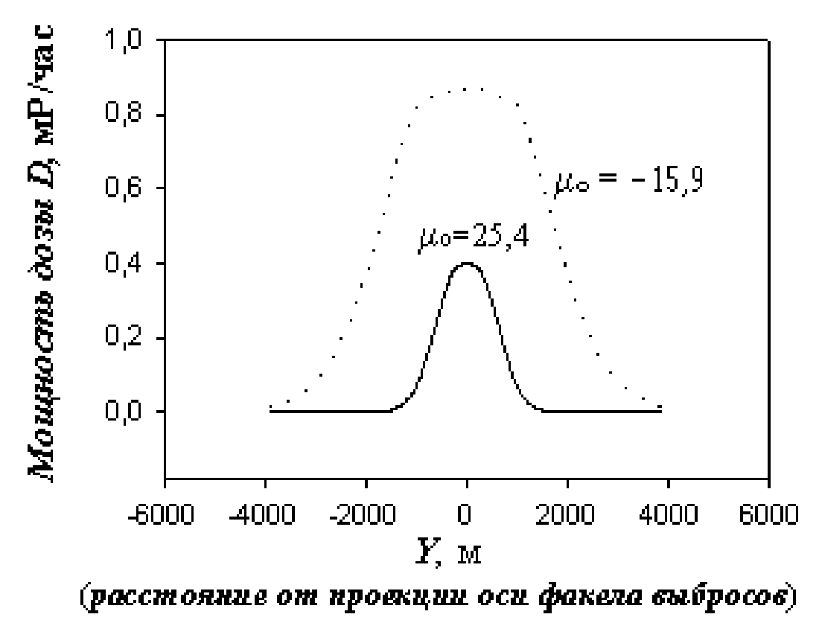

Fig. 2. The distribution of the dose rate in a direction perpendicular to the axis of the plume of emissions at *X* = 2750 m with stable μ0 = 25.4 and unstable μ0 = -15.8 conditions of the atmosphere [5]

|  |  |
| --- | --- |
| Мощность дозы D, мР/час  Y, м  Расстояние от проекции оси факела выбросов | Dose rate D, mR/h  Y, m  Distance from the emission plume projection axis |

Therefore, the determination algorithm for the adequate and sufficient quantity of ARSMS sensors located at the site and in the nuclear facility SPZ comes down to:

1. Setting the radius of the SPZ *R*0.

2. Defining the effective discharge elevation *h*eff.

3. Defining the direction of the discharge of the radioactive impurity to the atmosphere.

4. Calculating the spatial distribution of the dose rate of external exposure at 1 m elevation in the local coordinate system for the worst condition of atmospheric stability (type *F* condition in Pasquill-Gifford classification).

5. Structuring the distribution curve of the dose rate of external exposure in the local coordinate system *XY* at the boundary of the SPZ (Fig. 1) (maximum distribution (on axis *Y*) conforms to the dose rate for the population).

6. Finding on the structured distribution curve of the dose rate *D*'(*X*) values conforming to the limit sensitivity of the photon radiation sensor of the ARSMS system and abscissa *X*' = δ corresponding to this value.

7. Defining the required quantity of the number of photon radiation sensors of the ARSMS system with a whole part of the equation: *N*н = 2π*R*0/2δ = π*R*0/δ.

8. Defining the required quantity of the number of photon radiation sensors of the ARSMS system with the equation *N*д = π*R*0/δ +1.

The found values *N*н и *N*д will conform respectively to the required and adequate number of photon radiation sensors of the ARSMS system located around the NF.

The above assessment procedure of the required and adequate quantity of the number of photon radiation sensors of the ARSMS system is practical to be conducted, by collecting statistical data by seasonal and annual changes in wind speed and temperature, which characterizes the atmosphere stability condition, in the context of studies of meteorological peculiarities of the region, where the NPP is located.

List of references to Appendix No. 20

1. Automated radiation situation monitoring system in the location area of nuclear power plants (ARSMS). General technical requirements to the system and structure of location in the location area of the nuclear power plant. М.: Minatomenergo (Ministry of Atomic Energy) of USSR, 1988.

2. Kummel M. Development of the Optimum Measurement Network for Environmental Monitoring at NPP. In the book Nuclear safety assurance when operating nuclear power plants. Book 5, М.: Energoatomizdat, 1984, pp. 78–89.

3. Elokhin A.P. Principles of location of dose rate sensors around NPP Atomic Energy. Vol. 76, Ed. 3, 1994, pp. 188–193.

4. Accounting of dispersion parameters of the atmosphere during NPP siting. Safety Guides (safety series No. 50-SG-S3). The International Atomic Energy Agency, Viena, 1982, 105 p.

5. Yelokhin A.P. Optimization of methods and means of automated control systems of the environmental radiation situation. Thesis for degree of Doctor of Engineering. М.: MEPhI, 2001, 325 pp.

Appendix No. 21 to the Provision for forecast estimate precision enhancement of environmental radioactive contamination and personnel/public radiation exposures approved by the Order of the Federal Environmental, Industrial and Nuclear Supervision Service

**Deployment principle of ARSMS photon radiation detectors at the site and in the NF SPZ**

The location principle of monitoring posts in the SPZ discussed in Appendix No. 20 is expedient only provided that impurities under abnormal or emergency conditions are released from the vent stacks of NPP. In this case, the most important emission parameters as initial temperature *T*0 and jet pressure *Р*0, emission rate *P*В, radionuclide composition of impurities or spectral composition of photon radiation can be measured by dedicated sensors or their combination, installed in the mouth of the vent stack. A different situation occurs in case of an unauthorised discharge of impurities as a reheated gas jet from openings, valves, leaks of vessels, ragged holes or cracks, arising in case of an explosion or a rupture of high pressure and temperature vessels. In this case, experimentally it is virtually impossible to determine the parameters of a jet ejected from the holes, volumetric activity of impurities, their radiation characteristics since the spectrum or average energy of photon radiation is not known, and, ultimately, it is impossible to determine the scales of radioactive contamination of the environment and assess its environmental consequences as such accidents are extremely rare and cannot be predicted. Developing universal hardware, which could be used in the determination of the above parameters and characteristics in any situation is an almost impossible task and, besides, can lead to a dramatic rise in cost of NPP. Nevertheless radioactive contamination of the environment in case of a powerful non-stationary pulse discharge of impurities through the holes can be successfully assessed when using readings of process sensors that are installed in vessels and that determine the pressure and temperature of the medium, and readings of ARSMS sensors that determine the dose rate of external exposure from the cloud generated as a result of the discharge. The sensors at the site and SPZ must be located based on a certain rule that requires that the distance from a possible source of radiation hazard to any of the sensors is strictly different. In order to verify that, it will be sufficient to consider, in normal conditions, the equation for the dose rate in points *Pi*,*j*,*k* = *P*(*xi*, *yj*, *zk*), located on the underlying surface from the volumetric source (cloud) with volumetric activity distribution in it *q*(*x*, *у*, *z*):

|  |  |
| --- | --- |
| $$D_{i,j,k}=D\left(x_{i},y_{j},z_{k}\right)=\int_{E_{min}}^{E_{max}}{α\left(E\right)μ_{a}\left(E\right)φ\left(E\right)E\int_{V}{q(x,y,z)\left[B(E,R)/R^{2}\right]exp⁡(-μ(E)R)dvdE,}}$$ | (1) |

where α(*E*) – dependence of the detector sensitivity from the energy of the photon radiation in the cloud; μα(*E*), μ(*E*) – energy transfer and linear air photon radiation coefficients, respectively; *В*(*Е*, *R*) = 1 + *a*(*E*) μ(*E*)*R*ехр[*b*(*E*) μ(*E*)*R*] – accumulation factor; *a*(*E*), *b*(*E*) – known energy functions [1]; φ(*E*) – differential spectrum of photon radiation of impurities to be determined; *х*, *у*, *z* – current coordinates; *xi*, *yj*, *zk* – coordinates of ARSMS sensors; *V* – integration area; *d*v = *dxdydz*;

$$R=\sqrt{{(x-x_{i})}^{2}+{(y-y_{j})}^{2}+{(z-z_{k})}^{2}}.$$

Supposing that the discharge will last only for a short time, it is possible to neglect its shear in relation to its symmetry axis. The short duration requirement significantly simplifies the assessment method for the dose rate generated by the cloud, while the dose rate assessment in dynamic spread mode requires that consideration should be given not only to cloud deformation but also meteorological factors of the atmosphere, peculiarities of the underlying surface etc (it will be demonstrated below to overcome these difficulties).

We shall determine the coordinates of the center of cloud masses as follows:

$$x_{0}=\int_{V}{xq\left(x,y,z\right)dv/Q_{V}; y_{0}=\int_{V}{yq\left(x,y,z\right)dv/Q_{V}};}$$

$$z_{0}=\int_{V}{zq\left(x,y,z\right)dv/Q_{V}; Q_{V}=\int_{V}{q\left(x,y,z\right)dv}.}$$

Supposing that the distance $R_{i,j,k}=\sqrt{{(x_{0}-x_{i})}^{2}+{(y_{0}-y_{j})}^{2}+{(z_{0}-z_{k})}^{2}}$ from the point of the mass center to any monitoring post of the ARSMS is considerably greater than the typical size of the cloud, we shall present the volumetric activity *q*(*х*, *у*, *z*) as follows:

|  |  |
| --- | --- |
| $$q\left(x,y,z\right)=Q_{V}δ\left(x-x_{0}\right)δ\left(y-y_{0}\right)δ\left(z-z_{0}\right),$$ | (2) |

where δ(*x*) is the delta function. Integrating in the equation (1) by volume with *q*(*х*, *у*, *z*) of the form of the equation (2), we obtain:

|  |  |
| --- | --- |
| $$Q_{V}\int_{E_{min}}^{E_{max}}{α\left(E\right)μ_{a}\left(E\right)\left[{B\left(E,R_{i,j,k}\right)}/{R_{i,j,k}^{2}}\right]}exp\left[-μ\left(E\right)R_{i,j,k}\right]φ\left(E\right)EdE=D\left(R_{i,j,k}\right),$$ | (3) |

where *Ri*,*j*,*k ≡ Ri*; *i =* 1, 2, 3*...N*Д; *N*Д – adequate number of photon radiation detectors of the ARSMS system. The equation (3) in relation to function φ(*E*) is the Fredholm equation of the first kind and is related to the class of ill-conditioned problems at given measurement error ∆*D* of photon radiation sensors. A non-trivial solution of the equation is possible if

$$R_{i}≠R_{i+1}≠R_{i+2}…R_{N_{Д}}.$$

The equation is solved by replacing φ(*E*) with a group spectrum, approximation of the integral with a final sum and, therefore, with varying *i* the problem is reduced to the system of linear algebraic equations, i.e. solving the system of the form:

|  |  |
| --- | --- |
| $$\hat{A}φ=\vec{D},$$ | (4) |

where $\hat{A}$– matrix *N*д×*M* (*N*д ≥ *M*) with matrix element *ai*,*j* :

– desired solution vector with components $φ_{j},j=1,2,3…m;\vec{D}$– given vector of the results of measurements with components $D_{i}=D\left(R_{i}\right)R_{i}^{2}/Q_{v}$.

Out of available solution methods of such systems of equations, the most widely used ones are regularization [2, 3] and iterative regularization [4] method, where the required solution is found, considering the error both of the right part of the equation (4) and operator $\hat{A}$ if it exists (in this problem this error can be determined by the accumulation factor). In addition, special methods have been developed for the purposes of ionising radiation spectrometry; the peculiarity of these methods is a strict requirement of the positive solution of φ*j* ≥ 0, *j* = 1, 2, 3...*m* and absence of error in the operator $\hat{A}$ [5–7]. The "paper experiment" method is used to verify the calculation method φ*j*: initial spectrum φapr(*E*) is set, then by the equation (3) the values of *D*(*Ri*) is found, which are distorted within the error of real sensors (15÷25 %), after which the reverse problem of determination φ*j* is solved. If follows from the results of the solution of the equation (4) presented in Fig.1 that the initial and restored spectra are satisfactorily coordinated, while table 1, together the above spectra, specifies a solution of the system of linear algebraic equations received by a trivial conversion of the matrix (satisfactory solution):

$$\vec{φ}={({\hat{A}}^{*}A)}^{-1}\vec{b},$$

, where ${\hat{A}}^{*}$– conjugated matrix; $\hat{A}, {({\hat{A}}^{*}\hat{A})}^{-1}$– inverse matrix with size *М*×*М* ; $\vec{b}={\hat{A}}^{*}\vec{∆}$– vector.

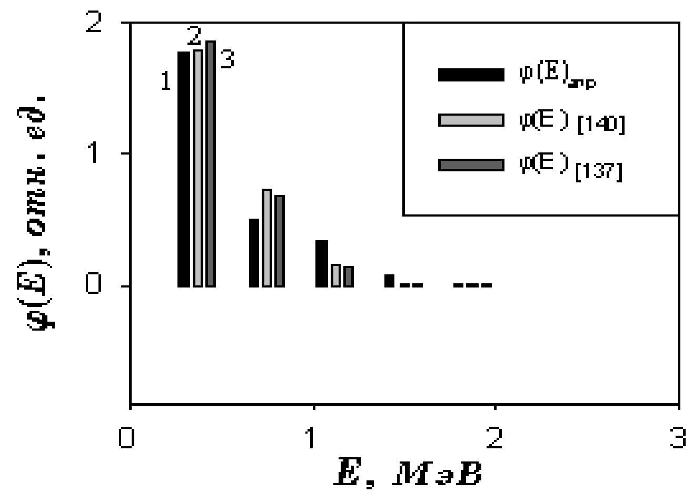

Fig. 1. Bar graphs of photon radiation spectra.

1 – initial φ(*E*)apr (*E*ср = 0.567 MeV), 2 – restored using method Y.Su (*E*ср = 0.526 MeV), 3 – restored by using the regularisation method of A.N. Tikhonov(*E*ср = 0.512 MeV)

|  |  |
| --- | --- |
| Φ(E), oтн. Ед.  E, МэВ | Φ(E), relative unit  E, MeV |

**Table 1**

**A comparison of initial φapr and restored spectra**

|  |  |  |  |  |  |
| --- | --- | --- | --- | --- | --- |
| Index *j* | Energy *Ej*, MeV | Spectrum φ*(Ej)* | | | |
| A priori | Calculated by the method | | |
| Y.Su | by A.N.Tikhonov | Inverse matrix |
| 1 | 0.37 | 1.768 | 1.784 | 1.851 | -0.088 |
| 2 | 0.748 | 0.503 | 0.731 | 0.671 | 0.0 |
| 3 | 1.1216 | 0.328 | 0.149 | 0.137 | -0.802 |
| 4 | 1.496 | 7.36E-2 | 1.56E-2 | 1.45E-2 | -1.1E-3 |
| 5 | 1.87 | 9.6 E-4 | 2.28E-4 | 2.13E-4 | 2.8434 |

In solving ill-conditioned problems two cases are normally considered. In the first case, the error is set in the right part (vector *D*), in the second case, the error is set by the right part and kernel of the equation (3). The submitted document is limited by the first case. At the same time, the paper [3] develops a stable solution method for the problem in either case. However, other methods can be used for the discussed problem. method N. Sconfield [5], Y. Su [6], H. Fabian [7]. These methods are different from the method discussed in the paper [2] by the fact that they strictly require that the solution is positive, which fully corresponds to the problem under consideration. Between themselves these methods are different by a certain algorithm, the essence of which amounts to the adjustment of diagonal elements of a matrix. The latter determines the speed of convergence of problems, which are solved using iterative procedures. Below are algorithms of the specified methods, which are implemented incrementally, the vector in the equation (4) corresponds to the vector ${\vec{X}}^{(m)}$ in methods I and II, while the vector of the right part $\vec{D}$ corresponds to the vector ${\vec{Y}}^{(m)}$:

|  |  |  |
| --- | --- | --- |
| I. Method N.E. Scofield | II. Method Y.SU | |
| 1. Assume ${\vec{X}}_{0}=\vec{Y}$ | 1. Assume ${\vec{X}}_{0}=\vec{Y}$ | |
| 2. Expressed as (*m*) = (*m*)  *m*=0*,* 1*,* 2*...*,  where **(***m***)** – vector of the right part; $\hat{A}$ –matrix; (*m*) – required vector. | 2. Expressed as (*m*) = (*m*)***,***  *m*=0*,* 1*,* 2*...*,  where **(***m***)** – vector of the right part; $\hat{A}$ –matrix; (*m*) – required vector. | |
| I. Method N.E. Scofield | II. Method Y.SU |
| 3. Found ${\hat{D}}^{(m)}$ from the equation $${\vec{Y}}^{(m)}={\hat{D}}^{(m)}{\vec{X}}^{(m)}$$ and found ${\left[{\hat{D}}^{(m)}\right]}^{-1}$, where $${\hat{D}}^{(m)}=\left(\begin{matrix}\begin{matrix}d_{11}^{(m)} & 0 & 0 \\ 0 & d_{22}^{(m)} & 0 \\ 0 & 0 & d_{33}^{(m)}\end{matrix} & \begin{matrix}… & 0 \\ … & 0 \\ … & 0\end{matrix} \\ \begin{matrix}… & … & … \\ 0 & 0 & 0\end{matrix} & \begin{matrix} … & … \\ 0 & d_{nn}^{(m)}\end{matrix}\end{matrix}\right)$$ | 3. Found ${\hat{B}}^{(m)}$ from the equation ${\vec{Y}}^{(m)}={\hat{B}}^{(m)}{\vec{X}}^{(m)}$ with boundedness condition $b_{j-1}^{\left(m\right)}/b_{j,j}^{\left(m\right)}=a_{j-1,j}/a_{j,j}$ and found ${\left[{\hat{B}}^{(m)}\right]}^{-1}$, where $${\hat{D}}^{(m)}=\left(\begin{matrix}\begin{matrix}b_{11}^{(m)} & 0 & 0 \\ b_{21}^{(m)} & b_{22}^{(m)} & 0 \\ 0 & b_{32}^{(m)} & b_{33}^{(m)}\end{matrix} & \begin{matrix}… & 0 \\ … & 0 \\ … & 0\end{matrix} \\ \begin{matrix}… & … & … \\ 0 & 0 & 0\end{matrix} & \begin{matrix} … & … \\ 0 & b_{nn}^{(m)}\end{matrix}\end{matrix}\right)$$ |
| 4. Expressed as ${\vec{X}}^{(m+1)}={\left[{\hat{D}}^{(m)}\right]}^{-1}\vec{Y}$ | 4. Expressed as ${\vec{X}}^{(m+1)}={\left[{\hat{B}}^{(m)}\right]}^{-1}\vec{Y}$ |
| 5. Next iteration (return to step 2) | 5. Next iteration (return to step 2) |

The initial equation in the paper [7] has a similar form:

|  |  |
| --- | --- |
| $$\sum_{i}{Q_{i,j}A_{j}=B_{i},i=1,2….m,}$$ | (5) |

where *Qi*,*j* – element of the matrix corresponding to the matrix element *аi,j* of the matrix $\hat{A}$ in the equation (4); the required vector $\vec{A}$– vector $\vec{φ}$; vector of the right part $\vec{B}$– vector $\vec{D}$. The required vector $\vec{A}$ in this paper is found from the equation:

|  |  |
| --- | --- |
| $$\vec{A}=\hat{δ}\vec{B},$$ | (6) |

where zero approximation of the required vector is ${\vec{A}}^{(0)}$ found by means of a single diagonal matrix δ(0) from the equation:

|  |  |
| --- | --- |
| $${\vec{A}}^{(0)}={\hat{δ}}^{(0)}\vec{B}.$$ | (7) |

This approximation generally does not satisfy the equation (5), but enables the zero approximation of the vector to be evaluated ${\vec{B}}^{(0)}$:

|  |  |
| --- | --- |
| $${\vec{B}}^{(0)}=\hat{Q}{\vec{A}}^{(0)},$$ | (8) |

which allows correction diagonal elements of the matrix δ:

|  |  |
| --- | --- |
| $$d_{kk}^{(1)}=\frac{A_{k}^{(0)}}{B_{k}^{(0)}}, k=1,2…m.$$ | (9) |

Therefore, the obtained assessments of the matrix elements of the diagonal matrix $\hat{δ}$ suggest the following algorithm of assessment of the required vector ${\vec{A}}^{(m)}$.

|  |
| --- |
| III. H.U. Method Fabian, U. Nemsmann |
| 1. The required vector is set (*m*) = (*m*) , where $\vec{B}$ is the vector of the right part; (O) is a single matrix. |
| 2. The vector of the right part is calculated (*m*) = (*m*) |
| 3. Convergence check: $R={\left\{\sum_{i}{{(B_{i}-B_{i}^{(j)})}^{2}}\right\}}^{1/2}<ε$ for the given error ε. |
| 4. "Corrected" diagonal elements of the matrix are found $\hat{δ}$: $d_{kk}^{(m+1)}=\frac{A_{k}^{(m)}}{B_{k}^{(m)}}$ |
| 5. The following approximation of the required vector is calculated: ${\vec{A}}^{(m+1)}={\hat{δ}}^{(m+1)}\vec{B}$ |
| 6. *m* = *m* + 1 - the following iteration is re-determined |
| 7. It is returned to the step (2). |

If the convergence condition is achieved in clause 3, then the solution is deemed found. In a number of cases, it is expedient to set the number of iterations rather than error, after which the solution is deemed found. It follows from Fig. 1 that the value of the average energy of restored spectra is smaller than the initial one. The latter is not difficult to understand if we consider that the average energy of the presented distribution is also an integral value:

$$E_{cp}=\int_{E_{max}}^{E_{max}}{Eφ\left(E\right)dE/\int_{E_{min}}^{E_{max}}{φ\left(E\right)dE.}}$$

However the presence of error in spectral distributions, which arise during the setting of the measuring error of sensors, confirm the correctness of the formula that describes the assessment of the average value of the argument of the accidental function with given relative error δ, which for the average energy <*Еtot*> will take the form: <*Etot*> = <*E*avr> (1 – δ).

It is noteworthy that the average energy of photon radiation found in this manner from the volumetric source generated as a result of a radiation accident at NF, by readings of sensors of the ARSMS system will not correspond to any certain radionuclide, but, nevertheless, enables radioactive contamination assessments and dose burdens on personnel and public to be carried out.

Therefore, the determination algorithm of the spectral composition of photon radiation of the radioactive impurity and its average energy amounts to the following:

1. The determination of the effective lifting elevation of the radioactive cloud during the use of readings of process sensors that measure medium pressure and temperature in a vessel.

2. The determination of readings of photon radiation detectors of the ARSMS system located at the site and in the SPZ.

3. The setting of the coordinates of the ARSMS sensors and coordinates of the source considering its effective elevation.

4. The computation of the distance $R_{i}=\sqrt{{(x_{0}-x_{i})}^{2}+{(y_{0}-y_{i})}^{2}+{(z_{0}-z_{i})}^{2}}$ from the source to each of the detectors.

5. The determination of the spectral composition of photon radiation of the radioactive impurity by one of the methods described above [5], [6], [7].

6. The determination of the average energy of photon radiation.

The condition *Ri* ≠ *Ri*+1 ≠ *Ri*+2…≠ *RNД* , *i =* 1, 2, 3…*N*д imposes certain requirements to the location of photon radiation detectors of the ARSMS, which amount to the exclusion of axial and central symmetry when they are located since, otherwise, the number of equation of the kind (3) and (4), different by the right part, will be reduced by 2 and 4 times (with axial symmetry) or will lead to the full degradation of the system of linear algebraic equations (when sensors are located around the perimeter of the SPZ, i.e. during central symmetry). Moreover, as it was mentioned, placing sensors around the perimeter of the zone enables the plume of the discharge or propagation of the cloud to be reliably recorded at any wind direction. Consideration of these two contradictory requirements leads to the fact that *Ri* of photon radiation sensors must grow with the increase of the azimuth angle, calculated from any direction (for instance, in Archimedes' spiral). The graphs of such curves are given in Fig.2 and are a smooth curve, for which *Ri* is a function of angle; *Ri* = *R*0θ*i*, θ*i* = *i*∆θ; *I* = 1, 2…*N*д; ∆θ = 2π/*N*д, or multi-beam star.

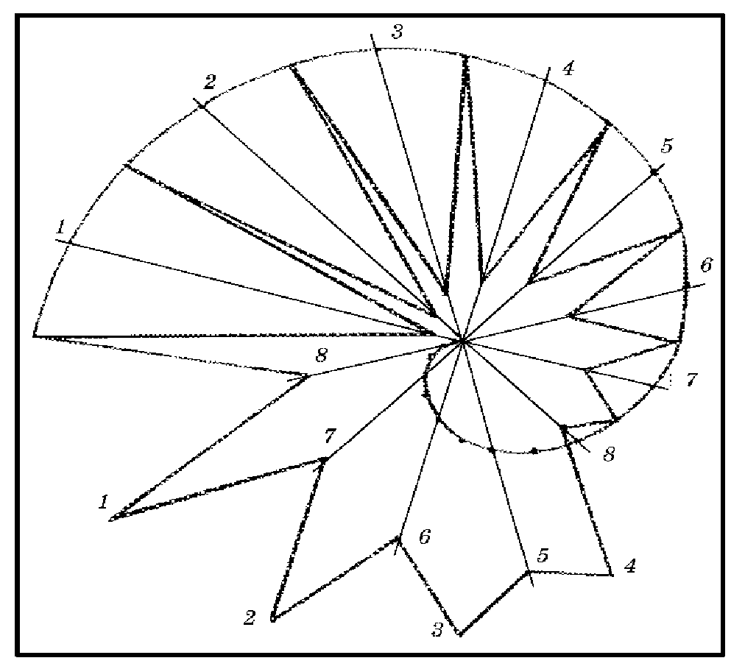

Fig. 2. Possible location of photon radiation sensors in the SPZ as per Archimedes's spiral (at the intersection of the curve with the beams) and a multiple-beam star at the top and base of the beams [8]

Pursuant to [8], each of sensors *Ni*, where *i* = 1, 2, ...*N*д, installed at a distance of the radius of vector *Ri*, from a source of radioactive emission (at a distance of *ri* from the base of the source), different from the corresponding distances of all other *γ*-sensors by the value ∆*Ri* (∆*ri* on the underlying surface) – Fig. 3, for *Ri* ≤ 1000 m ∆*Ri* is found from the equation:

|  |  |
| --- | --- |
| $$R_{i}=2∆R_{i}\left(2δD-1\right)\left[1-\left(2δD+\exp\left(-μ∆R_{i}\right)\right)\right],$$ | (10) |

and for *Ri*> 1000 m ∆*Ri* ≥ *W,* where

|  |  |
| --- | --- |
| $$W=[-ln⁡(1-2δD)/μ],$$ | (11) |

where δ*D –* maximum relative error of measurement of the dose rate with a photon radiation sensor; μ = μ(*E*ср) – linear coefficient of attenuation of photon radiation of the radioactive impurity in the air , м-1; *E*ср – average energy of photon radiation of the radioactive impurity MeV.

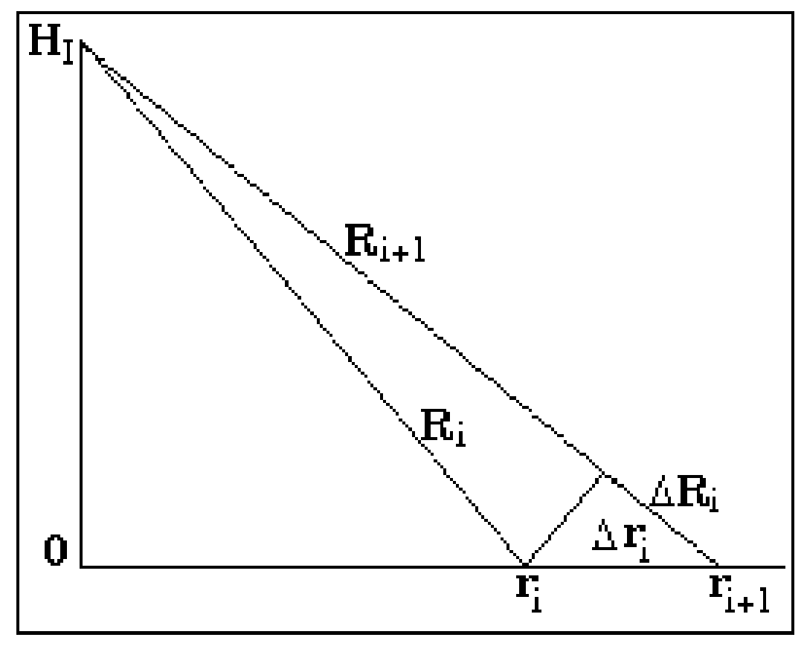

Fig. 3. Determination of the increment of the radius of the vector *Ri* and its next value by the previous one

*HI* is the source elevation; *ri* is the distance on the underlying surface from the basis of the source to the ARMS photon radiation detector

The conclusion of the formulas (10), (11) is based on the following considerations. The above two contradictory requirements for the location of ARSMS sensors can be taken into account if the distance from the discharge source to any of the control sensors *R*i is different from the corresponding distances of all other sensors by a value equal to or greater than the distance between two points at site, in which the relative difference of dose rates from a controlled source is at least equal to or greater than the value of the doubled value of the maximum relative measurement error of the dose rate by means of used sensors. These considerations are written by the equation:

|  |  |
| --- | --- |
| $$1-D(R+∆R)/D(R)=2δD,$$ | (12) |

where *D*(*R*+∆*R*), *D*(*R*) – dose rates in points (*R*+∆*R*), (*R*) respective and δ*D =* ∆*D*/*D*(*R*).

Since in the indefinite environment the dose rate is described by the equation *D*(*R*) = *QK*γ*B*(*E,R*)exp(-µ*R*)/*R*2, then in accordance with the formula (12) we shall obtain:

|  |  |
| --- | --- |
| $$1-[B\left(E,R+∆R\right)exp⁡(-μ(E)(R+∆R))/R^{2}]/\left[R^{2}\left(1+2\frac{∆R}{R}+{\left(\frac{∆R}{R}\right)}^{2}\right)\exp\left(-μ\left(E\right)R\right)B(E,R)\right]=2δD.$$ | (13) |

Assuming that in the last *B*(*E,R +* ∆*R*) ≈ *B*(*E,R*), if the inequality (∆*R/R*)2<< 1 is fulfilled, we shall obtain the equation (10), and if the inequality ∆*R/R*<< 1 is fulfilled, then we shall obtain the equation (11). In practice, the dependence ∆*Ri* = *f*(*Ri*), determined by the formula(10), is found from the curve, which is built according to the equation (10), using given values *Ri* as an argument. For *Ri*> 1000 m, *R*0 is found from the condition ∆*Ri* = *Ri*+1 – *Ri* = *W*, which gives *R*0 = *N*д*W*/2 and at δ*D* = 30% and *Е*cр = 1 MeV, *R*0 = 444 m, *W* = 111 m. With the given *R*0 the value *r*0 is determined from the condition: $H_{1}<r_{0}<\sqrt{R_{0}^{2}-H_{1}^{2}}.$

If *Ri* ≤ 1000 m and minimum value *Ri* is selected as equal to *Rmin* = *R*1 = where the height of the vent stack of the NPP *HI*, is taken as the source height, while the next values *Ri*+1, *Ri*+2 are found using the formula (10) or the curve fig. 4 to determine ∆*Ri* and the relationship: *Ri*+1 = *Ri* + ∆*Ri*. With *Ri*, ∆*Ri* found, the distances *ri* on the plane (underlying surface) from the base of the source to the sensor, at the given value *HI*, for big and small *Ri*, we shall find, assuming *rmin* = *r*1 = *НI*, from the equations:

|  |  |
| --- | --- |
| $$r_{i+1}=\left\{\begin{matrix}r_{i}\sqrt{1+(2∆R_{i}×R_{i})/r_{i}^{2},} & R_{i}≤1000 м \\ r_{i}\sqrt{1+(2W×R_{i})/r_{i}^{2},} & R_{i}>1000 м.\end{matrix}\right.$$ | (14) |

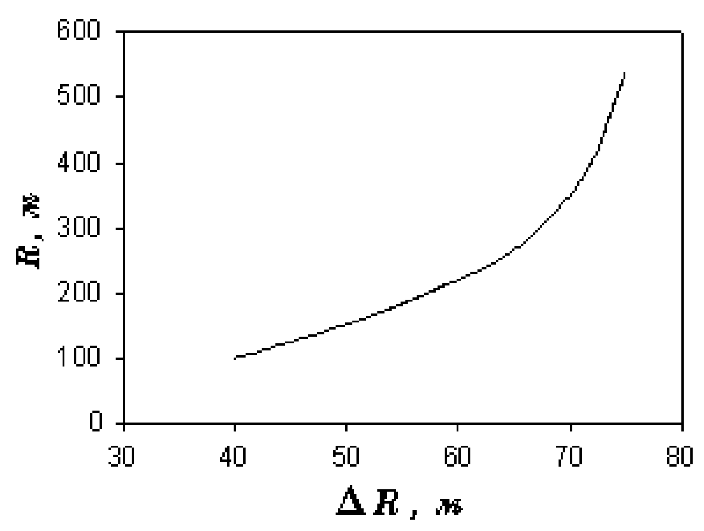

Fig. 4. Determination of the relationship ∆*Ri* as a function of the radius-vector *Ri* (∆*Ri* = *f*(*Ri*))

Therefore, the proposed method of arranging ARSMS photon radiation detectors, considering their required and adequate number and uniformity of azimuth distribution around the NPP, meets the economic, environmental and physical principles, which give grounds to assert that the arrangement of the monitoring stations performed by the above method is really optimum.

List of references to Appendix No. 21

1. Mashkovich V.P., Kudryavtseva A.V. Protection against ionising radiation. Reference Book. М.: Energoatomizdat, 1995, 496 pp.

2. Tikhonov A.N. Solving Ill-Conditioned Problems and Regularisation Method. Reports of the Academy of Sciences of the USSR, 1963, vol. 191, No. 3, pp. 501–509.

3. Tikhonov A.N. Stability of Inverse Problems. Reports of the Academy of Sciences of the USSR, 1943, vol. 39, No. 5, pp. 195–198.

4. Fridman V.M. Method of Sequential Approximations for Integral Fredholm Equations of the 1st Kind. Advances in Mathematical Sciences, 1956, vol. 11, No. 1, pp. 233–234.

5. Sconfield N. Proc. Symp. NAS-NS 3017, 1962, p.108.

6. Su Y. Study of scintillation spectrometry unfolding methods. Nucl. Instr. Meth., 1967, v. 54, p.109-115.

7. Fabian H.U., Nemsman U. Determination of the energy spectrum of a gamma-ray flash. - Atomkernenergie, 1970, BD 16, p. 143-145.

8. Yelokhin A.P., Rau D.F. The control system of the radiation situation in the areas of nuclear facilities. RF Patent No. 2042157, Bulletin No. 23 dated August 20, 1995.

Appendix No. 22 to the Provision for forecast estimate precision enhancement of environmental radioactive contamination and personnel/public radiation exposures approved by the Order of the Federal Environmental, Industrial and Nuclear Supervision Service

**Discharge rate clarification method**

The emission rate *PВ* is used as a multiplier when setting a task in the expression that describes an emission source of radioactive discharge in the equation (14) of Appendix No. 14. If the impurity under consideration is radioactive, which we shall subsequently suppose, the emission rate will be determined by the product of the flow *G* [m3/sec] for volumetric activity of the contamination *Q* [Ci/m3] (*Р*В = *GQ*). That is why two values must be measured to determine the discharge rate: flow *G* and volumetric activity *Q.* No sensors that directly measure the discharge rate are currently in development. The flow rate is normally determined based on the full capacity of air handling units with output to the vent stack. Volumetric activity cannot be determined in dynamic mode so the discharge rate is known with considerable error. In addition, once the discharge rate is clarified, both the volumetric activity of the air basin and scales of radioactive contamination of the environment as a whole are adjusted.

We shall take advantage of the fact that the equation (14) of Appendix No. 14 is a linear one and the discharge rate is included linearly in the solution, therefore, calculating some integral value, in which the discharge rate is included as a multiplier (for instance, the dose rate from the plume of radioactive discharges), and measuring this value, e.g., with ARSMS sensors, assuming that their quantity must be sufficient in the SPZ [1, 2], the numerical value of the discharge rate will be found as a ratio of the measured dose rate to the design rate (if $P_{В}={\dot{D}}_{γ}^{(m)}/{\dot{D}}_{γ}^{(c)}$– a single discharge rate, i.e., where ${\dot{D}}_{γ}^{(m)}$– a measured dose rate, ${\dot{D}}_{γ}^{(c)}$– a design value at a single rate). Generally, the algorithm of determination of the numerical value of *P*В looks as follows.

1. The sensor closest to the axis of the trace of the discharge on the underlying surface is selected.

2. The readings of this sensor are recorded in different moments of time ${\dot{D}}_{v}\left(t_{i}\right),$, where *i* = 1, 2, 3, ...., *L*, considering that the non-stationarity of the radioactive cloud transfer process as it moves along the axis.

3. The moment of time *t*\**,* in which the reading will be maximum, is found.

4. The dose rate ${\dot{D}}_{v}\left(t_{i}\right)$ at *P*В*=*1 is calculated at the same moment of time at the point of the selected sensor, i.e. it is found:

$${\dot{D}}_{v,ед}^{\left(c\right)}\left(x_{i},y_{j},z_{k},t^{*}\right)≈1,5∙{10}^{5}γ\left({\overline{E}}_{γ}\right){\overline{E}}_{γ}\int_{0}^{∞}{dx}\int_{0}^{∞}{dy}\int_{0}^{∞}{q_{ед}}\left(x,y,z,t^{*}\right)\left[\frac{B\left({\overline{E}}_{γ},R\right)}{R^{2}}\right]\exp\left[-μ({\overline{E}}_{γ})\right]dz,$$

in which *q*ед(*x, y, z, t*\*) is calculated by the equations (14) and (1) of Appendices No. 20, 21 at *P*В = 1.

5. Since *q*(*x*, *y*, *z*, *t*) *= P*В*q*ед(*x*, *y*, *z*, *t*), the measured quantity ${\dot{D}}_{v}^{\left(m\right)}(t^{*})$ and calculated at *P*В = 1 are determined by the ratiо: ${\dot{D}}_{v}^{\left(m\right)}\left(t^{*}\right)=P_{В}D_{v,ед}^{\left(c\right)}(t^{*})$, that allows find the source value $P_{В}={\dot{D}}_{v}^{\left(m\right)}(t^{*})/{\dot{D}}_{v,ед}^{\left(c\right)}(t^{*}).$

If several sensors *i =* 1, 2 are found in the propagation area of the trace of the radioactive cloud ... *N'* then, performing a similar procedure for each of the *i*th sensor, the absolute numerical value *P*В is found as a mean square value. $P_{В}=\sqrt{\sum_{i=1}^{N'}{P_{B_{i}}^{2}/N'.}}$

Such assessment will help avoid the influence of operational instability of one of the sensors on the value *P*В.

For the stationary discharge, measuring the dose rate of external exposure with ARSMS sensors, assuming that their quantity meets the sufficiency criteria, the numerical value of the discharge rate will be found as a ratio of the measured and design dose rates (at a single discharge rate) by the formula: $P_{В}={\dot{D}}_{v}^{(m)}/{\dot{D}}_{v,ед}^{(c)},$

where ${\dot{D}}_{v}^{(m)}$– measured value of dose rate;

${\dot{D}}_{v,ед}^{(c)}$– rated value at unit power.

After multiplying by *P*B all required functions, calculated with *q*ед(*x*, *y*, *z*, *t*), are distributed in absolute units.

It must be considered that as the measured dose rate decreases, *D*&*v* the relative contribution of the background dose rate is increased, and, therefore, the error of the emission rate grows. In order to verify this, let us consider the assessment of the discharge rate provided that the natural or human-induced background of photon ration is present.

Assume that the value *D’*ф is the background dose rate created by the photon radiation of natural or human-induced origin, and measurement of dose rate in the emergency emission conditions measured at tow points at distances *Y*1 and *Y*2, (*Y*1<*Y*2), located away from the discharge axis *X*, representing the values *D*´1 (*Y*1) and *D*´2(*Y*2) respectively, and satisfying the inequality *D*´1 (*Y*1) >*D*´2(*Y*2) (fig.1).

We shall introduce the weight δ*i*, being a relative contribution to the difference of the measured dose rate with the deduction of the background value to its absolute value . $δ_{i}=\frac{D_{i}^{'}-D_{ф}^{'}}{D_{i}^{'}}.$

It is evident that if the specified *D*i inequalities δ1> δ2 and δ2 ~ 0, if *Di*′ ~ *D’*ф. Under the conditions that we have determined, the value δ1 and δ2 will be as follows:

$δ_{1}=\frac{D_{1}^{'}-D_{ф}^{'}}{D_{1}^{'}}, δ_{2}=\frac{D_{2}^{'}-D_{ф}^{'}}{D_{2}^{'}},$ while the numerical values of the discharge rates measured with normalization for one or other detector considering the weights will be determined by the relationships respectively:

$$P_{В1}=D_{1,изм}^{'}∙δ_{1}/D_{1,рас}^{'}, P_{В2}=D_{2,изм}^{'}∙δ_{2}/D_{2,рас}^{'}$$

i

$$P_{В}=\sqrt{\left(P_{В1}^{2}+P_{В2}^{2}\right)/\left(δ_{1}^{2}+δ_{2}^{2}\right)}.$$

Thus, considering the background values, the general relationship for the numerical value of the discharge rate is determined by the expression:

$P_{В}=\sqrt{\sum_{i=1}^{N}{P_{В_{i}}^{2}}/\sum_{i=1}^{N}{δ_{i}^{2},}}$ where $δ_{i}=\left(D_{i}^{'}-D_{ф}^{'}\right)/D_{i}^{'}$ and $P_{В_{i}}=D_{i,изм}^{'}∙δ_{i}/D_{i,рас}^{'}$.

After multiplying all the required functions by *P*B, calculated with *q*ед(*x*, *y*, *z*, *t*), we shall obtain a distribution in absolute units.

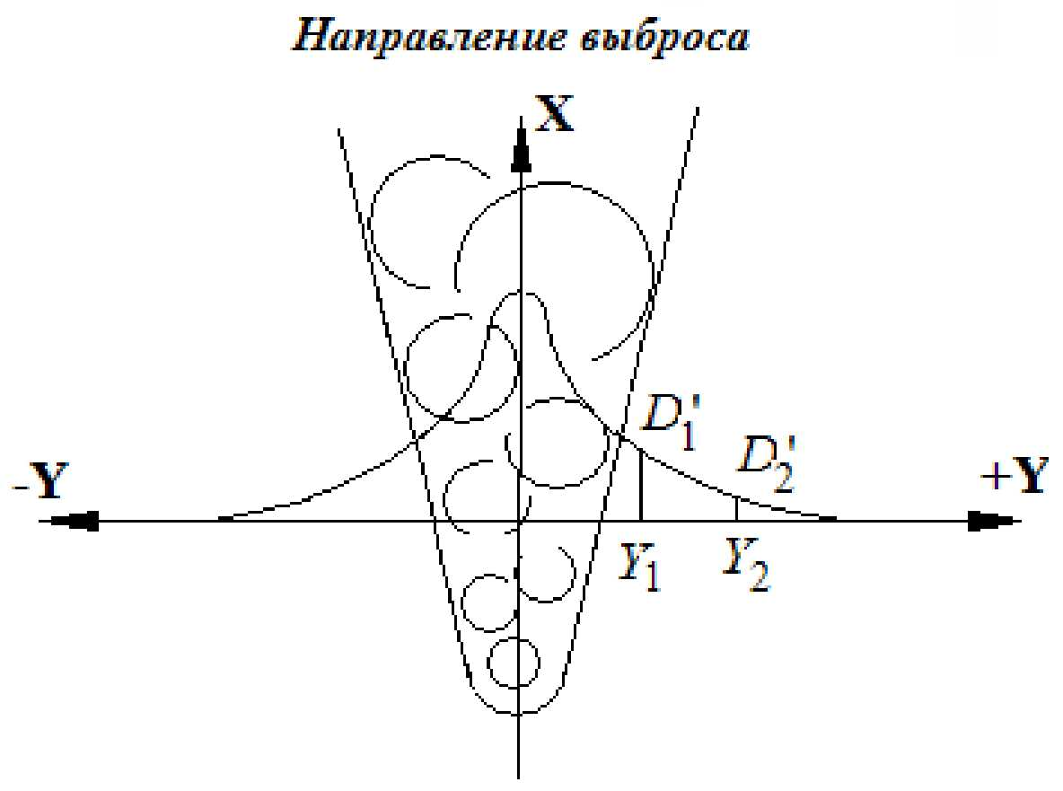

Fig. 1. Assessment of the discharge rate of the radioactive impurity to the atmosphere considering the background dose rate of natural or human-induced origin

|  |  |
| --- | --- |
| Направление выброса | Release direction |

List of references to Appendix No. 22

1. Korn G., Korn T. Mathematics handbook (for research workers and engineers). М.: Nauka, 1974, p. 48.

2. Yelokhin A.P., Solovey A.F. Assessment and Forecasting of Extent of Radioactive Contamination of the Environment during Discharges at NPPs. Nuclear energy, vol. 77, Ed. 2, 1994, p. 145–152.

Appendix No. 23 to the Provision for forecast estimate precision enhancement of environmental radioactive contamination and personnel/public radiation exposures approved by the Order of the Federal Environmental, Industrial and Nuclear Supervision Service

**Method for selecting the optimum sensor for specification**

If we fix photon detectors of photon radiation of radiation monitoring (ARSMS sensors), located in the SPZ, in the polar coordinate system ζ = ζ(*Ri*, φ*i*), where *Ri* – radius of the *i*th detector; φ*i* – azimuth angle, under which the detector is located in relation to the reference point (from north to south clockwise), then, if the direction of emission (bisector of plume opening), set by angle φ*b* one of photon radiation detectors will be located as close as possible to the axis of the emission (Fig.1). It is evident that the dose rate recorded by this ARSMS sensor will be higher than others. So the discharge rate should be determined by this sensor.

|  |
| --- |
|  |
| Fig. 1. The geometry of determination of coordinates and number of the sensor closest to the axis of the discharge of the radioactive impurity: 1–10 – photon radiation detectors of ARSMS monitoring stations; (X,Y) – rigid coordinate system; (X',У') – local coordinate system |

The algorithm for determination of the sensor closest to the axis of the emission looks as follows,

1. With a given direction of emission the sensor closest to the axis of the emission, selecting the minimum angle tangent of ARSMS sensors, placed in the solution (–90, +90) in relation to the direction of the emission (Fig. 1).

2. If the tangents of the angles, at which several sensors are located towards the direction of the discharge, will be equal, then the detector having the least radius *Ri* closest to the axis will be selected. The same thing is done if the detectors lie on the same straight line (on one beam).

3. The dose rate for each sensor in the SPZ is fixed in the computer and is stored in the table under its number "*i*". For the sensor selected closest to the axis of the emission, Cartesian coordinates(*хi, уi*) with axis «*X'*» along the direction of the emission and its number "*i*", by which then the dose rate recorded by this sensor is found.

|  |  |
| --- | --- |
| Направление выброса | Release direction |

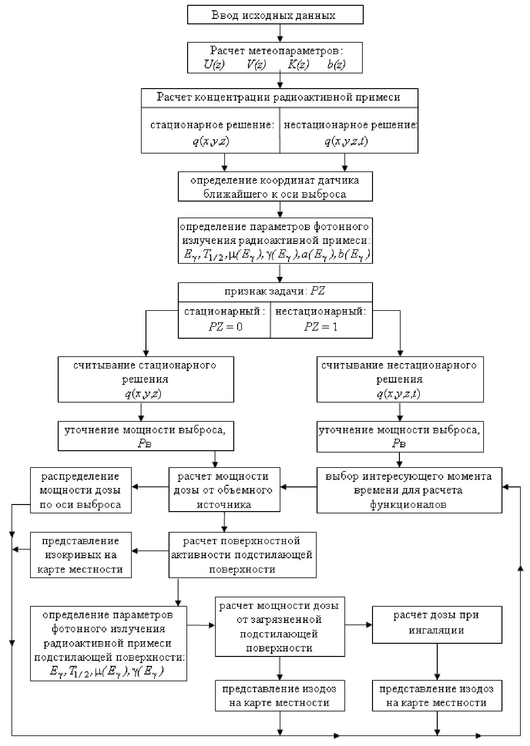

Fig. 2. Algorithm of calculation of environmental contamination and dose burden on personnel and public

|  |  |
| --- | --- |
| Ввод исходных данных  Расчет метеопараметров  Расчет концентрации радиоактивной примеси  Стационарное решение  Нестационарное решение  Определение координат датчика ближайшего к оси выброса  Определение параметров фотонного излучения радиоактивной примеси  Признак задачи:  Стационарный  Нестационарный  Считывание стационарного решения  Считывание нестационарного решения  Уточнение мощности выброса  Распределение мощности дозы по оси выброса  Расчет мощности дозы от объемного источника  Выбор интересующего момента времени для расчета функционалов  Представление изокривых на карте местности  Расчет поверхностной активности подстилающей поверхности  Расчет дозы при ингаляции  Расчет мощности дозы от загрязненной подстилающей поверхности  Определение параметров фотонного излучения радиоактивной примеси подстилающей поверхности  Представление изодозы на карте местности | Input of source data  Calculation of meteorological parameters  Calculation of radioactive impurity concentration  Stationary solution  Non-stationary solution  Determination of the coordinates of sensor nearest to the release axis  Determination of the parameters of photon exposure of radioactive impurity  Task attribute  Stationary  Non-stationary  Reading of stationary solution  Reading of non-stationary solution  Specification of emission intensity  Distribution of dose rate along the emission axis  Calculation of dose rate from volume source  Choice of interesting time for calculation of functional  Representation of isocurves on the location maps  Calculation of surface activity of the underlying surface  Calculation of dose in inhalation  Calculation of dose rate from contaminated underlying surface  Determination of photon radiation parameters of radioactive impurity of underlying surface  Representation of isodose on the location map. |

для

Appendix No. 24 to the Provision for forecast estimate precision enhancement of environmental radioactive contamination and personnel/public radiation exposures approved by the Order of the Federal Environmental, Industrial and Nuclear Supervision Service   
 dated ___________ 20__ №___

**Terms and definitions**

1. **The emission rate of the radioactive impurity,** [Bq/s] – value equal to the product of the second flow rate *G* [m3/s] by volumetric activity *Av* [Bq/m3].

2. **Orography of the underlying surface** – regional specifics addressing the peculiarities of the relief of the underlying surface and its roughness.

**3. Atmosphere boundary layer** – the atmosphere layer approximately 1,000 m high near the ground surface, the properties of which are basically determined by dynamic and thermal impacts of the ground surface.

**4. Atmosphere ground layer**  – part of the atmospheric boundary layer; low, layer of the troposphere 30–50 m thick adjacent to the ground surface (sometimes up to 250 m), the properties of which, to a considerable extent, are determined by the proximity to the underlying surface; in this layer of the atmosphere the wind speed, temperature and air humidity change especially fast with elevation, also near-ground inversion temperature, mists, frosts normally occur, contaminations are accumulated.

**5. Stability condition of the atmosphere boundary layer** – condition of the atmosphere boundary layer characterised by relatively time stable fields of meteorological elements (temperature, wind speed, its direction, humidity etc.).

**6. Roughness of the underlying surface** – irregularities of the underlying surface, in particular, municipal structures, vegetation cover, snow cover and other factors, which have a considerable impact on the nature of air flow propagation. Влияние таких неровностей учитывается с помощью изменения параметра шероховатости *z*0.

1. The Provision has been developed by a team of contributors by the Research and Technical Center for Nuclear and Radiation Safety of the Federal Environmental, Industrial and Nuclear Supervision Service, as well as the employees of VNIIAES OJSC represented by A.P. Yelokhin, M.V. Zhilin (SEC NRS), D.F. Rau, E.A. Ivanova (VNIIAES).
2. The reduction of the SPZ of the NPP and supervised areas is being looked at.