**FEDERAL ENVIRONMENTAL,   
INDUSTRIAL AND NUCLEAR SUPERVISION SERVICE**

APPROVED by   
Order of the Federal Environmental, Industrial and Nuclear Supervision Service No. 302 dated July 11, 2013

**SAFETY GUIDE IN THE USE OF ATOMIC ENERGY   
"MINIMIZATION OF SECONDARY CONTAMINATION OF TERRITORY, COMMUNICATIONS AND TRANSPORT FACILITIES ON EMERGENCY RECOVERY AT THE NUCLEAR FACILITIES. PROCEDURE FOR ARRANGEMENT OF TRANSPORTATION DIAGRAMS AND DECONTAMINATION STATIONS IN THE AREAS WITH DIFFERENT LEVELS OF CONTAMINATION"**

**(RB-084-13)**

Effective   
since July 11, 2013

**Moscow, 2013**

**Safety guide in the use of atomic energy "Minimization of secondary contamination of territory, communications and transport facilities on emergency recovery at the nuclear facilities. Procedure for arrangement of transportation diagrams and decontamination stations in the areas with different levels of contamination"**

**(RB-084-13)**

**Federal Environmental, Industrial and Nuclear Supervision Service - Moscow, 2013**

The safety guide in the use of atomic energy "Minimization of secondary contamination of territory, communications and transport facilities on emergency recovery at the nuclear facilities. The procedure for arrangement of transportation diagrams and decontamination stations in the areas with different levels of contamination" (RB-084-13) (hereinafter the Safety Guide) has been developed in accordance with the article 6 of the Federal Law No. 170-FZ dated November 21, 1995 "On atomic energy use" for promoting compliance with the requirements of the following Federal Rules and Regulations in the field of atomic energy use:

NP-015-12 "Standard content of the plan of actions for protection of personnel in the event of accident at a nuclear power plant" approved by Rostechnadzor Ordnance No. 518 dated September 18, 2012 (registered by the Ministry of Justice of the Russian Federation dated February 12, 2013, registration No. 27011);

NP-016-05 "General safety provisions of the nuclear fuel cycle facilities (GSP NFCF)", approved by the Rostechnadzor Ordnance No. 11 dated December 2, 2005 (registered by the Ministry of Justice of the Russian Federation dated February 1, 2006, registration No. 7433; Bulletin of Normative Acts of Federal Executive Bodies No. 12, 2006).

This Safety Guide contains recommendations of the Federal Environmental, Industrial and Nuclear Supervision Service for assessment of the level of emergency preparedness of the operating organizations with respect to organization of transportation diagrams on emergency recovery at the nuclear facilities (hereinafter the NF).

This Safety Guide shall be applicable to the NF classified under categories I and II by potential radiation hazard according to the classification established by the sanitary rules and standards SP 2.6.1.2612-10 "Main sanitary regulations for ensuring radiation safety (OSPORB-99/2010)" approved by the Rostechnadzor Ordnance No. 40 dated April 26, 2010 (registered by the Ministry of Justice of the Russian Federation dated August 11, 2010, registration No. 18115; Rossiiskaya Gazeta 2010 No. 210/1 (special issue).

This Safety Guide shall be applied by the experts of the Federal Environmental, Industrial and Nuclear Supervision Service for assessment of the level of emergency preparedness of the operating organizations with respect to organization of transportation diagrams on emergency recovery at the NF.

This Safety Guide has been developed considering the documents of the international organizations (IAEA-TECDOC-955 «Generic assessment procedures for determining protective actions during a reactor accident», IAEA, Vienna, 1997; Method for the Development of Emergency Response Preparedness for Nuclear or Radiological Accidents, IAEA-TECDOC-953, IAEA, Vienna (1997); Dangerous Quantities of Radioactive Material, EPR-D-VALUES (2006), IAEA, Vienna (2006); Criteria for Preparation and Evaluation of Radiological Emergency Response Plans and Preparedness in Support of Nuclear Power Plants, NUREG-0654 (FEMA-REP-1), Rev. 1, U.S. Nuclear Regulatory Commission and Federal Emergency and considering the domestic experience in regulation and safety assurance in the field of atomic energy use.

Published for the first time [1]

**I. General**

1. The safety guide in the use of atomic energy "Minimization of secondary contamination of territory, communications and transport facilities on emergency recovery at the nuclear facilities. The procedure for arrangement of transportation diagrams and decontamination stations in the areas with different levels of contamination" (RB-084-13) (hereinafter the Safety Guide) has been developed in accordance with Article 6 of the Federal Law No. 170-FZ dated November 21, 1995 "On atomic energy use" for promoting compliance with the requirements of the following Federal Rules and Regulations in the field of atomic energy use:

NP-015-12 "Standard content of the plan of actions for protection of personnel in the event of accident at a nuclear power plant" approved by Rostechnadzor Ordnance No. 518 dated September 18, 2012 (registered by the Ministry of Justice of the Russian Federation dated February 12, 2013, registration No. 27011);

NP-016-05 "General safety provisions of the nuclear fuel cycle facilities (GSP NFCF)", approved by the Rostechnadzor Ordnance No. 11 dated December 2, 2005 (registered by the Ministry of Justice of the Russian Federation dated February 1, 2006, registration No. 7433; Bulletin of Normative Acts of Federal Executive Bodies No. 12, 2006).

2. This Safety Guide contains recommendations of the Federal Environmental, Industrial and Nuclear Supervision Service for assessment of the level of emergency preparedness of the operating organizations with respect to organization of transportation diagrams on emergency recovery at the nuclear facilities (hereinafter the NF).

3. This Safety Guide shall be applicable to the NF classified under categories I and II by potential radiation hazard according to the classification established by the sanitary rules and standards SP 2.6.1.2612-10 "Main sanitary regulations for ensuring radiation safety (OSPORB-99/2010)" approved by the Rostechnadzor Ordnance No. 40 dated April 26, 2010 (registered by the Ministry of Justice of the Russian Federation dated August 11, 2010, registration No. 18115; Rossiiskaya Gazeta 2010 No. 210/1 (special issue) (hereinafter OSPORB-99/2010).

4. This Safety Guide shall be applied by the experts of the Federal Environmental, Industrial and Nuclear Supervision Service for assessment of the level of emergency preparedness of the operating organizations with respect to organization of transportation diagrams on emergency recovery at the NF.

5. The requirements stipulated by the regulatory legal acts given in the item 1 of this Safety Guide may be fulfilled by using other methods than those, which are contained in this Safety Guide on justification of the selected safety assurance methods.

**II. Recommended criteria for arrangement of transportation diagrams**

6. The vehicle movement along the communications (hereinafter the transportation diagrams) in accordance with this Safety Guide shall be arranged if severe accident occurs at the NFCF with area contamination (accidents at the nuclear power plants, the relevant categories A01 - A03 in compliance with the requirements of the Federal Rules and Regulations in the field of atomic energy use, and accidents at the nuclear fuel cycle enterprises corresponding to the categories A1 - A3 in compliance with the requirements of the Federal Rules and Regulations in the field of atomic energy use).

7. A two-zone or three-zone transportation diagram shall be arranged for minimizing the secondary contamination of the territories, communications and transportation facilities on emergency recovery and/or expected exposure levels.

8. A three-zone transportation diagram shall be arranged on occurrence of accidents at the NFCF leading to discharges of radioactive substances to the atmosphere, whereby exposure of persons from the public in doses exceeding the exposure level wherein urgent intervention is required, set in the sanitary rules SanPiN 2.6.1.2523-09 Radiation safety norms (NRB-99/2009) approved by the Ordnance of the Chief Public Health Officer of the Russian Federation No. 47 dated July 7, 2009 (registered by the Ministry of Justice of the Russian Federation dated August 14, 2009, registration No. 14534; Rossiiskaya Gazeta, 2009 No. 171/1) (hereinafter NRB-99/2009)

9. The two-zone transportation diagram shall be arranged during accident at the NF provided that the discharges caused by the accident may lead to exposure of public in the doses exceeding the level A for taking urgent decisions on evacuation of the population at the initial period of radiation accident established in compliance with the requirements of NRB-99/2009.

10. The occurrence of accident classified as accident of category A01 in compliance with the requirements of the Federal Rules and Regulations in the field of atomic energy use shall be taken for the nuclear power plants as the necessity criteria for arranging a three-zone transportation diagram. The occurrence of accident classified as accident of category A02 - A03 in compliance with the requirements of the Federal Rules and Regulations in the field of atomic energy use shall be taken as the necessity criteria for arranging a two-zone transportation diagram

11. The occurrence of accident classified as accident of category A1 in compliance with the requirements of the Federal Rules and Regulations in the field of atomic energy use shall be taken for the nuclear fuel cycle facilities as the necessity criteria for arranging a three-zone transportation diagram. The occurrence of accident classified as accident of category A2 - A3 - A03 in compliance with the requirements of the Federal Rules and Regulations in the field of atomic energy use shall be taken as the necessity criteria for arranging a two-zone transportation diagram.

12. The following transportation zone shall be set for the three-zone transportation diagram:

near transportation zone;

intermediate transportation zone;

common-use transportation zone.

Moreover, the external boundary of the transportation zone coincides with the inner boundary of the intermediate transportation zone, common use transportation zone in contrast to the near and intermediate transportation zones, not limited by any external perimeter, and the external boundary of the common use transport zone.

13. The following transportation zones shall be set for the two-zone transportation diagram:

intermediate transportation zone;

common-use transportation zone.

Besides the external boundary of the transportation zone coincides with the internal boundary of the common use transportation zone, and the common use transportation zone shall not be limited by any external parameter.

14. The boundaries of transportation zones for different NF shall be set in accordance with the table 1 of Appendix No. 1 to this Safety Guide.

15. The landmarks to the location, which shall clearly and uniquely characterize the boundaries of the specified zones (for example, river, road, forest strip) shall be defined in view of the fact that the determination of the boundaries of transportation zone in the form of circles conditionally may lead to varying interpretations of the boundaries of the zones.

16. The correction of the transportation zone boundaries set in accordance with the item 14 of this Safety Guide shall be performed after the initial setup of the boundaries of the zone in accordance with Appendix No.1 to this Safety Guide as and when radiation monitoring data is received.

**III. Recommendations on actions performed when arranging the three-zone transportation diagram**

17. The following shall be recommended if three-zone transportation diagram is arranged:

not allow exit of transport from the near transportation zone to the intermediate transportation zone;

not allow intersection of the communications designed for different types of transportation zones;

perform the following actions directed at reducing dust concentration of the transport routes in the near transportation zone, viz.:

limitation of vehicle traffic speed of maximum 30 km/h;

washing of dust from the transport routes or its fixation by special fluids;

fixation of dust on the curbs by special fluids;

periodic replacement of soil if required on the curbs for limiting the accumulation of considerable amount of radionuclides on the curbs;

covering of the transport routes if required by a new covering (for example, with asphalt);

signing along the transport routes prohibiting crossover to the curb;

replacement (if required) of the means of transportation taken out of service by sequential transfer of the required number of vehicles operated earlier from the intermediate zone to nearest transport are with simultaneous transfer of the same number of vehicles from the common use transportation zone to the intermediate transprotation zone.

18. The points of decontamination, dosimetric control, cargo transshipment areas and transshipment areas of people (separate into conditionally clean and conditionally contaminated zone).

19. The determination of the points of decontamination, dosimetric control, cargo transshipment areas and transshipment areas of people shall be best to make in the direction opposite to that in which the main trace of radioactive fallouts were formed to the extent possible considering the availability of required transport routes.

20. If the arrangement of point of decontamination, dosimetric control, areas of cargo transshipment and transshipment of people in accordance with the item 19 of this Safety Guide is unreasonable due to the absence of transport routes passing through the NF and boundary of the near transportation zone, the arrangement of point of decontamination, dosimetric control, areas of cargo transshipment and transshipment of people at other sections of the boundary of the near transportation zone is possible with the exception of the section of near transportation zone boundary located on the main trace of the radioactive fall-outs.

21. After the arrival of the vehicles at the conditionally contaminated zone of the point of cargo transshipment and transshipment of people if the rated permissible time of performing the planned works, delivery to the place of performing thereof is planned to carry out in the arrived vehicle, below, than the time required for their performance

22. The calculation of permitted time to perform the planned works shall be made according to the following formula:

|  |  |  |
| --- | --- | --- |
| $t_{раб}=\frac{E_{доп}-E_{путь}∙t_{путь}}{E_{раб}}$, |  | (1) |

where *E*perm - permissible level of planned special exposure, established in accordance with NRB-99/2009

*E*path - measured effective dose rate of external exposure

*E*work - measured effective dose rate of external exposure at the place of planned works;

*t*path, - time required for transportation vehicle to reach the place of planned works.

23. The vehicle shall be decontaminated at the decontamination station using hardware allowing minimize the quantity of radioactive wastes.

24. The organizational and technical measures providing the fastest transshipment of people from the vehicle of the conditionally contaminated zone to te conditionally clean vehicle shall be developed.

25. The point of decontamination, dosimetric control, areas of cargo transshipment and transshipment of people shall be arranged at the points of intersection of the transport routes of the boundaries of intermediate transportation zone and common use transportation zone , excluding the transport routes coinciding with the direction of the passage path of discharge cloud.

26. Surface contamination monitoring of the vehicles for excess of the permitted contamination levels established in the regulatory legal acts shall be made, and if it is not possible the exit of the vehicles shall not be allowed from the intermediate transportation zone at the point of decontamination and dosimetric control, located between the intermediate transportation zone and common use transportation zone.

27. A map of radiological contamination of the near and intermediate transportation zones considering the following approaches shall be made:

the intermediate transportation zone is divided into sections contained by sixteen sectors and circles with radius in multiples of 5 km;

near transportation zone is divide into section contained by sixteen sectors and circles with radii in multiples of 1 km.

The recommended indexing of the radioactive contamination map sections and examples of the radioactive contamination maps of the near and intermediate transportation zones are given in Appendix 2 to this Safety Guide.

28. The value of the maximum recorded effective dose rate at the given section shall be presented on compilation of the radioactive contamination map for each map section.

29. Apart from the radioactive contamination map, a transportation map shall be compiled by dividing all the available transport routes in the near and intermediate zones into individual direct sections. The width of the road bed and its length shall be specified for each such section. Based on the map compiled thus determine the suitability of the transport routes for travel of vehicles on it using the recommended width of the road bed according to Appendix 3 to this Safety Guide.

30. The travel routes of the vehicles shall be arranged considering the maps compiled according to the items 27 - 29 of this Safety Guide, in addition select the route when passing through it the employees receive the least dose.

31. A system of administrative measures directed at minimization of the stops and parking of transport shall be developed when arranging the travel routes of the transport vehicles in the near and intermediate transportation zones.

**IV. The recommendations on the action performed when arranging the two-zone trasport diagram**

32. The arrangement of points of decontamination, dosimetric control, areas of cargo transshipment and transshipment of people in accordance with the item 19, 23 and 26 of this Safety Guide.

33. If the arrangement of point of decontamination, dosimetric control, areas of cargo transshipment and transshipment of people in accordance with the item 19 of this Safety Guide is unreasonable due to the absence of transport routes passing through the NF and outer boundary of the intermediate transportation zone, the arrangement of point of decontamination, dosimetric control, areas of cargo transshipment and transshipment of people at other sections of the outer boundary of the intermediate transportation zone is possible with the exception of the section of intermediate transportation zone boundary located on the main trace of the radioactive fall-outs.

34. The following actions directed at reducing dust concentration of the transport routes shal be performed in the intermediate transpotation zone:

limitation of vehicle traffic speed of maximum 30 km/h;

washing of dust from the transport routes or its fixation by special fluids;

fixation of dust on the curbs by special fluids;

periodic replacement of soil if required on the curbs for limiting the accumulation of considerable amount of radionuclides on the curbs;

covering of the transport routes if required by a new covering (for example, with asphalt);

signing along the transport routes prohibiting crossover to the curb;

replacement (if required) of equipment taken out of service by sequential transition of the required quantity of similar equipment operated earlier from the common use transportation zone to the intermediate transportation zone.

35. A radioactive contamination map of the intermediate zone shall be made.

36. When compiling the contamination map, the intermediate transportation zone shall be divided into sections contained by sixteen sectors and circles with radii multiples of one fifth or less of the radius of the intermediate transportation zone.

37. The route in which the employees get the smallest exposure dose shall be selected for arrangement of the travel routes.

38. A system of administrative measures directed at minimization of the stops and parking of transport shall be developed when arranging the travel routes of the transport vehicles in the intermediate transportation zone.

APPENDIX No. 1

to the safety guide in the use of atomic energy "Minimization of secondary contamination of territory, travel routes and transport facilities on emergency recovery at the NF. Procedure for arrangement of transportation diagrams and points of decontamination in the areas with different contamination level" approved by the order of the Federal Environmental, Industrial and Nuclear Supervision Service

dated , 20 No.

**Recommended radii of the transportation zone boundaries**

Table 1

**Recommended boundaries of the transportation zones for various nuclear facilities (in accordance with the recommendations of IАЕА-ТЕСDОС-955, IАЕА-ТЕСDОС-953, EPR-D-VALUES (2006), NUREG-0654 (FЕМА-RЕР-1)**

|  |  |  |  |  |  |  |
| --- | --- | --- | --- | --- | --- | --- |
| **NF characteristic** | | | **Radius of the near transportation zone boundary, km** | | | **Radius of the intermediate transportation zone boundary, km** |
| Reactor plants of potential radiation hazard category I and II | | | | | | |
| Thermal output P>1000 MW | | | 3-5 1) | | | 25 |
| Thermal output P=100-1000 MW | | | 0.5-3 2) | | | 5-25 3) |
| Thermal output P=10-100 MW | | | -9) | | | 0.5-5 4) |
| Thermal output P=2-10 MW | | | -9) | | | 0.5 |
|  | Spent nuclear fuel storage facilities | | | | | |
| Potential radiation hazard category | I | | | 5 | | 25 |
| II 5) | | | -9) | | 5 |
| Spent nuclear fuel processing plants | | | | | |
| I | | | 5 | | 25 |
| II | | | -9) | | 5 |
| Storage facilities for radiactive substances and radioactive wastes | | | | | | |
| A/D2 ≥ 105 | | | 3-5 1) | | | 25 |
| A/D2 ≥ 104 - 105 | | 0.5-3 6) | | | 5-25 7) | |
| A/D2 ≥ 103 - 104 | | -9) | | | 0.5-5 8) | |
| A/D2 ≥ 102 - 103 | | -9) | | | 0.5 | |

*Remarks to the table 1*

1) The zone radius shall be taken equal to 5 km, however it reduction is allowed following radiation monitoring.

2) The zone radius is calculated by the approximation formula 2.778-∙10-3∙Р+0.222.

3) The zone radius is calculated by the approximation formula 0.022∙Р+2.778.

4) The zone radius is calculated by the approximation formula 0.05∙Р.

5) If the object is classified as category II by potential hazard as per OSPROB-99/2010, but contains more than 1017 Bq (137Ca) then the zones shal be set as for the category I objects

6) The zone radius is calculated by the approximation formula 2.778-∙10-5-A/D2+0.222.

7) The zone radius is calculated by the approximation formula 2.2∙10-4 A/D2+2.778.

8) The zone radius is calculated by the approximation formula 5∙10-4 A/D2

***9)***  Setup of the near transportation zone is not required

The quantity A/D2 is calculated using the following formula:

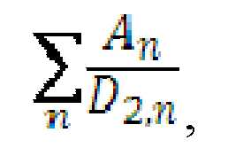

where - activity of *p-*th radionuclide; *D2n -*  value *D2*- values for n-th radionuclide (*D2*- value - *D*- value calculated based on exposure scenario from the dispersed radioactive substance).

The values *D2*-of the quantities are given in table 2

Table 2.

**Values of *D2*-quantities**

| **Isotope** | *D2*, **TBq** |
| --- | --- |
| Н-3 | 2.0Е+03 |
| Ве-10 | 3.0Е+01 |
| С-14 | 5.0Е+01 |
| Nа-22 | 2.0Е+01 |
| A1-26 | 5.0Е+00 |
| Si-321) | 7.0Е+00 |
| Cl-36 | 2.0E+01 |
| Ar-39 | 3.0E+04 |
| K-40 | - |
| Ca-41 | - |
| Ti-441) | 9.0E+00 |
| Mn-53 | - |
| Fe-55 | 8.0E+02 |
| Fe-601) | 1.0E+01 |
| Co-60 | 3.0E+01 |
| Ni-59 | 1.0E+03 |
| Ni-63 | 6.0E+01 |
| Se-79 | 2.0E+02 |
| Kr-81 | 7.0E+02 |
| Kr-85 | 2.0E+03 |
| Rb-87 | - |
| Sr-901) | 1.0E+00 |
| Zr-931) | - |
| Nb-93m | 3.0E+02 |
| Nb-94 | 3.0E+01 |
| Mo-931) | 2.0E+03 |
| Tc-97 | - |
| Tc-98 | 1.0E+01 |
| Tc-99 | 3.0E+01 |
| Ru-1061) | 1.0E+01 |
| Rh-101 | 1.0E+02 |
| Rh-102 | 3.0E+01 |
| Pd-107 | - |
| Ag-108m | 2.0E+01 |
| Cd-109 | 3.0E+01 |
| Cd-113m | 4.0E+01 |
| Sn-121m1) | 7.0E+01 |
| Sn-1261) | 7.0E+00 |
| Sb-1251) | 3.0E+01 |
| I-129 | - |
| Cs-132 | 1.0E+02 |
| Cs-134 | 3.0E+01 |
| Cs-135 | - |
| Cs-1371) | 2.0E+01 |
| Ba-133 | 7.0E+01 |
| La-137 | 5.0E+02 |
| Pm-145 | 4.0E+02 |
| Pm-147 | 4.0E+01 |
| Sm-147 | - |
| Sm-151 | 5.0Е+02 |
| Eu-152 | 3.0Е+01 |
| Eu-154 | 2.0Е+01 |
| Eu-155 | 1.0Е+02 |
| Gd-148 | 4.0Е-01 |
| Tb-157 | 1.0Е+03 |
| Tb-158 | 5.0Е+01 |
| Но-166ш | 3.0Е+01 |
| Tm-171 | 4.0Е+02 |
| Lu-173 | 2.0Е+02 |
| Lu-174 | 1.0Е+02 |
| Hf-1721) | 6.0Е+00 |
| Hf-1821) | - |
| Та-179 | 6.0Е+02 |
| Re-187 | - |
| Os-1941) | 9.0Е+00 |
| Pt-193 | 3.0Е+03 |
| Hg-1941) | 9.0Е+00 |
| Тl-204 | 2.0Е+01 |
| Рb-2021) | 6.0Е+01 |
| Рb-205 | - |
| Рb-2101) | 3.0Е-01 |
| Вi-207 | 4.0Е+01 |
| Вi-210ш | 3.0Е-01 |
| Rа-2261) | 7.0Е-02 |
| Rа-2281) | 4.0Е-02 |
| Ас-2271) | 4.0Е-02 |
| Тh-2281) | 4.0Е-02 |
| Тh-2291) | 1.0Е-02 |
| Тh-2301) | 9.0Е+02 |
| Тh-2321) | - |
| Ра-2311) | 6.0Е-02 |
| U-2321) | 6.0Е-02 |
| U-233 | 7.0Е-02 |
| U-2341) | 1.0Е-01 |
| U-2351) | 8.0Е-05 |
| U-236 | 2.0Е-01 |
| U-2381) | - |
| Unatural | - |
| Udepleted | - |
| Uenriched up to 10-20% | 8.0Е-04 |
| Uenriched above 20% | 8.0E-05 |
| Np-235 | 2.0E+02 |
| Np-236b1) | 7.0E-03 |
| Np-2371) | 7.0E-02 |
| Pu-236 | 1.0E-01 |
| Pu-238 | 6.0E-02 |
| Pu-239 | 6.0E-02 |
| Pu-240 | 6.0E-02 |
| Pu-2411) | 3.0E+00 |
| Pu-242 | 7.0E-02 |
| Pu-2441) | 3.0E-04 |
| Am-241 | 6.0E-02 |
| Am-242m1) | 3.0E-01 |
| Am-2431) | 2.0E-01 |
| Cm-243 | 2.0E-01 |
| Cm-244 | 5.0E-02 |
| Cm-245 | 9.0E-02 |
| Cm-246 | 2.0E-01 |
| Cm-247 | 1.0E-03 |
| Cm-248 | 7.0E-02 |
| Bk-247 | 8.0E-02 |
| Cf-249 | 1.0E-01 |
| Cf-250 | 1.0E-01 |
| Cf-251 | 1.0E-01 |
| Cf-252 | 1.0E-01 |
| 239Pu/9Be2) | 6.0E-02 |
| 241Am/9Be2) | 6.0E-02 |

Remark to the table No. *2*

1) - Daughter nuclides make a large contribution to the exposure dose as compared to the mother radionuclides.

2) - Activity is given for alpha-emitting radionuclide contained in the neutron source, i.e. 239Pu and 241Am.

APPENDIX No. 2  
 to the safety guide in the use of atomic energy "Minimization of secondary contamination of territory, communications and transport facilities on emergency recovery at the nuclear facilities. Procedure for arrangement of transportation diagrams and decontamination stations in the areas with different contamination level" approved by the order of the Federal Environmental, Industrial and Nuclear Supervision Service   
 dated , 20 No.

**Recommended indexing of the radioactive contamination map sections**

Recommended indexing of the sections of radioactive contamination map of the near and intermediate transportation zones depending on the direction and from the distance from the NF is given in the tables 1, 2 respectively.

Table 1

**Recommended indexing of radioactive contamination map sections of the near and intermediate transportation zones depending on the direction**

|  |  |  |  |  |  |  |  |  |
| --- | --- | --- | --- | --- | --- | --- | --- | --- |
| **Direction, rhumb** | N | NNE | NE | ENE | E | ESE | SE | SSE |
| **Section index** | A | B | E | D | E | F | G | H |
| **Direction** | S | SSW | SW | WSW | H | WNW | NW |  |
| **Section index** | I | K | L | M | Н | O | P | Q |

Table 2

**Recommended indexing of radioactive contamination map sections of the near and far transportation zones depending on the distance from the NF**

|  |  |  |  |  |  |  |  |
| --- | --- | --- | --- | --- | --- | --- | --- |
| **Distance up to the NF, km** | 0-1 | 1-2 | 2-3 | 3-4 | 4-5 | 5-10 | 10-15 |
| **Section index** | 1 | 2 | 3 | 4 | 5 | 6 | 7 |
| **Distance up to the NF, km** | 15-20 | 20-25 | 25-30 | 30-35 | 35-40 | 40­-45 | 45-50 |
| **Section index** | 8 | 9 | 10 | 11 | 12 | 13 | 14 |

Examples of indexing of sections of the radioactive contamination map of near and far transportation zones are presented in the section 1, 2.

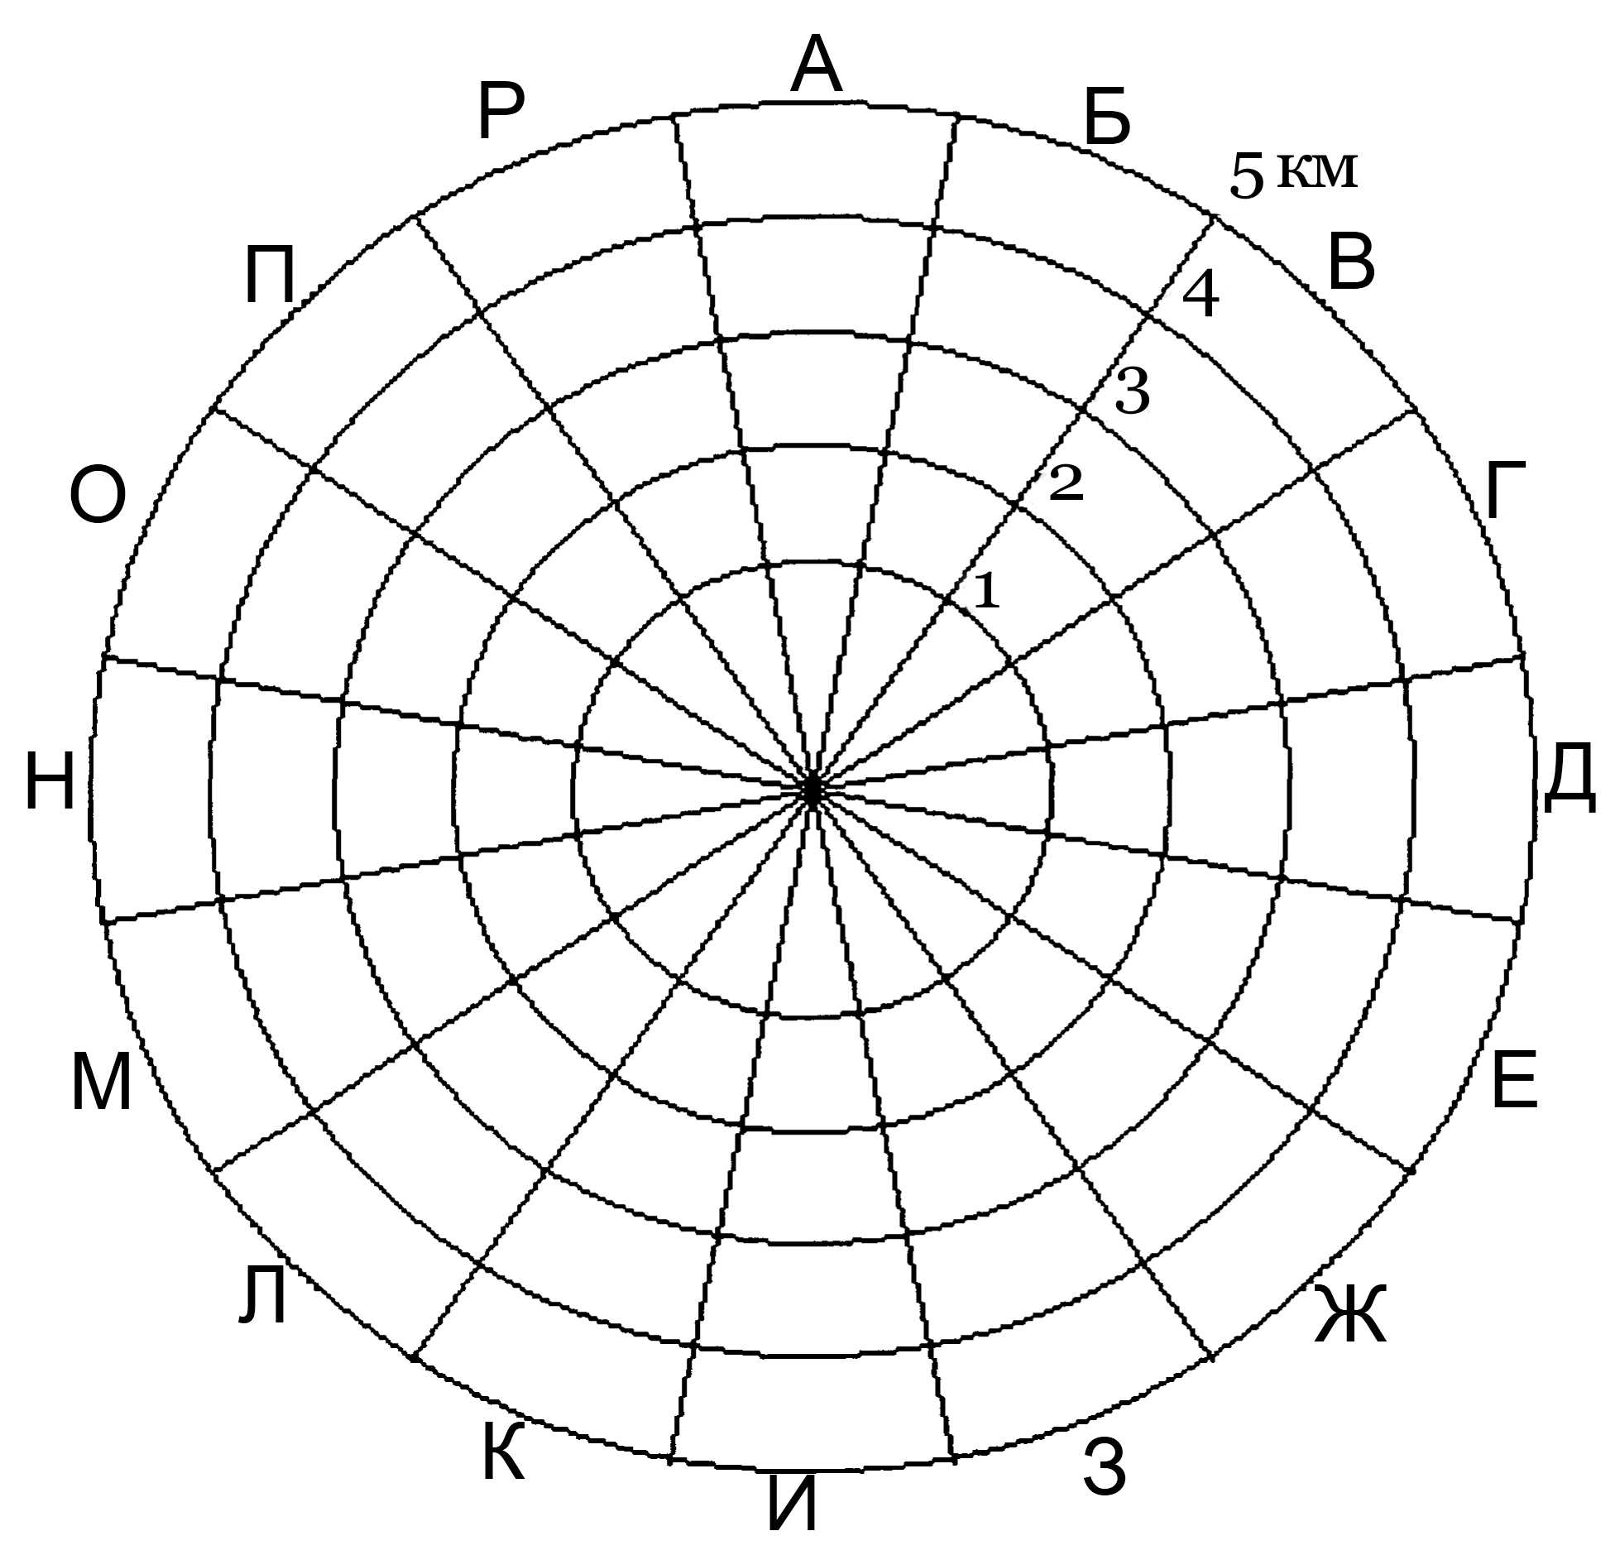

5 km

Fig. 1. Example of indexing of sections of the radioactive contamination map of near transportation zone

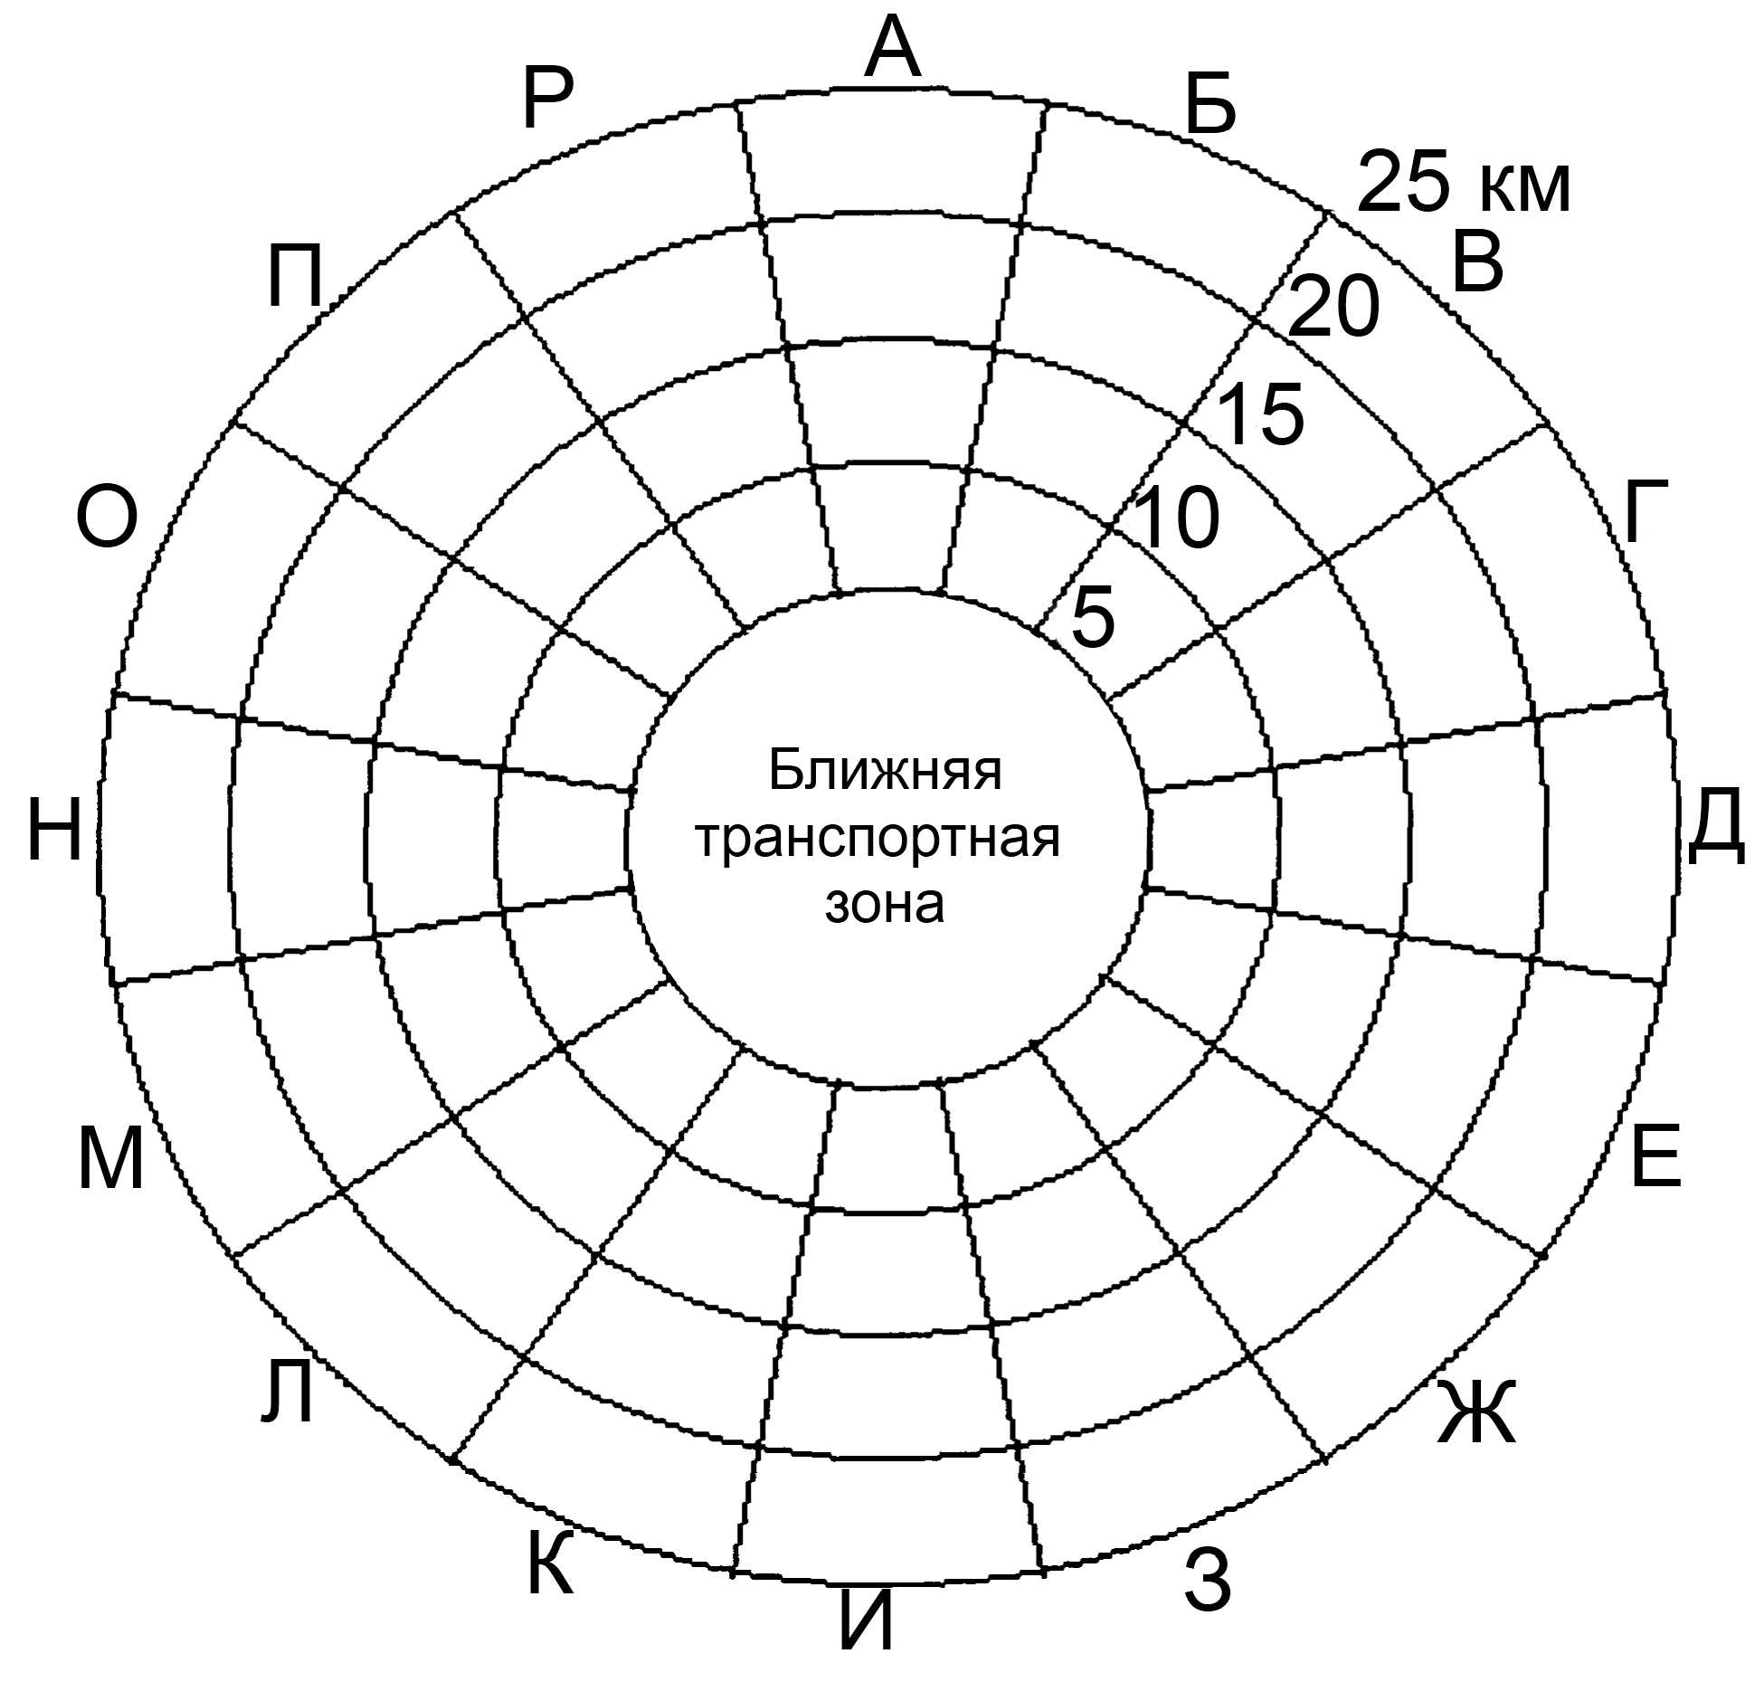

25 km

Fig. 2. Examples of indexing of sections of the radioactive contamination map of intermediate transportation zone

|  |  |
| --- | --- |
| Ближняя транспортная зона | Near transportation zone |

APPENDIX No. 3   
to the safety guide in the use of atomic energy "Minimization of secondary contamination of territory, communications and transport facilities on emergency recovery at the nuclear facilities. Procedure for arrangement of transportation diagrams and decontamination stations in the areas with different contamination level" approved by the order of the Federal Environmental, Industrial and Nuclear Supervision Service   
 dated , 20 No.

**Recommended width of roadway**

|  |  |  |  |  |
| --- | --- | --- | --- | --- |
| **Vehicle type** | **Width of roadway based on vehicle speed** | | | |
| **30 km/h** | **40 km/h** | **50 km/h** | **60 km/h** |
| Motor car | 2.7 | 2.8 | 2.9 | 3.0 |
| Truck | 3.4 | 3.5 | 3.6 | 3.7 |
| Large vehicle | 3.6 | 3.7 | 3.8 | 3.9 |

1. Developed by a team of authors comprising of: A.A. Stroganov, A.V. Kuryndin, A.S. Shapovalov, M.Yu. Orlov (FBU NTTs YaRB).