Approved by
Order of the Federal Environmental, Industrial and Nuclear Supervision Service
dated March, 19, 2014 No. 107

SAFETY GUIDE
IN THE USE OF ATOMIC ENERGY "MINIMIZATION OF RADIOLOGICAL CONSEQUENCES FOR THE PUBLIC AND THE PERSONNEL IN THE COURSE OF POST-ACCIDENT CLEAN-UP AT THE POWER UNITS OF VARIOUS NUCLEAR POWER PLANT TYPES.
METHODOLOGY FOR OPTIMIZATION OF THE ARRANGEMENTS FOR PROTECTION OF THE PUBLIC AND TERRITORIES"

RB-094-14

I. General provisions

1. This safety guide in the use of atomic energy "Minimization of Radiological Consequences for the Public and the Personnel in the Course of Post-Accident Clean-Up at the Power Units of Various Nuclear Power Plant Types. Methodology for Optimization of the Arrangements for Protection of the Public and Territories" (RB-094-14) (hereinafter - the Safety Guide) has been developed in accordance with Article 6 of Federal Law No. 170-FZ dated November, 21, 1995 "On atomic energy use" for the purpose of compliance with the requirements of the Federal Rules and Regulations in the area of atomic energy use "Standard Content of the Action Plan for Protection of the Personnel in Case of Any Accident at the Nuclear Power Plant" (NP-015-12) approved by Order of the Federal Environmental, Industrial and Nuclear Supervision Service No. 518 dated September, 18, 2012 (registered by the Ministry of Justice of the Russian Federation on February, 12, 2013, registration No. 27011) (hereinafter - NP-015-12).
2. This Safety Guide contains the recommendations of the Federal Environmental, Industrial and Nuclear Supervision Service for the operating organization to comply with the requirements of the rules and regulations in the field of atomic energy use with regard to minimization of radiological consequences for the public and the personnel in the course of post-accident clean-up at the power units of various types of nuclear power plants (hereinafter - the NPPs).
3. This Safety Guide shall be applicable to nuclear power plants with power units of various types.
4. This Safety Guide is intended to be applied by the specialists of operating organizations in development of the action plans for protection of the personnel in case of any accident at the nuclear power plant, as well as by the specialists of the Federal Environmental, Industrial and Nuclear Supervision Service in assessment of the emergency preparedness level of the operating organizations, emergency response drills and trainings of the operating organizations as well as the actions of the operating organization in case of any accident.
5. The requirements of NP-015-12 may be implemented through the use of any other methods than the ones contained in this Safety Guide subject to substantiation of the selected methods for safety assurance.

II. Zoning of territories in order to minimize radiological consequences for the public and the personnel

6. In order to implement the provisions of par. 3.1 of the Appendix to NP-015-12 it is recommended to define the dimensions of the radioactive contamination zones with due regard for the recommendations of this Safety Guide.
7. It is recommended to substantiate the dimensions of the radioactive contamination zones in the NPP safety analysis report (hereinafter - the NPP SAR) with due regard for the maximum release possible in case of severe beyond design basis accidents from among all accidents considered in the analysis.
8. The zone dimensions substantiated in the NPP SAR should be specified in the action plan for protection of the personnel thus enabling to make a definite and urgent decision with regard to arrangement of the radioactive contamination zones and implementation of the measures aimed to minimize radiological consequences for the public and the personnel not to be engaged in mitigation and elimination of the accident consequences in case of any radiation-hazardous situation occurrence subsequent to determination of the possibility for this radiation-hazardous situation escalation into a severe beyond design basis accident with contamination of any territories (before any releases).
9. It is recommended to establish the radioactive contamination zones in accordance with the table provided in Appendix 1 to this Safety Guide; in this case it is recommended to assign the numbers from 1 to 4 to the zones according to the distance between their outer boundaries and the power unit affected by the accident.
10. It is recommended to take the dimension ranges for Zones 1-4 specified in the table of Appendix 1 to this Safety Guide as the first approximation. It is recommended to define the final dimensions of the zones in the NPP SAR based on the analysis of accidents within the dimension ranges specified in the table of Appendix 1 to this Safety Guide. In this case it is recommended to take into account the equilibrium composition of inert radioactive gases with the half-life of up to 1 month within the isotope composition of a radioactive release (apart from cesium and iodine isotopes) for the maximum power of the unit.
11. It is recommended to take the expected exposure levels requiring urgent intervention and established by the requirements of Section VI of the Sanitary Standards and Rules SanPiN 2.6.1.2523-09 "Radiation Safety Standards (NRB-99/2009)" approved by Resolution of the Chief Public Health Officer of the Russian Federation No. 47 dated July, 7, 2009 (registered by Ministry of Justice of the Russian Federation on August, 14, 2009, registration number No. 14534; Russian Newspaper, 2009, No. 171/1) (hereinafter - NRB-99/2009) as the criterion to determine the dimensions of Zone 1.
12. It is recommended to take the double value of "A" level (according to the whole-body dose) for making of urgent decisions with regard to evacuation of the public at the initial stage of a radiation accident established by the requirements specified in Section VI of NRB-99/2009 as the criterion to determine the dimensions of Zone 2.
13. The recommendations on the emergency release air transport model used to define the dimensions of Zones 1 and 2 are given in Appendix 2 to this Safety Guide.
14. It is recommended to define the dimensions of Zones 1 and 2 with due regard for the following exposure pathways:
external exposure from the radioactive release cloud;
external exposure from radioactive depositions on the ground surface;
internal exposure due to inhalation of radionuclides from the radioactive release cloud.
15. It is recommended to calculate the doses for determination of the Zone 2 dimensions assuming that external exposure from radioactive depositions on the ground surface takes place within 24 hours.
16. Within the framework of substantiation of the Zone 2 dimensions in the NPP SAR it is recommended to determine the dimensions of this zone assuming that iodine prophylaxis and sheltering have been carried out. It is recommended to consider iodine prophylaxis and sheltering by application of the reduction factors specified in the table of Appendix 2 to this Safety Guide.
17. It is recommended to take the double value of "A" level (according to the effective dose) for making of the decisions on relocation established by the requirements of NRB-99/2009 as the criterion to determine the dimensions of Zones 3 and 4.
18. It is recommended to assess the doses for determination of the Zone 3 dimensions with due regard for the following exposure pathways:
external exposure from radioactive depositions on the ground surface;
internal exposure due to inhalation of airborne radionuclides (particularly due to inhalation of the secondary dust raised from the ground surface).
19. It is recommended to assess the doses for determination of the Zone 4 dimensions with due regard for the exposure pathways recommended in par. 18 of this Safety Guide and also with due regard for the exposure pathway associated with consumption of contaminated water and foodstuff.
20. In case of any radiation-hazardous situation occurrence at the NPP it is recommended to perform qualitative assessment of the probability for this radiation-hazardous situation development into a severe beyond design basis accident with contamination of any territories. It is recommended to take reaching and (or) exceedance of the preset limit values by the directly measurable parameters of the reactor facility and NPP state (or by the values derived from the directly measurable parameters through calculation and evaluation) as the sign bearing evidence to high probability of the event. Reaching of these limit values bears evidence to significant probability of the radiation-hazardous situation development into a severe beyond design basis accident.
21. In case the preset limit values mentioned in par. 20 of this Safety Guide are reached it is recommended to establish the radioactive contamination zones in accordance with their dimensions substantiated in the SAR and specified in the action plan for the personnel protection prior to the release or prior to receipt of the radioactive territory contamination monitoring data (if the release has already occurred).
22. In case any emergency release has occurred, and the radioactive territory contamination monitoring data has not been obtained yet it is recommended to use the monitoring data with regard to the wind direction time dependency covering the time period of the emergency release in order to determine Zones 3 and 4. In this case it is recommended to assume that Zones 3 and 4 are limited with the radii substantiated in advance in accordance with par. 17-19 of this Safety Guide and sectors determined subsequent to the wind direction time dependency monitoring. In the absence of any wind direction time dependency monitoring data it is recommended to assume that Zones 3 and 4 are not limited to sectors and take the form of circles.
23. Due to the fact that determination of the circular radioactive contamination zone boundaries is rather uncertain and can result in ambiguous interpretation of the zone boundaries it is recommended to define the landmarks characterizing the boundaries of Zones 1 and 2 clearly and unambiguously (for example, a river, a road, a forest strip) as shown in Figure 1 of Appendix 1 to this Safety Guide.

III. Arrangements for minimization of radiological consequences for the public and the personnel within the established zones

24. In order to implement the provisions of par. 9.5.2 of the Appendix to NP-015-12 it is recommended to plan and to perform (in case of any radiation-hazardous situation capable of causing a severe beyond design basis accident with contamination of any territories) the evacuation arrangements in advance (prior to any release) within Zones 1 and 2 established in accordance with Section I of this Safety Guide.
25. In order to implement the provisions of sub-paragraph "c", par. 9.5.2 of the Appendix to NP-015-12 it is recommended to take reaching of the preset limit values by the directly measurable parameters of the reactor facility and NPP state, or by the values derived from these parameters through calculation and evaluation as the criteria for the necessity of any evacuation arrangements within Zones 1 and 2.
26. It is recommended to carry out proactive evacuation (prior to any release) from Zones 1 and 2 established in accordance with Section I of this Safety Guide. In the course of evacuation from both Zones 1 and 2 it is recommended to consider evacuation out of Zone 2 as sufficient.
27. In the course of planning and implementation of the proactive arrangements for evacuation from Zone 2 it is recommended to consider evacuation from Zone 1 as priority. It is recommended to carry out proactive evacuation from Zone 2 upon completion of the proactive evacuation arrangements in Zone 1. Simultaneous proactive evacuation from Zones 1 and 2 is permitted provided that evacuation from the latter zone would not defer evacuation from the former one.
28. In case any radiation-hazardous situation results in a severe beyond design basis accident accompanied with a release it is recommended to arrange urgent evacuation outside Zone 2 at the areas where exceedance of the limits specified in NRB-99/2009 will be detected subsequent to the radiation monitoring results.
29. In case it is impossible to arrange immediate and safe proactive evacuation or urgent evacuation (for example, in presence of any weather conditions preventing from evacuation) it is recommended to use sheltering in combination with iodine prophylaxis as the protective measure in Zones 1 and 2 as well as at any areas outside Zone 2 where any exceedance of the limits established by the regulations will be detected subsequent to the radiation monitoring results.
30. It is recommended to consider sheltering as a temporary protection measure and not to use it for any time period exceeding one day in the following cases:
the need of the sheltered people for food, water and power is not satisfied at the sheltering location;
communication of the information to the sheltered people via the mass media and annunciation systems is not provided;
radiation monitoring of the sheltering location area is not performed.
31. In order to reduce contamination of the territories and to minimize radiological consequences for the personnel and the public in the course of accident management in case of any emergency release it is recommended also to adhere to the provisions of the Safety guide in the use of atomic energy "Minimization of Secondary Contamination of Territories, Transportation Routes and Vehicles in the Course of Post-Accident Clean-Up at Nuclear Facilities. Procedure for Arrangement of Transportation Patterns and Decontamination Stations in the Areas with Different Contamination Level" (RB-084-13) approved by Order of the Federal Environmental, Industrial and Nuclear Supervision Service dated July, 11, 2013 No. 302.

IV. Minimization of radiological consequences for the personnel in the course of post-accident clean-up

32. It is recommended to carry out the post-accident clean-up works, particularly the works for decontamination of the equipment, rooms, civil structures and territories performed under the conditions of intensive radiation fields according to the sequence and methods ensuring the minimal collective dose for the personnel.
33. In order to comply with the recommendations of par. 32 it is recommended to develop the arrangements aimed to minimize the dose burden for the personnel engaged in the post-accident clean-up prior to commencement of the works with due regard for the recommendations stated in this section of this Safety Guide.
34. The arrangements aimed to minimize the dose burden for the personnel engaged in the post-accident clean-up should:
provide for determination of the spatial distribution of radioactive contamination prior to commencement of the post-accident clean-up works;
define the set of works (stages of the works) to be performed in the course of post-accident clean-up;
define the estimated duration and methods for performance of each work (stage of works);
assess the contribution of each radioactive contamination source to the dose characteristics of the emergency situation at the work sites through the use of calculations (the recommendations on assessment of the radioactive contamination source contributions to the dose characteristics of the emergency situation at the work sites are given in Appendix 3 to this Safety Guide, and the reference data for assessment of the radioactive contamination source impact on the dose characteristics of the emergency situation at the work sites are provided in Appendix 4 to this Safety Guide);
define the possibility and method for usage of additional shady shielding at each workplace;
determine the "dose criterion" value for completion of the works (the expected "residual" dose rate level) for each work (stage of the works);
assess the collective dose values for the personnel in all possible sequences of individual works (stages of the works) and define the sequence of the works with the minimal collective dose burdens for the personnel.
35. In the course of the post-accident clean-up works it is recommended to adjust the arrangements for minimization of the dose burdens for the personnel engaged in the post-accident clean-up in a timely manner with due regard for dynamics of the radiation situation changes in the course of any post-accident clean-up measure implementation in order to optimize the sequence of the works and to minimize the collective dose for the personnel.

V. In-service assessment of correctness of the arrangements for protection of the public and the personnel

36. In the course of in-service assessment of correctness of the personnel protection arrangements implemented at the nuclear power plant, the measures recommended by the nuclear power plant technical support centers and the measures recommended by the nuclear power plants to the persons responsible for making of the decisions on implementation of the public protection arrangements it is recommended to assess correctness of the radioactive contamination zone radii evaluated by the technical support centers.
37. It is recommended to assess correctness of the radioactive contamination zone radii evaluated by the technical support centers through the use of the recommendations provided in Appendix 5 to this Safety Guide with regard to assessment of the correct determination of the zone where urgent decisions on evacuation at the initial stage of a radiation accident are necessary.

Appendix 1
to the Safety guide in the use of atomic energy "Minimization of Radiological Consequences for the Public and the Personnel in the Course of Post-Accident Clean-Up at the Power Units of Various Nuclear Power Plant Types. Methodology for Optimization of the Arrangements for Protection of the Public and Territories" approved by Order of the Federal Environmental, Industrial and Nuclear Supervision Service
dated March, 19, 2014 No. 107

RECOMMENDATIONS
ON DETERMINATION OF THE RADIOACTIVE CONTAMINATION ZONES

Table

RECOMMENDED DIMENSIONS OF THE RADIOACTIVE CONTAMINATION ZONE BOUNDARIES (IN ACCORDANCE WITH THE RECOMMENDATIONS OF THE INTERNATIONAL ATOMIC ENERGY AGENCY "ACTIONS TO PROTECT THE PUBLIC IN AN EMERGENCY DUE TO SEVERE CONDITIONS AT A LIGHT WATER REACTOR")

Zone number according to the distance between its outer boundary and the NPP | Expected maximum radius (km)
 | Thermal output >= 1000 MW | Thermal output < 1000 MW
1 | 3 - 5
2 | 10 - 30
3 | 100 | 50
4 | 300 | 100

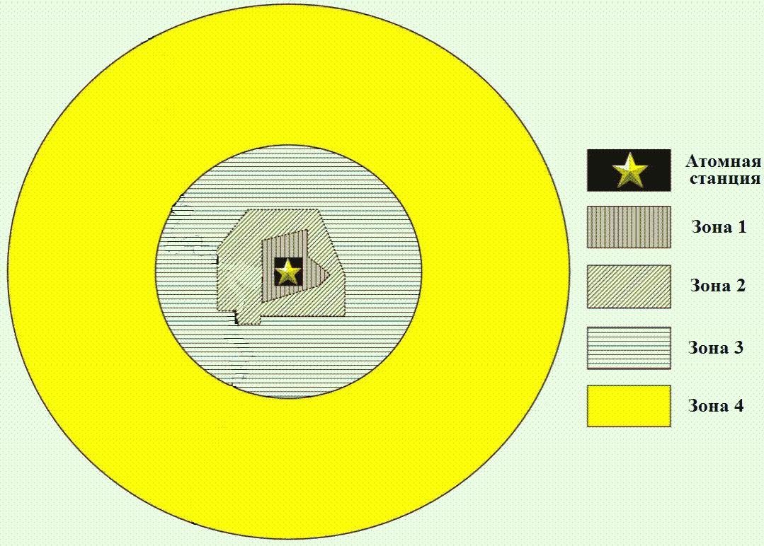
Nuclear power plant
Zone 1
Zone 2
Zone 3

Fig. 1. Sample numeration of the radioactive contamination zones

Appendix 2
to the Safety guide in the use of atomic energy "Minimization of Radiological Consequences for the Public and the Personnel in the Course of Post-Accident Clean-Up at the Power Units of Various Nuclear Power Plant Types. Methodology for Optimization of the Arrangements for Protection of the Public and Territories" approved by Order of the Federal Environmental, Industrial and Nuclear Supervision Service
dated March, 19, 2014 No. 107

RECOMMENDATIONS
ON THE EMERGENCY RELEASE AIR TRANSPORT MODEL USED TO DEFINE THE DIMENSIONS OF ZONES 1 AND 2

It is recommended to use the Gaussian model of air transport in order to determine the dimensions of Zones 1 and 2.

1. General formulae for calculation of the emergency release dispersal

In order to evaluate the radiological consequences of the cloud passing at the point x located on the cloud center movement path it is necessary to know the time integral of the ground-level concentration (volumetric activity) at this point.
The following formula is used to determine the time integral of the ground-level concentration (Bq·s/m3):

where:
- the instantaneous release of radionuclide r (Bq);
u - the wind speed at the release height (m/s);
, - release clouds depending on the dispersion distance, - in the horizontal direction crosswise of the wind (m), and - in the vertical direction (m).

2. Calculation of the cloud fallout onto the ground surface

It is recommended to calculate non-recurrent deposition of radionuclide r onto the ground surface at the distance x from the release source in accordance with the following formula:

where:
- non-recurrent release of radionuclide r (Bq);
- the pollutant washout coefficient which is recommended to be assumed equal to for all radionuclides, except for inert gases (for inert gases the above-mentioned parameter value is recommended to be assumed equal to 0).

3. Calculation of the dispersion coefficients and

It is recommended to use the following formulae to calculate the dispesion coefficients and included into Formulae (1) and (2):

where x is the distance from the release source (m).

4. Formulae for calculation of the doses to determine the dimensions of Zones 1 and 2

It is recommended to use the following formula in order to calculate the committed effective dose for Zone 2 (Sv) or the absorbed dose (for Zone 1) (Gy) for a person from radionuclide r due to external exposure to the passing release cloud:

where:
- the ground-level concentration (volumetric activity) integral for radionuclide r at the point x under consideration calculated in accordance with Formula (1) (Bq·s/m3);
- the dose coefficient of radionuclide r (the "concentration in air - dose rate" conversion coefficient) (Sv·m3/(s·Bq) - for Zone 2 or Gy·m3/(s·Bq) - for Zone 1).
It is recommended to use the following formula in order to calculate the committed effective dose for Zone 2 (Sv) or the absorbed dose for Zone 1 (Gy) for an adult due to radionuclide r generated by gamma- or beta-radiation from the contaminated ground surface:

where:
- non-recurrent deposition of radionuclide r onto the ground surface at the distance x from the release source calculated in accordance with the Formula (2) (Bq/m2);
- the dose coefficient for radionuclide r in case of exposure from the ground surface (Sv·m3/(s·Bq) - for Zone 2 or Gy·m3/(s·Bq) - for Zone 1);
- the parameter recommended to be assumed equal to 86400 (s);
- the decay coefficient for radionuclide r
It is recommended to use the following formula in order to calculate the committed effective dose for Zone 2 (Sv) or the absorbed dose (for Zone 1) (Gy) for a person of the age group from radionuclide r due to inhalation in the course of the cloud passing:

where:
- breathing intensity for the persons from among the public of the age group taken in accordance with NRB-99/2009, or the intensity equal to for the persons from among the personnel (m3/s);
- the dose coefficient (the "inhalation - dose" conversion coefficient) for radionuclide r for a person from among the public of the age group (Sv/Bq - for Zone 2 or Gy/Bq - for Zone 1).
It is recommended to use the reduction factors presented in the table of this Appendix to take into account the effective dose reduction due to implementation of the protective arrangements (sheltering and iodine prophylaxis) in calculations of the Zone 2 dimensions.

Table

REDUCTION FACTORS
(IN ACCORDANCE WITH THE RECOMMENDATIONS OF THE INTERNATIONAL ATOMIC ENERGY AGENCY "ACTIONS TO PROTECT THE PUBLIC IN AN EMERGENCY DUE TO SEVERE CONDITIONS AT A LIGHT WATER REACTOR")

Protective arrangement | Reduction factor | Dose subject to application of the reduction factor, formula subject to application of the reduction factor and the method of its application
Sheltering in residential houses and any other buildings not equipped for the radiation protection purposes | 0.4 | calculated in accordance with Formula (6). The factor is to be multiplied by
 | 0.6 | calculated in accordance with Formula (5). The factor is to be multiplied by
 | 0.5 | calculated in accordance with Formula (7). The reduction factor is to be multiplied by
Sheltering in protected accommodations and radiation-proof shelters | 0.02 | calculated in accordance with Formula (6). The reduction factor is to be multiplied by
 | 0.3 | calculated in accordance with Formula (5). The reduction factor is to be multiplied by
 | 0.2 | calculated in accordance with Formula (7). The reduction factor is to be multiplied by
Iodine prophylaxis | 0.036 | The calculated value of the equivalent dose to the thyroid multiplied by the reduction factor shall be subtracted from calculated in accordance with Formula (7). The equivalent dose shall be determined in accordance with the formula similar to Formula (7) with the "inhalation - dose" dose coefficient adopted for the thyroid.

Appendix 3
to the Safety guide in the use of atomic energy "Minimization of Radiological Consequences for the Public and the Personnel in the Course of Post-Accident Clean-Up at the Power Units of Various Nuclear Power Plant Types. Methodology for Optimization of the Arrangements for Protection of the Public and Territories" approved by Order of the Federal Environmental, Industrial and Nuclear Supervision Service
dated March, 19, 2014 No. 107

RECOMMENDATIONS
ON ASSESSMENT OF THE RADIOACTIVE CONTAMINATION SOURCE CONTRIBUTIONS TO THE DOSE CHARACTERISTICS OF THE EMERGENCY SITUATION AT THE WORK SITES

1. The full radiation source value at any given time in case of known space and energy distribution of the radioactive contamination sources in the rooms, structures and territories generated as a result of a radiation accident at a certain initial moment as the set of partial sources may be expressed in the following way:

where:
- an isotropic point source of unit activity consisting of a single i-th radionuclide;
- the activity of this source at the time ;
- the coefficient describing the behavior of this partial source in time both due to radioactive decay and reduction of this particular source activity in the course of decontamination works.
2. The dose rate value H(P,t) due to the impact of the specified combination of sources at any space point P and at any time t with due regard for geometric attenuation of the source radiation, attenuation by the protective material (the civil structures of the facility, special-purpose temporary radiation protection) as well as for the radiation reflection (albedo) from the protective media or the near-ground layer of atmospheric air (radiation skyshine) shall be defined in accordance with the following equation:

where is the coefficient numerically equal to the dose rate at the point P generated by the i-th isotropic point source of unit activity located within the space element with due regard for attenuation by geometry and the protection material as well as the contribution of radiation albedo (A) and skyshine (SH). The dose rate presentation provided in Formula (2) is due to the linear property of the equation for radiation transport in relation to the independent source.
3. As a rule, decontamination (removal) or suppression of the particular j-th partial source shall be performed as a result of the particular stage of works. Thus these works require presence of the personnel at the location of the suppressed source (with implementation of the additional arrangements for protection against the radiation of this source or any other sources as far as possible). The dose rate at each particular workplace may be represented in the following way:

4. It can be seen from Equation (3) that exposure of the personnel under the conditions of multiple simultaneous impact of several sources will be due to both the "suppressed" source (the relevant dose rate component will decrease in the course of this source decontamination) and all other sources. Moreover, the second component shall be minimized in all cases as the exposure due to this component is not reduced over time. The illustration of this provision is given in Fig. 1 of this Appendix where the simplest situation with the necessity to decontaminate two identical adjacent areas of the room affected by the accident (the roof of the structure and the site territory) and radioactively contaminated with different specific surface activity is presented. It is obvious that the full collective exposure dose for the personnel in the course of decontamination works within the same specified scope in the sequence "decontamination , decontamination " will be lower than in case of the reverse sequence.

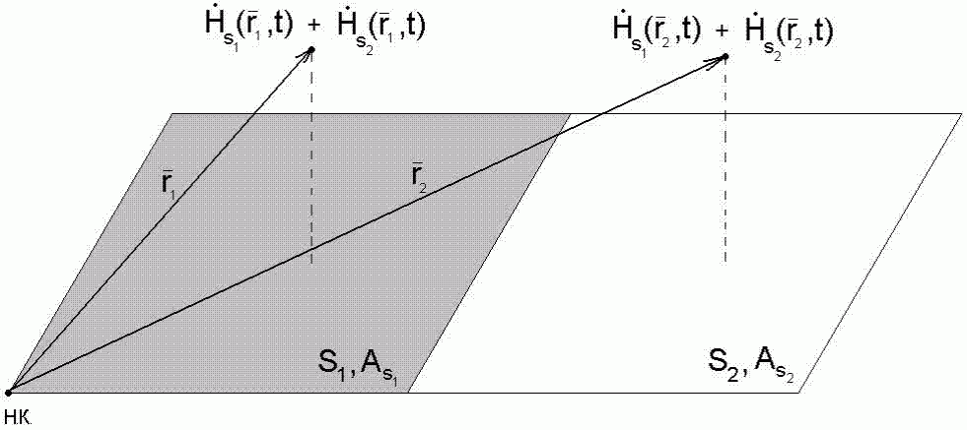

Fig. 1. Analysis of the dose rate field structure at the workplaces of the personnel for optimization of the collective exposure dose from the sources
on the "line of sight"

5. In practice emergency contamination of the NPP rooms, structures and territory can be of much more complicated nature, and the ratio between the contributions of different components of the full dose rate generated at different workplaces by different partial sources is quite unevident (see Fig. 2 of this Appendix). In these cases it is recommended to calculate the contributions from each source at each workplace of the personnel engaged in the post-accident clean-up works using the calculated sets of factors and the experimental data on the spatial distribution of all local partial sources generated in the course of accident .

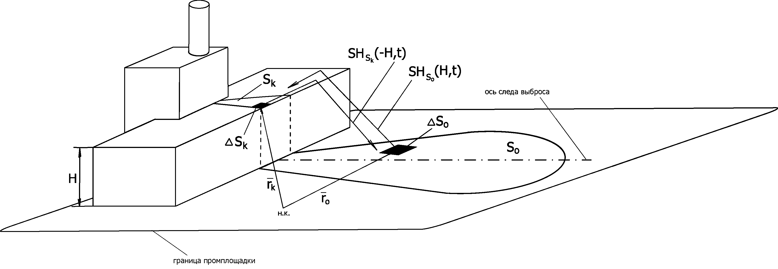
Release trace axis
Industrial site boundary

Fig. 2. Analysis of the dose rate field structure at the workplaces of the personnel for optimization of the collective exposure dose from multiple sources typical for an accident at the NPP

6. It is recommended to calculate the coefficients with the use of engineering methods. It is recommended to use the coefficients for radionuclides , and causing contamination typical for the majority of accidents at NPPs in accordance with this Safety Guide.

Appendix 4
to the Safety guide in the use of atomic energy "Minimization of Radiological Consequences for the Public and the Personnel in the Course of Post-Accident Clean-Up at the Power Units of Various Nuclear Power Plant Types. Methodology for Optimization of the Arrangements for Protection of the Public and Territories" approved by Order of the Federal Environmental, Industrial and Nuclear Supervision Service
dated March, 19, 2014 No. 107

REFERENCE DATA FOR ASSESSMENT OF THE RADIOACTIVE CONTAMINATION SOURCE IMPACT ON THE DOSE CHARACTERISTICS OF THE EMERGENCY SITUATION AT THE WORK SITES

1. Recommended skyshine coefficients for gamma-radiation

The skyshine coefficients for gamma-radiation are provided for the following source data: a flat square source parallel to the ground surface with the dimensions of 1x1 m located at the height h with the activity distributed evenly across its area is present (within the framework of this Appendix ). The effective dose rate for a person at the distance of 50 to 500 m from the edge of the source is evaluated. The dose rate value for the activity of radionuclide A may be defined in accordance with the following formula due to linearity of the transport equation:

Tables 1-5 of this Appendix contain the skyshine coefficients of gamma-radiation for the elevation differences of 0, 10, 20, 30 and 50 m respectively.

Table 1

DEPENDENCE OF THE EFFECTIVE DOSE RATE (MSV/H) FROM THE DISTANCE FOR THE ELEVATION DIFFERENCE OF 0 M

Distance, m | Dose rate (mSv/h)
50 | 6.18E-04 | 2.36E-04 | 2.51E-04
75 | 3.77E-04 | 1.40E-04 | 1.52E-04
100 | 2.46E-04 | 8.86E-05 | 9.94E-05
125 | 1.68E-04 | 5.82E-05 | 6.75E-05
150 | 1.17E-04 | 3.92E-05 | 4.70E-05
175 | 8.35E-05 | 2.68E-05 | 3.34E-05
200 | 6.03E-05 | 1.86E-05 | 2.40E-05
225 | 4.41E-05 | 1.31E-05 | 1.75E-05
250 | 3.25E-05 | 9.23E-06 | 1.29E-05
275 | 2.42E-05 | 6.57E-06 | 9.51E-06
300 | 1.81E-05 | 4.71E-06 | 7.09E-06
325 | 1.36E-05 | 3.39E-06 | 5.31E-06
350 | 1.03E-05 | 2.46E-06 | 4.00E-06
375 | 7.82E-06 | 1.79E-06 | 3.03E-06
400 | 5.97E-06 | 1.30E-06 | 2.30E-06
425 | 4.57E-06 | 9.54E-07 | 1.76E-06
450 | 3.52E-06 | 7.01E-07 | 1.34E-06
475 | 2.71E-06 | 5.17E-07 | 1.03E-06
500 | 2.10E-06 | 3.83E-07 | 7.94E-07

Table 2

DEPENDENCE OF THE EFFECTIVE DOSE RATE (MSV/H) FROM THE DISTANCE FOR THE ELEVATION DIFFERENCE OF 10 M

Distance, m | Dose rate (mSv/h)
50 | 3.85E-04 | 1.61E-04 | 1.57E-04
75 | 2.69E-04 | 1.07E-04 | 1.09E-04
100 | 1.89E-04 | 7.16E-05 | 7.67E-05
125 | 1.35E-04 | 4.89E-05 | 5.45E-05
150 | 9.72E-05 | 3.38E-05 | 3.91E-05
175 | 7.08E-05 | 2.36E-05 | 2.84E-05
200 | 5.20E-05 | 1.66E-05 | 2.08E-05
225 | 3.85E-05 | 1.18E-05 | 1.53E-05
250 | 2.87E-05 | 8.38E-06 | 1.14E-05
275 | 2.15E-05 | 6.01E-06 | 8.50E-06
300 | 1.62E-05 | 4.33E-06 | 6.38E-06
325 | 1.23E-05 | 3.14E-06 | 4.81E-06
350 | 9.35E-06 | 2.28E-06 | 3.65E-06
375 | 7.14E-06 | 1.66E-06 | 2.77E-06
400 | 5.47E-06 | 1.22E-06 | 2.12E-06
425 | 4.21E-06 | 8.95E-07 | 1.62E-06
450 | 3.25E-06 | 6.60E-07 | 1.24E-06
475 | 2.51E-06 | 4.88E-07 | 9.57E-07
500 | 1.95E-06 | 3.61E-07 | 7.39E-07

Table 3

DEPENDENCE OF THE EFFECTIVE DOSE RATE (MSV/H) FROM THE DISTANCE FOR THE ELEVATION DIFFERENCE OF 20 M

Distance, m | Dose rate (mSv/h)
50 | 2.68E-04 | 1.18E-04 | 1.10E-04
75 | 2.03E-04 | 8.38E-05 | 8.29E-05
100 | 1.51E-04 | 5.90E-05 | 6.12E-05
125 | 1.11E-04 | 4.15E-05 | 4.50E-05
150 | 8.22E-05 | 2.93E-05 | 3.32E-05
175 | 6.10E-05 | 2.08E-05 | 2.45E-05
200 | 4.55E-05 | 1.48E-05 | 1.82E-05
225 | 3.40E-05 | 1.06E-05 | 1.36E-05
250 | 2.56E-05 | 7.64E-06 | 1.02E-05
275 | 1.94E-05 | 5.51E-06 | 7.66E-06
300 | 1.47E-05 | 4.00E-06 | 5.79E-06
325 | 1.12E-05 | 2.91E-06 | 4.39E-06
350 | 8.55E-06 | 2.12E-06 | 3.34E-06
375 | 6.55E-06 | 1.55E-06 | 2.55E-06
400 | 5.04E-06 | 1.14E-06 | 1.95E-06
425 | 3.89E-06 | 8.41E-07 | 1.50E-06
450 | 3.01E-06 | 6.21E-07 | 1.16E-06
475 | 2.34E-06 | 4.60E-07 | 8.92E-07
500 | 1.82E-06 | 3.42E-07 | 6.90E-07

Table 4

DEPENDENCE OF THE EFFECTIVE DOSE RATE (MSV/H) FROM THE DISTANCE FOR THE ELEVATION DIFFERENCE OF 30 M

Distance, m | Dose rate (mSv/h)
50 | 1.98E-04 | 8.94E-05 | 8.15E-05
75 | 1.57E-04 | 6.69E-05 | 6.45E-05
100 | 1.21E-04 | 4.89E-05 | 4.95E-05
125 | 9.22E-05 | 3.54E-05 | 3.75E-05
150 | 6.97E-05 | 2.55E-05 | 2.82E-05
175 | 5.26E-05 | 1.84E-05 | 2.12E-05
200 | 3.98E-05 | 1.32E-05 | 1.60E-05
225 | 3.01E-05 | 9.57E-06 | 1.20E-05
250 | 2.29E-05 | 6.94E-06 | 9.11E-06
275 | 1.74E-05 | 5.05E-06 | 6.91E-06
300 | 1.33E-05 | 3.68E-06 | 5.25E-06
325 | 1.02E-05 | 2.69E-06 | 4.00E-06
350 | 7.81E-06 | 1.97E-06 | 3.06E-06
375 | 6.02E-06 | 1.45E-06 | 2.35E-06
400 | 4.65E-06 | 1.07E-06 | 1.80E-06
425 | 3.60E-06 | 7.88E-07 | 1.39E-06
450 | 2.79E-06 | 5.84E-07 | 1.07E-06
475 | 2.17E-06 | 4.34E-07 | 8.31E-07
500 | 1.69E-06 | 3.23E-07 | 6.45E-07

Table 5

DEPENDENCE OF THE EFFECTIVE DOSE RATE (MSV/H) FROM THE DISTANCE FOR THE ELEVATION DIFFERENCE OF 50 M

Distance, m | Dose rate (mSv/h)
50 | 1.21E-04 | 5.59E-05 | 5.00E-05
75 | 1.01E-04 | 4.42E-05 | 4.14E-05
100 | 8.15E-05 | 3.40E-05 | 3.34E-05
125 | 6.46E-05 | 2.57E-05 | 2.64E-05
150 | 5.06E-05 | 1.91E-05 | 2.06E-05
175 | 3.93E-05 | 1.42E-05 | 1.59E-05
200 | 3.04E-05 | 1.05E-05 | 1.23E-05
225 | 2.35E-05 | 7.71E-06 | 9.43E-06
250 | 1.82E-05 | 5.68E-06 | 7.25E-06
275 | 1.40E-05 | 4.19E-06 | 5.58E-06
300 | 1.08E-05 | 3.09E-06 | 4.30E-06
325 | 8.39E-06 | 2.28E-06 | 3.31E-06
350 | 6.51E-06 | 1.69E-06 | 2.56E-06
375 | 5.05E-06 | 1.25E-06 | 1.98E-06
400 | 3.93E-06 | 9.26E-07 | 1.53E-06
425 | 3.07E-06 | 6.88E-07 | 1.19E-06
450 | 2.39E-06 | 5.13E-07 | 9.23E-07
475 | 1.87E-06 | 3.82E-07 | 7.19E-07
500 | 1.47E-06 | 2.86E-07 | 5.60E-07

2. Recommended attenuation factors

Fig. 1 of this Appendix represents the geometry for which the attenuation factors for the gamma-radiation dose rate at the point D located on the building roof due to the isotropic point source S located at the height h from the room floor are specified for different angles between the normal n to the floor and the line connecting the source and the detector. The roof thickness is assumed to be t = 6 g/cm2, the height H = 50 m, the height of the source above the floor h = 0; 10; 20; 30; 40 m, the angle - 0° to 80° with the increment of 10°.

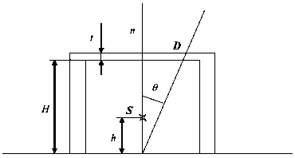

Fig. 1. Geometry for the specified factors of the dose rate attenuation on the roof from the source inside the room

The factors of the dose rate attenuation on the roof from the source inside the rooms are specified in Tables 6-8 of this Appendix.

Table 6

FACTORS OF THE DOSE RATE ATTENUATION ON THE ROOF FROM A SINGLE ISOTROPIC POINT SOURCE LOCATED INSIDE THE ROOM

, degrees | Dose rate on the roof (mSv/h) for different heights of the source h, m
 | 0 | 10 | 20 | 30 | 40
0 | 1.033E-03 | 1.663E-03 | 3.042E-03 | 7.030E-03 | 2.881E-02
10 | 9.967E-04 | 1.606E-03 | 2.940E-03 | 6.798E-03 | 2.787E-02
20 | 8.935E-04 | 1.444E-03 | 2.648E-03 | 6.134E-03 | 2.520E-02
30 | 7.363E-04 | 1.196E-03 | 2.202E-03 | 5.121E-03 | 2.111E-02
40 | 5.457E-04 | 8.943E-04 | 1.661E-03 | 3.889E-03 | 1.613E-02
50 | 3.477E-04 | 5.792E-04 | 1.093E-03 | 2.595E-03 | 1.089E-02
60 | 1.720E-04 | 2.954E-04 | 5.744E-04 | 1.404E-03 | 6.053E-03
70 | 4.956E-05 | 9.110E-05 | 1.892E-04 | 4.935E-04 | 2.268E-03
80 | 2.091E-06 | 4.871E-06 | 1.274E-05 | 4.161E-05 | 2.381E-04

Table 7

FACTORS OF THE DOSE RATE ATTENUATION ON THE ROOF FROM A SINGLE ISOTROPIC POINT SOURCE LOCATED INSIDE THE ROOM

, degrees | Dose rate on the roof (mSv/h) for different heights of the source h, m
 | 0 | 10 | 20 | 30 | 40
0 | 2.822E-03 | 4.543E-03 | 8.309E-03 | 1.920E-02 | 7.867E-02
10 | 2.724E-03 | 4.389E-03 | 8.031E-03 | 1.857E-02 | 7.613E-02
20 | 2.442E-03 | 3.945E-03 | 7.233E-03 | 1.676E-02 | 6.882E-02
30 | 2.014E-03 | 3.268E-03 | 6.018E-03 | 1.399E-02 | 5.766E-02
40 | 1.494E-03 | 2.446E-03 | 4.540E-03 | 1.063E-02 | 4.406E-02
50 | 9.543E-04 | 1.587E-03 | 2.990E-03 | 7.094E-03 | 2.976E-02
60 | 4.745E-04 | 8.132E-04 | 1.577E-03 | 3.847E-03 | 1.656E-02
70 | 1.387E-04 | 2.537E-04 | 5.245E-04 | 1.363E-03 | 6.239E-03
80 | 6.304E-06 | 1.441E-05 | 3.705E-05 | 1.192E-04 | 6.732E-04

Table 8

FACTORS OF THE DOSE RATE ATTENUATION ON THE ROOF FROM A SINGLE ISOTROPIC POINT SOURCE LOCATED INSIDE THE ROOM

, degrees | Dose rate on the roof (mSv/h) for different heights of the source h, m
 | 0 | 10 | 20 | 30 | 40
0 | 7.174E-04 | 1.163E-03 | 2.135E-03 | 4.940E-03 | 2.022E-02
10 | 6.916E-04 | 1.122E-03 | 2.063E-03 | 4.777E-03 | 1.957E-02
20 | 6.176E-04 | 1.006E-03 | 1.855E-03 | 4.309E-03 | 1.770E-02
30 | 5.048E-04 | 8.281E-04 | 1.538E-03 | 3.593E-03 | 1.483E-02
40 | 3.684E-04 | 6.119E-04 | 1.150E-03 | 2.717E-03 | 1.132E-02
50 | 2.280E-04 | 3.869E-04 | 7.424E-04 | 1.790E-03 | 7.599E-03
60 | 1.066E-04 | 1.880E-04 | 3.746E-04 | 9.379E-04 | 4.133E-03
70 | 2.687E-05 | 5.168E-05 | 1.121E-04 | 3.043E-04 | 1.452E-03
80 | 7.254E-07 | 1.846E-06 | 5.290E-06 | 1.895E-05 | 1.189E-04

The reverse situation with the switched places of the source and the detector is presented in Fig. 2 of this Appendix. The change ranges for the values h (in this case - the height of the detector above the room floor) and (the angle between the normal n to the roof and the line connecting the source and the detector) and the values of other parameters are assumed to be the same. The factors of the dose rate attenuation inside the room from the source located on the roof are specified in Tables 9-11 of this Appendix.

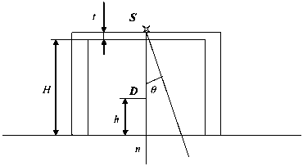

Fig. 2. Geometry for the specified factors of the dose rate attenuation inside the room from the source on the roof

Table 9

FACTORS OF THE DOSE RATE ATTENUATION INSIDE THE ROOM FROM A SINGLE ISOTROPIC POINT SOURCE LOCATED ON THE ROOF

, degrees | Dose rate inside the room (mSv/h) for different heights of the source h, m
 | 0 | 10 | 20 | 30 | 40
0 | 1.092E-03 | 1.663E-03 | 3.042E-03 | 7.030E-03 | 2.881E-02
10 | 1.055E-03 | 1.606E-03 | 2.940E-03 | 6.798E-03 | 2.787E-02
20 | 9.498E-04 | 1.444E-03 | 2.648E-03 | 6.134E-03 | 2.520E-02
30 | 7.886E-04 | 1.196E-03 | 2.202E-03 | 5.121E-03 | 2.111E-02
40 | 5.918E-04 | 8.943E-04 | 1.661E-03 | 3.889E-03 | 1.613E-02
50 | 3.851E-04 | 5.792E-04 | 1.093E-03 | 2.595E-03 | 1.089E-02
60 | 1.973E-04 | 2.954E-04 | 5.744E-04 | 1.404E-03 | 6.053E-03
70 | 6.042E-05 | 9.110E-05 | 1.892E-04 | 4.935E-04 | 2.268E-03
80 | 2.828E-06 | 4.871E-06 | 1.274E-05 | 4.161E-05 | 2.381E-04

Table 10

FACTORS OF THE DOSE RATE ATTENUATION INSIDE THE ROOM FROM A SINGLE ISOTROPIC POINT SOURCE LOCATED ON THE ROOF

, degrees | Dose rate inside the room (mSv/h) for different heights of the source h, m
 | 0 | 10 | 20 | 30 | 40
0 | 2.972E-03 | 4.543E-03 | 8.309E-03 | 1.920E-02 | 7.867E-02
10 | 2.873E-03 | 4.389E-03 | 8.031E-03 | 1.857E-02 | 7.613E-02
20 | 2.586E-03 | 3.945E-03 | 7.233E-03 | 1.676E-02 | 6.882E-02
30 | 2.147E-03 | 3.268E-03 | 6.018E-03 | 1.399E-02 | 5.766E-02
40 | 1.612E-03 | 2.446E-03 | 4.540E-03 | 1.063E-02 | 4.406E-02
50 | 1.050E-03 | 1.587E-03 | 2.990E-03 | 7.094E-03 | 2.976E-02
60 | 5.398E-04 | 8.132E-04 | 1.577E-03 | 3.847E-03 | 1.656E-02
70 | 1.669E-04 | 2.537E-04 | 5.245E-04 | 1.363E-03 | 6.239E-03
80 | 8.266E-06 | 1.441E-05 | 3.705E-05 | 1.192E-04 | 6.732E-04

Table 11

FACTORS OF THE DOSE RATE ATTENUATION INSIDE THE ROOM FROM A SINGLE ISOTROPIC POINT SOURCE LOCATED ON THE ROOF

, degrees | Dose rate inside the room (mSv/h) for different heights of the source h, m
 | 0 | 10 | 20 | 30 | 40
0 | 8.102E-04 | 1.163E-03 | 2.135E-03 | 4.940E-03 | 2.022E-02
10 | 7.830E-04 | 1.122E-03 | 2.063E-03 | 4.777E-03 | 1.957E-02
20 | 7.046E-04 | 1.006E-03 | 1.855E-03 | 4.309E-03 | 1.770E-02
30 | 5.843E-04 | 8.281E-04 | 1.538E-03 | 3.593E-03 | 1.483E-02
40 | 4.369E-04 | 6.119E-04 | 1.150E-03 | 2.717E-03 | 1.132E-02
50 | 2.812E-04 | 3.869E-04 | 7.424E-04 | 1.790E-03 | 7.599E-03
60 | 1.402E-04 | 1.880E-04 | 3.746E-04 | 9.379E-04 | 4.133E-03
70 | 3.923E-05 | 5.168E-05 | 1.121E-04 | 3.043E-04 | 1.452E-03
80 | 1.244E-06 | 1.846E-06 | 5.290E-06 | 1.895E-05 | 1.189E-04

The attenuation factors for the contaminated surface section S with the dimensions of 1 m x 1 m at the height h=1 m are provided in Table 12 of this Appendix for different angles between the normal n to this section and the line connecting the source and the detector within the range of 0° to 89° (Fig. 3 of this Appendix).

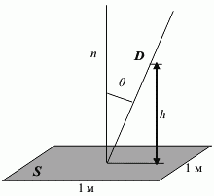
1 m
1 m

Fig. 3. Geometry for the specified attenuation factors from the contaminated surface section

Table 12

ATTENUATION FACTORS FOR THE DOSE RATE GENERATED BY THE CONTAMINATED SURFACE SECTION

, degrees | Dose rate (mSv/h) for different flat sources
0 | 2.884E+00 | 7.592E+00 | 1.939E+00
10 | 2.825E+00 | 7.439E+00 | 1.900E+00
20 | 2.647E+00 | 6.970E+00 | 1.780E+00
30 | 2.342E+00 | 6.167E+00 | 1.575E+00
40 | 1.910E+00 | 5.033E+00 | 1.285E+00
50 | 1.386E+00 | 3.654E+00 | 9.329E-01
60 | 8.473E-01 | 2.236E+00 | 5.708E-01
70 | 3.933E-01 | 1.040E+00 | 2.654E-01
80 | 9.938E-02 | 2.644E-01 | 6.747E-02
85 | 2.462E-02 | 6.585E-02 | 1.689E-02
89 | 9.147E-04 | 2.471E-03 | 6.650E-04

3. Recommended gamma-radiation albedo coefficients

The dose albedo coefficients for gamma-radiation are specified in Tables 13-18 of this Appendix for the following situations:
for the source located on the room floor (at the distance of h=50 m from the ceiling) the dose rate due to radiation dispersed from the ceiling at the angles of 10° to 80° in the points located at the distance of 10, 20, 30, 40 and 50 m from the ceiling is specified (Fig. 4 of this Appendix);

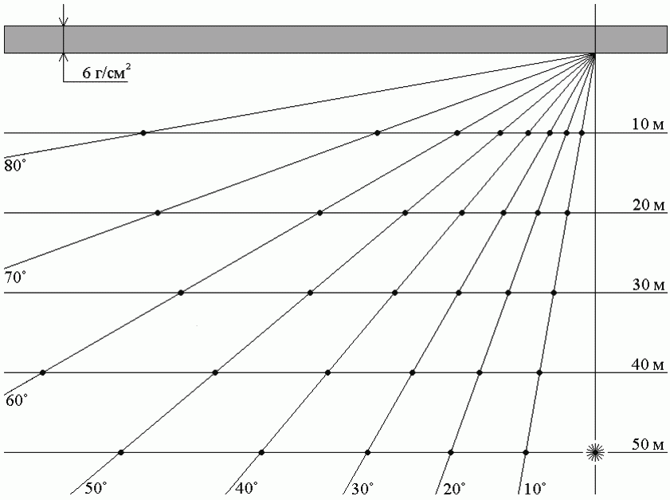
6 g/cm²
10 m
20 m
30 m
40 m
50 m

Fig. 4. Geometry for the specified coefficients of gamma-radiation albedo from the ceiling

for the source located on the room floor at the distance of 10, 20, 30, 40 and 50 m from the wall the dose rate due to radiation dispersed from the wall at the angles of 10° to 80° in the points located at the distance of 10, 20, 30, 40 and 50 m from the wall is specified (Fig. 5 of this Appendix).

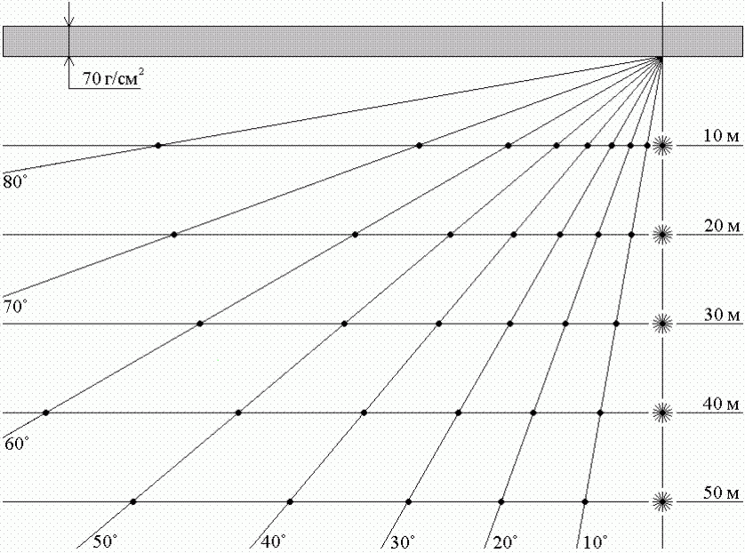
70 g/cm²
50 m
40 m
30 m
20 m
10 m

Fig. 5. Geometry for the specified coefficients of gamma-radiation albedo from the wall

Table 13

COEFFICIENTS OF GAMMA-RADIATION DOSE ALBEDO FROM THE CEILING

Distance from the ceiling | Dispersal angle | Dose rate of dispersed gamma-radiation,
10 | 10 | 5.16E-10 | 5.22E-10 | 5.71E-10
10 | 20 | 5.15E-10 | 5.21E-10 | 5.72E-10
10 | 30 | 5.13E-10 | 5.19E-10 | 5.69E-10
10 | 40 | 5.12E-10 | 5.15E-10 | 5.63E-10
10 | 50 | 5.05E-10 | 5.08E-10 | 5.51E-10
10 | 60 | 4.92E-10 | 4.96E-10 | 5.32E-10
10 | 70 | 4.56E-10 | 4.61E-10 | 4.84E-10
10 | 80 | 3.42E-10 | 3.44E-10 | 3.35E-10
20 | 10 | 3.68E-10 | 3.73E-10 | 4.16E-10
20 | 20 | 3.67E-10 | 3.70E-10 | 4.12E-10
20 | 30 | 3.61E-10 | 3.66E-10 | 4.06E-10
20 | 40 | 3.55E-10 | 3.58E-10 | 3.95E-10
20 | 50 | 3.43E-10 | 3.48E-10 | 3.77E-10
20 | 60 | 3.20E-10 | 3.24E-10 | 3.43E-10
20 | 70 | 2.70E-10 | 2.73E-10 | 2.75E-10
20 | 80 | 1.60E-10 | 1.61E-10 | 1.42E-10
30 | 10 | 2.80E-10 | 2.83E-10 | 3.17E-10
30 | 20 | 2.77E-10 | 2.81E-10 | 3.13E-10
30 | 30 | 2.72E-10 | 2.75E-10 | 3.06E-10
30 | 40 | 2.65E-10 | 2.67E-10 | 2.93E-10
30 | 50 | 2.50E-10 | 2.53E-10 | 2.72E-10
30 | 60 | 2.23E-10 | 2.26E-10 | 2.34E-10
30 | 70 | 1.76E-10 | 1.77E-10 | 1.72E-10
30 | 80 | 9.01E-11 | 9.05E-11 | 7.52E-11
40 | 10 | 2.21E-10 | 2.24E-10 | 2.51E-10
40 | 20 | 2.19E-10 | 2.21E-10 | 2.47E-10
40 | 30 | 2.14E-10 | 2.16E-10 | 2.39E-10
40 | 40 | 2.05E-10 | 2.07E-10 | 2.25E-10
40 | 50 | 1.90E-10 | 1.92E-10 | 2.04E-10
40 | 60 | 1.64E-10 | 1.66E-10 | 1.69E-10
40 | 70 | 1.23E-10 | 1.23E-10 | 1.16E-10
40 | 80 | 5.62E-11 | 5.63E-11 | 4.47E-11
50 | 10 | 1.81E-10 | 1.83E-10 | 2.04E-10
50 | 20 | 1.78E-10 | 1.80E-10 | 2.00E-10
50 | 30 | 1.72E-10 | 1.75E-10 | 1.92E-10
50 | 40 | 1.63E-10 | 1.65E-10 | 1.79E-10
50 | 50 | 1.49E-10 | 1.51E-10 | 1.58E-10
50 | 60 | 1.26E-10 | 1.27E-10 | 1.27E-10
50 | 70 | 9.03E-11 | 9.12E-11 | 8.34E-11
50 | 80 | 3.66E-11 | 3.65E-11 | 2.78E-11

Table 14

COEFFICIENTS OF GAMMA-RADIATION DOSE ALBEDO FROM THE WALL FOR A SOURCE AT THE DISTANCE OF 10 M

Distance from the wall | Dispersal angle | Dose rate of dispersed gamma-radiation,
10 | 10 | 8.94E-09 | 9.04E-09 | 8.67E-09
10 | 20 | 8.66E-09 | 8.76E-09 | 8.48E-09
10 | 30 | 8.25E-09 | 8.37E-09 | 7.94E-09
10 | 40 | 7.69E-09 | 7.76E-09 | 7.19E-09
10 | 50 | 6.79E-09 | 6.73E-09 | 6.17E-09
10 | 60 | 5.39E-09 | 5.24E-09 | 4.66E-09
10 | 70 | 3.39E-09 | 3.29E-09 | 2.75E-09
10 | 80 | 1.13E-09 | 1.13E-09 | 8.40E-10
20 | 10 | 4.20E-09 | 4.26E-09 | 3.92E-09
20 | 20 | 4.02E-09 | 4.06E-09 | 3.73E-09
20 | 30 | 3.68E-09 | 3.72E-09 | 3.39E-09
20 | 40 | 3.23E-09 | 3.23E-09 | 2.91E-09
20 | 50 | 2.62E-09 | 2.62E-09 | 2.30E-09
20 | 60 | 1.88E-09 | 1.83E-09 | 1.57E-09
20 | 70 | 1.01E-09 | 1.02E-09 | 8.12E-10
20 | 80 | 2.91E-10 | 3.01E-10 | 2.09E-10
30 | 10 | 2.45E-09 | 2.43E-09 | 2.26E-09
30 | 20 | 2.30E-09 | 2.30E-09 | 2.09E-09
30 | 30 | 2.07E-09 | 2.09E-09 | 1.88E-09
30 | 40 | 1.76E-09 | 1.75E-09 | 1.55E-09
30 | 50 | 1.38E-09 | 1.37E-09 | 1.16E-09
30 | 60 | 9.24E-10 | 9.21E-10 | 7.62E-10
30 | 70 | 4.85E-10 | 4.95E-10 | 3.78E-10
30 | 80 | 1.31E-10 | 1.31E-10 | 9.19E-11
40 | 10 | 1.60E-09 | 1.59E-09 | 1.44E-09
40 | 20 | 1.49E-09 | 1.49E-09 | 1.34E-09
40 | 30 | 1.32E-09 | 1.33E-09 | 1.18E-09
40 | 40 | 1.10E-09 | 1.11E-09 | 9.59E-10
40 | 50 | 8.48E-10 | 8.40E-10 | 7.08E-10
40 | 60 | 5.56E-10 | 5.55E-10 | 4.54E-10
40 | 70 | 2.84E-10 | 2.90E-10 | 2.19E-10
40 | 80 | 7.17E-11 | 7.27E-11 | 4.92E-11
50 | 10 | 1.12E-09 | 1.11E-09 | 1.00E-09
50 | 20 | 1.04E-09 | 1.04E-09 | 9.30E-10
50 | 30 | 9.17E-10 | 9.21E-10 | 8.13E-10
50 | 40 | 7.60E-10 | 7.58E-10 | 6.52E-10
50 | 50 | 5.71E-10 | 5.68E-10 | 4.77E-10
50 | 60 | 3.70E-10 | 3.74E-10 | 3.01E-10
50 | 70 | 1.86E-10 | 1.90E-10 | 1.45E-10
50 | 80 | 4.49E-11 | 4.52E-11 | 3.06E-11

Table 15

COEFFICIENTS OF GAMMA-RADIATION DOSE ALBEDO FROM THE WALL FOR A SOURCE AT THE DISTANCE OF 20 M

Distance from the wall | Dispersal angle | Dose rate of dispersed gamma-radiation,
10 | 10 | 3.75E-09 | 3.84E-09 | 3.69E-09
10 | 20 | 3.72E-09 | 3.80E-09 | 3.66E-09
10 | 30 | 3.67E-09 | 3.76E-09 | 3.59E-09
10 | 40 | 3.53E-09 | 3.70E-09 | 3.42E-09
10 | 50 | 3.34E-09 | 3.47E-09 | 3.14E-09
10 | 60 | 2.94E-09 | 3.03E-09 | 2.85E-09
10 | 70 | 2.25E-09 | 2.38E-09 | 1.95E-09
10 | 80 | 9.71E-10 | 9.65E-10 | 7.81E-10
20 | 10 | 2.24E-09 | 2.27E-09 | 2.15E-09
20 | 20 | 2.20E-09 | 2.22E-09 | 2.08E-09
20 | 30 | 2.08E-09 | 2.12E-09 | 1.98E-09
20 | 40 | 1.93E-09 | 1.98E-09 | 1.82E-09
20 | 50 | 1.72E-09 | 1.73E-09 | 1.55E-09
20 | 60 | 1.33E-09 | 1.33E-09 | 1.18E-09
20 | 70 | 8.32E-10 | 8.25E-10 | 7.11E-10
20 | 80 | 2.83E-10 | 2.85E-10 | 2.13E-10
30 | 10 | 1.46E-09 | 1.50E-09 | 1.40E-09
30 | 20 | 1.42E-09 | 1.45E-09 | 1.37E-09
30 | 30 | 1.33E-09 | 1.36E-09 | 1.25E-09
30 | 40 | 1.19E-09 | 1.23E-09 | 1.10E-09
30 | 50 | 9.95E-10 | 9.97E-10 | 9.05E-10
30 | 60 | 7.34E-10 | 7.31E-10 | 6.39E-10
30 | 70 | 4.17E-10 | 4.24E-10 | 3.46E-10
30 | 80 | 1.29E-10 | 1.31E-10 | 9.49E-11
40 | 10 | 1.04E-09 | 1.06E-09 | 9.82E-10
40 | 20 | 9.98E-10 | 1.02E-09 | 9.37E-10
40 | 30 | 9.19E-10 | 9.39E-10 | 8.53E-10
40 | 40 | 8.07E-10 | 8.16E-10 | 7.36E-10
40 | 50 | 6.55E-10 | 6.52E-10 | 5.85E-10
40 | 60 | 4.59E-10 | 4.64E-10 | 3.94E-10
40 | 70 | 2.58E-10 | 2.56E-10 | 2.03E-10
40 | 80 | 7.24E-11 | 7.35E-11 | 5.10E-11
50 | 10 | 7.80E-10 | 7.92E-10 | 7.33E-10
50 | 20 | 7.42E-10 | 7.62E-10 | 6.87E-10
50 | 30 | 6.74E-10 | 6.93E-10 | 6.17E-10
50 | 40 | 5.79E-10 | 5.86E-10 | 5.32E-10
50 | 50 | 4.62E-10 | 4.60E-10 | 4.00E-10
50 | 60 | 3.16E-10 | 3.21E-10 | 2.65E-10
50 | 70 | 1.70E-10 | 1.73E-10 | 1.35E-10
50 | 80 | 4.50E-11 | 4.57E-11 | 3.10E-11

Table 16

COEFFICIENTS OF GAMMA-RADIATION DOSE ALBEDO FROM THE WALL FOR A SOURCE AT THE DISTANCE OF 30 M

Distance from the wall | Dispersal angle | Dose rate of dispersed gamma-radiation,
10 | 10 | 2.08E-09 | 2.08E-09 | 2.05E-09
10 | 20 | 2.06E-09 | 2.22E-09 | 2.04E-09
10 | 30 | 2.09E-09 | 2.05E-09 | 2.05E-09
10 | 40 | 2.03E-09 | 2.00E-09 | 2.02E-09
10 | 50 | 1.99E-09 | 1.96E-09 | 1.89E-09
10 | 60 | 1.80E-09 | 1.83E-09 | 1.70E-09
10 | 70 | 1.53E-09 | 1.54E-09 | 1.38E-09
10 | 80 | 8.17E-10 | 8.10E-10 | 6.54E-10
20 | 10 | 1.38E-09 | 1.39E-09 | 1.36E-09
20 | 20 | 1.36E-09 | 1.38E-09 | 1.33E-09
20 | 30 | 1.34E-09 | 1.35E-09 | 1.29E-09
20 | 40 | 1.28E-09 | 1.28E-09 | 1.21E-09
20 | 50 | 1.17E-09 | 1.18E-09 | 1.09E-09
20 | 60 | 9.89E-10 | 9.90E-10 | 8.99E-10
20 | 70 | 6.80E-10 | 6.75E-10 | 5.78E-10
20 | 80 | 2.53E-10 | 2.58E-10 | 2.01E-10
30 | 10 | 9.98E-10 | 9.99E-10 | 9.61E-10
30 | 20 | 9.72E-10 | 9.74E-10 | 9.34E-10
30 | 30 | 9.59E-10 | 9.46E-10 | 8.83E-10
30 | 40 | 8.62E-10 | 8.72E-10 | 8.23E-10
30 | 50 | 7.58E-10 | 7.65E-10 | 6.94E-10
30 | 60 | 5.93E-10 | 5.87E-10 | 5.22E-10
30 | 70 | 3.67E-10 | 3.61E-10 | 3.07E-10
30 | 80 | 1.26E-10 | 1.24E-10 | 9.49E-11
40 | 10 | 7.43E-10 | 7.50E-10 | 7.25E-10
40 | 20 | 7.20E-10 | 7.27E-10 | 6.92E-10
40 | 30 | 6.80E-10 | 6.91E-10 | 6.58E-10
40 | 40 | 6.16E-10 | 6.28E-10 | 5.73E-10
40 | 50 | 5.21E-10 | 5.21E-10 | 4.70E-10
40 | 60 | 3.91E-10 | 3.84E-10 | 3.46E-10
40 | 70 | 2.29E-10 | 2.26E-10 | 1.87E-10
40 | 80 | 7.17E-11 | 7.21E-11 | 5.34E-11
50 | 10 | 5.80E-10 | 5.90E-10 | 5.58E-10
50 | 20 | 5.57E-10 | 5.65E-10 | 5.60E-10
50 | 30 | 5.23E-10 | 5.31E-10 | 4.88E-10
50 | 40 | 4.71E-10 | 4.71E-10 | 4.26E-10
50 | 50 | 3.81E-10 | 3.79E-10 | 3.43E-10
50 | 60 | 2.76E-10 | 2.71E-10 | 2.42E-10
50 | 70 | 1.56E-10 | 1.54E-10 | 1.25E-10
50 | 80 | 4.49E-11 | 4.54E-11 | 3.24E-11

Table 17

COEFFICIENTS OF GAMMA-RADIATION DOSE ALBEDO FROM THE WALL FOR A SOURCE AT THE DISTANCE OF 40 M

Distance from the wall | Dispersal angle | Dose rate of dispersed gamma-radiation,
10 | 10 | 1.32E-09 | 1.32E-09 | 1.28E-09
10 | 20 | 1.31E-09 | 1.32E-09 | 1.28E-09
10 | 30 | 1.33E-09 | 1.31E-09 | 1.29E-09
10 | 40 | 1.28E-09 | 1.29E-09 | 1.30E-09
10 | 50 | 1.27E-09 | 1.26E-09 | 1.25E-09
10 | 60 | 1.20E-09 | 1.25E-09 | 1.13E-09
10 | 70 | 1.06E-09 | 1.06E-09 | 9.53E-10
10 | 80 | 6.81E-10 | 6.79E-10 | 5.94E-10
20 | 10 | 9.41E-10 | 9.59E-10 | 9.24E-10
20 | 20 | 9.27E-10 | 9.48E-10 | 9.19E-10
20 | 30 | 9.17E-10 | 9.32E-10 | 9.01E-10
20 | 40 | 8.83E-10 | 9.12E-10 | 8.88E-10
20 | 50 | 8.33E-10 | 8.42E-10 | 7.93E-10
20 | 60 | 7.34E-10 | 7.38E-10 | 7.19E-10
20 | 70 | 5.58E-10 | 5.56E-10 | 4.86E-10
20 | 80 | 2.38E-10 | 2.36E-10 | 1.93E-10
30 | 10 | 7.13E-10 | 7.19E-10 | 6.97E-10
30 | 20 | 7.26E-10 | 7.07E-10 | 6.98E-10
30 | 30 | 6.86E-10 | 6.89E-10 | 7.41E-10
30 | 40 | 6.39E-10 | 6.46E-10 | 6.11E-10
30 | 50 | 5.81E-10 | 5.77E-10 | 5.56E-10
30 | 60 | 4.87E-10 | 4.76E-10 | 4.28E-10
30 | 70 | 3.20E-10 | 3.18E-10 | 2.70E-10
30 | 80 | 1.14E-10 | 1.16E-10 | 8.83E-11
40 | 10 | 5.62E-10 | 5.63E-10 | 5.36E-10
40 | 20 | 5.49E-10 | 5.50E-10 | 5.64E-10
40 | 30 | 5.26E-10 | 5.21E-10 | 5.11E-10
40 | 40 | 4.81E-10 | 4.80E-10 | 4.53E-10
40 | 50 | 4.24E-10 | 4.18E-10 | 3.85E-10
40 | 60 | 3.37E-10 | 3.27E-10 | 2.89E-10
40 | 70 | 2.04E-10 | 2.04E-10 | 1.71E-10
40 | 80 | 6.74E-11 | 6.90E-11 | 5.16E-11
50 | 10 | 4.47E-10 | 4.65E-10 | 4.39E-10
50 | 20 | 4.35E-10 | 4.40E-10 | 4.13E-10
50 | 30 | 4.09E-10 | 4.11E-10 | 3.93E-10
50 | 40 | 3.72E-10 | 3.72E-10 | 3.47E-10
50 | 50 | 3.20E-10 | 3.17E-10 | 2.86E-10
50 | 60 | 2.42E-10 | 2.37E-10 | 2.08E-10
50 | 70 | 1.40E-10 | 1.42E-10 | 1.16E-10
50 | 80 | 4.25E-11 | 4.32E-11 | 3.19E-11

Table 18

COEFFICIENTS OF GAMMA-RADIATION DOSE ALBEDO FROM THE WALL FOR A SOURCE AT THE DISTANCE OF 50 M

Distance from the wall | Dispersal angle | Dose rate of dispersed gamma-radiation,
10 | 10 | 9.22E-10 | 9.08E-10 | 8.82E-10
10 | 20 | 9.20E-10 | 9.39E-10 | 9.38E-10
10 | 30 | 9.09E-10 | 9.14E-10 | 8.97E-10
10 | 40 | 8.92E-10 | 9.11E-10 | 9.14E-10
10 | 50 | 8.72E-10 | 8.89E-10 | 8.35E-10
10 | 60 | 8.56E-10 | 8.61E-10 | 8.04E-10
10 | 70 | 7.95E-10 | 7.77E-10 | 7.45E-10
10 | 80 | 5.45E-10 | 5.35E-10 | 4.69E-10
20 | 10 | 6.91E-10 | 6.90E-10 | 6.66E-10
20 | 20 | 6.84E-10 | 6.82E-10 | 6.59E-10
20 | 30 | 6.76E-10 | 6.79E-10 | 6.81E-10
20 | 40 | 6.48E-10 | 6.78E-10 | 6.33E-10
20 | 50 | 6.16E-10 | 6.61E-10 | 6.14E-10
20 | 60 | 5.69E-10 | 5.73E-10 | 5.31E-10
20 | 70 | 4.57E-10 | 4.52E-10 | 4.11E-10
20 | 80 | 2.26E-10 | 2.21E-10 | 1.77E-10
30 | 10 | 5.36E-10 | 5.43E-10 | 5.22E-10
30 | 20 | 5.65E-10 | 5.34E-10 | 5.13E-10
30 | 30 | 5.15E-10 | 5.37E-10 | 5.06E-10
30 | 40 | 4.93E-10 | 5.01E-10 | 4.84E-10
30 | 50 | 4.61E-10 | 4.61E-10 | 4.31E-10
30 | 60 | 3.98E-10 | 4.02E-10 | 3.64E-10
30 | 70 | 2.84E-10 | 2.79E-10 | 2.44E-10
30 | 80 | 1.11E-10 | 1.14E-10 | 8.53E-11
40 | 10 | 4.36E-10 | 4.38E-10 | 4.26E-10
40 | 20 | 4.30E-10 | 4.28E-10 | 4.16E-10
40 | 30 | 4.12E-10 | 4.23E-10 | 4.04E-10
40 | 40 | 3.87E-10 | 3.89E-10 | 3.68E-10
40 | 50 | 3.47E-10 | 3.58E-10 | 3.27E-10
40 | 60 | 2.85E-10 | 2.81E-10 | 2.57E-10
40 | 70 | 1.88E-10 | 1.85E-10 | 1.57E-10
40 | 80 | 6.52E-11 | 6.72E-11 | 4.88E-11
50 | 10 | 3.68E-10 | 3.59E-10 | 3.45E-10
50 | 20 | 3.51E-10 | 3.51E-10 | 3.60E-10
50 | 30 | 3.33E-10 | 3.33E-10 | 3.18E-10
50 | 40 | 3.08E-10 | 3.12E-10 | 2.93E-10
50 | 50 | 2.70E-10 | 2.69E-10 | 2.49E-10
50 | 60 | 2.13E-10 | 2.09E-10 | 1.88E-10
50 | 70 | 1.32E-10 | 1.32E-10 | 1.18E-10
50 | 80 | 4.14E-11 | 4.20E-11 | 3.06E-11

Appendix 5
to the Safety guide in the use of atomic energy "Minimization of Radiological Consequences for the Public and the Personnel in the Course of Post-Accident Clean-Up at the Power Units of Various Nuclear Power Plant Types. Methodology for Optimization of the Arrangements for Protection of the Public and Territories" approved by Order of the Federal Environmental, Industrial and Nuclear Supervision Service
dated March, 19, 2014 No. 107

RECOMMENDATIONS
ON ASSESSMENT OF CORRECT DETERMINATION OF THE ZONE WHERE URGENT DECISIONS WITH REGARD TO EVACUATION AT THE INITIAL STAGE OF A RADIATION ACCIDENT ARE REQUIRED

It is recommended to use the curves presented in Fig. 1-12 for in-service assessment of correctness of the emergency zone size determination by the technical support centers with regard to the zones where urgent decisions on evacuation of the public and the personnel at the initial stage of a radiation accident are required. The values of parameters or recommended to be defined according to the Formulae (1) and (2) are presented on the X axis of these curves:

where:
m is the shelter type;
- release of the r-th radionuclide expected or occurred in the course of any accident or emergency response drills and trainings (Bq);
and - coefficients for the r-th radionuclide and the shelter type m with the values specified in the table.

Table

VALUES OF THE COEFFICIENTS AND FOR VARIOUS SHELTER TYPES

Radionuclide | m = 1 |  | m = 2
Radionuclide | ,  (Sv·m3)/(Bq·s) | ,  (Sv·m2)/(Bq·s) | ,  (Sv·m3)/(Bq·s) | ,  (Sv·m2)/(Bq·s)
Cs-134
Cs-137
I-131
I-132
I-133
I-134
I-135
Kr-85 |  | 0 |  | 0
Kr-85m |  | 0 |  | 0
Kr-87 |  | 0 |  | 0
Xe-133 |  | 0 |  | 0
Xe-135 |  | 0 |  | 0
Xe-138 |  | 0 |  | 0

The shelter type 1 means sheltering in houses and any other buildings not equipped for the purposes of radiation protection. The shelter type 1 means sheltering in radiation-proof accommodations and shelters.
In case of any precipitation in the course of an accident or emergency response drills and trainings it is recommended to apply the dependencies presented in Fig. 1-10 of this Appendix.
The recommended dependencies of the Zone 2 radii from for different levels of urgent decisions on evacuation of the public at the initial stage of a radiation accident established in accordance with the requirements of NRB-99/2009 with the fixed values of equal to , , , , , , (designated with the numbers of 1 to 7 respectively) for the shelter type 1 are presented in Fig. 1-5.
The recommended dependencies of the Zone 2 radii from for different levels of urgent decisions on evacuation of the public at the initial stage of a radiation accident established in accordance with the requirements of NRB-99/2009 with the fixed values of equal to , , , , , , (designated with the numbers of 1 to 7 respectively) for the shelter type 2 are presented in Fig. 6-10.
In the absence of any precipitation in the course of an accident or emergency response drills and trainings it is recommended to apply the dependencies presented in Fig. 11 and 12 of this Appendix; in this case the value of should not be calculated and used for the Zone 2 radii evaluation.
The dependencies of the Zone 2 radius from for the shelter type 1 and the levels of urgent decisions on evacuation of the public at the initial stage of a radiation accident equal to 100, 200, 300, 400 and 500 mSv (designated with the numbers of 1 to 5 respectively) as established according to the requirements of NRB-99/2009 are presented in Fig. 11.
The dependencies of the Zone 2 radius from for the shelter type 2 and the levels of urgent decisions on evacuation of the public at the initial stage of a radiation accident equal to 100, 200, 300, 400 and 500 mSv (designated with the numbers of 1 to 5 respectively) as established according to the requirements of NRB-99/2009 are presented in Fig. 12.

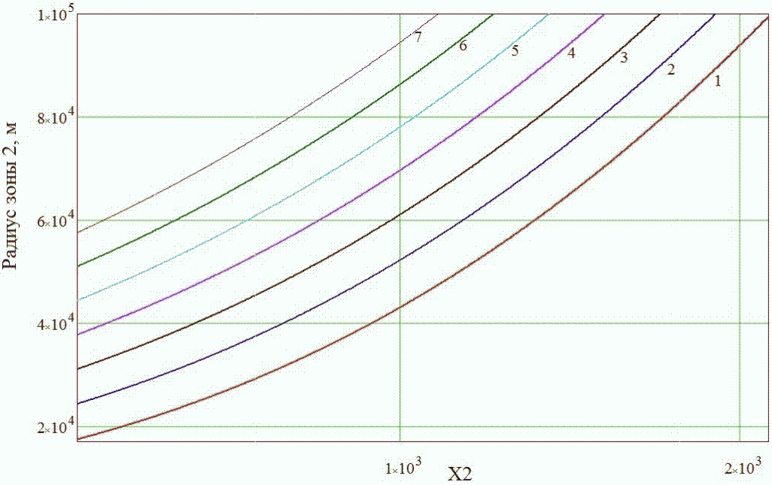
Zone 2 radius, m

Fig. 1. Dependency of the Zone 2 radii from for the level of urgent decisions on evacuation of the public at the initial stage of a radiation accident equal to 100 mSv

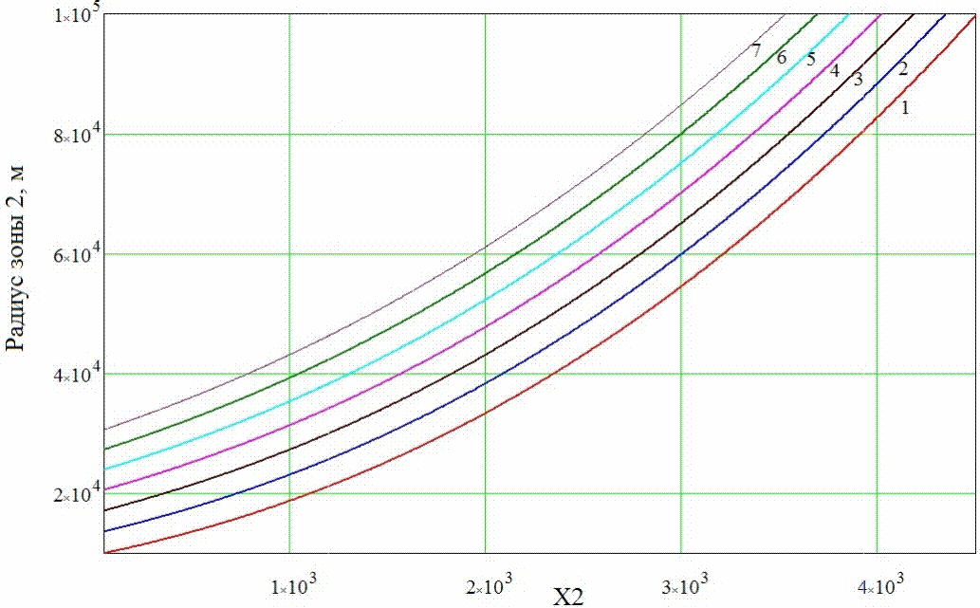
Zone 2 radius, m

Fig. 2. Dependency of the Zone 2 radii from for the level of urgent decisions on evacuation of the public at the initial stage of a radiation accident equal to 200 mSv

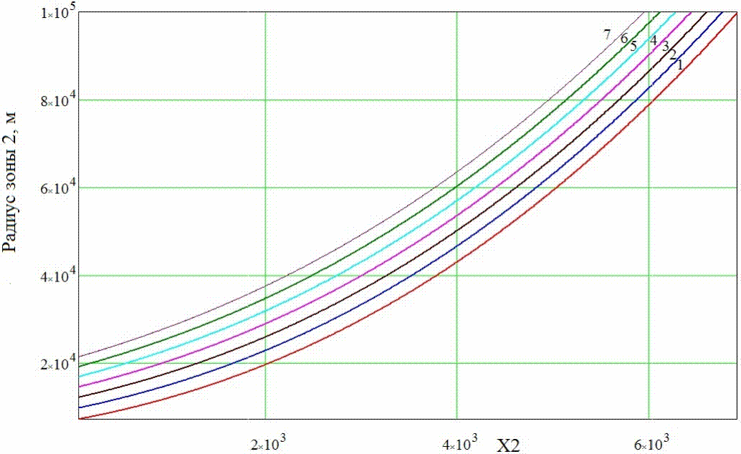
Zone 2 radius, m

Fig. 3. Dependency of the Zone 2 radii from for the level of urgent decisions on evacuation of the public at the initial stage of a radiation accident equal to 300 mSv

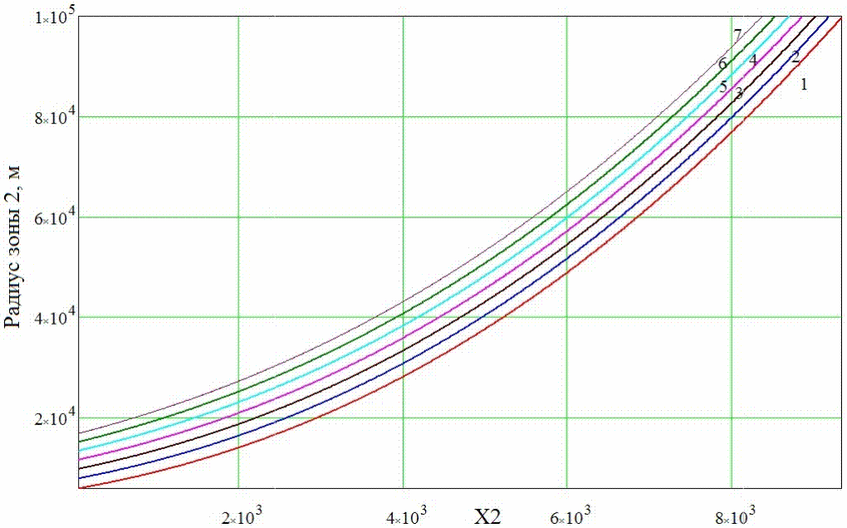
Zone 2 radius, m

Fig. 4. Dependency of the Zone 2 radii from for the level of urgent decisions on evacuation of the public at the initial stage of a radiation accident equal to 400 mSv

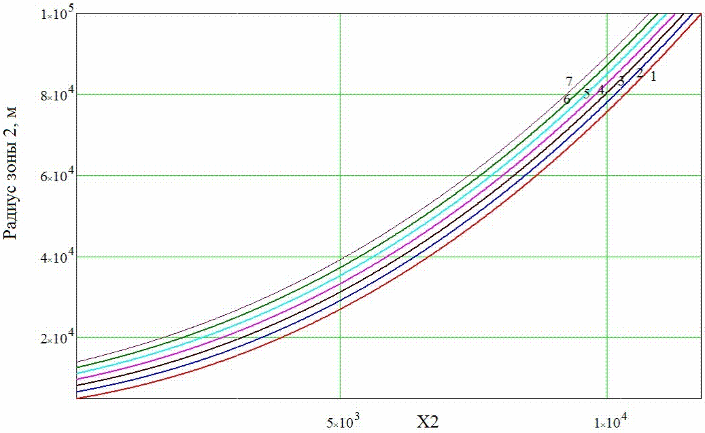
Zone 2 radius, m

Fig. 5. Dependency of the Zone 2 radii from for the level of urgent decisions on evacuation of the public at the initial stage of a radiation accident equal to 500 mSv

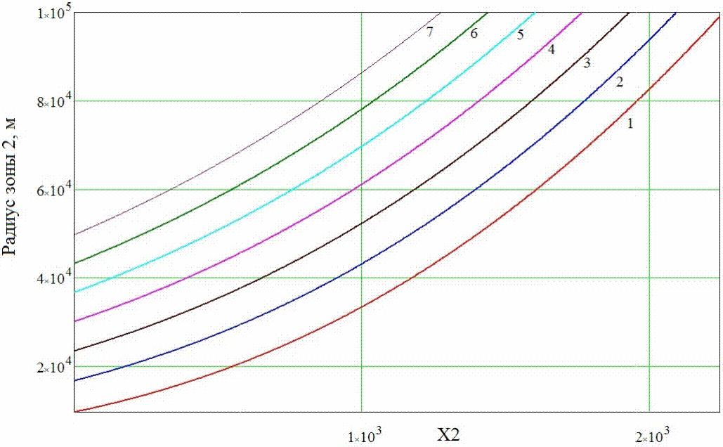
Zone 2 radius, m

Fig. 6. Dependency of the Zone 2 radii from for the level of urgent decisions on evacuation of the public at the initial stage of a radiation accident equal to 100 mSv

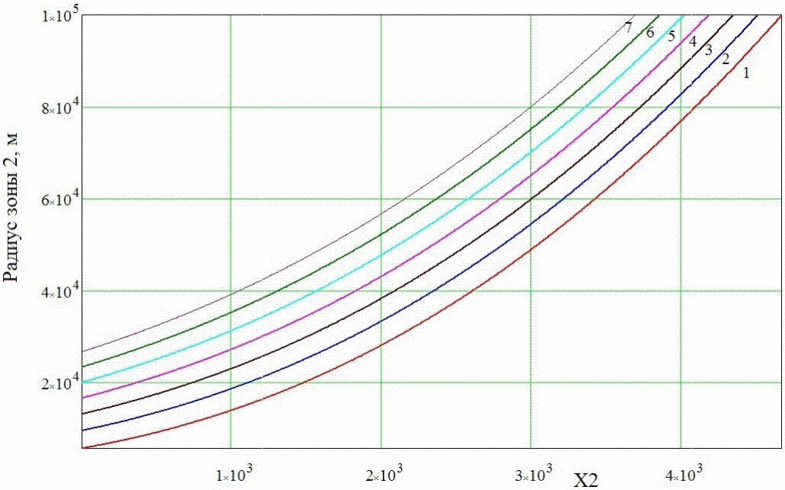
Zone 2 radius, m

Fig. 7. Dependency of the Zone 2 radii from for the level of urgent decisions on evacuation of the public at the initial stage of a radiation accident equal to 200 mSv

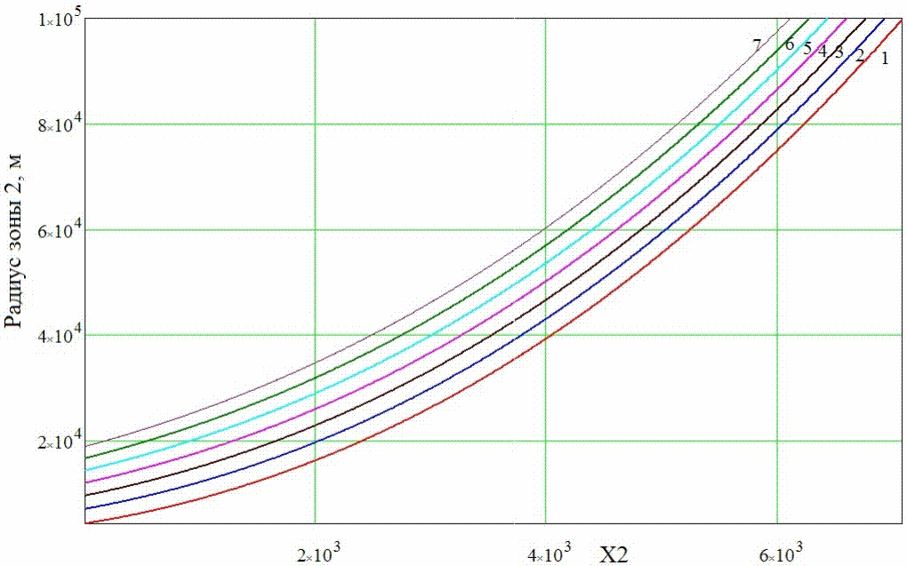
Zone 2 radius, m

Fig. 8. Dependency of the Zone 2 radii from for the level of urgent decisions on evacuation of the public at the initial stage of a radiation accident equal to 300 mSv

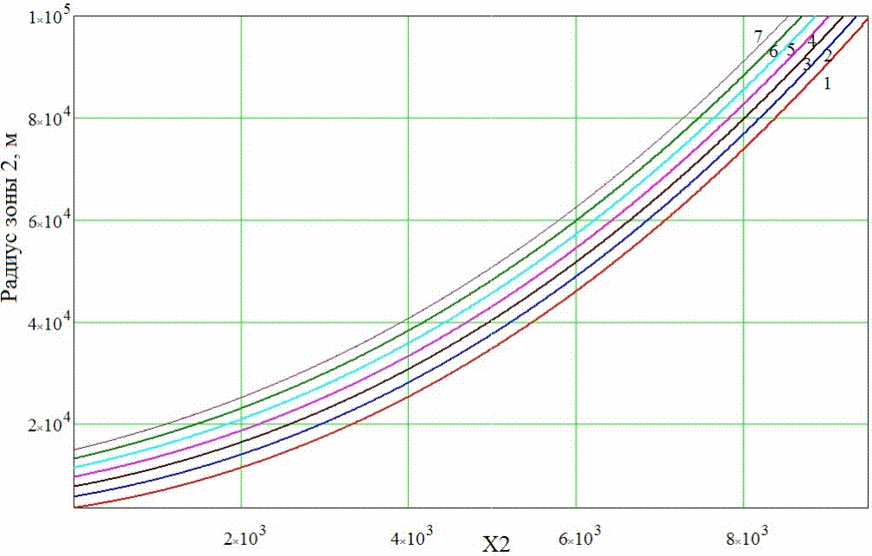
Zone 2 radius, m

Fig. 9. Dependency of the Zone 2 radii from for the level of urgent decisions on evacuation of the public at the initial stage of a radiation accident equal to 400 mSv

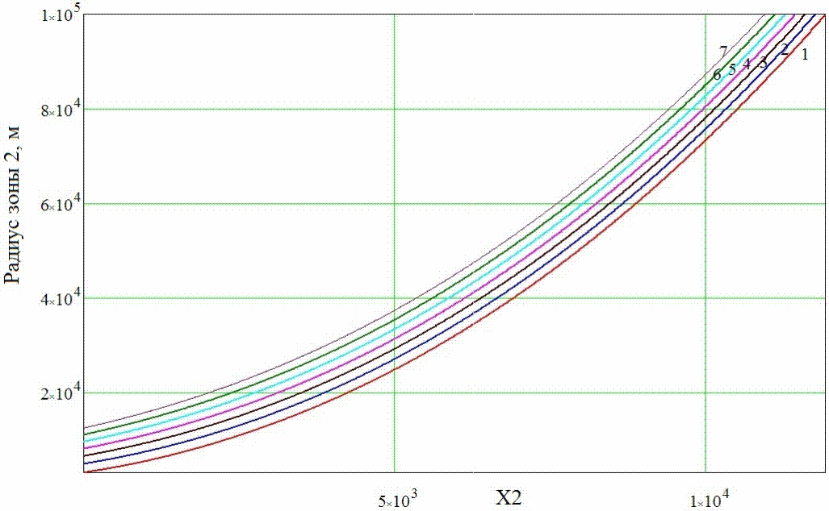
Zone 2 radius, m

Fig. 10. Dependency of the Zone 2 radii from for the level of urgent decisions on evacuation of the public at the initial stage of a radiation accident equal to 500 mSv

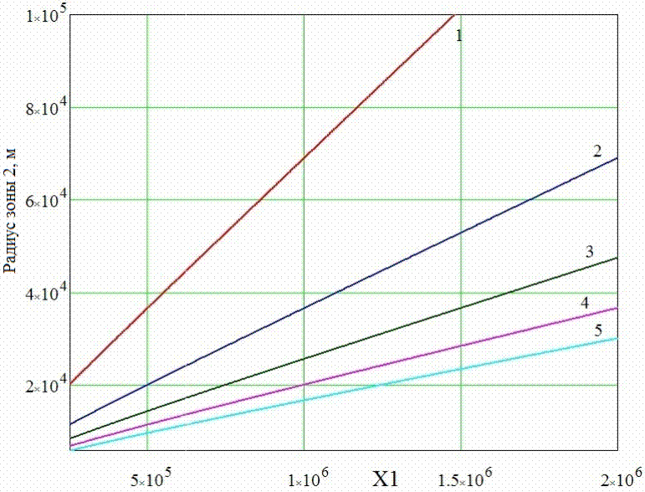
Zone 2 radius, m

Fig. 11. Dependency of the Zone 2 radii from for different levels of urgent decisions on evacuation of the public at the initial stage of a radiation accident

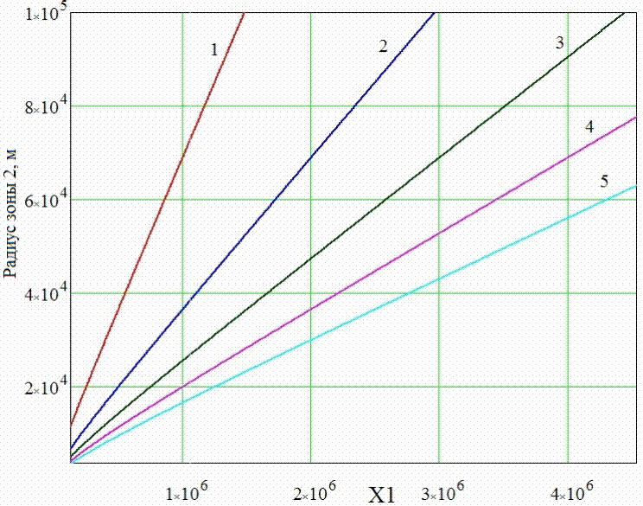
Zone 2 radius, m

Fig. 12. Dependency of the Zone 2 radii from for different levels of urgent decisions on evacuation of the public at the initial stage of a radiation accident

