Approved
by the Order of the Federal Environmental, Industrial and Nuclear Supervision Service No. 458
dated November 2, 2016

SAFETY GUIDE
IN THE USE OF ATOMIC ENERGY "RECOMMENDATIONS ON THE RISK-INFORMED APPROACH APPLICATION IN JUSTIFICATION OF RISK INFORMED DECISIONS ASSOCIATED WITH A NPP UNIT SAFETY"
(RB-101-16)

I. General

1. The safety guide in the use of atomic energy "Recommendations on the Risk-Informed Approach Application in Justification of Risk-Informed Decisions Associated with a NPP Unit Safety" (RB-101-16) (hereinafter - the Safety Guide) has been developed in accordance with Article 6 of Federal Law No. 170-FZ dated November, 21, 1995 "On Atomic Energy Use" for facilitating compliance with the requirements of item 6 and item 16 of the Federal Rules and Regulations in Atomic Energy Use "Basic Requirements to Probabilistic Safety Analysis of a Nuclear Power Plant Unit" (NP-095-15) approved by order of the Federal Environmental, Industrial and Nuclear Supervision Service No. 311 dated August 12, 2015 .
2. This Safety Guide contains the recommendations for risk-informed approach application in justification of risk-informed decisions, which include qualitative and quantitative assessments obtained on the basis of deterministic and probabilistic safety analysis.
3. The Safety Guide contains the recommendations, fulfilment thereof shall provide with acceptance of the risk-informed decisions associated with:
the changes of safe operation conditions;
alterations of the safety-related systems and elements;
alterations in the design and operation documentation;
other alterations changing the NPP operation procedure.
4. This Safety Guide is intended for use:
by the operator in analysis of the alterations, changing the NPP operation procedure, listed in the item 3 of this Safety Guide an in justification of the decisions taken based on the results of such analyses;
by Rostechnadzor in taking decisions on the possibility of implementation of the risk-informed decisions at the nuclear power plant.
5. The justification of the risk-informed decisions taken may be made using any other approaches different from the ones recommended in this Safety Guide subject to their substantiation for safety assurance.
6. The recommendations of this Safety Guide refer to the objectives, volume, scope and content of the deliverables and quality assurance in analysis and justification of the decisions.
The list of the abbreviations used in this Safety Guide is presented in Appendix N 1, and the terms and definitions - in Appendix N 2.

II. General information

7. The risk-informed method may be used in:
safety level assessment of the NPP unit;
risk monitoring;
significance study of the deviations from the requirements of regulatory documents for NPP unit safety.
8. The implementation of the recommendations of this Safety Guide in preparing and substantiating the risk-informed decisions shall provide acceptance of the proposed risk-informed decision.
9. The cumulative probability of severe accidents and its change (when implementing the decision) for each NPP unit over a year, cumulative probability of a large-scale emergency release and its change (in implementing the decision) for each NPP unit over a year, and instant probability of severe accidents being probabilistic safety indices used in justification for risk-informed decisions shall be assessed considering all types of initiating events (failures of NPP systems (elements), human errors, internal impacts, external impacts of natural and human-induced origin), all operational states of the NPP unit (power operation, shutdown, shutdown cooling, refueling of nuclear fuel, maintenance and repair of systems (elements), heating, start-up modes), all available locations of the nuclear materials, radioactive substances and RW available at the NPP unit where NPP operational occurrences may occur.
10. The risk-informed decisions shall be justified considering the following:
the requirements of the Federal Rules and Regulations in the field of atomic energy use;
operation experience of NPP unit on which the risk-informed decisionis planned to be implemented as wel as similar NPP units;
current development level of science, technology and production;
impact of the decision on defence in depth and its components;
PSA levels 1 and 2 complying with the requirements of the Federal Rules and Regulations in the field of atomic energy use to probabilistic safety assessment of the NPP unit;
impact of the decision on NPP physical protetion assurance.
11. The risk-informed decision is justified if the following conditions are simultaneously met:
the assessed risk of the NPP unit is acceptable;
no negative impact of the risk-informed decision on defence in depth or impact of risk-informed decision on the defence in depth is assessed as acceptable;
no negative impact of risk-informed decision on the physical protection of NPP;
the requirements of the Federal Rules and Regulations in the field of atomic energy use, other regulatory documents are observed in implementing the risk-informed decision.
12. The fulfilment of the conditions specified in the item 11 of this Safety Guide shall be justified for each of the risk-informed decision.
13. The risk-informed decisions shall be justified iteratively according to the accounting procedure of deterministic and probabilistic aspects in assessment of the risk-informed decisions given in Appendix No. 3 to this Safety Guide.

III. Preparation for analysis of risk-informed decisions

14. The NPP systems and elements, which may be impacted by the proposed risk-informed decision, shall be identified, and the regulatory documents regulating the requirements to the identified NPP systems and elements, operational documents and human actions related to identified NPP systems and element shall be stipulated.
15. The NPP unit operation experience PSA results, and the results of other studies related to proposed risk-informed decision shall be analyzed.
16. Information for analysis of the impact of risk-informed decision on defence in depth considering the assessment procedure of the impact of accepted risk-informed decision on the defence in depth and its components stated in Appendix No. 4 to this Safety Guide shall be prepared.

IV. Assessment of the impact of risk-informed decision on the probabilistic safety indices of the NPP

17. The impact of risk-informed decision on the probabilistic safety indices of the NPP shall be assessed using PSA. The applicability of used probabilistic models of NPP unit for analysis of the proposed risk informed decisions (including require detail of the probabilistic model of the NPP unit, no disbalances (for example, conservative approaches and assumptions), not allowing assess the impact of the analyzed risk-informed decisions for safety of the NPP unit, compliance with other current requirements for use of the probabilistic safety analysis). The justification of risk-informed decision shall be presented in the report for analysis of the risk-informed decision.
18. The probabilistic model of the NPP unit used in justification of the risk-informed decision shall be developed subject to:
real state of the NPP unit;
operation documentation in force at the NPP (operation, maintenance, test and repair procedures);
operation experience of the NPP unit.
19. The aspects considered in PSA shall be stipulated for assessment of the risk-informed decision using PSA, on which the risk-informed decision exerts influence and if required correspondingly the NPP unint probabilistic model is reworked.
20. PSA not allowing (due to the simulation assumptions, non-availability of the required system elements and/or initiating events in the probabilistic model of the NPP unit) to consider all the aspects of impact of the risk-informed decision on the risk assessment of the NPP unit to the full extent shall be supplemented and reworked.
The justifications stipulated by the item 17 of this Safety Guide shall be met for the supplemented and reworked PSA in accordance with the provisions of the items 19 and 20 of this Safety Guide. In addition, the reworked and supplemented probabilistic model of the NPP unit is the basic model for assessment of the probabilistic safety indices, and the probabilistic indices are basic.
22. The reworking of the probabilistic model of NPP unit may include:
specification of the level of detailing of the NPP unit probabilistic model (for example, detailed modeling of the elements of motor drive equipment control diagrams, not included earlier in the scope of PSA model of this equipment, record of power supply cable failures not considered earlier in the PSA model);
supplementing the list of IE with the events giving rise to the processes, the flow thereof is subject to the accepted risk-informed decision;
segregation of individual IE from the group of IE related to equipment failures affected by the risk-informed decision;
specification of the equipment reliability models affected by the risk-informed decision;
inclusion of the models of actions of personnel in the NPP unit PSA model, the risk-informed decision affects the procedure and reliability of performance thereof;
other measures.
23. The following probabistic indices shall be used in justification of the risk-informed decision:
Cumulative probability of severe accidents for each NPP unit over a year;
Change of the cumulative probability of severe accidents for each NPP unit over a year (after implementation of the decision);
Instant probability of severe accident (after implementation of the decision);
Cumulative probability of a large-scale emergency release for each NPP unit over a year;
Change of the cumulative probability of a large-scale emergency release for each NPP unit over a year (after implementation of the decision);
24. Algorithm for assessment of risk-informed decisions for conformity to the probabilistic criteria is given in Appendix No. 5 to this Safety Guide.

V. Probabilistic criteria

25. The risk acceptability assessment of the NPP unit shall be made by comparing the mean values of probabilistic measures obtained with the probabilistic criteria stipulated considering the requirements of the general provisions for NPP safety assurance.
26. The following probabilistic criteria shall be used in assessing the risk acceptability of the NPP unit based on cumulative probability of severe accidents and its change pursuant to the implementation of the risk-informed decision:
if the implementation of risk-informed decision leads to reduction of the cumulative probability of severe accidents (negative value of the change of cumulative probability of severe accidents), the change of NPP unit risk shall be acceptable;
if the implementation of risk-informed decision leads to increase of the cumulative probability of severe accident, but its value is in the scope III (the diagram N 1 of Appendix No. 6 to this Safety Guide), the change of NPP unit risk shall be acceptable;
if the risk-informed decision leads to increase of the cumulative probability of severe accidents and is in the scope II (diagram N 1 of Appendix N 6 to this Safety Guide, remedial measures shall be developed for reducing the absolute probability value of severe accidents and reassessment procedure of the probabilistic measures shall be performed; the risk-informed decision and remedial measures must conform to each other in the field of action (safety aspects of the NPP unit, which they affect); the change of the probability of severe accidents accumulated following implementation of the previous risk-informed decisions shall be taken into consideration;
if the risk-informed decision leads to increase of the cumulative probability of severe accidents and its value is in the field I (diagram N 1 of Appendix N 6 to this Safety Guide), the risk-informed decisio shall be rejected.
27. The following probabilistic criteria shall be used in assessing the risk acceptability of the NPP unit based on cumulative probability of a large accidental release and its change pursuant to the implementation of the risk-informed decision:
if the implementation of risk-informed decision leads to reduction of the cumulative probability of a large accidental release (negative value of the change of cumulative probability of accidental release), the change of NPP unit risk related the large accidental release shall be acceptable;
if the implementation of risk-informed decision leads to increase of the cumulative probability of large accidental release, but its value is in the scope III (the diagram N 2 of Appendix No. 6 to this Safety Guide), the change of NPP unit risk related the large accidental release shall be acceptable;
if the risk-informed decision leads to increase of the cumulative probability of large accidental release and its value is in the scope II (diagram N 2 of Appendix N 6 to this Safety Guide, remedial measures shall be developed for reducing the absolute probability value of large accidental release and reassessment procedure of the probabilistic measures shall be performed; the risk-informed decision and remedial measures must conform to each other in the field of action (safety aspects of the NPP unit, which they affect); the change of the probability of large accidental release accumulated following implementation of the previous risk-informed decisions shall be taken into consideration;
if the implementation of risk-informed decision leads to increase of the cumulative probability of large accidental release and its value is in the field I (diagram N 2 of Appendix N 6 to this Safety Guide), the risk-informed decision shall be rejected.
28. If the implementation of risk-informed decision leads to increase of the instantaneous value of the probability of severe accidents up to the value more than 1·10⁻³ 1/(reactor.year), the risk-informed decision is rejected.
29. The cumulative probability of severe accidents for each NPP unit over one year shall be considered in assessment of the acceptability of risk-informed decision. Moreover, one should strive that the specified value did not exceed the benchmark on cumulative probability of severe accidents equal to 10⁻⁵ for each NPP unit over one year stipulated in the general provisions for safety assurance of the nuclear power plants.
30. The cumulative probability of a large emergency release for each NPP unit over a interval of one year shall be considered in assessing the acceptance of risk-informed decision. Moreover, one should strive that the specified value did not exceed the benchmark on cumulative probability of large accidental release equal to 10⁻⁷ for each NPP unit over one year stipulated in the general provisions for safety assurance of the nuclear power plants.
31. The values of the changes of mean values of probabilistic measures shall be determined by deducting from the mean value the relevant probabilistic measures obtained considering the risk-informed decision, the values of these indices obtained without considering the implementation of risk-informed decision. The same initial probabilistic model of the NPP unit shall be used. The pointwise values of the probabilistic measures of the NPP unit obtained shall be compared with the probabilistic criteria.

VI. Assessment of the impact of risk-informed decision on defence in depth and acceptability of risk-informed decision

32. The recommended assessment procedure of the impact of risk-informed decision on defence in depth and its components is set forth in Appendix No. 4 to this Safety Guide.
33. The proposed risk-informed decision shall be acceptable if the risk-informed decision complies with the requirements of the Federal Rules and Regulations in the field of atomic energy use, negative impact of the risk-informed decision on the defense in depth and its components is shown, absence of negative impact of the risk-informed decision on physical protection of NPP is shown, the assessment made in accordance with the rules set forth in the items 26, 27 of this Safety Guide shows the risk acceptability of the NPP unit.

VII. Documenting justification of the acceptance of risk-informed decision

34. The used information on risk-informed decisions, probabilistic measures analysis and identification of acceptable risk-informed decisions shall be documented in the scope sufficient for formulating the conclusions in accordance with the recommendations of this Safety Guide, and for reproducing the specified analysis if required.
35. Detailed information on the deterministic analysis (assessment of the impact of risk-informed decision on the defense in depth and its components), its results and conclusions on the correspondence of the decisions to deterministic principles, probabilistic safety analysis, its results and conclusions on risk acceptability of the NPP unit shall be included in the deliverable for justification of the risk-informed decisions.
36. The information on boundary conditions of analysis, assumptions, factors contributing to uncertainty in the results, and on the remedial measures or actions leading to change of the probabilistic measures conditioned by the implementation of risk-informed decision shall be included in the deliverable for justification of the risk-informed decisions.
37. The following information shall be presented in the reporting documentation for justification of the risk-informed decisions:
description of the problems requiring the taking of risk-informed decisions;
description of the risk-informed decisions taken
probabilistic model of the NPP unit, and probabilistic model with respect to simulation of the justified risk-informed decision;
justification of the applicability of probabilistic model for assessment of the risk acceptability assessment of the NPP unit;
justification of the risk acceptability of NPP unit;
assumptions and limitation of analysis;
description of the factors inducing uncertainty in the results;
results of risk sensitivity analysis of the NPP unit calculated considering the implementation of risk-informed decision with respect to the assumptions and most significant elements of the PSA model;
justification of the unavailability of negative influence or acceptable influence of the risk-informed decision on the defense in depth and its components;
justification of the compliance with the requirements of the rules and regulation in the field of atomic energy use in implementing the risk-informed decision;
justification of the operation experience of NPP and other NPP, where the risk-informed decision is implemented;
justification of no negative impact of risk-informed decision on the physical protection of NPP.

Appendix No. 1
to the safety guide in the use of atomic energy "Recommendations on the risk-informed approach application in justification of risk-informed decisions associated with a NPP Unit safety" approved by Order of the Federal Environmental, Industrial and Nuclear Supervision Service No. 458
dated November 2, 2016 .

ABBREVIATIONS

NPP | - Nuclear Power Plant
MCR | - Main Control Room
PSA | - Probabilistic Safety Analysis
- | - Containment
IE | - Initiating Event
CPS CR | - Control and Protection System Control Rod
RS | - Radioactive Substance
ECR | - Supplementary Control Room

Appendix No. 2
to the safety guide in the use of atomic energy "Recommendations on the risk-informed approach application in justification of risk-informed decisions associated with a NPP Unit safety" approved by Order of the Federal Environmental, Industrial and Nuclear Supervision Service No. 458
dated November 2, 2016 .

TERMS AND DEFINITIONS

Acceptable risk of a NPP unit - NPP unit risk satisfying the probabilistic criteria.
Risk of NPP unit - cumulative probability of severe accidents for each NPP unit over a year, and cumulative probability of large-scale emergency release for each NPP unit over a year.
Instant probability of severe accident for each NPP unit - cumulative probability of severe accident for each NPP unit over a year calculated in the assumption that the NPP unit configuration (state of the reactor plant, systems and elements of the NPP unit, other factors considered in the probabilistic model of the NPP unit) at the considered time is constant over a time interval equal to one year.
Risk-informed decision - decision associated with alterations to the conditions of safe operation, safety-critical systems and elements, to the design or operational documentation or by other means altering the operation procedure of the NPP unit, accepted using the risk-informed method.
Risk-informed method - system method using the qualitative and quantitative assessments made on the deterministic safety analysis and probabilistic safety analysis, requirements of regulatory documents.

Appendix No. 3
to the safety guide in the use of atomic energy "Recommendations on the risk-informed approach application in justification of risk-informed decisions associated with a NPP Unit safety" approved by Order of the Federal Environmental, Industrial and Nuclear Supervision Service No. 458
dated November 2, 2016 .

ACCOUNTING PROCEDURE OF THE DETERMINISTIC AND PROBABILISTIC ASPECTS IN RISK-INFORMED DECISIONS

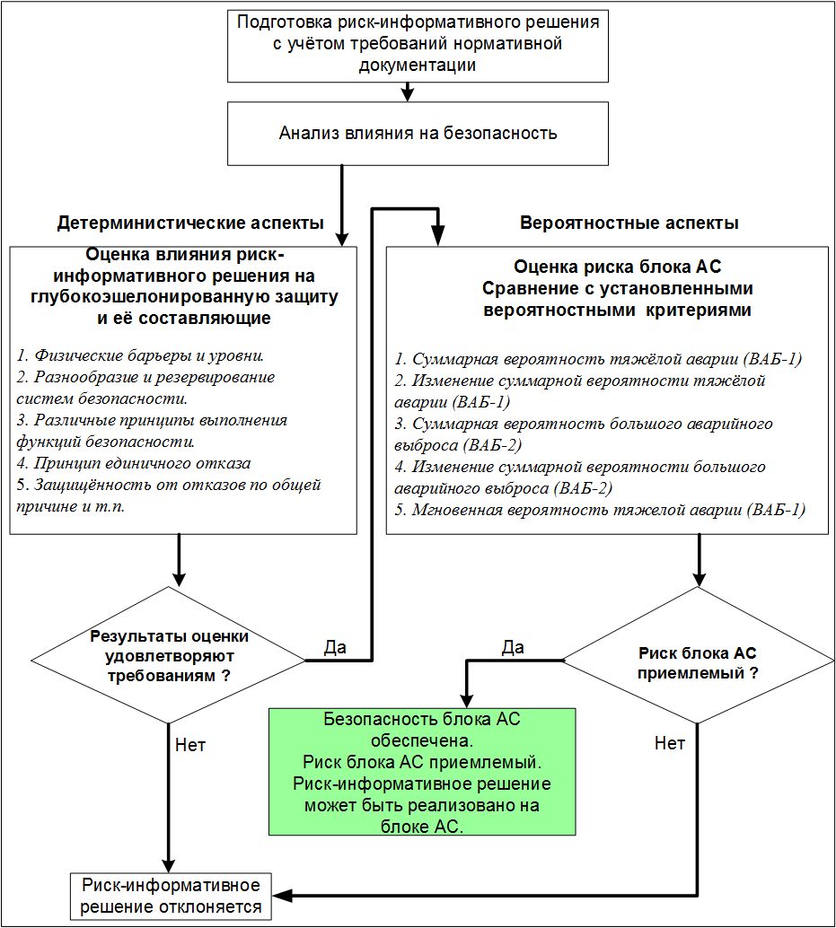
Do the assessment results comply with the requirements?
Is the NPP unit risk acceptable?
Preparation of risk-informed decision considering the requirements of the regulatory documents
Safety impact analysis
Assessment of the impact of risk-informed decision on defence in depth and its components

- Physical barriers and levels.
- Diversity and redundancy of safety systems.
- Different principles for performing safety functions
- Single failure principle
- Common cause failure safety etc.
Risk assessment of NPP unit
Comparison with the stipulated probabilistic criteria

- Cumulative probability of severe accident (PSA-1)
- Change of cumulative probability of severe accident (PSA-1)
- Cumulative probability of large-scale emergency release (PSA-2)
- Change of cumulative probability of large-scale emergency release (PSA-2)
- Instant probability of severe accident (PSA-1)
Risk-informed decision is rejected
Safety of NPP unit is assured
NPP unit risk is acceptable
The risk-informed decision may be implemented at the NPP unit.
Deterministic aspects
Probabilistic aspects
Yes
Yes
No

Appendix No. 4
to the safety guide in the use of atomic energy "Recommendations on the risk-informed approach application in justification of risk-informed decisions associated with a NPP Unit safety" approved by Order of the Federal Environmental, Industrial and Nuclear Supervision Service No. 458
dated November 2, 2016 .

RECOMMENDED ASSESSMENT PROCEDURE OF THE IMPACT OF ACCEPTED RISK-INFORMED DECISIONS ON DEFENSE IN DEPTH AND ITS COMPONENTS

The impact of accepted risk-informed decision on each of the threat implementation methods of defence in depth presented in the column 5 of table No. 1 of this Appendix shall be analyzed in assessment of the impact of accepted risk-informed decision on defence in depth.
The possibility of negative influence of the risk-informed decision on the defence in depth shall be assessed, i.e. to the occurrence of a more vulnerable state of defence in depth as a result of increase of the influence of the specific mechanism of threat implementation on it or to enhancement of the probability with which the specific mechanism leads to unwanted impact on the defence in depth components.
The conclusions on no negative impact of the accepted risk-informed decision on defence in depth for each threat implementation mechanism shall be justified.
In establishing the negative impact on the defence in depth of the accepted risk-informed decision this impact may be recognized as acceptable if there are justifications that the physical barriers and measures for their protection retain adequate reliability, do not lead to considerable change of the possibility of occurrence of operational occurrence, including accidents and do not reduce the NPP unit capability to remedy and limit the consequences of operational occurrences, including accidents.
The recommended format for presentation of the results of analysis of the impact of decision taken on defence in depth and its components is given in the table 2 of this Appendix.

Table 1

NOMENCLATURE OF DEFENCE IN DEPTH THREATS OF NPP UNIT AND THEIR IMPLEMENTATION MECHANISMS

S. No. | Defence-in-Depth level | Affected basic safety functions | Defence-in-Depth threats | Threat implementation mechanisms | Protection assurane methods against threat
1 | 2 | 3 | 4 | 5 | 6
1. | First | All | 1. Natural factors at the site impacting the NPP. | 1. NPP location area and site seismology is earthquake adverse and threatens the stability of the NPP constructions and elements.  2. NPP site hydrology is not suitable from the flooding point of view.  3. NPP site hydrology is not suitable from the point of view of RS propagation.  4. Extreme meteorological conditions (wind, temperature etc.). | 1. Determination of the occurrence probability of natural phenomena leading to substantial radiation consequences.  2. Analysis of impact on NPP safety.  3. Choice of natural impacts as design initiating events considered in the design.  4. Assessment of the possibility of developing remedial measures.  5. Implementation of measures arising from the recommendations on results of safety analysis.  6. Provision of sufficient (adequate) reserves (for example strength) in the NPP design.
1. | First | All | 1. Man-made factors at the site impacting the NPP. | 1. Release of toxic and combustible gases, chemical impact.  2. Impact of aircrafts  3. Explosions  4. Other hazards | 1. Determination of the occurrence probability of human-caused phenomena leading to substantial radiation consequences.  2. Analysis of impact on NPP safety.  3. Restriction of human activity near the NPP  4. Choice of human impacts as design initiating events considered in the design.  5. Assessment of the possibility of developing remedial measures.  6. Implementation of measures arising from the recommendations on results of safety analysis.  7. Provision of sufficient (adequate) reserves (for example strength) in the NPP design.
2. | First | 1. Limitation of RS output during operation  2. Limitation of RS output from fuel outside the primary circuit | Unforeseen transfer paths of RS | 1. Propagation of RS through air  2. Propagation of RS through food chains  3. Propagation of RS through water | 1. Study of physical characteristics and characteristics of the environment.  2. Analysis of the radiation effects during normal operation and operational occurrences.  3. Study of population distribution near the NPP location area
3. | Second | 1. Limitation of RS output during operation  2. Limitation of RS output from fuel outside the primary circuit | Unforeseen transfer paths of RS | 1. Propagation of RS through air  2. Propagation of RS through food chains  3. Propagation of RS through water | 1. Limitation of radioactive releases and discharges  2. Observation over flora and fauna
4. | Third and fourth | 1. Limitation of RS output during operation  2. Limitation of RS output from fuel outside the primary circuit | Unforeseen transfer paths of RS | 1. Propagation of RS through air  2. Propagation of RS through food chains  3. Propagation of RS through water | 1. Stipulation of radiological acceptance criteria for radioactive releases during accident:  a) during design basis accidents;  b) during beyond design basis accidents.  2. Adequate monitoring of radiation situation during design-basis and beyond design-basis accidents (fixed radiation monitors, information on MCR, determination of the concentration of radionuclides in the liquid and gas specimen, RS monitoring before and during the release to the atmosphere).  3. Determination of radionuclide impact near NPP.
5. | First, second, third and fourth | 1. Residual heat removal during normal operation and accidents if there are no primary circuit leakages.  2. Heat removal from the core during primary circuit leakages for limiting fuel damage.  3. Heat removal from the safety systems to the ultimate heat sink | 1. Inadequacy of ultimate heat sink for long-duration heat removal | 1. Loss of source of water (sea, river, lake etc.) as a result of external impact.  2. Atmospheric ultimate heat sink has not been designed for external impacts.  3. Equivocation of heat transfer systems | 1. Analysis of specific external impacts for the NPP site:  a) natural phenomena;  b) anthropogenous phenomna.  2. Adequate accounting of external impacts in the ultimate heat sink design:  a) natural phenomena;  b) anthropogenic phenomena;  c) complying with the diversity principle for the ultimate heat sink;  d) complying with the diversity principle for the supporting systems.  3. Design of heat transfer systems in accordance with the importance of their contribution in performing the heat transfer function:  a) time tested elements;  b) redundancy;  c) diversity;  d) interrelation;  e) physical separation.
5. | First, second, third and fourth |  | 2. Vulnerability of heat removal systems to the ultimate heat sink. | 1. Water expulsion in the ultimate heat sink operationalized.  2. Temperature increase of water in the ultimate heat sink operationalized.  3. Disadvantages of designing systems being secondary for the ultimate heat sink. | 1. Proper design of the heat transfer systems:  a) limitations of the flow rate value;  b) limitations of pressure values;  c) segregation and mutual redundancy  d) detection of leakages;  e) proper supporting systems;  f) operating capacity on power outage from the sources external with respect to the NPP sources;  g) redundancy;  h) diversity;  i) design reserves;  j) design measures, protection against external impacts.  2. Additional possibilities of heat removal in the event of severe accidents:  a) ventilation;  b) heat removal due to sprinkler system operation.
6. | First, second, third and fourth | All | Degradation of the functional capability of safety-releated elements. | 1. Unexpected behavior of NPP in normal operation conditions or operational occurrences. | 1. Use of decisions time tested earlier for similar applications.  2. Use of new solutions only of they are confirmed by research and tests.  3. Study of the applied operation experience in selection of the process solutions.
 |  |  |  | 2. Latent failures in the safety-related NPP elements. | 1. Preference to equipment with detectable types of failures  2. Provision of operational monitoring of operational characteristics
 |  |  |  | 3. Unspecified failure mechanisms of the safety-related NPP elements. | 1. Preference to equipment with detectable types of failures  2. Selection of elements conforming to the reliability objectives  3. Study of the applied operation experience in selection of the process solutions.
 |  |  |  | 4. Unexpected operability limitations of the safety-related elements. | 1. Performance of deterministic and probabilistic safety analysis:  a) use of realistic simulation and data;  b) additional use of conservative models;  c) analytical models, experimentally validated.
 |  |  |  | 5. Unexpected degradation of physical barriers | 1. Design and manufacture of equipment in accordance with the applied standards.  2. Regular in-service inspection  3. Use of available experience and reputation of the suppliers
7. | First, second, third and fourth | All | 1. Design inadequacy with respect to normal operation | Unspecified behavior of instrumentation and control system | 1. Provision of sufficient design margin for stable operation.  2. Establishing the required operation conditions and requirements for management of process parameters  3. Consideration of the necessity for preventing operational occurrences in the control systems design
7. | First, second, third and fourth | All | 2. Design inadequacy with respect to anticipated operational occurrences and design basis accidents. | 1. Inadequate stipulation of the postulated initiating events in the design | Classification of the postulated initiating events in accordance with the frequency of occurrence:  a) stipulating the approach to classification of IE;  b) list of design IE.
 |  |  |  | 2. Non-design functioning of the NPP systems and elements | Classification of NPP systems and elements for determining the rules of design, engineering design, manufacture, installation, operation and repair.
 |  |  |  | 3. Wrong execution of the safety analysis  4. Wrong execution of verification. | 1. Acceptance criteria with respect to each postulated IE.  2. Conservative analysis for all postulated events  3. Performance of PSA.  4. Inspection by Regulatory Authority  5. Inspection by special missions (for example, IAEA)
 |  |  |  | 5. NPP systems and elements have been designed to not withstand the impacts of design-basis accidents | 1. Stipulation of the determining postulated events for assessment of the operability margins of the systems and elements.  2. Justification of the operability of systems and elements in environmenta l conditions  3. Requirements of periodic control for performance assessment of their functions by the systems and elements.  4. Provision of independency of the systems and elements from other NPP systems.
7. | First, second, third and fourth | All | 3. Design inadequacy with respect to beyond design basis accidents. | Beyond design-basis accidents have not been duly accounted in the design. | 1. Determination of the scenarios and acceptability criteria for beyond design basis accidents.  2. Реалистический анализ запроектных аварий.  3. Introduction of additional possibilities for mitigation of the beyond design-basis accidents.
8. | First | 1. Prevention of inadmissible reactivity measurements  2. Maintenance of the reactor in safe shutdown condition after transfer to the shutdown condition  3. Reactor shutdown for preventing escalation of operational occurrences into design-basis accident, and for limiting the consequences of design-basis accidents. | 1. Unsatisfactory maintenance of neutron-physical and thermal-hydraulic parameters within the operation boundaries that shall lead to large number of requirements of safety systems operation.  2. Reliability of safety systems has bee weakened by their frequent starts. | 1. Wrong actions of the operator during manual control. | 1. Minimization of manual operations by the operator  2. Use of relevant operational procedures
 |  |  |  | 2. The actuation set points and safety limits have been wrongly set. | 1. Setting the operational limits for process parameters.  2. Stipulation of safety limits based on conservative approach
 |  |  |  | 3. Insufficiency of automatic control | 1. Exclusion of frequent occurrences of requirements for safety systems operaiton  2. System for quick remedy of disadvantages in the automatic control systems
9. | Second | 1. Prevention of inadmissible reactivity changes  2. Maintenance of the reactor in safe shutdown condition after transfer to the shutdown condition  3. Reactor shutdown for preventing escalation of operational occurrences into design-basis accident, and for limiting the consequences of design-basis accidents. | 1. Unsatisfactory maintenance of neutron-physical and thermal-hydraulic parameters within the operation boundaries that shall lead to large number of requirements of safety systems operation.  2. Reliability of safety systems has bee weakened by their frequent starts. | 1. Wrong actions of the operator during manual control. | Correct determination of set points of safety systems start
 |  |  |  | 2. The actuation set points and safety limits have been wrongly set. | Correct determination of set points of safety systems start
 |  |  |  | 3. Insufficiency of automatic control | Maintaining the automatic control systems in operable state
10. | Third | All | Degradation of basic safety function performance as a results of inadequate response to the event of automatic safety systems | 1. Safety systems became inoperative during the previous operation. | 1. Indication of the operational state of safety systems  2. Automatic self-diagnosis of safety systems  3. Mandatory requirements for preventing safety system failure to operate  4. Operational limitations in inoperative safety systems.
 |  |  |  | 2. Safety systems do not actuate to the request. | 1. Reliable/redundant start of safety systems  2. Consideration of the safety system failures in the emergency procedures for personnel  3. Training of operators for response to failures in the safety systems.
 |  |  |  | 3. Safety systems fail following failure of auxiliary systems. | 1. Reliable power supply supporting systems  2. Reliable instrumentation and controls and automation.  32. Consideration of the safety system failures in the emergency procedures for personnel  4. Training of operators for response to failures in the safety systems.
 |  |  |  | 4. Degradation of the safety systems operability following severe operational conditions | Justification of equipment operability for operation in severe conditions
 |  |  |  | 5. Inadequate performance of its functions by the safety system | 1. NPP design in accorance with the single failure principle.  2. Preference to the designs of systems complying with the safe failure principle.  3. Prevention of common cause failures in the safety systems  4. Implementation of conservative design with respect to performance of their functions by the safety systems
 |  |  |  | 6. Взаимовлияние систем АС. | 1. Provision of greater priority for performing safety functions  2. Normal operation systems cut-off from safety systems
11. | Third | All | Failure of safety systems to perform its functions due to low reliability | 1. Reliability of safety systems do not conform to their importance to safety | 1. Setting the target reliability indices for the safety systems based on PSA  2. Reliability analysis for the safety systems and safety functions  3. Stipulation of requirements for testing (confirmation of operability) corresponding to target reliability indices.  4. Use of systems, confirmation of operability thereof is possible during operation.  5. Use of additional equipment if required for achieving the target safety indices.
 |  |  |  | 2. Vulnerability of safety systems to common cause failures
 |  |  |  | 3. Insufficient reliability of supporting systems | 1. Providing simple and frequent insectiosn.  2. Provision of access to safety system equipment for the life duration of NPP unit  3. Provision of operational control for assessment of material degradation  4. Periodic testing for confirming functional operability  1. Monitoring of the operational state of safety systems  6. Possibility of automatic self-diagnosis
12. | Third | All | Failure of safety systems to perform its functions due to common cause failures | 1. Отказ по общей причине вследствие внутренних событий (потеря энергоснабжения, исчерпание топлива для дизель-генератора и т.д.). | 1. Обеспечение независимости систем безопасности от других станционных систем.  2. Использование безопасного отказа в системах безопасности, насколько это возможно.  3. Достаточное резервирование и разнообразие в источниках энергоснабжения.  4. Достаточное резервирование и разнообразие в обеспечивающих системах безопасности.  5. Взаимодействие одновременно работающих систем безопасности.
 |  |  |  | 2. Отказ по общей причине вследствие ошибок при проектировании, изготовлении, эксплуатации, техническом обслуживании, испытаниях. | 1. Использование независимых резервируемых систем, являющихся разнообразными по отношению друг к другу.  2. Программа обеспечения качества, внедряемая на всех этапах жизненного цикла АС.  3. Independent verification/assessment of design  4. Проектные запасы, достаточные с учетом эффектов старения и износа.  5. Координация деятельности различных ремонтных групп, групп техобслуживания.
 |  |  |  | 3. Отказ по общей причине вследствие возникновения события на другом блоке той же АС. | 1. Отказ от совместного использования систем, важных для безопасности, несколькими блоками АС.  2. Доказательство обеспечения безопасности для всех эксплуатационных состояний при возникновении проектного события на любом блоке АС.  3. Обеспечение безопасного останова и расхолаживания реактора при возникновении тяжелой аварии на другом блоке той же АС.
 |  |  |  | 4. Отказ по общей причине вследствие внутренних воздействий (затопления, летящие предметы, реактивные струи, хлыстовые эффекты от высокоэнергетичных трубопроводов). | 1. Анализ риска от внутренних воздействий и принятие контрмер.  2. Физическое разделение барьерами, расстоянием или ориентацией.  3. Расположение резервируемых систем в разных помещениях.  4. Justification of the operability of critical equipment in environmental conditions  5. Учет внешних воздействий как причин внутренних (пожары, затопления и т.д.) воздействий.  6. Исключение переопрессовки одной системы от другой системы, с ней связанной.
 |  |  |  | 5. Отказ по общей причине вследствие пожаров и взрывов в пределах площадки АС. | 1. Выполнение анализа пожаров для определения (подтверждения) необходимых барьеров, системы обнаружения и тушения пожара.  2. Использование негорючих, пожаростойких и термостойких материалов.  3. Preferable use of non-combustible lubricating materials  4. Обеспечение достаточных резервов средств пожаротушения.  5. Inspections, maintenance and repair of firefighting equipment  6. Exclusion of unfavorable impact on the safety systems of firefighting system operation  7. Organization of required training of NPP personnel  8. Preference to operation of systems with safet failures  9. Segregation of duplicating systems by fire walls / doors  10. Monitoring of combustible substances and source of fire  11. Automatic start of firefighting systems  12. Fire protected systems for shutdown, residual heat removal, monitoring RS localization  13. Consideration of the possibility of employing firefighting forces and equipment from outside
 |  |  |  | 6. Common cause failure due to earthquake | 1. Consideration of seismicity  2. Set up of sufficient margins of antiseismic protection in the design  3. Подтверждение тестами и анализом квалификации оборудования, важного для безопасности на сейсмическое воздействие.  4. Учет событий, являющихся следствием землетрясения (например, затоплений).  5. Исключение влияния отказов в оборудовании, неважном для безопасности, на оборудование, важное для безопасности.
 |  |  |  | 7. Отказ по общей причине вследствие техногенного внешнего воздействия (падение летательного аппарата, взрывы, газовые облака и др.). | 1. Анализ риска от техногенных внешних воздействий.  2. Включение внешних событий техногенного происхождения в проектные основы.  3. Запрещение использования транспортных путей вблизи АС.
 |  |  |  | 8. Отказ по общей причине вследствие внешнего природного воздействия (сильный ветер, затопления, экстремальные погодные условия). | Учет наиболее тяжелых условий в проекте АС
13. | Third | All | 1. Safety systems and elements not certified for operation in emergency conditions | 1. Accident conditions not duly considered in the design  2. Equipment qualificatio not confirmed by test. | 1. Stipulation of environmental conditions for design-basis accidents  2. Учет условий тяжелых аварий в проекте новых АС.  3. Учет в проекте условий при внешних воздействиях.  4. Испытания прототипов.
13. | Third | All | 2. Необходимая надежность не обеспечивается в течение срока службы. | Способность АС противостоять условиям окружающей среды страдает из-за старения. | 1. Учет в проекте влияния старения на способность АС противостоять условиям окружающей среды.  2. Учет в проекте отказов по общим причинам вследствие старения.
14. | All | All | Невыявляемая деградация функциональной способности оборудования, важного для безопасности вследствие недостатков инспекций | 1. Ограниченность инспекций вследствие трудностей в доступе к оборудованию. | 1. Учет при проектировании барьеров необходимости проведения инспекций.  2. Учет при конструировании барьеров необходимости проведения инспекций.
 |  |  |  | 2. Недостаточность запасов по безопасности для покрытия имеющихся интервалов между инспекциями. | 1. Учет при проектировании оборудования, важного для безопасности, необходимости проведения инспекций.  2. Учет при конструировании оборудования, важного для безопасности, необходимости проведения инспекций.  3. Проектирование оборудования, важного для безопасности, с достаточными запасами по безопасности.
15. | First | 1. Ограничение выхода радиоактивности при нормальной эксплуатации. | 1. Выход РВ сверх установленных пределов. | 1. Необнаруженная утечка жидких или газообразных радиоактивных веществ. | Система контроля местности
 |  |  |  | 2. Неправильные измерения активности отходов. | 1. Консервативная система технологического контроля.  2. Программа контроля окружающей среды.
15. | First | 2. Поддержание условий окружающей среды в помещениях АС. | 2. Переоблучение эксплуатационного или ремонтного персонала сверх установленных пределов. | 3. Загрязнение работников радиоактивными веществами. | 1. Подходящие контейнеры для радиоактивных веществ.  2. Использование систем вентиляции с адекватной фильтрацией.  3. Установки контроля персонала и окружающей среды.  4. Установки для дезактивации персонала.  5. Обработка поверхностей для облегчения дезактивации.
 |  |  |  | 4. Непосредственное облучение работников. | 1. Адекватное экранирование оборудования АС.  2. Соответствующее расположение оборудования АС.  3. Исключение проектных решений, вследствие которого в оборудовании удерживаются РВ.  4. Мониторинг и управление условиями окружающей среды.  5. Контроль доступа в радиоактивные зоны.  6. Консервативный проект систем по обращению с радиоактивными отходами.  7. Учет требований по радиационной защите при планировке АС.  8. Использование материалов, мало активируемых нейтронами.  9. Выбор материалов с низкой остаточной радиоактивностью.  10. Минимизация деятельности людей в радиационных полях.  11. Планируемая и согласованная деятельность по ремонту и модернизации.
16. | First | Prevention of unacceptable reactivity of the processes | Reactivity input representing fuel damage hazard | 1. Release of CPS CR | 1. Консервативный проект чехла ОР СУЗ.  2. Использование качественных материалов и обеспечение качественного изготовления чехла ОР СУЗ.
 |  |  |  | 2. Withdrawal of CPS CR | 1. Проектные запасы, минимизирующие автоматический контроль.  2. Правила реагирования на несанкционированное извлечение ОР СУЗ.
 |  |  |  | 3. Failure of CPS CR (fall, improper position) | 1. Испытания положения ОР СУЗ при пуске.  2. Надежная и отказобезопасная конструкция ОР СУЗ.
 |  |  |  | 4. Unauthorized start operation of the reactor coolant system loop | 1. Адекватные эксплуатационные процедуры.  2. Запирание устройств, которые могут привести к запуску петли в работу.
 |  |  |  | 5. Утечка поглотителя. | 1. Анализ потенциальных отказов и их последствий.  2. Адекватный водно-химический режим.
 |  |  |  | 6. Ошибочные операции при перегрузке. | 1. Проверка расположения топливных кассет.  2. Адекватные эксплуатационные процедуры.
 |  |  |  | 7. Несанкционированное снижение концентрации бора. | 1. Адекватные эксплуатационные процедуры.  2. Автоматические блокировки для предотвращения разбавления бора.
17. | Second | Prevention of unacceptable reactivity of the processes | Reactivity input representing fuel damage hazard | 1. Извлечение ОР СУЗ. | 1. Мониторинг положения ОР СУЗ.  2. Ограничение скорости перемещения ОР СУЗ.  3. Ограничение физического веса группы ОР СУЗ.
 |  |  |  | 2. Отказ ОР СУЗ (падение, неправильное положение). | 1. In-core monitoring  2. Мониторинг положения ОР СУЗ.
 |  |  |  | 3. Unauthorized start operation of the reactor coolant system loop | 1. Limitation of the parameters of the inoperative reactor coolant system loop  2. Limitation of rate of bringing into operation of the reactor coolant system loop
 |  |  |  | 4. Poison leakage | 1. Adequate water chemistry regime  2. In-core monitoring
 |  |  |  | 5. Erroneous operations during refuelling | 1. In-core monitoring  2. Sufficient safety margins during shutdown  3. Negativity of feedback on reactivity
 |  |  |  | 6. Unauthorized reduction of boron concentration. | 1. Adequate operation ocumentation  2. System of monitoring for primary circuit makeup system  3. Providing the operator the duration of time required for response.
18. | Third | Prevention of unacceptable reactivity of the processes | Reactivity input representing fuel damage hazard | 1. Release of CPS CR | 1. Negativity of feedback on reactivity  2. Restriction of physical weigh of single CPC CR.  3. Reliable and quick reactor shutdown system
 |  |  |  | 2. Withdrawal of CPS CR | 1. Negativity of feedback on reactivity  2.Conservative assignment of setpoints for reactor emergency shutdown system  3. Reliable and quick reactor shutdown system
 |  |  |  | 3. Failure of CPS CR (fall, improper position) | 1. Conservative set points for reactor emergency shutdown system  2. Reliable and quick reactor shutdown system
 |  |  |  | 4. Unauthorized start operation of the reactor coolant system loop | Reliable and quick reactor shutdown system
19. | First | 1. Prevention of unacceptable reactivity processes  2. Reactor shutdown for preventing escalation of operational occurrence into design-basis accident, and for limiting the consequences of design-basis accidents.  3. Heat removal from the core during primary circuit leakages for limiting fuel damage.  4. Heat removal from the core in entire primary circuit  5. Providing acceptable integrity of the claddings of fuel elements in the core. | 1. Input of reactivity following core distortion due to mechanical impact  2. Delayed or incomplete input of CPS CR into the core due to core distortion by mechanical impact  3. Violation of the effective core cooling following core distortion due to mechanical impact.  4. Повреждение оболочки тепловыделяющих элементов из-за механического воздействия. | 1. Чрезмерные осевые усилия, вызванные внутренними нагрузками (пружина).  2. Динамические силы, вызванные землетрясением. | 1. Аналитическое и экспериментальное обоснование стабильности активной зоны во время землетрясения.  2. Проектирование активной зоны на статические и динамические, включая сейсмические, нагрузки.  3. Контроль качества топлива и внутрикорпусных устройств.
 |  |  |  | 3. Тепловые, механические и радиационные эффекты, включая фреттинг и износ во время эксплуатационных режимов. | 1. Проектные запасы для топлива, обеспечивающие приемлемые проектные пределы (в том числе для режима перегрузки).  2. Предотвращение искривления или сдвига топлива при чрезмерных осевых нагрузках или тепловом воздействии.  3. Анализ потенциального влияния на безопасность от ограничителей.  4. Контроль качества при проектировании и изготовлении топлива.  5. Ограничение изменений размеров, вызванных радиацией.  6. Одобрение конструкции топлива и технологии его производства регулирующим органом.
 |  |  |  | 4. Вибрация тепловыделяющих элементов вследствие теплогидравлических эффектов. | 1. Конструкция топлива, предотвращающая вибрацию.  2. Установка механических ограничителей.  3. Анализ потенциального влияния на безопасность от ограничителей.
 |  |  |  | 5. Повреждение топлива посторонними предметами. | 1. Контроль качества при проектировании и изготовлении топлива, а также элементов контура охлаждения реактора.  2. Проверка целостности топлива во время перегрузки.  3. Установление ограничений для эксплуатации с поврежденным топливом.  4. Мониторинг посторонних предметов.
 |  |  |  | 6. Чрезмерные осевые усилия вследствие распухания конструкционных материалов. | 1. Адекватные проектные запасы топлива для противостояния излучению нейтронов.  2. Консервативное ограничение для величины максимального выгорания топлива.  3. Experimental justification of the fact that the fuel design provides the anticipated design characteristics
20. | Second | 1. Prevention of unacceptable reactivity processes  2. Reactor shutdown for preventing escalation of operational occurrence into design-basis accident, and for limiting the consequences of design-basis accidents.  3. Heat removal from the core during primary circuit leakages for limiting fuel damage.  4. Heat removal from the core in entire primary circuit  5. Providing acceptable integrity of the claddings of fuel elements in the core. | 1. Input of reactivity following core distortion due to mechanical impact  2. Delayed or incomplete input of CPS CR into the core due to core distortion by mechanical impact  3. Violation of the effective core cooling following core distortion due to mechanical impact.  4. Damage of FE cladding due to mechanical impact. | 1. Thermal, mechanical and radiation effects, including fretting and wear during operation modes. | In-core monitoring of the neutron flux and primary circuit activity in operation modes
 |  |  |  | 2. Vibration of fuel elements as a result of thermohydraulic effects. | Noise-induced monitoring of FE vibration
 |  |  |  | 3. Damage of fuel by foreign items | Primary circuit activity monitoring in operation modes
 |  |  |  | 4. Excessive axial force due to swelling of materials. | 1. Sufficient design reserves of fuel for countering neutron exposure.  2. Conservative limitation of the maximum burnup value.  3. Experimental justification of the fact that the fuel design provides the anticipated design characteristics
21. | Third | 1. Prevention of unacceptable reactivity processes  2. Reactor shutdown for preventing escalation of operational occurrence into design-basis accident, and for limiting the consequences of design-basis accidents.  3. Heat removal from the core during primary circuit leakages for limiting fuel damage.  4. Heat removal from the core in entire primary circuit  5. Providing acceptable integrity of the claddings of fuel elements in the core. | 1. Input of reactivity following core distortion due to mechanical impact  2. Delayed or incomplete input of CPS CR into the core due to core distortion by mechanical impact  3. Violation of the effective core cooling following core distortion due to mechanical impact.  4. Damage of FE cladding due to mechanical impact. | Mechanical loads from design basis accidents. | 1. Analytical/experimental justification of the core stability during impact stress occurring during design-basis accidents  2. Special measures for quality assurance in fuel design and production.  3. Limiters for preventing unexpected changes in the core geometry.  4. Analysis of potential impact on safety from the limiters  5. Design of internals with sufficient safety margins.
22. | Third and fourth | 1. Maintenance of reactor in shutdown state | 1. Unauthorized reactivity insertion during and after shutdown. | 1. Unauthorized displacement of poison | 1. Analysis of the event consequences  2. Development and implementation of the procedure for preventing the event.  3. Installation of tracking systems of poison position.  4. Setting limit of poison trave rate  5. Redundancy and diversity of shutdown systems
 |  |  |  | 2. Slow and quick boron dilution | 1. Analysis of the event consequences  2. Development and implementation of the procedure for preventing the event.  3. Preventing the formation of clean water obstructions
 |  |  |  | 3. Single failure in the shutdown systems | Availability of at least two independent reactor shutdown equipment (systems)
 |  |  |  | 4. Quick shutdown cooling following secondary circuit loss of integrity | 1. Analysis of the event consequences  2. Development and implementation of the procedure for preventing the event.  3. Adequate safety margins for shutdown mode
 |  |  |  | 4. Inappropriate shutdown cooling of primary circuit by the operator | 1. Development and implementation of the procedure for preventing the event.  2. Setting the limits and conditions with sufficient margins.
22. | Third and fourth | 2. Reactor shutdown for preventing escalation of operational occurrence into design-basis accident, and for limiting the consequences of design-basis accidents. | 2. Inadequacy of reactor shutdown means | 6 Delayed or incomplete entry of CPS CR in the core  7. Failure of automatic shutdown system | 1. Analysis of the event consequences  2. Plant design so that the ATWS type events (expected transition processes without actuation of emergency protection of the reactor) did not make significant contribution to the risk.
 |  |  |  | 8. Insufficient independency of the shutdown systems from the control systems (normal operation). | 1. Minimization of the use of common sensors and devices based on the reliability analysis.  2. Segregation of the electric sections and logic circuits for avoiding mutual interaction.  3. Provision of shutdown possibility by the control system (normal operation).
 |  |  |  | 9. Shutdown equipment (system) does not conform to the stipulated limitations. | Efficiency, quick response and safety margins during shutdown must conform to the stipulated limits
 |  |  |  | 10. Impossibility to transfer the reactor to sub-critical state from the normal operation state or during design-basis accident. | 1. Одна из двух систем останова должна быть способна остановить реактор и удерживать его в состоянии останова.  2. Переходный процесс с повторной критичностью допускается только в случае отсутствия повреждения топлива.
 |  |  |  | 11. Приборы и устройства контроля реактивности становятся уязвимы от долгой эксплуатации. | 1. Для определения отказов необходимы испытания.  2. Учет в проекте эффектов износа и воздействия радиации на системы останова.
23. | First | 1. Heat removal from the core in entire primary circuit  2. Providing acceptable integrity of the claddings of fuel elements in the core.  3. Provision of the primary circuit integrity | 1. Degradation possibility of heat removal from the core. | 1. Loss of primary circuit water reserve | 1. Conservative seismic resistant design  2. Use of relevant materials  3. Operation procedures do not allow unauthorized drainage of the primary circuit  4. In-service inspection of primary circuit metal
 |  |  |  | 2. Degradation of the possibilities of heat removal in the secondary circuit systems (for dual circuit NPP) | 1. Conservative design of secondary circuit  2. Implementation of adequate operation procedures  3. Qualification of operators allowing carry out heat removal through the secondary circuit
 |  |  |  | 3. Unexpected increase of heat release in the core. | 1. Conservative core design  2. Experience operators:  3. Reliable control system CPS CR  4. Adequate operation procedures
23. | First |  | 2. Anomalous temperature distribution in the core. | 4. Blocking of coolant flow rate in the core channels. | 1. Adequate core design  2. Adequate materias for primary circuit  3. Adequate water chemistry regime  4. Reliable production of primary circuit components
 |  |  |  | 5. Anomalous peak value of temperature due to unexpected distribution of neutron flow. | 1. Conservative neutron physical design  2. Skilled workforce  3. Adequate operation procedures
24. | Second | 1. Heat removal from the core in entire primary circuit  2. Providing acceptable integrity of the claddings of fuel elements in the core.  3. Provision of the primary circuit integrity | 1. Degradation possibility of heat removal from the core. | 1. Loss of primary circuit water reserve | 1. Installation of primary circuit makeup system  2. Installation of a reliable and quick acting reactor shutdown system.  3. Monitoring of water reserve in the primary circuit
 |  |  |  | 2. Degradation of the possibilites of heat removal in the secondary circuit systems | 1. Installation of secondary circuit control systems  2. Installation secondary circuit process parameters control system  3. Installation of a reliable and quick acting reactor shutdown system.  4. Installation of steam dump system
 |  |  |  | 3. Unexpected increase of heat release in the core. | 1. Neutron flux and temperature control system.  2. Reliable and quick acting reactor shutdown system  3. Control system and reactor limitation system  4. Common negative reactivity coefficient
24. | Second |  | 2. Anomalous temperature distribution in the core. | 4. Blocking of coolant flow rate in the core channels. | 1. Monitoring system of foreign objects  2. Temperature measurement at output from the core.
 |  |  |  | 5. Anomalous peak value of temperature due to unexpected distribution of neutron flow. | 1. Periodic removal of neutron flow distribution inside the core.  2. Temperature measurement at output from the core.
25. | All | All | 1. Increase of NPP vulnerability due to growth of the probability of events on the shutdown unit. | 1. A large probability of events caused by personnel errors. | 1. Restriction of personnel at places in the unit for reducing the probability of events caused by the personnel.  2. Assessment of the restrictions and/or enhancing the availability of devices / measuring instrument on the shutdown unit.  3. Special attention for fuel handling operations.  4. Development of operational procedures applicable to start, shutdown and operaton at low power.  5. Administrative control providing work performance in accordance with the requirements related to them.
25. | All | All | 2. Degradation of the possibility to overcome the events at other operation mode than at power operation. | 2. Reduction of coolant reserve, unusual feedbacks and other change of NPP parameters.  3. Reduction of efficiency of barriers on the RS propagation path.  4. Limited accessibility of several components/systems following repair replacement). | 1. Detailed study of the parameters of NPP in shutdown modes.  2. Accounting of the specific conditions of shutdown for providing required redundancy, reliability and operability of equipment for detection and overcoming accidents  3. Procedures and establishment of acceptance criteria for analysis of accidents in shutdown modes.  4. Detailed assessment of NPP system state in the shutdown modes.  5. A comprehensive list of unintentional occurrences, specific for the shutdown mode.  6. Performance of PSA of NPP unit for shutdown modes.  7. Development of safety analysis report for the startup, shutdown modes and operation at low power levels.
26. | Third | 1. Heat removal from the core during primary circuit leakages for limiting fuel damage.  2. Heat removal from the core in entire primary circuit  3. Providing acceptable integrit of the claddings of fuel elements in the core. | Loss of capability to cool down fuel in accident conditions | 1. Loss of flow rate through the core. | 1. Effective natural circulation in the primary circuit.  2. Adequate power of heat removal system through the secondary circuit.  3. Development and implementation of emergency instructions.
 |  |  |  | 2. Loss of coolant accidents | 1. Analysis for the entire spectrum of accidents with coolant leakages.  2. Reliable and effective system of emergency core cooling for the entire spectra of accidents.  3. Reliable and effective system of after heat removal.  4. Development and implementation of emergency instructions.  5. Proof of the capacity of long-duration operation of after heat removal systems.
 |  |  |  | 3. Loss of normal heat removal through the secondary circuit. | 1. Installation of reliable and efficient emergency heat removal system for the entire spectrum of accidents.  2. Development and implementation of emergency instructions.
 |  |  |  | 4. Loss of capability to remove heat from the fuel in shutdown modes. | 1. Analysis of accidents in shutdown modes.  2. Special protected heat removal system.  3. Justification of the use of atmosphere as the ultimate heat sink.  4. Development and implementation of emergency instructions.
27. | Fourth | All | 1. Excess heat liberation due to re-criticality. | 1. Re-criticality due to change of geometry or scope of fuel. | Use of boron water for core cooling
27. | Fourth | All | 2. Inadequate heat removal from the damaged core | 2. Heating and displacement of core elements. | 1. Heat removal through the secondary circuit  2. Pressure decay in the primary circuit.  3. Water supply by any means to the core
 |  |  |  | 3. Hydrogen generation | Prevention of core heating
27. | Fourth | All | 3. Dependent damage of primary circuit following inadequate heat removal. | 4. Vessel rupture | 1. In-vessel core cooling or its moldings by water supply to the vessel  2. Corium retention within the vessel by external cooling  3. Pressure decay in the primary circuit.
 |  |  |  | 5. Dependent failures of the steam generator tubes | 1. Steam generator make-up  2. Pressure decay in the primary circuit.
27. | Fourth | All | 4. Inadequate heat removal from the containment | 6. Slow overpressurization due to steam generation. | 1. Installation of sprinkler system in the containment.  2. Installation of external sprinkler system.  3. Filtrated ventilation  4. Medium cooling in the suppression pool.  5. Medium cooling in the sump  6. Use of fan coolers.
 |  |  |  | 7. Inaccessibility of ultimate heat sink. | 1. Restoration measures of ultimate heat sink.  2. Taking the alternative ultimate heat sink for consideration (for example, atmosphere).
28. | First | Provision of the primary circuit integrity | Degradation of the properties of primary circuit equipment and piping materials | 1. Wrong design or choice of material | 1. Classification of elements  2. Use of verified materials  3. Structural analysis of all the design conditions for confirmation of integrity  4. Protection of the primary circuit against overpressure  5. Assignment of design code to each element.  6. Taking into account various phenomena leading to deterioration of properties, erosion, corrosion, fatigue).  7. Design protection means against external and internal impacts with sufficient reserve.  8. Operational restrictions for preventing the growth of potentially undetected defects.
 |  |  |  | 2. Wrong manufacturing technology | 1. Use of verified technologies and design codes.  2. Engagement of proven manufactures using quality assurance program  3. Multiple inspections and tests of primary circuit integrity (ultrasound testing, radiographic testing, hydrotests etc.)
29. | Second | Provision of the primary circuit integrity | Degradation of the properties of primary circuit equipment and piping materials | Inadequate tests and in-service inspection | 1. Components life utilization monitoring system  2. Current non-destructive testing methods for recognizing potential defects  3. Means for implementing the concept "Leak before damage".  4. Use of surveillance specimens for state control of basic metal and welded joints.  Establishment of permitted test parameters of primary circuit for the entire life cycle.  7. Special procedures for testing primary circuit during operation  7. Installation interlocks preventing primary circuit refuelling during the tests.  8. Executability of repairs and replacements
30. | Third | 1. Limitation of the radiactive discharges from the containment in emergency and post-emergency conditions. | 1. Loss or insufficiency of containment function.. | 1. No containment | 1. Proof of acceptability of alternative decisions  2. NPP upgrade with installation of containment
 |  |  |  | 2. The containment density degrades during operation | 1. Establishment of the containment density limits.  2. Regular inspection of density  3. Development of program for increasing containment density  4. Prevention of discharge through leakages
 |  |  |  | 3. Containment insulation failure | 1. Adequate redundancy of containment insulation  2. Maintenance, tests, monitoring and inspections of the system insulation  3. Functional tests of the insulation system  4. The equipment condition monitoring, carrying out insulation.  5. Re-insulation  6. Depressurization in the containment.
 |  |  |  | 4. Pressurization in the containment due to energy released in the primary circuit. | 1. Maintenance, tests, monitoring and inspections of the containment  2. Containment functional tests  3. Adequate performance of after heat removal.  4. Sprinkle system and fans-coolers  5. Cooling of sump and suppression pond medium  6. Dual cladding  7. Discharge of post-accident mixture through the filters
30. | Third |  | 2. High radioactivity level in the containment having design leakage | 2. Discharge through overpressure protection system of the primary circuit | 1. Prevention of primary circuit system actuation against pressurization  2. Pressure control in the pressure relief tank
 |  |  |  | 6. Accident conditions related to breach of the primary circuit boundaries | 1. Primary circuit integrity assurance measures  2. SNF afterheat removal for minimizing fuel damage.  3. Operation of in-containment sprinkler system for removal of radio activematerials.  4. Use of additives to the medium supplied by the sprinkler system.  5. Operation of filtrating ventilation system
 |  |  |  | 7. Inadequate control of radioactivity in the primary circuit having rated leakage. | 1. Setting the primary circuit activity limits  2. Setting the limits of fuel damage  3. Tightness control of fuel before refuelling  4. Operation of water treatment systems
30. | Third |  | 3. Containment bypass | 8. Leakage from the primary to the secondary circuit  9. Leakage from the primary circuit to the interfacing systems | 1. In-service inspection for reducing the event probability.  2. Development and implementation of leakage control system from the primary to the secondary circuit.  3. Insulation of high-pressure systems  4. Primary circuit pressure reduction  5. Detection of bypass paths and coolant retention
31. | Third | Limitation of radiation exposure of the public and NPP personnel during and after the design-basis accidents and selected severe accidents, wherein releases outside the containment take place | 1 Release of radioactivity during the accident at the spent fuel pool | 1. Damage of fuel assemblies due to overheating | 1. Analysis and implementation of adequate operational procedures.  2. Prevention of non-compliances related to input of reactivity.  3. After heat removal system reliability.  4. Maintenance, test, inspection of relevant safety-related systems.  5. Prevention of spent fuel pool draining by schematic.  6. Monitoring of water level and detection of leakage in the spent fuel pool.  7. Chemical and radiation monitoring  8. Installation of ventilation/filtration systems
 |  |  |  | 2. Damage of fuel assemblies due to mechanical loads. | 1. Analysis and implementation of adequate operational procedures.  2. Prevention of fall of heavy objects on the fuel assemblies  3. Prevention of inadmissible forces on the fuel elements in the fuel handling process.
31. | Third |  | 2. Radioactive releases during accident in the radioactive waste handling systems. | 3. Uncontrolled release of radioactive fluid to the environment. | 1. Restriction of the quantity and concentrations of radioactive materials within the stipulated limits.  2. Installation of devices for emissions monitoring of radioactive fluids to the environment
 |  |  |  | 4. Uncontrolled release of radioactive gas to the environment | 1. Restriction of the quantity and concentrations of radioactive materials within the stipulated limits.  2. Installation of suitable devices for monitoring contaminated air bursts.  3. Efficiency test of filtering system
31. | Third |  | 3. Radioactive discharges during accident in transporting spent nuclear fuel. | 5. Damage of container for fuel transportation | 1. Deterministic / probabilistic safety analysis  2. Use of adequately designed and certified containers  3. Reduction of accident probability by selecting the acceptable transportation routes.  4. Measures for preventing fall of fuel container in transportation  5. Prevention of external causes of damage (fires etc.)  6. Countermeasures against propagation of RS during accidents
31. | Third |  | 4. Release of radioactivity during the accident at the dry spent fuel pool storage. | 6. Damage of container for fuel storage | 7. Prevention of inadmissible loads on the fuel assemblies when handling.  Reliable after heat removal from the container  9. Adequate operational instructions  10. Radioactivity monitoring.  11. Installation of ventilation/filtration systems
32. | Third | Maintenance of containment integrity in emergency and post-emergency conditions | Loss of containment integrity | 1. Overpressurization of containment due to energy liberated from the primary circuit. | 2. Accounting of all the energy sources in the design.  2. Performance of containment tests by excess pressure.  3. Performance of functional tests of containment systems  4. Installation of sprinkler system in the containment with sufficient output.  5.Installation and confirmation of the sufficiench of fans-coolers  6. Residual heat removal  7. Discharge of post-accident mixture through the filters  8. Reduction of leakiness in the containment.
 |  |  |  | 2. Overpressurization of containment due to hydrogen burning | 1. Analysis and reduction of the quantity of hydrogen liberated in the chemical and radiolytic reactions.  2. Installation of hydrogen removal system  3. Addition of non-condensing gases  4. Mixing of containment atmosphere for avoiding local combustion.
 |  |  |  | 3. Containment evacuation | 1. Measures for containment cooling outage.  1. Installation of vacuum breakers  3. Addition of non-condensing gases
 |  |  |  | 4. Containment damage by internally generated missiles | 1. Prevention of missile appearance by design means  2. Reinforcement of containment internal structures  3. Set up of barriers around the critical components  4. Protection of containment cladding from fall of internal walls.
33. | Fourth | Maintaining containment integrity | 1. Slow overpressure of containment | 2. Steam formation | 1. Installation of inner sprinkler system  2. Installation of external sprinkler system.  3. Installation of ventilation cooling system  4. Installation of ventilation filtering system  5. Installation of sump cooling systems  6. Installation of suppression pool
 |  |  |  | 2. Exit of non-condensing gases | 1. Installation of ventilation filtering system  2. Installation of afterburners and recombiners.
33. | Fourth | Maintaining containment integrity | 2. Quick overpressure of containment | 3. Direct heating of containment | 1. Pressure reduction in the reactor cooling circuit  2. Use of additional barriers for minimization of corium dispersion
 |  |  |  | 4. Combustion of combustible gases | 1. Installation of afterburners and recombiners  2. Refilling of containment atmosphere with inert gas  3.Mixing of containment atmosphere  4. Filterable vent for purposes of reducing pressure preceding the burning
 |  |  |  | 5. Ex-vessel vapor explosion | 1. Variation of cavity flooding time  2. Corium retention within the vessel by external cooling  3. Corium retention within the vessel by water supply inside the vessel
 |  |  |  | 6. Accelerated vapor generation during reactor vessel damage | 1. Corium retention within the vessel by external cooling  2. Corium retention within the vessel by water supply inside the vessel  3. Arrangement of adequate vapor removal paths from the reactor pit
33. | Fourth | Maintaining containment integrity | 3. Failure of containment penetration areas | 7. Temperature degradation | 1. Cooling of container atmosphere  2. Protection of penetration areas against flame impact  3. Additional barriers (for example, sump protection)
33. | Fourth | Maintaining containment integrity | 4. Reevacuation of containment | 8. Condensation after exit of non-condensing gases | 1. Installation of vacuum breakers  2. Addition of non-condensing gases  3. Outage of automatic or manual cooling
33. | Fourth | Maintaining containment integrity | 5. Containment foundation melt through | 9. Corium interface with concrete | 1. Installation of corium trap  2. Flooding of reactor cavity
33. | Fourth | Maintaining containment integrity | 6. Containment attack by internally generated missiles | 10 Missiles occurring following in-vessel explosion  11. Missiles occurring following ex-vessel explosion | 1. Prevention of energy explosion  2. Strengthening of civil structures  3. Prevention of hydrogen detonation  4. Prevention of core damage at high pressure by reducing pressure in the primary circuit  5. Prevention of ex-vessel vapor explosion  6. Considering the necessity of additional barriers
34. | First and second | All | 1. NPP operation outside the validated safety boundaries (safe operation limits and conditions) due to lack of knowledge and understanding of NPP safety by the personnel. | 1. Deficiency of information presentation for determining the NPP state.  2. Inadequate presentation of NPP safety-related information | 1. Assuring representation of selected parameters on MCR  2. Adequate instrumentation, state alarm, parameters change trends  3. Clear vision of the information on NPP state on MCR  4. Man-machine interface and accounting human factor.
 |  |  |  | 3. The occurrence of internal or external event is not diagnosed. | 1. Diagnostics tools of events occurrence on MCR  2. Automatic reaction means following diagnosis  3. Set of annunciations on process parameters (consumption, vibration, leakages, humidity etc.) adequate to the resoloved tasks
 |  |  |  | 4. Skills shortage of MCR operators  5. Adverse interaction of shift personnel | 1. Employment of experienced operators  2. Procedures for information exchange, means of communication
34. | First and second | All | 2. Operator does not to early evidence of problem origin | 6. Reduction of consumption, vibration, leakage and humidity, radiation measurements | Adequate monitoring of system equipment
35. | Third and fourth | All | Inappropriate operator response in emergencies due to lack of knowledge or understanding on NPP state | 1. No operation indication of safety systems for the operator | 1. Assuring representation of selected parameters on MCR  2. Assuring representation of selected parameters on ECR
 |  |  |  | 2. Origin of internal or external event is not diagnosed. | Availability of event diagnosis tools at MCR
 |  |  |  | 3. No information of the NPP state | 1. NPP condition monitoring equipment at MCR/ECR  2. Means for relevant arrangement and representation data.
 |  |  |  | 4. Misunderstanding by the operator | Inclusion of NPP condition monitoring in personnel training activities
 |  |  |  | 5. Unproductive communication between the shift personnel | Required communication means between the shift personnel
36. | First - fourth | All | Degradation of possibilities of operator to control NPP | 1. Fire at MCR | 1. Firefighting draft of control panels  2. Installation of fire detection systems and fire suppression systems  3. Providing protective gear to the MCR operators
 |  |  |  | 2. Propagation of hazardous substances from the external sources to various place at the NPP site. | 1. Identification of internal / external events representing the threat directly to MCR (radiation, explosion hazardous (radiation, explosion hazardous or toxic gases),  2. Recirculation ventilaton systems for providing vitality of control stations.  3. Installation of alarm systems on threat about MCR habitability  4. Providing protective gear to MCR operators
 |  |  |  | 3. Serious external or internal threat, or sabotage influencing the control panel | 1. Conservative seismically stable building project of MCR building.  2. Reliable power supply for the important equipment, control instrumentation during NPP de-energization.  3. Making provision for resources for the basic safety functions in MCR non-availability in conditions MCR non-availability.  4. Availability of ECT, cooldown panels.  5. Reliable communications between the places remote from each other, from where the safety-related actions are performed.  6. Physical protection of control panels
37. | Third and fourth | All | Failure of systems and equipment due to de-energization of NPP. | Simultaneous loss of power supply from external and internal sources | 1. Analysis of the core damage frequency following de-energization.  2. Analysis of vulnerability of NPP with respect to de-energization.  3. Analysis of the vulnerability of safety functions with respect to de-energization.  4. Providing a variety of sources of power supply (diesel, turbine, battery).  5. High reliability assurance of normal and emergency power supply.  6. Installation of additional sources of energy (hydroturbine, gas turbine, network) based on analysis.
38. | Third | All | Delayed or inadequate response to the events postulated in the design, leading to accident development of beyond design-basis event: | 1. Shortage of automation equipment. | 1. Effective means of determining neutron parameters  2. Efficient control systems  3. Redundancy of automatic safety systems launch systems
 |  |  |  | 2. Inadequate manual actions cancelling the action of automation equipment | 1. Adequate manual control  2. Adequate measurement and diagnosis equipment  3. Suitable location of equipment for manual actions  4. Assurance of required environmental conditions for personnel actions.  5. Providing justification of the sufficiency of time for taking decision by the operator  6. Symptom oriented operation procedures
 |  |  |  | 3. Shortage of safety systems | 1. Provision of sufficient resources for reactor shutdown, core cooling and retention of radioactive substances.  2. Sufficiency of safety systems  3. Providing capability of safety systems to withstand design initial events.
39. | First and second | 1. Heat removal from fuel located outside the RP  2. Provision of subcriticality of fuel found outside the RP. | 1. Inadequacy of fresh and spent fuel storages design  2. Inadequacy of fresh and spent fuel operation storages design | 1. Lost of heat removal in storage or transportation | 1. Sufficiency of heat removal capacity for fresh and spent fuel storage.  2. Systems providing heat removal from the fuel in all anticipated conditions  3. Prevention of unauthorized draw-off of fuel pool
 |  |  |  | 2. Fuel damage in storage or transportation | 1. Reliable cooling of fuel in storage and transportation  2. Measures for preventing fall of fuel during transportation  3. Measures for preventing fall of heavy objects on fuel  4. Measures for determining, handling and storage of defective fuel assemblies  5. Periodic tests of equipment for storage and transportation  6. Use of suitable routers for transportations, allowing avoid fuel damage in the event of fall.  7. Use of adequate procedures for fuel physical protection assurance  8. Provision of fuel storage and transportation shields if required.  9. Prevention of excess loads on fuel assemblies during transportation.
 |  |  |  | 3. Input of reactivity during storage or transportation | 1. Equipment for maintaining the design configuration of fuel.  2. Equipment for excluding fuel movement in the contaner during trasportation
40. | First | All | 1. Damage of safety equipment due to unauthorized actions  2. Illegal release of radioactive materials  3. Withdrawal of nuclear materials | Loss of vigilance | 1. Implementation of physical protection program  2. Establishment of access control  3. Assurance of physical protection  4. Implementation of physical protection procedures in case of emergency  5. Physical protection of vital equipment outside the NPP
41. | Second | All | 1. Damage of safety equipment due to unauthorized actions  2. Illegal release of radioactive materials  3. Withdrawal of nuclear materials | Project vulnerability with respect to potential threats | 1. Probabilistic safety analysis with respect to potential threats  2. Segregation of redundant equipment locations  3. Implementation of ECR  4. Implementation of physical protection equipment  5. Verification/modification of the NPP master layout to potential threats  6. Verification of design solutions stability to postulated threats
42. | First - fourth | All | Inadequacy of NPP safety following shortcomings of the design verification in safety assessment | 1. Safety-related issues have been inadequately considered by the Project Engineer.  2. No independent safety assessment of operating organization or is considerably delayed | 1. Regular contact between the Project Engineers and the operating organization at the project development stage  2. Determination of the stages for which the final design and adequacy of safety-related issues must be verified for the final design.  3. Coordinated safety assessment of the design and its implementation  4. Highlighting significant issues , which shall be subject to resolution at the construction stage.
 |  |  |  | 3. No assessment by the regulatory authority or significant delayed. | 1. Preliminary Safety Assurance Report shall be presented to the Regulatory authority well in advance  2. Regular contacts with the regulator for use of feedback on the design
43. | First - fourth | All | Degradation of the operating capabilities of the safety-critical elements caused by limitation of quality assurance during manufacture or design | 1. Non adequate documentation for production/manufacture of safety-related equipment.  2. Unqualified safety-related equipment suppliers.  3. Non-compliance with the stipulated quality assurance requirements.  4. Control weakness from the part of operating organization of manufacturers and suppliers | Quality assurance control
44. | First - fourth | All | 1. Compromise of the operator actions by flawed operation procedures. | 1. No validation of procedures for NPP normal operation | 1. Use of NPP construction stage for optimizing and modifying the normal operation procedures.  2. Involvement of the NPP personnel at the NPP construction stage  3. Use of simulator for validation of the normal operation procedures.  4. Use of simulator for training personnel, its trainings and familiarization with the NPP.
44. | First - fourth | All | 2. Compromise of operating capabilities of safety-related equipment by flawed functional test procedures | 2. No validation of procedures for functional tests. | 1. Use of NPP construction stage for verification of the methods subject to use in the functional testing of safety-related equipment.  2. Use of project data and safety justification report for validation of the procedures of functional tests of safety-related equipment.
45. | First - fourth | All | 1. Wrong actions of personnel in normal NPP operation | 1. Scarcity of skilled workforce | Training of a sufficient number of skilled workforce
 |  |  |  | 2. Inadmissible stress or delay in actions | Proper planning of operation activity
 |  |  |  | 3. Poor supervision during increased load periods | Proper planning of supervision
 |  |  |  | 4. Scarcity of personnel | 1. Creation of reserve for key positions  2. Consideration of "setting"  3. Redundancy of time for retraining
45. | First - fourth | All | 2. Improper actions by personnel in emergency conditions. | 5. Personnel not trained for performing the special tasks. | 1. Availability of skilled workforce for damage assessment and accident management.  2. Availability of skilled workforce for implementing accident prevention procedures.  3. Availability of skilled workforce for firefighting.  4. Availability of skilled workforce for rendering first-aid.  5. Availability of skilled workforce for assessment of the situation within and outside the site limits.
46. | First | All | 1. Personnel incapable of safety managing the NPP. | 1. Shortage of skilled workforce | 1.Provision of the availability of adequate training and trained personnel.  2.Establishing the qualification requirements for NPP personnel.
 |  |  |  | 2. The personnel in charge is not attentive or relaxed. | 1. Health and good physical form assurance measures of the personnel in charge.  2. Disciplinary action for cases of being in alcoholic intoxication.
 |  |  |  | 3. No information of the NPP state | 1. Continuous NPP state monitoring  2. Verification and record of data in MCR.  3. Availability of formal system of communications with recording and possibility of playback.  4. Thorougb control of repair and testing activity.
46. | First | All | 2. No safety culture. | 4. The situation is not favorable for safety. | 1. Expected behavior must be welcomed by the management.  2. Exclusion of untenable work habits.  3. Attention to support of order in the rooms.  4. Labor discipline.
 |  |  |  | 5. Inappropriate response of individuals. | 1. Knowledge about the influence of activity and potential errors on safety.  2. Concentrated attention on occurrence of unexpected phenomena.  3. Strict and rational reaction to alarm signal.  4. Immediate actions on reactions to the identified shortcomings.
46. | First | All | 3. Actions performed outside the procedures. | 6. Shortage of commitment to approved procedures. | 1. Hiearchy of approved procedures.  2. Reconsideration of written procedures.  3. Adequate approval level of deviations from the procedure.
 |  |  |  | 7. Operations are inappropriately executed by the personnel. | 1. Administrative procedures for preventing unauthorized actions.  2. Physical devices for preventing intended and unintended actions.  3. Physical protection
47. | First, second, third | All | 1. The ordinary action of personnel during operation represents a safety threat due to shortage of skilled workforce. | 1. Insufficient training in safety issues. | 1. Training program for the entire personnel.  2. Providing the training department with required resources.  3. Inclusion of safety principles in the training program.  4. Conflict management between the requirement of power generation and training of personnel.  5. Assessment and improveement of the training program.  6. Training of outside personnel. Organizing effective coordination of outside personnel and NPP personnel.  7. Inclusion of testing in the personnel training program.
 |  |  |  | 2. Inadequate sustainment of personnel. | 1. System approach to training  2. Vastness of training topics: neutron-physical, thermo-hydraulic, radiological, process aspects.  3. Inclusion of the issues on importance of maintaining the basic safety functions in the training program.  4. Inclusion of the issues on the importance of compliance with the limits and conditions in the training program in the training program.  5. Inclusion of the study of process diagrams, and safety-related systems and elements in the training program.  6. Inclusion of information on the locations of RP and measures preventing their propagation in the training program.  7. Inclusion of the study of normal operation modes, operational occurrences including accidents in the training program.  8. Establishing strict periodicity of measures for maintaining personnel qualification.
47. | First, second, third | All | 2. Decrease of NPP security level due to imprecise safety management. | 3. Management personnel proficiency maintenance system is inadequate. | 1. Focus on priority for safety against energy generation during training.  2. Providing adequate role for the management in NPP safety assurance.  3. Inclusion of the results of probabilistic safety analysis in the proficiency maintenance program  4. Study of the analysis results of design basis accidents.  5. Study of the operation experience of this and similar NPP.
47. | First, second, third | All | 3. Unqualified execution of MCR operations due to incomprehension. | 4. Incompleteness or obsolescence of knowledge. | 1. Practice of skills required during normal operation  2. Study of NPP and site practice  3. Simulator practice  4. Inclusion of questions on operational mode analysis in the practices
 |  |  |  | 5. Limited theoretical and practical knowledge of the NPP | 1. Inclusion of the results of probabilistic safety analysis in the personnel training program  2. Study of the results of analysis of design-basis accidents by the personnel  3. Formation of accident diagnosis skills  4. Detailed personnel traiing on actions in accordance with the emergency procedures with subsequent check.  5. Training of command skills and coordination of actions in a shift  6. Use of full-scale simulator for workout of emergency response  7. Analysis of transition processes that took place at the given and similar NPP
47. | First, second, third | All | 4. NPP equipment failures caused by or being the consequence of poor quality maintenance. | 6. Inadequacy of maintenance personnel sustainment system. | 1. Sustainment measures directly at the work place.  2. Use of special equipment and simulators in the training.  3. Explanation of the safety impact of potential technical and procedural errors.  4. Documenting of errors and failures during maintenance.  5. Analysis of the consequences of unauthorized startup of equipment during maintenance.
48. | First, second, third | All | NPP operation outside the boundaries in which safety is justified as a result of wrong stipulation of the design limits and conditions | 1. Operation parameters and conditions are outside the limits wherein the safety is conservatively justified.  2. Degradation of the measuring instruments of key parameters  3. Inadequate determination of the starting units of safety systems.  4. Insufficient readiness or availability of safety systems | 1. Development of design limits and conditions considering the mutual influence of systems  2. Stipulation of design conditions based on conservative approach  3. Reconsideration of the design conditions with due regard to operation experience
 |  |  |  | 5. Shortage of operational personnel | Stipulation and compliance with the requirements on personnel strength
 |  |  |  | 6. Prohibited NPP configuration | Providing for the fact that the supervision program of systems and elements had not violated the stipulated safe operation conditions
49. | Second, third, fourth | All | Inadequate operator reaction to operational occurrences or accident following inadequacy of the relevant instructions. | 1. Invalid selection of emergency instruction by the operator. | 1. Improvement of the measurement equipment and submission of information  2. Development and implementation of a proper training program  3. Implementation of an independent (alternative) procedure of diagnosis and appointment of an independent person in charge for this purpose
 |  |  |  | 2. Incomplete scope of emergency instructions | 1. Development of procedures for the entire spectrum of design-basis and beyond design-basis accidents  2. Implementation of event-oriented procedures  3. Implementation of symptom-oriented procedures  4. Development of instructions for long-term revival.  5. Actions for limitation of radiological consequences
 |  |  |  | 3. Emergency instructions are inadequate for the conditions in beyond design-basis accidents | Accounting of the phenomenology of beyond design-basis accidents (including severe) in the emergency instructions
50. | First, second, third, fourth | 1. Limitation of radioactive release from the containment during accident.  2. Maintenance of the permitted ambient conditions in the NPP rooms. | Radiation exposure above the stipulated limits following inefficiency of radiation protection measures | 1. Inadequate radiation protection procedures | 1. Implementation of radiation protection programs at the NPP  2. Measurement of the radioactivity levels in the key regions  3. Monitoring of radioactive releases from the NPP  4. Monitoring of RW handling  5. Precise documentation on radiation protection  6. Monitoring and documentation of attendant loads  7. Monitoring of decontamination works  8. Motivation of employees for monitoring their exposure doses
 |  |  |  | 2. Radiation protection measures are performed by non-specialized qualified personnel | 1. Availability of sufficient number of trained and qualified personnel at the NPP  2. Staffing level for performing each radiation protection task  3. Allocation of responsibility for actions during emergencies
 |  |  |  | 3. Lack of authorities for the personnel liable for radiation protection | 1. Direct access of the personnel providing radiation protection to the NPP management  2. Unhindered access of personnel providing radiation protection to the plant management
 |  |  |  | 4. Inadequacy of special equipment for critical operations | 1. Availability of special equipment for performing operations  2. Special technical means preventing unauthorized access to the high-radiation area  3. Drills of personnel for using special equipment
51. | First, second, third, fourth | All | Degradation of operating capabilities of safety-critical elements following poor performance of maintenance and repair | 1. Late performance of overhaul  2. Incomprehension of system unavailability and necessity of repair.  3. Problems caused by improper repairs.  4. Non-detectable degradation of physical barriers due to impact of radiation, thermal cycling etc. | 1. Regular scheduled performance of in-service inspection  2. Regular scheduled functional verifications  3. Regular execution of scheduled maintenance and repair
52. | First, second, third, fourth | All | Degradation of the operating capabilities of safety-critical elements following non-conformance to the due quality assurance program | 1. Inadequate set of quality assurance requirements during operatiom | 1. Classification of systems and elements, and activity (works).  2. Quality conforms to safety significance.  3. Comprehensive quality assurance program.
 |  |  |  | 2. Performance of works by unqualified personnel falling under the quality assurance program. | 1. Recruitment of personnel and their traning to quality assurance procedures.  2. Adaptation to the national cultural and technical norms.
 |  |  |  | 3. Shortcomings of operational management. | 1. Good management and operation management  2. Specific assignment of liability.  3. Determination of procedure hierarchy.  4. Independence of personnel controlling quality.
 |  |  |  | 4. Shortcoming of quality control and inspections. | 1. Implementation of quality assurance procedures.  2. Quality management.  3. Documenting the issues related to quality.

Table 2

RECOMMENDED FORMAT FOR PRESENTATION OF RESULTS OF ANALYSIS OF THE DECISION TAKEN FOR DEFENCE IN DEPTH AND ITS COMPONENTS

Threat implementation mechanism of defence in depth (hereinafter DiD) (all the mechanisms specified in the column 5 of table 1 are considered) | Negative impact yes/no | Description of negative impact on DiD and its components |  | Acceptance (non-acceptance) evaluation of the negative impact on DiD or justification of the absence of negative influence
 | Negative impact yes/no | Increase of DiD exposure | Increase of the threat implementation mechanism probability
1. Seismology of the site is earthquake adverse and threatens the stability of the NPP constructions and elements
2. Site hydrology is not suitable from the flooding point of view
3. Site hydrology is not suitable from the point of view of RS propagation

Appendix No. 5
to the safety guide in the use of atomic energy "Recommendations on the risk-informed approach application in justification of risk-informed decisions associated with a NPP Unit safety" approved by Order of the Federal Environmental, Industrial and Nuclear Supervision Service No. 458
dated November 2, 2016 .

ASSESSMENT ALGORITHM OF RISK-INFORMED DECISIONS FOR COMPLIANCE WITH PROBABILITY CRITERIA

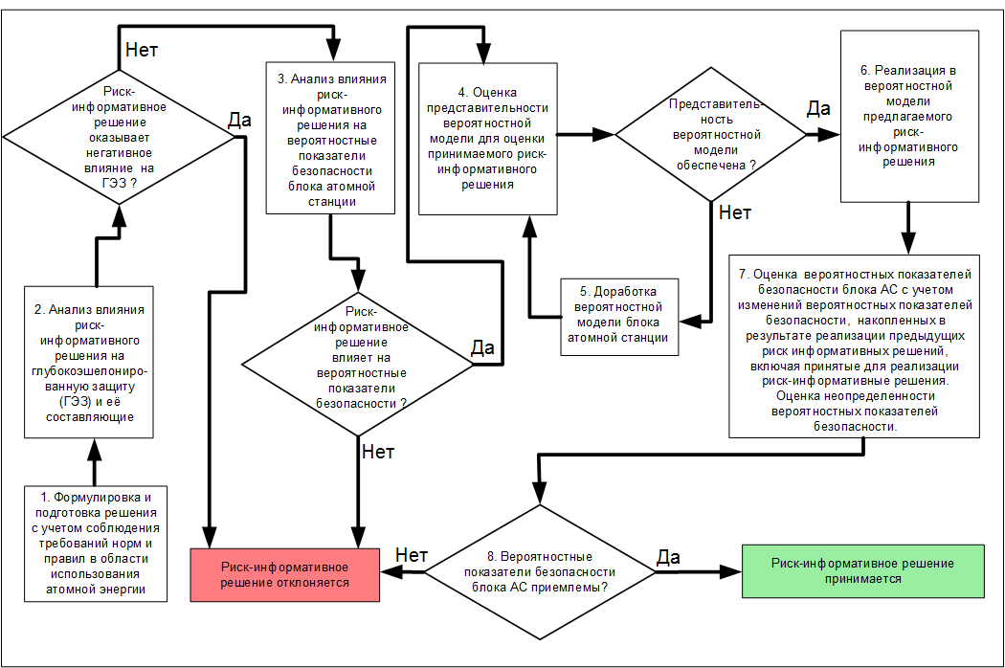
Is the representativity of the probabilistic model provided?
Does the risk-informed decision impact the probabilistic safety indices?
Are the probabilistic safety indices acceptable?
Does the risk-informed decision negatively impact DiD?
6. Implementation of the proposed risk-informed decision in the probabilistic model
3. Analysis of impact of risk-informed decision on the probabilistic safety indices of the NPP unit
4. Assessment of the representativity of the probabilistic model for assessment of the accepted risk-informed decision
2. Analysis of the impact of risk-informed decision on defence in depth (DiD) and its components
5. Follow-on revision of the probabilisti model of the NPP unit
7. Assessment of the probabilistic safety indices of the NPP unit considering the changes of probabilistic safety indices, accumulated following implementation of the previous risk-informed decisions, including accepted for implementation of the risk-informed decision. Evaluation of the interdeterminacy of probabilistic safety indices.
No
Yes
Yes
Yes
Yes
No
No
- Formulation and preparation of decisions considering the compliance with the rules and regulations requirements in the field of atomic energy use.
Risk-informed decision is rejected
Risk-informed decision is accepted
No

Appendix No. 6
to the safety guide in the use of atomic energy "Recommendations on the risk-informed approach application in justification of risk-informed decisions associated with a NPP Unit safety" approved by Order of the Federal Environmental, Industrial and Nuclear Supervision Service No. 458
dated November 2, 2016 .

PROBABILISTIC CRITERIA

Diagram No. 1 (assessment of risk acceptance of the NPP unit based on cumulative probability of severe accidents for each NPP unit over a year)

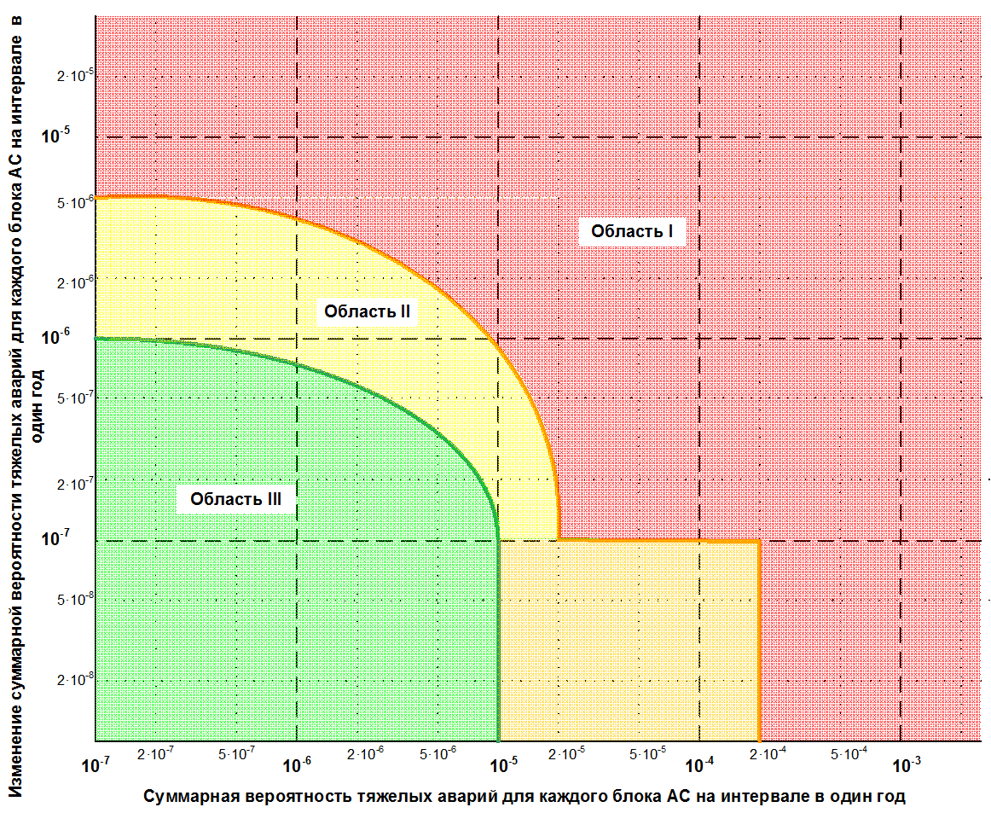
Change of the cumulative probability of severe accidents for each NPP unit over a year
Cumulative probability of severe accidents for each NPP unit over a year
Region I
Region II
Region III

The numerical values of the boundary between the regions presented in the diagram No 1 of this Appendix have been presented below for assessment of risk acceptance of the NPP unit based on cumulative probability of severe accidents.

NUMERICAL VALUES OF THE BOUNDARIES OF REGIONS IN DIAGRAM No. 1

Cumulative probability of severe accidents for each NPP unit over a year | Change of the cumulative probability of severe accidents for each NPP unit over a year
 | Boundary between the regions I and II | Boundary between the regions II and III
1·10⁻⁷ | 5·10⁻⁶ | 1·10⁻⁶
2·10⁻⁷ | 5·10⁻⁶ | 9.5·10⁻⁷
5·10⁻⁷ | 9·10⁻⁶ | 9·10⁻⁷
1·10⁻⁶ | 4·10⁻⁶ | 7·10⁻⁷
2·10⁻⁶ | 5.5·10⁻⁶ | 5.5·10⁻⁷
5·10⁻⁶ | 1.5·10⁻⁶ | 3·10⁻⁷
1·10⁻⁵ | 9·10⁻⁷ | 1·10⁻⁷
2·10⁻⁵ | 1·10⁻⁷ | -
1·10⁻⁴ | 1·10⁻⁷ | -
2·10⁻⁴ | 1·10⁻⁷ | -
> 2·10⁻⁴ | - | -

Diagram No. 2 (assessment of risk acceptance of the NPP unit based on cumulative probability of a large-scale emergency release for each NPP unit over a year)
Change of the cumulative probability of a large-scale emergency release for each NPP power unit over a year
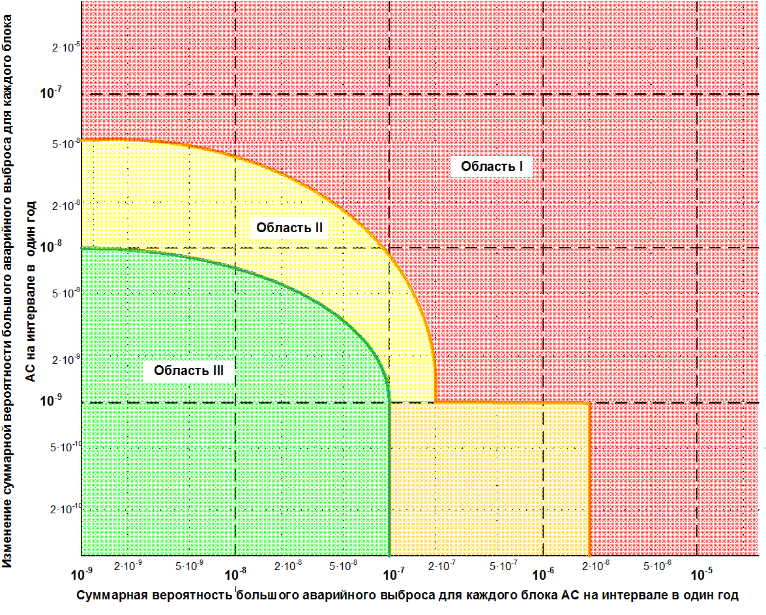
Region I
Region II
Region III
Cumulative probability of a large-scale emergency release for each NPP power unit over a year

The numerical values of the boundary between the regions presented in the diagram N 2 of the Appendix have been presented for assessment of risk acceptance of the NPP unit based on cumulative probability of large-scale emergency release.

NUMERICAL VALUES OF THE BOUNDARIES OF REGIONS IN DIAGRAM N 2

Cumulative probability of a large-scale emergency release for each NPP power unit over a year | Change of the cumulative probability of a large-scale emergency release for each NPP power unit over a year
 | Boundary between the regions I and II | Boundary between the regions II and III
1·10⁻⁹ | 5·10⁻⁸ | 1·10⁻⁸
2·10⁻⁹ | 5·10⁻⁸ | 9.5·10⁻⁹
5·10⁻⁹ | 9·10⁻⁸ | 9·10⁻⁹
1·10⁻⁸ | 4·10⁻⁸ | 7·10⁻⁹
2·10⁻⁸ | 5.5·10⁻⁸ | 5.5·10⁻⁹
5·10⁻⁸ | 1.5·10⁻⁸ | 3·10⁻⁹
1·10⁻⁷ | 9·10⁻⁹ | 1·10⁻⁹
2·10⁻⁷ | 1·10⁻⁹ | -
1·10⁻⁶ | 1·10⁻⁹ | -
2·10⁻⁶ | 1·10⁻⁹ | -
> 2·10⁻⁶ | - | -

