**FEDERAL ENVIRONMENTAL,**

**INDUSTRIAL AND NUCLEAR SUPERVISION SERVICE (ROSTECHNADZOR)**

**ORDER**

|  |  |  |  |
| --- | --- | --- | --- |
| *July, 24, 2015* |  | No. | *288* |

Moscow

**On approval of the safety guide in the use of atomic energy "Recommendations on the Structure and Content of the Guidelines for Management of Beyond Design Basis Accidents Including Severe Accidents"**

For the purposes of exercising the powers as established by sub-par. 5.3.11 of the Provision on the Federal Environmental, Industrial and Nuclear Supervision Service approved by Resolution of the Government of the Russian Federation No. 401 dated July, 30, 2004, I hereby order:

To approve the attached safety guide in the use of atomic energy "Recommendations on the Structure and Content of the Guidelines for Management of Beyond Design Basis Accidents Including Severe Accidents".

|  |  |  |
| --- | --- | --- |
| Director | */Signature/* | А.V. Alyoshin |

|  |  |
| --- | --- |
| **FBI STC NRS** | |
| **Reg. No.** | *31* |
| **Date** | *28.07.2015* |
| **Number of  sheets** | *1+53* |

FEDERAL ENVIRONMENTAL,   
INDUSTRIAL AND NUCLEAR SUPERVISION SERVICE

APPROVED   
by Order of the Federal Environmental, Industrial and Nuclear Supervision Service No. 288 dated July, 24, 2015

**SAFETY GUIDE IN THE USE OF ATOMIC ENERGY "RECOMMENDATIONS ON THE STRUCTURE AND CONTENT OF THE GUIDELINES FOR MANAGEMENT OF BEYOND DESIGN BASIS ACCIDENTS INCLUDING SEVERE ACCIDENTS" (RB-102-15)**

Effective since July, 24, 2015

**Moscow, 2015**

**SAFETY GUIDE IN THE USE OF ATOMIC ENERGY "RECOMMENDATIONS ON THE STRUCTURE AND CONTENT OF THE GUIDELINES FOR MANAGEMENT OF BEYOND DESIGN BASIS ACCIDENTS INCLUDING SEVERE ACCIDENTS" (RB-102-15)**

**Federal Environmental, Industrial and Nuclear Supervision Service**

**Moscow, 2015**

This safety guide in the use of atomic energy has been developed in accordance with Article 6 of Federal Law No. 170-FZ dated November, 21, 1995 "On atomic energy use" in order to facilitate compliance with the requirements of the federal rules and regulations in the area of atomic energy use: par. 1.2.3, 1.2.16, 4.2.4, 5.1.4, 5.5.6 of the General Provisions for Nuclear Power Plant Safety Assurance (OPB-88/97) approved by Resolutions of the Russian Federal Nuclear and Radiation Safety Supervision Authority (Gosatomnadzor) No. 9 dated November, 14, 1997; par. 4.10 of the Nuclear Safety Rules for Reactor Facilities of Nuclear Power Plants (NP-082-07) approved by Resolution of the Federal Environmental, Industrial and Nuclear Supervision Service No. 4 dated December, 10, 2007.

This Safety Guide contains the recommendations of the Federal Environmental, Industrial and Nuclear Supervision Service on the structure and contents of the guidelines for management of beyond design basis accidents (including severe accidents) at nuclear power plants.

This Safety Guide is intended for the specialists of operating organizations and design organizations developing the beyond design basis accident management guidelines.

Published for the first time[1]

**I. General provisions**

1.1. This safety guide in the use of atomic energy "Recommendations on the Structure and Content of the Guidelines for Management of Beyond Design Basis Accidents Including Severe Accidents" (RB-102-15) (hereinafter - the Safety Guide) has been developed in accordance with Article 6 of Federal Law No. 170-FZ dated November, 21, 1995 "On atomic energy use" in order to facilitate compliance with the requirements of the federal rules and regulations in the area of atomic energy use: sub-par. 1.2.3, 1.2.16, 4.2.4, 5.1.4, 5.5.6 of the General Provisions for Nuclear Power Plant Safety Assurance (OPB-88/97) approved by Resolutions of the Russian Federal Nuclear and Radiation Safety Supervision Authority (Gosatomnadzor) No. 9 dated November, 14, 1997; par. 4.10 of the Nuclear Safety Rules for Reactor Facilities of Nuclear Power Plants (NP-082-07) approved by Resolution of the Federal Environmental, Industrial and Nuclear Supervision Service No. 4 dated December, 10, 2007.

1.2. This Safety Guide contains the recommendations of the Federal Environmental, Industrial and Nuclear Supervision Service on the structure and contents of the guidelines for management of beyond design basis accidents (including severe accidents) (hereinafter - the beyond design basis accident management guidelines) at nuclear power plants.

1.3. The requirements of the Federal Rules and Regulations in the area of atomic energy use for the structure and content of beyond design basis accident management guidelines may be implemented through the use of any other techniques (methods) different from the ones specified in this Safety Guide subject to substantiation of the selected techniques (methods) for safety assurance.

1.4. This Safety Guide is intended for the specialists of operating organizations and design organizations developing the beyond design basis accident management guidelines.

1.5. The designations and abbreviations used are given in Appendix 1, terms and definitions - in Appendix 2 to this Safety Guide.

**II. General recommendations for the content of the beyond design basis accident management guidelines**

2.1. Actions of the NPP personnel for BDBA management prescribed in the BDBA management guidelines are aimed to achieve the following main objectives:

- to stop the chain fission reaction in the reactor and to maintain the reactor in the sub-critical state;

- to ensure nuclear fuel cooling (to prevent the BDBA escalation to the severe stage or to terminate further development of severe nuclear fuel damage in case it has already begun);

- to ensure sub-criticality and cooling of the nuclear fuel in the spent fuel pools and other spent nuclear fuel storage facilities;

- to confine radioactive substances within the boundaries established in the NPP design and to minimize RS releases into the environment;

- to ensure the safe, stable and controlled state of the NPP.

General information on the BDBA management peculiarities is provided in Appendix 3 to this Safety Guide.

2.2. The BDBA management guidelines include the instructions on the NPP state diagnostics, selection and implementation of the beyond design basis accident management strategy aimed to achieve the BDBA management objectives structured in the form of manuals, procedures and reference appendices.

2.3. Beyond design basis accident management guidelines shall be developed for all NPP power units regardless of the severe accident probability and probability of a large-scale emergency release.

2.4. The BDBA management guidelines shall cover the entire range of beyond design basis accidents (including severe accidents) presented in the NPP SAR.

2.5. All refurbishment and retrofitting works carried out at the NPP power unit as well as the available experience in elimination of operational occurrences and accident management shall be taken into account for development of the BDBA management guidelines.

2.6. The personnel's actions prescribed in the BDBA management guidelines shall be based on the attributes of the events and states of the reactor facility and the entire NPP, as well as on prediction of the conditions expected in the course of accident development.

2.7. Determination of the state attributes for the reactor facility and the entire NPP within the framework of the BDBA management guidelines should be correlated to the values of the parameters measured at the NPP (NPP power unit) as far as possible. In the absence of any possibility for direct measurement of the required parameters auxiliary evaluation tools (see Section 6.1 of this Safety Guide) may be used for fast assessment of the required parameter value.

2.8. All potential operational states of the NPP power unit prescribed in the process regulations for safe operation including the power operation modes of the NPP unit, shutdown states for refueling and scheduled preventive maintenance shall be considered as the initial states in development of the BDBA management guidelines, with due regard for availability of the systems and equipment typical for each operational state of the NPP power unit.

2.9. In development of the BDBA management guidelines for the initial NPP power unit states with the reactor shut down the following shall be taken into account:

- detection and diagnostics of any NPP operational occurrences may be difficult, as some automatic protections and signals can be disabled;

- the probability of human errors increases due to increased number of the personnel's actions performed remotely or locally;

- the amount of equipment available for accident management and the number of measuring instruments decreases as some of them can be inoperable;

- the actions in the states with the reactor shut down are less frequently performed by the personnel and thus they are less familiar that can also result in the increased number of errors.

2.10. All locations of nuclear materials, radioactive substances and radioactive wastes at the NPP that can be associated with occurrence of a beyond design basis accident shall be considered in development of the BDBA management guidelines:

- the reactor;

- the spent fuel pool;

- the spent nuclear fuel storage facility at the NPP site (if any);

- other NM locations (the fresh fuel facility, in-plant transporting packaging sets);

- RW storage facilities.

2.11. Potential occurrence of the NPP power unit conditions capable of perplexing any beyond design basis accident management (particularly for severe accidents) shall be taken into account in development of the BDBA management guidelines (for example, long-term loss of power supply, loss of the controls, fires, rubbles, flooding, smoke contamination, ionizing radiation, loss of connections with the external infrastructure).

2.12. The hardware of the adjacent NPP power units (availability of the power and water sources, equipment) that may be used at the accident-affected NPP power unit without any deterioration in the state of the adjacent power units shall be taken into account in development of the BDBA management guidelines for any power unit of a multi-unit NPP.

2.13. In development of the BDBA management guidelines it shall be taken into account that usage of the available equipment and engagement of the NPP personnel can be complicated by simultaneous occurrence of a beyond design basis accident (particularly a severe one) at several NPP power units within the same site.

2.14. The selected method for presentation of the BDBA management instructions shall ensure:

- structuring of the NPP personnel's actions within the framework of the BDBA management guidelines;

- prevention of omission of any instructions (important information) to be considered by the personnel in the course of accident management;

- the transition logic within a single instruction and between various instructions of the BDBA management guidelines easy for the NPP personnel's perception;

- absence of any text inserts (for example, comments) complicating perception of the instructions contained in the guidelines;

- correct perception of the text information (wording of the instructions and provisions of the management rules shall not admit any ambiguous interpretation; it is recommended to use an easy-to-read font);

- simple search of the required information through the use of the references provided in the guidelines.

2.15. The arrangements aimed to reduce the probability of human errors in performance of the skill-based actions and rule-based actions shall be provided in the BDBA management guidelines. These arrangements include:

- inclusion of the instructions on the need to check the performed actions (self-control and checks by any other person from among the NPP personnel) into the text of the BDBA management guidelines;

- inclusion of special warnings in cases with the increased probability of the personnel's erroneous actions (for example, when the required sequence of actions is different from the similar sequence of actions performed by the personnel more frequently or more familiar for the personnel) into the text of the BDBA management guidelines.

The probability of human errors in the course of accident management (errors in performance of knowledge-based actions) shall be also analyzed in development of the BDBA management guidelines. The arrangements aimed to reduce the probability of human errors include:

- performance of more comprehensive design analyses of accidents (including severe ones) as far as possible and development of the representative technical substantiation of the BDBA management guidelines;

- in-depth theoretical education of the personnel with regard to phenomenology of severe accidents;

- analysis (particularly subsequent to the results of the personnel's training) of the possibilities for wrong diagnostics of the NPP state by the personnel and making of a wrong decision on accident management with subsequent introduction of the warnings and recommendations for the personnel into the BDBA management guidelines in order to reduce the probability of a wrong decision.

The information on the types of human errors and their brief characteristics are given in Appendix 4 to this Safety Guide.

**III. Structure of the beyond design basis accident management guidelines**

3.1. The BDBA management guidelines shall include the following sections:

- general provisions;

- the operating section containing the basic guidelines consisting of the diagnostic instructions and instructions on implementation of the beyond design basis accident management strategies as well as the instructions on performance of the individual beyond design basis accident management tasks (instructions on restoration/ maintenance of safety functions);

- the reference appendix containing the auxiliary evaluation tools, the substantiation calculations for the BDBA management guidelines, the technical substantiation of the BDBA management guidelines and phenomenology description for severe accidents.

3.2. The BDBA management guidelines may be provided in the form of a single document or a package of documents representing their individual parts.

3.3. The general algorithm for the personnel's actions in accordance with the BDBA management guidelines is presented in Appendix 5 to this Safety Guide. The approximate content of the BDBA management guidelines (through the example of a NPP power unit with the reactor of VVER type) is given in Appendix 6 to this Safety Guide.

**IV. Structure and content of the section "General provisions" of the beyond design basis accident management guidelines**

The section "General provisions" of the BDBA management guidelines shall include the following sub-sections:

- purpose and application scope of the BDBA management guidelines. Structure of the BDBA management guidelines;

- organizational structure of beyond design basis accident management;

- the general procedure for commencement of application of the BDBA management guidelines, transition from one instruction of the BDBA management guidelines to another, including the conditions for proceeding to the BDBA management at the severe accident stage, termination of the activities in accordance with the BDBA management guidelines;

- the procedure for performance of any actions not prescribed in the BDBA management guidelines, the procedure and conditions for the NPP personnel's intervention into operation of the automatic devices;

- relation of the BDBA management guidelines to the operation documentation effective at the NPP;

- the recommendations on the personnel's proficiency maintenance in the area of beyond design basis accident management.

**4.1. Purpose and application scope of the beyond design basis accident management guidelines. Structure of the beyond design basis accident management guidelines**

4.1.1. The purpose of the BDBA management guidelines as the document defining the personnel's actions for management of beyond design basis accidents shall be described.

4.1.2. The application scope of the BDBA management guidelines shall be described. It should be demonstrated that all operational states of the NPP are taken into account in the BDBA management guidelines (the corresponding operational states shall be listed) as well as all NM, RS and RW locations at the NPP (the corresponding locations shall be listed). The classes of beyond design basis accidents covered by the BDBA management guidelines shall be specified.

4.1.3. The structure of the BDBA management guidelines shall be described.

**4.2. Organizational structure of beyond design basis accident management**

4.2.1. The organizational structure of beyond design basis accident management shall be described; it is reasonable to base this structure on the existing structure established at the NPP for elimination of operational occurrences and design basis accidents subject to any supplements in case of necessity with due regard for the BDBA peculiarities (including the severe stage). These peculiarities of BDBA management may include establishment of the special-purpose technical group consisting of the main NPP specialists (for example, deputy chief engineers of the NPP, heads and deputy heads of the main NPP structural units). The objective of this group is to develop the proposals on accident management for the emergency response supervisor based on the instructions and the reference section of the BDBA management guidelines.

The special-purpose assistance group (the NPPEA group) and industry-specific technical support centers may be also engaged in development of the BDBA management proposals. The emergency response supervisor shall make the decisions with regard to accident management.

4.2.2. The liabilities and responsibility of the personnel engaged in management of beyond design basis accidents at all levels of the accident management organizational structure shall be described. In description of responsibility it is recommended to distinguish the responsibility for decision making and the responsibility for correct performance of the actions within the framework of the decision made.

**4.3. The general procedure for commencement of application of the BDBA management guidelines, transition from one instruction of the BDBA management guidelines to another, including the conditions for proceeding to the BDBA management at the severe accident stage, termination of the activities in accordance with the BDBA management guidelines**

4.3.1. The general procedure for decision making by the NPP personnel with regard to commencement of application of the BDBA management guidelines as well as termination of the activities in accordance with the BDBA management guidelines shall be described.

4.3.2. The conditions for transition from one instruction of the BDBA management guidelines to another shall be described. The conditions when the BDBA management activities at the severe core damage prevention stage shall be stopped, and the personnel shall proceed to the BDBA management activities at the severe core damage stage shall be described separately.

**4.4. Procedure for performance of any actions not prescribed in the beyond design basis accident management guidelines Procedure and conditions for the nuclear power plant personnel intervention to operation of the automatic devices**

4.4.1. It shall be specified that the emergency response supervisor may make the decision on impossibility to achieve the BDBA management objectives in accordance with the instructions of the BDBA management guidelines. Making of such decision is the last resort in the course of beyond design basis accident management, it shall be based on the NPP power unit state analysis with due regard for the available knowledge on the phenomenology and time characteristics of the accident processes and accompanied with substantiation of impossibility to achieve the BDBA management objectives in accordance with the instructions of the BDBA management guidelines.

In case the above-mentioned decision is made any equipment or techniques for accident management not specified in the BDBA management guidelines shall be used in accordance with the instructions of the emergency response supervisor.

4.4.2. The procedure and conditions for the NPP personnel intervention to operation of the automatic devices shall be specified. It is recommended to provide the possibility for intervention into operation of automatic devices in the following cases:

- obvious malfunctions of the automatic devices;

- in case such intervention is required in accordance with the BDBA management guidelines;

- in case the emergency response supervisor makes the decision on impossibility to achieve the BDBA objectives in accordance with the instructions of the BDBA management guidelines.

**4.5. Relation of the beyond design basis accident management guidelines to the operation documentation effective at the nuclear power plant**

4.5.1. The documents (the process regulations for the NPP power unit operation, the emergency operating procedures, the operation manuals for the systems) containing the actions that are to be completely or partially stopped upon commencement of application of the BDBA management guidelines shall be specified.

4.5.2. The documents containing the actions the NPP personnel shall proceed to upon termination of the activities in accordance with the BDBA management guidelines shall be specified.

**4.6. Recommendations on the personnel's proficiency maintenance in the area of beyond design basis accident management**

Recommendations on the personnel training and proficiency maintenance in the area of beyond design basis accident management (particularly with regard to the scope of theoretical education, frequency and topics of the training through the use of full-scale and other simulators, frequency and topics of emergency response drills) shall be provided.

**V. Structure and content of the operating section of the beyond design basis accident management guidelines**

The operating section of the BDBA management guidelines consists of:

- the basic guidelines;

- the instructions on performance of the individual beyond design basis accident management tasks at the severe core damage prevention and severe core damage stages (the individual tasks may include restoration of safety functions, beyond-design use of the equipment, etc.).

**5.1. The basic guidelines**

The basic guidelines shall contain the instructions on the NPP personnel's actions within the framework of the BDBA management guidelines. In this case the following data shall be specified:

- the conditions when the personnel shall make the decision on commencement of application of the BDBA management guidelines;

- immediate actions to be performed upon commencement of application of the BDBA management guidelines;

- the procedure for initial diagnostics of the NPP state in order to define the necessity for proceeding to the BDBA management actions at the severe accident stage or to the actions at the severe core damage prevention stage;

- the beyond design basis accident management strategy at the severe core damage prevention stage;

- the beyond design basis accident management strategy at the severe core damage stage;

- conditions for termination of the activities in accordance with the BDBA management guidelines.

**5.1.1. Conditions for commencement of application of the beyond design basis accident management guidelines**

It is recommended to determine the conditions for commencement of application of the BDBA management guidelines in such a way so that the personnel should proceed to the actions in accordance with the BDBA management guidelines in the following situations:

- in case of any operational occurrence for which no actions are prescribed in the process regulations for the NPP power unit operation, the operation guidelines for the reactor facility, the NPP systems and components as well as in the emergency response procedures;

- in case of failure to eliminate any accident through application of the emergency operating procedures;

- in case the personnel find any difficulties in identification of an operational occurrence or making a decision on the applicable instructions of the BDBA management guidelines.

**5.1.2. Immediate actions to be performed upon commencement of application of the beyond design basis accident management guidelines**

The procedure for performance of the immediate actions upon commencement of application of the BDBA management guidelines shall be presented. These actions include:

- the actions for the reactor facility bringing into the sub-critical state;

- termination (completion) of all nuclear hazardous works and any other works if their performance distracts the NPP personnel from the accident mitigation (management).

Where possible the nature of the impact which has caused the need to commence application of the BDBA management guidelines (explosion, fire, flooding, any other internal or external impact) shall be also identified; in case of necessity the works for emergency aid to the injured people, evacuation of the NPP personnel from the impact areas of damage effects shall be arranged.

**5.1.3. Initial diagnostics of the nuclear power plant state in order to define the necessity for proceeding to the beyond design basis accident management activities at the severe core damage prevention stage or at the severe core damage stage**

The procedure for initial diagnostics of the NPP state performed right after completion of the immediate actions shall be provided. The above-mentioned diagnostics is performed in order to define the necessity for proceeding to the BDBA management activities at the severe core damage prevention stage or at the severe accident stage.

It shall be specified that depending on the results of the initial NPP state diagnostics the NPP personnel shall proceed to determination of the beyond design basis accident management strategy at the severe core damage prevention stage or determination of the beyond design basis accident management strategy at the severe core damage stage.

**5.1.4. Beyond design basis accident management strategies at the severe core damage prevention stage**

5.1.4.1. The procedure for the NPP state diagnostics shall be established in this section for the NPP operator to determine the beyond design basis accident management strategy at the severe core damage prevention stage.

5.1.4.2. The NPP state diagnostics shall be carried out within the scope sufficient for the NPP personnel to select the beyond design basis accident management strategy from among the strategies presented in this section and substantiated in the Technical Substantiation for the BDBA management guidelines.

5.1.4.3. For the purposes of the NPP state diagnostics it is reasonable to define the set of safety functions enabling achievement of the BDBA management objectives specified in par. 2.1 of this Safety Guide.

The above-mentioned set of safety functions may include both safety functions directly related to achievement of these BDBA management objectives and the auxiliary safety functions indirectly supporting achievement of the BDBA management objectives (auxiliary safety functions include, in particular, maintenance of the normal conditions for functioning of the equipment and the personnel engaged in the BDBA management - auxiliary power supply of the NPP, fire protection, protection against flooding).

The approximate list of safety functions (through the example of a NPP reactor facility with the reactor of VVER type) is given in Appendix 7 to this Safety Guide.

5.1.4.4. For each safety function included into the set of safety functions compiled in accordance with par. 5.1.4.3 it is reasonable to specify the potential states with performance of this safety function.

Both the state of physical barriers and presence of any direct and potential threats for the integrity of these barriers (including the threats associated with inoperability of the systems intended to protect the physical barriers) shall be taken into account in order to determine the potential states with performance of any safety function.

Compliance with the following conditions shall be checked in order to determine the potential states with performance of any safety function:

- various states with performance of safety functions require the personnel's actions different in their content, or are characterized by significantly different time allowance for performance of the necessary personnel's actions (i.e. various states with performance of safety functions shall require implementation of different BDBA management strategies);

- criteria should be available for the personnel to distinguish one state from another.

5.1.4.5. The criteria (conditions) to be used by the NPP personnel in order to identify this state shall be specified for each state with performance of each safety function determined in accordance with par. 5.1.4.4. The measurable parameters available for the NPP personnel (such as pressure, temperature, levels, media flow rates, other measurable parameters) as well as the state of the NPP systems (for example, operable, partially operable, inoperable) or combinations thereof shall be used as the criteria (conditions) for the NPP personnel to identify the defined states with performance of safety functions. The information on the preceding accident development available for the NPP personnel may be also used in compilation of the criteria (conditions).

The criteria (conditions) may be presented in the form of the table containing the NPP state attributes available for the NPP personnel and requiring implementation of this or that instruction for maintenance (restoration) of safety functions.

Adequacy of the list of parameters measured at the NPP power unit as well as adequacy of the instruments and their measurement ranges for diagnostics of the NPP state (monitoring of the state with performance of safety functions) shall be evaluated in development of the BDBA management guidelines.

The example of determination of the criteria (conditions) for diagnostics of the state for the safety function "Heat removal from the core" is given in Appendix 8 to this Safety Guide.

5.1.4.6. The actions for restoration (maintenance) of safety functions shall be performed in accordance with the SF restoration instructions.

The relevant instruction for restoration (maintenance) of this safety functions shall be specified for each state with performance of safety functions identified in accordance with par. 5.1.4.5.

5.1.4.7. Depending on the NPP state diagnostics results the possibility for simultaneous restoration (maintenance) of safety functions shall be determined. As a rule, simultaneous restoration (maintenance) of all safety functions is prescribed.

However, the necessity to establish the priorities in the SS restoration (maintenance) sequence may be detected according to the results of the analysis performed during development of the BDBA management guidelines and reflected in the Technical Substantiation of the BDBA management guidelines. The priorities in the SS restoration (maintenance) sequence shall be established in the following cases:

- impossibility to restore certain safety functions before restoration of other safety functions (for example, in case of auxiliary NPP power supply loss a wide range of opportunities for restoration of safety functions becomes unavailable, and thus the priority may be assigned to the actions for restoration of power supply);

- the existing direct risks for integrity of particular physical barriers require the highest priority for restoration of safety functions aimed to combat these threats;

- the time period available for the NPP personnel to perform the actions aimed to prevent considerable deterioration of the accident development is significantly shorter than the time period available for performance of any other actions aimed to restore (maintain) the safety functions requiring participation of the same persons from among the personnel (in this case the priority shall be assigned to the actions with less time for their performance by the personnel).

The procedure for determination of priority in restoration (maintenance) of safety functions shall be specified with due regard for the above-mentioned circumstances.

5.1.4.8. In parallel with performance of the actions within the framework of the selected instruction (instructions) for restoration (maintenance) of safety functions continuous monitoring of the NPP state (including the diagnostics of the state with performance of all safety functions) shall be provided. If the NPP state monitoring shows any changes thereof requiring any BDBA management strategy different from the one currently implemented the decision shall be made on commencement of the actions for restoration (maintenance) of safety functions in accordance with the new selected BDBA management strategy; in this case the actions performed in accordance with the previous BDBA management strategy may be suspended.

5.1.4.9. It shall be specified that the decision on termination of the BDBA management activities at the severe core damage prevention stage shall be made upon proceeding to the BDBA management at the severe core damage stage, or upon achievement of the conditions for termination of these activities in accordance with the BDBA management guidelines.

5.1.4.10. Decisions on modification of the BDBA management strategy as well as on termination of the management activities at the severe core damage prevention stage shall be made by the person responsible for these aspects in accordance with the sub-section "Organizational structure of beyond design basis accident management" of the section "General provisions" of the BDBA management guidelines.

**5.1.5. Beyond design basis accident management strategies at the severe core damage stage**

5.1.5.1. Beyond design basis accident management strategies at the severe core damage stage shall be presented in this section. All physical (physical and chemical) processes posing direct threats for the physical barriers (first of all, the reactor facility containment) and requiring urgent actions for mitigation of the threats, as well as any physical (physical and chemical) processes requiring the control actions aimed to protect the physical barriers but not requiring any urgent measures (potential threats) shall be identified in development of the BDBA management guidelines for the NPP personnel to define the necessary beyond design basis accident management strategy at this stage.

The list of possible physical (physical and chemical) processes and phenomena in the course of a severe accident development (through the example of a NPP with the reactor of VVER type) is provided in Appendix 9 to this Safety Guide.

Examples of possible beyond design basis accident management strategies at the severe core damage stage for a NPP reactor facility with the reactor of VVER type are given in Appendix 10 to this Safety Guide.

5.1.5.2. The beyond design basis accident management strategy at the severe core damage stage shall be selected based on the results of the NPP state diagnostics with due regard for the following:

- the information on the state of physical barriers in the paths of RS propagation into the environment available for the NPP personnel;

- assessment of the processes and phenomena posing a direct threat for the operable physical barriers and requiring urgent actions;

- assessment of other processes and phenomena posing a potential threat for the operable physical barriers;

- any available operable equipment that may be used for protection of the physical barriers;

- assessment of radiation exposure for the personnel, the public and the environment.

5.1.5.3. Periodic control of the NPP state characterized by the above-mentioned aspects shall be provided in the course of BDBA management at the severe core damage stage; the decision on further implementation of the selected beyond design basis accident management strategy or the need to implement a new beyond design basis accident management strategy shall be made according to the results of such control.

The decision on modification of the beyond design basis accident management strategy shall be made by the person responsible for these aspects in accordance with the sub-section "Organizational structure of beyond design basis accident management" of the section "General provisions" of the BDBA management guidelines.

5.1.5.4. Selection of the beyond design basis accident management strategy at the severe core damage stage is usually carried out under the conditions of low familiarization with the phenomenology of such accident development at both in-vessel and ex-vessel stages; efficiency of the beyond design basis accident management strategy at the severe core damage stage cannot always be substantiated in advance with sufficient accuracy.

It is recommended to provide analysis of any potential positive and negative consequences of implementation of various beyond design basis accident management strategies at the severe core damage stage in the BDBA management guidelines for the severe core damage stage. It is recommended to specify that the decision on implementation of a certain beyond design basis accident management strategy at the severe core damage stage shall be made with due regard for any positive and negative consequences of its implementation under the particular severe accident development conditions.

5.1.5.5. In the absence of comprehensive substantiation calculations for efficiency of beyond design basis accident management strategies at the severe core damage stage the operating section of the BDBA management guidelines for this stage shall be presented in the form of instructions where the actions are not prescribed but recommended with indication of the need to consider any potential negative consequences under the particular severe accident development conditions.

5.1.5.6. It is permitted to include references to the instructions on performance of individual BDBA management tasks with the prescribed sequence of actions into the operating section for the severe core damage stage subject to availability of the representative substantiation calculations for the actions prescribed by the instructions, and provided that the NPP state monitoring is carried out in parallel with performance of the actions in accordance with these instructions (the factors specified in par. 5.1.5.2 are evaluated), and the decision on termination of any actions according to the above-mentioned instructions and proceeding to other accident management actions may be made on the basis of such monitoring results.

5.1.5.7. It is recommended to avoid instructions (recommendations) on transitions from the instructions of the BDBA management guidelines for the severe core damage stage to the instructions of the BDBA management guidelines for the severe core damage prevention stage in the structure of the BDBA management guidelines.

**5.1.6. Conditions for termination of the activities in accordance with the beyond design basis accident management guidelines**

It is recommended to provide for termination of the activities in accordance with the BDBA management guidelines (departure from the BDBA management guidelines) upon restoration of the controlled and stable state of the NPP power unit, in the absence of any risks of deviation from this state, including any threats associated with depletion of water or fuel stocks, or other cliff edge effects.

**5.2. Instructions for performance of individual beyond design basis accident management tasks**

5.2.1. Instructions for performance of individual beyond design basis accident management tasks may represent instructions for restoration (maintenance) of safety functions, instructions on beyond-design use of the NPP systems and components or instructions on any other tasks related to BDBA management.

5.2.2. All equipment available at the NPP that may be used to achieve the objective of the instruction performance shall be specified in the instruction for performance of individual BDBA management tasks. It shall be specified what equipment available at the NPP power unit is more efficient and reliable.

5.2.3. It is recommended to present alternative sequences of actions to be implemented in cases when implementation of the main sequence of actions is impossible (for example, because of equipment failures) in the instructions for performance of individual BDBA management tasks together with the main sequence of actions aimed to restore (maintain) the safety functions. Recommendations for the NPP personnel to make the choice between the main and alternative sequence of actions shall be specified in the basic guidelines.

5.2.4. The instruction for performance of individual BDBA management tasks shall specify the conditions for termination of the activities in accordance with this instruction and return to the basic guidelines.

**VI. Content of the reference appendices to the beyond design basis accident management guidelines**

The following shall be included as reference appendices to the BDBA management guidelines:

- auxiliary evaluation tools;

- technical substantiation of the BDBA management guidelines;

- description of the severe accident phenomenology.

**6.1. Auxiliary evaluation tools**

The NPP state diagnostics under the BDBA conditions may require comparison of several measurements, and in certain cases - performance of additional calculations. In order to simplify the NPP state diagnostics it is recommended to determine the parameters necessary for comparison in advance, to carry out evaluations, variant calculations and to provide supporting materials for the BDBA management guidelines containing the results of preliminary assessments and calculations (for example, in the form of curves, nomographic charts, tables). Examples of auxiliary evaluation tools are given in Appendix 11 to this Safety Guide.

**6.2. Technical substantiation of the beyond design basis accident management guidelines**

6.2.1. The technical substantiation of the BDBA management guidelines shall contain confirmation of the correct selection of beyond design basis accident management strategies with due regard for performed thermal, hydraulic and any other calculations, description of the applied hardware and instruments necessary for the NPP state diagnostics, substantiation of the selected criteria for commencement of certain actions prescribed in the instructions of the BDBA management guidelines, the typical time intervals between occurrence of safety-significant events in the course of accident process development defined on the basis of the calculation results, confirmation of sufficiency of the time allowance for implementation of the BDBA management strategies prescribed in the BDBA management guidelines, results of the analysis with regard to positive and negative consequences of the performed accident management actions at the severe core damage stage.

6.2.2. It shall be substantiated that the BDBA management guidelines provide the required coverage of beyond design basis accidents, particularly that the instructions of the BDBA management guidelines for selection and implementation of beyond design basis accident management strategies are sufficient for management of all beyond design basis accidents (including severe ones) specified in the BDBA list presented in the NPP safety analysis report. Besides, applicability of the above-mentioned instructions to all NPP states different in the degree of damage for the physical barriers in the paths of RS and (or) ionizing radiation propagation into the environment as well as in operability or inoperability of the safety systems and special-purpose BDBA management hardware shall be also demonstrated. For this purpose, the list of postulated NPP states shall be compiled in the technical substantiation; each of these states represents the combination of damage degrees for different physical barriers as well as operability or inoperability states of the safety systems and special-purpose BDBA management hardware.

6.2.3. Substantiation of the recommended scope of drilling of any actions associated with BDBA management by the NPP personnel shall be provided (the scope of theoretical education, exercises on the full-scale simulator, emergency response drills with the list of scenarios subject to drilling and indication of the optimum frequency for each scenario drilling necessary to maintain the required skills). In substantiation of the recommended scope of drilling for the actions special attention shall be paid to the personnel's preparedness for the BDBA management activities in case of incomplete information on the NPP state.

6.2.4. The arrangements implemented in development of the BDBA management guidelines and aimed to reduce the probability of human errors (separately for skill-based actions, rule-based actions and knowledge-based actions) shall be described, and their adequacy shall be substantiated.

6.2.5. The package of design BDBA analyses substantiating efficiency of beyond design basis accident management strategies and reflected in the instructions of the BDBA management guidelines shall be provided. Any beyond design basis accident management strategy shall be deemed efficient if its implementation results in restoration of safety functions (bringing of the NPP into the stable and controllable state) or considerable mitigation of the accident consequences.

6.2.6. The design analysis aimed to substantiate efficiency of the selected BDBA management strategies shall be performed for all actions of the personnel prescribed in the instructions of the BDBA management guidelines - both basic and alternative actions (prescribed in case of the basic action failures) shall be taken into account.

6.2.7. Not only efficiency of the certain sequence of actions prescribed in the selected beyond design basis accident management strategy but also the conditions for application of the guidelines, the conditions defined in the instructions for commencement of certain actions, the conditions for proceeding to other steps and instructions, particularly the conditions for proceeding to BDBA management at the severe stage shall be substantiated.

6.2.8. In order to substantiate efficiency of the selected beyond design basis accident management strategies it shall be taken into account that the NPP personnel need some time to perform any actions prescribed in the instructions of the BDBA management guidelines as well as to prepare for use of the required equipment.

6.2.9. The realistic (non-conservative) approach shall be applied for design analyses of beyond design basis accidents performed to substantiate the BDBA management guidelines (the reality requirements shall be applied to both software tools and the initial and boundary conditions) to the extent possible with due regard for the state of the art in science and technology. Consequences of any necessary deviations from realistic modeling due to low familiarization with the modelled processes and phenomena shall be assessed in each particular case. Validated software tools shall be used for design analyses.

6.2.10. In the course of substantiation calculations it shall be taken into account that in case if certain accidents the processes with the risk of damage for the physical barriers can develop simultaneously at the reactor facility, in the reactor facility containment and the spent fuel pool. In this case the above-mentioned processes can affect each other. In these cases integral or conjugated software tools shall be used in order to take into account mutual influence of the processes developing in different locations at the NPP.

**6.3. Description of the severe accident phenomenology**

Detailed explanation of the accident development phenomenology shall be provided. In this case physical, physical and chemical and any other processes and phenomena typical for all severe accident development stages shall be considered. The available information of the time characteristics of the above-mentioned processes shall be also provided. References to the sources of information used shall be given.

The above-mentioned information shall be used in the NPP personnel training with regard to the accident management issues and also as reference materials that may be used in accident management. This section shall be updated upon acquiring of new knowledge.

APPENDIX 1   
to the Safety guide in the use of atomic energy "Recommendations on the Structure and Content of the Guidelines for Management of Beyond Design Basis Accidents Including Severe Accidents" RB-102-15 approved by Order of the Federal Environmental, Industrial and Nuclear Supervision Service No. 288   
dated July, 24, 2015

**Designations and abbreviations**

|  |  |
| --- | --- |
| NPP | - Nuclear Power Plant |
| EFWP | - Emergency Feedwater Pump |
| MCR | - Main Control Room |
| VVER | - Pressurized Water Reactor |
| AET | - Auxiliary Evaluation Tool |
| HA | - Hydraulic Accumulator |
| BDBA | - Beyond Design Basis Accident |
| PRZ PORV | - Pressurizer Pilot-Operated Relief Valve |
| SAR | - Safety Analysis Report |
| NPPEA | - Nuclear Power Plant Emergency Assistance |
| OSG | - Outdoor Switchgear |
| CDD | - Core Damage Degree |
| SG | - Steam Generator |
| ST | - Software Tool |
| RW | - Radioactive Wastes |
| RS | - Radioactive Substances |
| ECR | - Emergency Control Room |
| BDBA management guidelines | - Beyond Design Basis Accident Management Guidelines |
| ECCS | - Emergency Core Cooling System |
| HP ECCS | - High Pressure Emergency Core Cooling System |
| LP ECCS | - Low Pressure Emergency Core Cooling System |
| EPSS | - Emergency Power Supply System |
| CPS | - Reactor Control and Protection System |
| SF | - Safety Function |
| NM | - Nuclear Materials |

APPENDIX 2   
to the Safety guide in the use of atomic energy "Recommendations on the Structure and Content of the Guidelines for Management of Beyond Design Basis Accidents Including Severe Accidents" RB-102-15 approved by Order of the Federal Environmental, Industrial and Nuclear Supervision Service No. 288   
dated July, 24, 2015

**Terms and definitions**

The following terms are used for the purposes of this Safety Guide:

**Auxiliary evaluation tool** - pre-arranged calculation results in the form of curves, nomographic charts, tables, etc. that can be easily used for the accident management purposes.

**Instruction of the BDBA management guidelines** - the set of actions recommended by the BDBA management guidelines in order to implement the beyond design basis accident management strategy with the pre-determined conditions for commencement and termination of the actions and evaluated potential negative consequences, or the prescribed actions for performance of individual BDBA management tasks.

**Symptom-based approach to accident management** - the approach to management of beyond design basis accidents based on the symptoms - directly measured parameters of the reactor facility and the NPP, or the symptoms derived from the measurable parameters through simple calculations and evaluation.

**State with performance of a safety function** - the degree to which the NPP power unit achieves the state when the specific particular objective related to a safety function is implemented, and, besides, presence (or absence) of any potential possibility for deterioration of the above-mentioned state achievement degree, including the possibilities related to inoperability of the hardware necessary for the safety function performance.

**NPP state** - the complex of the state of physical barriers and also the state with performance of the basic safety functions.

**BDBA management strategy** - the action plan with the preset sequence of objectives and the methods for their implementation aimed to achieve the main BDBA management objectives.

**Severe accident** - a beyond design basis accident with damage of fuel elements exceeding the maximum design limit.

**Severity levels** - the set of postulated NPP states where each state is characterized by the degree of damage to the physical barriers in the paths of RS and/ or ionizing radiation propagation into the environment.

APPENDIX 3   
to the Safety guide in the use of atomic energy "Recommendations on the Structure and Content of the Guidelines for Management of Beyond Design Basis Accidents Including Severe Accidents" RB-102-15 approved by Order of the Federal Environmental, Industrial and Nuclear Supervision Service No. 288   
dated July, 24, 2015

**General information on the peculiarities of beyond design basis accident management**

Beyond design basis accidents differ from design basis accidents considered in the emergency operating procedures for design basis accidents to a large extent. These differences are related both to the development character of beyond design basis accidents and their severity and potential quantity.

Design basis accidents are characterized by the measurable number of initiating events; a potential single failure in the safety systems or a single human error in the course of actions prescribed in the relevant guidelines is considered in the analysis of design basis accidents. Occurrence and development of such accidents can be quite fully and reliably predicted through the use of the existing analysis methods; the operating personnel can monitor the accident development according to the equipment activation or failure to activate, occurrence of any failures in the systems and other similar events.

Initiating events not included into the list of initiating events for design basis accidents can be the causes of beyond design basis accidents. Besides, beyond design basis accidents can develop with unlimited number of failures thus considerably complicating their identification and accident development prediction. It is impossible to monitor and predict the development and consequences of beyond design basis accidents only through the use of the approaches adopted for design basis accidents. Under the BDBA conditions it is necessary to focus on the current NPP power unit state defining it according to the signs or symptoms characterizing the state of physical barriers in the paths of RS propagation into the environment, or the state with performance of safety functions as well as the state of the NPP systems and equipment required to perform safety functions. This approach is conventionally called the symptom-based approach.

Damage of fuel elements in case of a beyond design basis accident can exceed the maximum design limit (in this case beyond design basis accidents shall be classified as severe). Phenomenology of severe accidents has not been fully investigated yet, and this is one of the reasons (apart from immeasurable number of scenarios) for impossibility to predict BDBA development exactly. In this context the operating personnel of the NPP have to work under the conditions of significant uncertainty in case of any beyond design basis accident. All these aspects shall be taken into account in development of the BDBA management guidelines.

In spite of the great number of potential scenarios the representative BDBA list for planning of the emergency response activities, particularly for development of the BDBA management guidelines may be compiled through development of the closed scale of potential NPP states with different severity levels. The term "severity levels" means the set of postulated NPP states where each state is characterized by the degree of damage to the physical barriers in the paths of RS and/ or ionizing radiation propagation into the environment.

The final BDBA list to be covered by the BDBA management guidelines shall be specified in the NPP SAR.

The BDBA management actions shall be performed by well-trained operating personnel with the high level of engineering and physical knowledge. The BDBA management guidelines shall be focused on the knowledge-based work of the operating personnel. In this case the NPP personnel shall be trained in such a way so that to make decisions and perform the required actions referring to the information support documentation only in case of necessity. The work with performance of predicable and well-drilled actions may be carried out on the basis of the rules and practiced skills.

APPENDIX 4   
to the Safety guide in the use of atomic energy "Recommendations on the Structure and Content of the Guidelines for Management of Beyond Design Basis Accidents Including Severe Accidents" RB-102-15 approved by Order of the Federal Environmental, Industrial and Nuclear Supervision Service No. 288   
dated July, 24, 2015

**Types of human errors and their brief characteristics**

The personnel's actions are classified in the following way:

- skill-based actions;

- rule-based actions;

- knowledge-based actions.

Skill-based actions usually include routine operations often performed mechanically and exercised in the course of drills or daily activities. Manipulations of the operator with various controls may serve as an example of skill-based actions.

Rule-based actions include any operations performed in accordance with the provisions of any documents (guidelines, rules, regulations) establishing the requirements for performance of such operations. Performance of a step-by-step procedure described in the guidelines or program by the operator may serve as an example of rule-based actions.

Knowledge-based actions include any decisions made on the basis of the available knowledge on the situation around the personnel's activities, the ongoing processes and phenomena and their interrelation in the absence of any rules regulating the procedure for such decision making or in case of inapplicability (limited applicability) of the existing rules. The operator's actions aimed to find the technique for the cable routing from the mobile diesel generator in case of impossibility to lay these cables in the way prescribed by the guidelines (for example, due to inaccessibility of the routes because of a fire, collapses due to an earthquake and in other cases) may serve as an example of knowledge-based actions.

Each type of the personnel's actions (knowledge-based actions, rule-based actions and skill-based actions) is characterized by the probability of errors peculiar for this type of actions; brief characteristics thereof are given in the table below.

|  | **Errors in performance of skill-based actions** | **Errors in performance of rule-based actions** | **Errors in performance of knowledge-based actions** |
| --- | --- | --- | --- |
| **Type of activities** | Routine operations | Activities related to problem solving | |
| **Focusing of the personnel's attention** | On anything different from the performed task | On the issues related to the performed task | |
| **Control method** | Mainly mechanical | | Conscious to a certain extent |
| According to the established schemes | According to the effective rules |
| **Predictability of error types** | Mainly predictable.  Errors of the type "resolute but wrong behavior" | | Inconsistent |
| **The ratio between the number of errors and probabilities of errors** | Though the absolute number of errors may be significant they represent the minor part of all potential errors. | | The absolute number of errors is small but the ratio between the number of errors and the existing possibilities for their occurrence is great |
| **Impact of the situational factors** | From low to moderate, as a rule, the internal factors (such as frequency of the action performance in the past) have predominant effect | | As a rule, external factors have predominant effect |
| **Ease of the error detection** | Detection is usually quite fast and efficient | | Detection of errors is usually complicated and implemented only via external intervention |
| **Correlation between any changes in the action performance conditions and the error** | The error can result from the personnel's failure to assess the knowledge on changes in the action performance conditions in a timely manner | As a rule, changes are predictable (based on the available experience or performed analysis) and reflected in the procedures in any way. However, lack of knowledge with regard to when and how the expected changes take place can be the source of errors. | There is no preparedness for changes, or they are not expected |

APPENDIX 5

to the Safety guide in the use of atomic energy "Recommendations on the Structure and Content of the Guidelines for Management of Beyond Design Basis Accidents Including Severe Accidents" RB-102-15 approved by Order of the Federal Environmental, Industrial and Nuclear Supervision Service No. 288   
dated July, 24, 2015

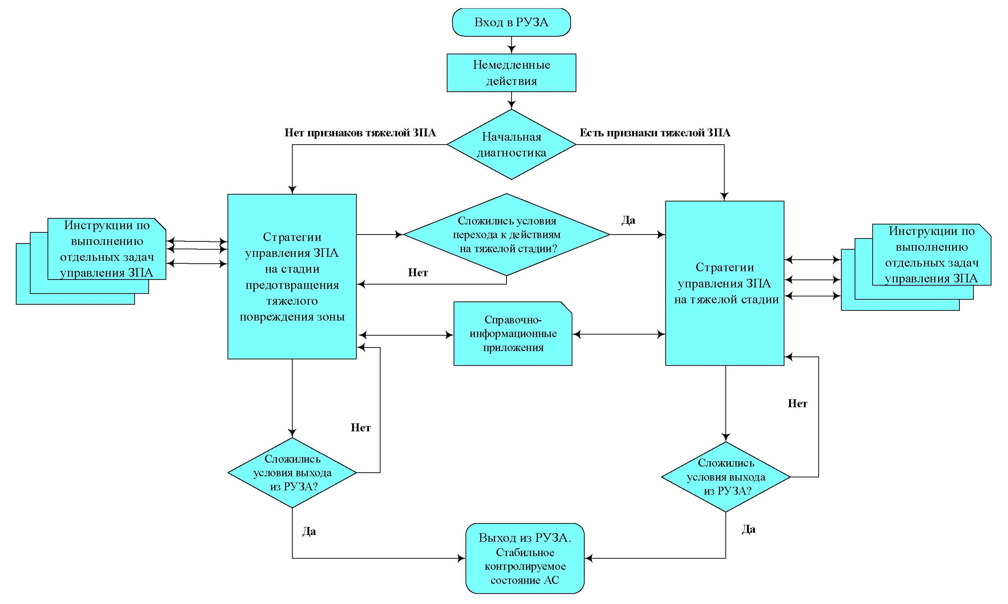

|  |  |
| --- | --- |
| Вход в РУЗА | Commencement of the BDBA management guidelines application |
| Немедленные действия | Immediate actions |
| Начальная диагностика | Initial diagnostics |
| Нет признаков тяжелой ЗПА | No signs of a severe accident |
| Есть признаки тяжелой ЗПА | Any signs of a severe accident |
| Стратегии управления ЗПА на стадии предотвращения тяжелого повреждения зоны | BDBA management strategies at the severe core damage prevention stage |
| Инструкции по выполнению отдельных задач управления ЗПА | Instructions for performance of individual BDBA management tasks |
| Сложились условия перехода к действиям на тяжелой стадии? | Are there any conditions for proceeding to the actions at the severe stage? |
| Да | Yes |
| Нет | No |
| Справочно-информационные приложения | Reference appendices |
| Сложились условия выхода из РУЗА? | Are there any conditions for the BDBA management guidelines termination? |
| Стратегии управления ЗПА на тяжелой стадии | BDBA management strategies at the severe stage |
| Выход из РУЗА. Стабильное контролируемое состояние АС | Termination of the BDBA management guidelines application. Stable controlled state of the NPP |

APPENDIX 6   
to the Safety guide in the use of atomic energy "Recommendations on the Structure and Content of the Guidelines for Management of Beyond Design Basis Accidents Including Severe Accidents" RB-102-15 approved by Order of the Federal Environmental, Industrial and Nuclear Supervision Service No. 288   
dated July, 24, 2015

**Approximate content of the beyond design basis accident management guidelines (through the example of a nuclear power plant with the reactor of VVER type)**

**1. General provisions**

1.1. Purpose and application scope of the BDBA management guidelines. Structure of the BDBA management guidelines.

1.2. Organizational structure of BDBA management

1.3. The general procedure for commencement of application of the BDBA management guidelines, transition from one instruction of the BDBA management guidelines to another (including the conditions for proceeding to the BDBA management at the severe accident stage), termination of the activities in accordance with the BDBA management guidelines.

1.4. Procedure for performance of any actions not prescribed in the BDBA management guidelines. Procedure and conditions for the NPP personnel intervention to operation of the automatic devices. Procedure for beyond-design use of the equipment for performance of safety functions.

1.5. Relation of the BDBA management guidelines to the operation documentation effective at the NPP.

1.6. Maintenance of the personnel's proficiency in the area of BDBA management.

**2. Operating section**

**2.1. The basic guidelines**

2.1.1. Conditions for commencement of application of the BDBA management guidelines.

2.1.2. Immediate actions to be performed upon commencement of application of the BDBA management guidelines.

2.1.3. Initial diagnostics of the NPP state.

2.1.4. Beyond design basis accident management strategies at the severe core damage prevention stage.

2.1.5. Beyond design basis accident management strategies at the severe core damage stage.

2.1.6. Conditions for termination of the activities in accordance with the BDBA management guidelines.

**2.2. Instructions for performance of individual beyond design basis accident management tasks**

2.2.1. Bringing (maintenance) of the reactor in the sub-critical state (in case of any CPS malfunction).

2.2.2. Urgent arrangement of the core cooling with the ECCS (from the normal operation make-up system).

2.2.3. Arrangement of the core cooling with the ECCS (from the normal operation make-up system).

2.2.4. Arrangement of the core cooling from the ECCS HA and low-pressure ECCS (in case of inoperability of the HP ECCS and high pressure in the primary circuit).

2.2.5. Arrangement of the core cooling in case of the primary-to-secondary circuit leakage.

2.2.6. Arrangement of the core cooling in case of leakage from the primary circuit to the adjacent systems.

2.2.7. Replenishment of the water stock in the ECCS tanks.

2.2.8. Arrangement of the primary circuit make-up through the use of mobile equipment of the BDBA management hardware.

2.2.9. Arrangement of heat removal from the primary circuit through the use of "feed-and-bleed" procedure.

2.2.10. Arrangement of heat removal from the primary circuit via steam generators.

2.2.11. Arrangement of heat removal from the primary circuit via the make-up system.

2.2.12. Arrangement of heat removal from the primary circuit through the use of mobile equipment of the BDBA management hardware.

2.2.13. Reduction of pressure in the containment.

2.2.14. Isolation of the containment in case of any leakages inside the containment.

2.2.15. Isolation in case of any primary circuit leakage to the adjacent systems outside the containment.

2.2.16. Actions aimed to minimize the leakage from the containment.

2.2.17. Restoration of the auxiliary power supply by inter-unit switchings and switching to the OSG.

2.2.18. Restoration of the auxiliary power supply through the use of the EPSS diesel generators and the normal operation diesel generator.

2.2.19. Restoration of the auxiliary power supply through the use of mobile equipment of the BDBA management hardware.

2.2.20. General procedure in case of a fire at the NPP.

2.2.21. Actions in case of a fire in the MCR, the ECR and on the CPS panel.

2.2.22. Actions in case of a fire in the EPSS rooms.

2.2.23. Actions in case of a fire in the rooms of safety-related systems within the controlled access area.

2.2.24. Actions in case of a fire in the rooms of safety-related systems within the uncontrolled access area.

2.2.25. Actions in case of flooding (risk of flooding) of any safety-related system rooms.

2.2.26. Actions aimed to mitigate the consequences of RS releases into the environment.

2.2.27. Actions for prevention (mitigation) of hydrogen combustion risk in the containment.

2.2.28. Actions for prevention (mitigation) of hazardous vacuumizing risk in the containment.

2.2.29. Actions aimed to prevent the risk of the reactor vessel melt-through under high pressure in the primary circuit.

2.2.30. Actions aimed to prevent the risk of the reactor vessel melt-through under low pressure in the primary circuit.

**3. Reference appendices to the BDBA management guidelines**

2.1. Auxiliary evaluation tools

2.2. Technical substantiation of the BDBA management guidelines

2.3. Substantiation calculations for the BDBA management guidelines

2.4. Description of the severe accident phenomenology.

APPENDIX 7   
to the Safety guide in the use of atomic energy "Recommendations on the Structure and Content of the Guidelines for Management of Beyond Design Basis Accidents Including Severe Accidents" RB-102-15 approved by Order of the Federal Environmental, Industrial and Nuclear Supervision Service No. 288  
 dated July, 24, 2015

**Approximate list of safety functions (through the example of a nuclear power plant reactor facility with the reactor of VVER type)**

1. Reactor sub-criticality

2. Heat removal from the core

3. Heat removal from the primary circuit to the ultimate heat sink

4. Integrity of the primary circuit

5. Integrity of the reactor facility containment

6. Maintenance of the normal conditions for functioning of the equipment and personnel (auxiliary power supply of the NPP, absence of fires and flooding)

Note.

Maintenance of the normal conditions for functioning of the equipment is specified as an individual safety function because it requires individual specific actions for restoration, and restoration (maintenance) of other safety functions can be difficult or impossible without successful restoration (maintenance) of this safety function.

APPENDIX 8   
to the Safety guide in the use of atomic energy "Recommendations on the Structure and Content of the Guidelines for Management of Beyond Design Basis Accidents Including Severe Accidents" RB-102-15 approved by Order of the Federal Environmental, Industrial and Nuclear Supervision Service No. 288   
dated July, 24, 2015

**Example of determination of the criteria (conditions) for diagnostics of the state for the safety function "Heat removal from the core"**

|  |  |  |
| --- | --- | --- |
| **State with performance of the safety function** | **Criterion (conditions) for diagnostics** | **Applicable instruction for performance of individual BDBA management tasks** |
| Serious malfunction of cooling. | The coolant temperature at the core outlet exceeds 360°С | Instruction 1 |
| Cooling can be impaired in case of high pressure in the primary circuit. | (The boiling margin at the core outlet is less than 10°С)  and  (pressure in the primary circuit is above the discharge pressure of the LP ECCS) and  (the HP ECCS is inoperable). | Instruction 2 |
| Cooling can be impaired in case of low pressure in the primary circuit. | (The boiling margin at the core outlet is less than 10°С)  and  (the HP ECCS and the LP ECCS are inoperable). | Instruction 3 |
| Unsatisfactory cooling. | (A non-compensated leakage of the primary circuit coolant is present)*  and  (the active ECCS is inoperable)**. | Instruction 4 |
| Satisfactory cooling. | (The boiling margin at the core outlet is more than 10°С)  and  (at least one channel of the active ECCS** is operable, or any primary circuit leakage is absent)*. | Instruction 5 |

*The signs of the primary circuit leakage include the signs of leakage in the containment (increase of pressure, humidity and activity in the containment), or signs of leakage to the secondary circuit (increase in activity of the SG boiler water or in the main steam pipelines), or signs of any leakage to the adjacent systems outside the containment (increase of activity, temperature and humidity in the relevant NPP rooms, increase of activity in the adjacent systems).

**The active ECCS shall be deemed inoperable if all high-pressure ECCS pumps are inoperable (with the primary circuit pressure exceeding 10 kgf/cm2), or all low-pressure ECCS pumps are inoperable (with the primary circuit pressure exceeding 10 kgf/cm2), or the level in the emergency boron solution storage tank GA-201 is low-low.

APPENDIX 9   
to the Safety guide in the use of atomic energy "Recommendations on the Structure and Content of the Guidelines for Management of Beyond Design Basis Accidents Including Severe Accidents" RB-102-15 approved by Order of the Federal Environmental, Industrial and Nuclear Supervision Service No. 288   
dated July, 24, 2015

**List of possible physical (physical and chemical) processes and phenomena in the course of a severe accident development (through the example of a nuclear power plant with the reactor of VVER type)**

**1. In-vessel phase**

1.1. Heating of the fuel and FE claddings

1.2. Exothermic reactions for oxidation of the FE claddings and other metal surfaces with steam accompanied with hydrogen release

1.3. Thermal and mechanical damage of the FE claddings

1.4. Melting of the FE claddings, metalwork, nuclear fuel, generation of corium in the core area

1.5. Movement of the corium from the core to the lower section of the reactor vessel

1.6. Interaction of the corium with the remaining coolant in the lower reactor chamber (the risk of steam explosion is possible)

1.7. Thermal and physical processes in the lower reactor chamber

1.8. Interaction of the corium with the reactor vessel and its melt-through

**2. Ex-vessel phase**

2.1. Damage of the containment due to direct contact with the corium (direct heating of the containment)

2.2. Ignition (deflagration/ detonation) of hydrogen released into the containment in the course of the in-vessel phase and later in the course of the ex-vessel phase due to interaction of the corium with concrete; in this case carbon monoxide (CO) which is also flammable is generated in the course of the reaction apart from hydrogen; in addition to integral combustion local deflagration/ detonation sources also pose a threat, as they can cause formation of small missiles capable of damaging the containment

2.3. Interaction of the corium with the containment foundation concrete resulting in melt-through of the foundation

2.4. Generation and spreading of aerosols inside the containment

2.5. Prolonged exposure to the increased parameters (pressure and temperature) capable of causing damage of the containment

2.6. Possible bypassing of the containment and release of radioactive substances into the environment, for example, through the SG tubes damaged under the impact of hot gases

APPENDIX 10   
to the Safety guide in the use of atomic energy "Recommendations on the Structure and Content of the Guidelines for Management of Beyond Design Basis Accidents Including Severe Accidents" RB-102-15 approved by Order of the Federal Environmental, Industrial and Nuclear Supervision Service No. 288   
dated July, 24, 2015

**Examples of possible beyond design basis accident management strategies at the severe core damage stage for the nuclear power plant reactor facility with the reactor of VVER type**

**Strategy 1. Water supply to the steam generator**

Objectives:

- to protect the SG tubes against damage due to high-temperature creep;

- to confine the fission products entering the SG through damaged tubes; to remove heat from the primary circuit via the SG.

Possible negative consequences:

- thermal shock capable of causing damage of the SG casing or tubes;

- possible release of fission products (bypass of the containment) in case of any damage of the tubes and opening of the secondary circuit steam dump valves;

- accelerated corrosion of the heat-exchange surfaces (in case of raw water use).

**Strategy 2. Pressure reduction in the primary circuit**

Objectives:

- to prevent breakage of the SG tubes;

- to prevent release of the corium from the reactor vessel under high pressure; to ensure boron solution supply from the ECCS pumps;

- to reduce primary to secondary cross-flows in case of any inter-circuit leakage.

Possible negative consequences:

- increased risk of steam explosion in the reactor vessel;

- risk of the relief device "sticking" after opening;

- possible disturbance of natural circulation (if any).

**Strategy 3. Water supply to the primary circuit**

Objectives:

- to remove residual heat and thus to prevent or delay damage of the reactor vessel;

- to ensure re-flooding of the corium/ core debris in order to confine the fission products.

Possible negative consequences:

- enhancement of the steam-zirconium reaction (threat for the containment integrity);

- increased risk of damage for the SG tubes due to high-temperature creep (because of "displacement" of hot gases into the SG and increase of the primary circuit pressure).

**Strategy 4. Water supply to the containment**

Objectives:

- to ensure cooling of the corium/ core debris outside the reactor vessel;

- to ensure re-flooding of the corium/ core debris outside the containment in order to confine the fission products.

Possible negative consequences:

- increased risk of hydrogen ignition;

- dilution of the boron concentration in the sump tank.

APPENDIX 11   
to the Safety guide in the use of atomic energy "Recommendations on the Structure and Content of the Guidelines for Management of Beyond Design Basis Accidents Including Severe Accidents" RB-102-15 approved by Order of the Federal Environmental, Industrial and Nuclear Supervision Service No. 288   
dated July, 24, 2015

**Examples of auxiliary evaluation tools**

**1. Auxiliary evaluation tool No. 1: the flow rate required for the core filling**

Purpose: to determine the primary circuit emergency make-up flow rate sufficient for re-wetting and filling of the core and to make the conclusion on the need to use any additional emergency make-up means apart from the devices operable at the decision making moment.

Assumptions adopted in development of the calculation tool: quasi-steady-state conditions in the primary circuit;

- the core geometry is maintained;

- all supplied water reaches the core and is used for its cooling and filling;

- the removed heat includes: residual heat, energy emitted in the course of oxidation reaction and energy accumulated in the core structures;

- the afterheat output shall be calculated according to the conditions of the rated break-even reactor power prior to activation of the emergency protection; it is supposed that the residual heat level corresponds to the moment 3 hours after the emergency protection activation, i.e. approximately 1% of the rated power;

- the oxidation energy corresponds to the reaction for oxidation of 25% of the total zirconium mass in the core; the oxidation energy emitted in the core at the stage of release from the primary circuit shall be considered with the accumulated energy;

- the mass of zirconium is assumed equal to 110% of the core zirconium mass;

- the accumulated energy is a function of the core temperature which is assumed equal to 2650°С across the entire core; although the adopted temperature value does not comply with the assumption with regard to the core geometry integrity this assumption provides for conservative assessment of the accumulated energy;

- the value of convection heat transfer from the fuel to the coolant is assumed to be large enough to remove accumulated heat within the time period required for the core filling; under actual conditions the core will be filled before its re-wetting; movement of unwetted core material is possible, and filling of the core does not guarantee prevention of the reactor vessel damage;

- it is assumed that the initial water level in the reactor vessel coincides with the lower elevation of the core (if the core is partially covered with water when water supply to the core is started the amount of water required for its filling will be less);

- the supplied water enters the reactor vessel in the under-heated state and leaves the core in the form of saturated steam; if the core is bare the steam at the core outlet will be actually super-heated; energy removal due to steam super-heating is not taken into account;

- steam quality in the filled core is assumed equal to 0.4;

- steam removal is arranged via the PRZ PORV;

- heat removal via the SG is disregarded (if at least one steam generator acts as heat outlet from the primary circuit the core will be wetted and filled earlier).

- operation of hydraulic accumulators is disregarded.

Note**.**

The minimal requirement for the core filling prescribes the core filling in two hours. The maximal requirement for the core filling prescribes the core filling in 45 minutes. If the core has been bare for a long period of time the reactor vessel damage can occur shortly after commencement of water supply regardless of the water supply flow rate. Consequently, water supply does not guarantee prevention of the reactor vessel damage.

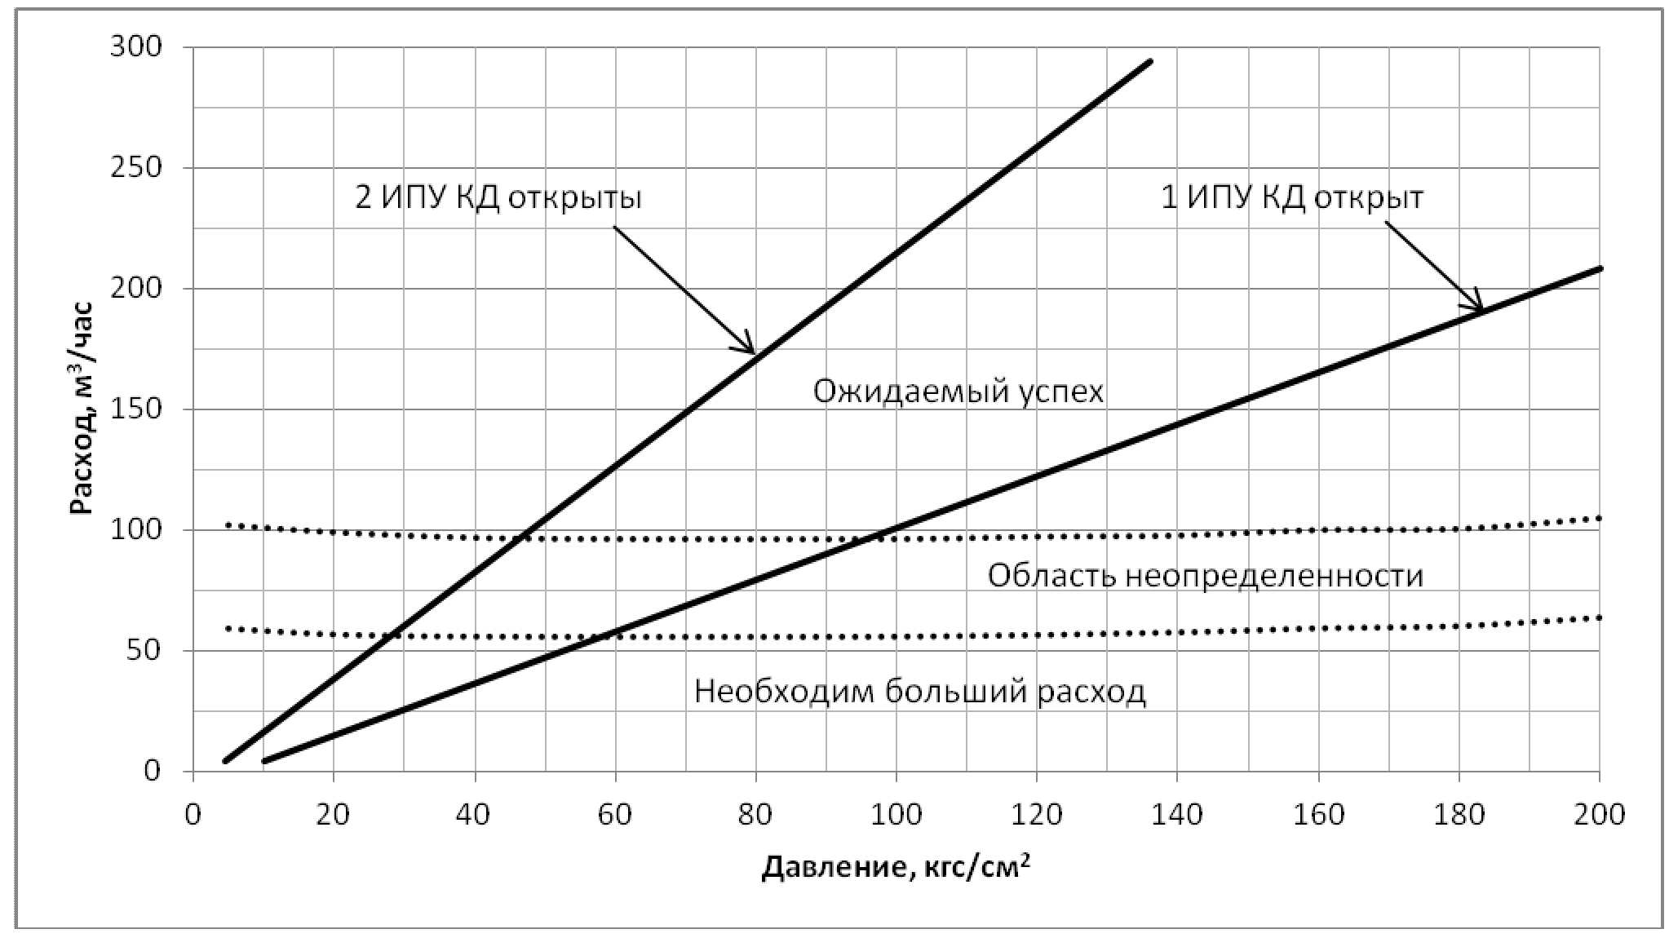

Fig. 1. The flow rate required for the core filling

|  |  |
| --- | --- |
| Расход, м3/час | Flow rate, m3/h |
| Давление, кгс/см2 | Pressure, kgf/cm2 |
| 2 ИПУ КД открыты | 2 PRZ PORVs are open |
| 1 ИПУ КД открыт | 1 PRZ PORV is open |
| Ожидаемый успех | Success expected |
| Область неопределенности | Range of uncertainty |
| Необходим больший расход | Higher flow rate is required |

**Auxiliary evaluation tool No. 2: the flow rate necessary for residual heat removal**

Purpose: to determine the minimum primary circuit emergency make-up flow rate sufficient for residual heat removal.

Limitation of application: not applicable in case of non-cooled or poorly cooled configuration of the core.

Assumptions adopted in development of the calculation tool:

- quasi-steady-state conditions in the primary circuit;

- the core is filled with water (if the core is partially bare this AET is not applicable, and AET-1 shall be used instead until the core is filled with water);

- the core geometry is maintained;

- all supplied water reaches the core and is used for its cooling;

- the removed energy includes only residual heat; the afterheat output shall be calculated according to the conditions of the rated break-even reactor power prior to activation of the emergency protection;

- the supplied water enters the reactor vessel or steam generators in the under-heated state and leaves the core or steam generators in the form of saturated steam;

- the saturated steam enthalpy corresponds to the PRZ PORV opening pressure.

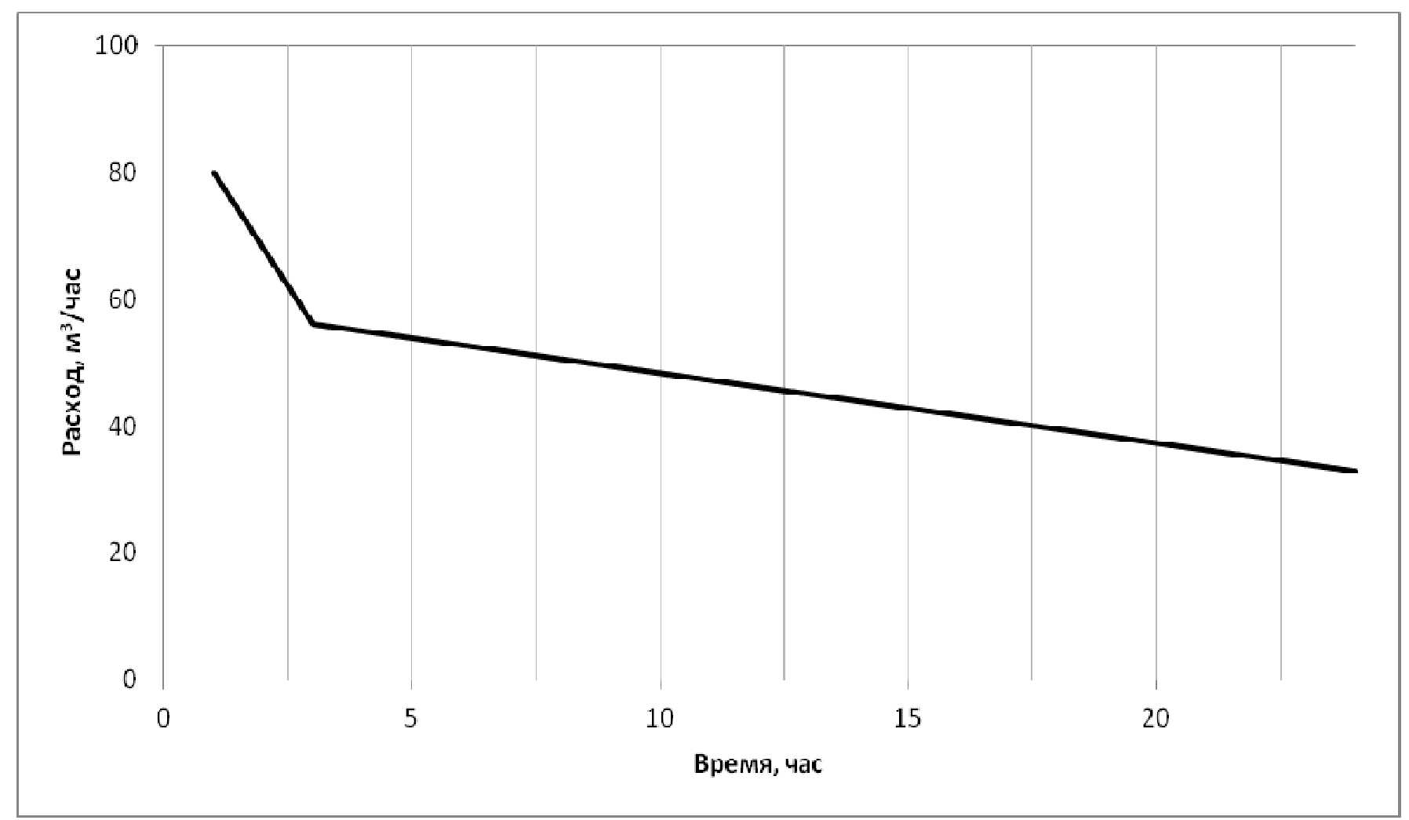

Fig. 2. Flow rate required for residual heat removal within 1 day after the accident

|  |  |
| --- | --- |
| Расход, м3/час | Flow rate, m3/h |
| Время, час | Time, h |

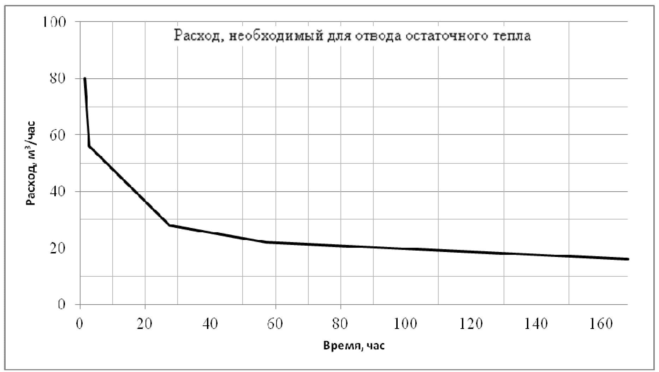

Fig. 3. Flow rate required for residual heat removal within 7 days after the accident

|  |  |
| --- | --- |
| Расход, необходимый для отвода остаточного тепла | Flow rate required for residual heat removal |
| Расход, м3/час | Flow rate, m3/h |
| Время, час | Time, h |

1. Developed by the collective of authors including M.Yu. Lankin, Sc. D., A.M. Bukrinsky, Sc.D., N.A. Kozlova, Sc.D., R.B. Sharafutdinov, Sc.D. (FBI STC NRS), M.I. Miroshnichenko, V.A. Manakov (Rostechnadzor).