Approved by   
Order of the Federal Environmental, Industrial and Nuclear Supervision Service   
dated July 1, 2016 No. 281

SAFETY GUIDE   
IN THE USE OF ATOMIC ENERGY "RECOMMENDATIONS FOR USE OF PROBABILISTIC SAFETY ASSESSMENT IN EVALUATING NPP OPERATIONAL DISTURBANCES"

(RB-104-16)

I. General

1. This safety guide in the use of atomic energy "Recommendations on use of probabilistic safety assessment in evaluating Nuclear Power Plant operational disturbances" (RB-104-18) (hereinafter - the Safety Guide) has been developed in accordance with Article 6 of Federal Law No. 170-FZ dated November, 21, 1995 "On atomic energy use", items 6, 7, 0 of the Russian Federation Government Decree No. 372 dated April 23, 2012 "On approval of the Provision on regime of continuous state supervision at nuclear facilities", item 4.1 of Appendix No. 2 of the Federal Rules and Regulations in the field of nuclear energy use "Position on the procedure of investigation and record of disturbances of nuclear power plants" (NP-004-08), approved by the Ordnance of the Federal Environmental, Industrial and Nuclear Supervision Service No. 280 dated May 14, 2008 (hereinafter referred to as NP-004-08).

2. This Safety Guide contains the Rostechnadzor recommendations for application of probabilistic safety assessment (hereinafter PSA) of the operational disturbances of nuclear power plants (hereinafter NPP) for performing safety significance assessment (impact on safety) of NPP in compliance with the classification established in NP-004-08, and operational events according to the classification accepted by the operator (hereinafter the disturbances).

The fulfilment of these recommendations shall assist in achieving an acceptable quality of disturbance assessment.

3. This Safety Guide is intended for use:

by the operators, project and design organizations during investigations of the operational disturbances of nuclear power plants for accounting the corrective actions during development for preventing repeat of the disturbances and enhancing the safety level;

by Rostechnadzor while taking regulating decisions considering of assessment of operational disturbances of nuclear power plants.

4. Requirements of item 4.1 of Appendix No. 2 NP-004-08 may be met using other techniques (methods), different from that specified in this Safety Guide. When using other techniques (methods) different from that indicated in this Safety Guide, the justification of the applicability of these techniques (methods) for safety analysis shall be given.

5. The recommendations for performing calculation of the probabilistic safety indicators on evaluation of operational disturbances are given in Appendix No. 1 to this Safety Guide, the significance analysis diagram of the operational disturbances of NPP using PSA is given in Appendix No. 2 to this Safety Guide.

II. General recommendations

6. Evaluation of the disturbances significance for safety (hereinafter evaluation of disturbances) shall be made using probabilistic safety indicators specified in the section III of this Safety Guide. The logical probabilistic models developed when performing PSA of the NPP power unit (hereinafter NPP power unit PSA models), scope of modeling and quality thereof conforms to the current requirements for PSA and confirmed by the Rostechnadzor review.

7. Preliminary analysis of the disturbances for possibility of their evaluation using PSA shall be performed. Impossibility of disturbance evaluation using PSA shall be justified.

8. The justification of applicability of NPP power units PSA model used for disturbance evaluation shall be given in the report on investigation of the disturbance.

9. The NPP power unit PSA model taking account of the updated condition of the NPP power unit systems (elements), current operation, maintenance, testing and repair procedures, as well as the operation experience of the NPP power unit where the disturbance took place and operation experience of the prototypes power units shall be used for evaluation of the disturbances.

10. The PSA model of the NPP power unit not allowing perform evaluation of the disturbances due to implementation of the assumptions simplifying simulation, lack of required systems (elements) and/or initiating events or due to any other reason shall be reworked.

Suppementation and rework of the NPP power unit PSA model may include:

specification of the level of detailing of the NPP power unit model (for example, detailed modeling of the elements of motor drive equipment control diagrams, not included earlier in the scope of PSA model, record of power supply cable failures not considered in the PSA model);

supplementation of the list of initiating events by the events caused by the evaluated disturbance and formation of new groups of initiating events if required;

specification of the reliability models of the systems (elements) the evaluated disturbance impacts the reliability thereof;

inclusion of the new actions of personnel in the NPP power unit PSA model, the evaluated disturbance impacts the procedure and reliability of performance thereof.

III. Probabilistic Safety Indices

11. The following probabilistic safety indices shall be used for evaluation of disturbances:

CSAbasic - Basic compound probability of severe off-design accidents for the reference state of the NPP power unit for one year.

CSA - compound probability of severe off-design accidents for one NPP power unit for one year considering the disturbance;

base_1_239394_32768 increase of the compound probability of severe off-design accidents for one NPP power unit for one year caused by the evaluated disturbance;

CPSA - conditional probability of severe off-design accidents for one NPP power unit on implementation of the evaluated disturbance.

CPSA shall be calculated as CSA for the NPP power unit for one year for the disturbances not leading to implementation of the accident initiating event on implementation of the conditions of the evaluated disturbance during a year.

For the disturbances leading to implementation of the accident initiating event, CCSA shall be calculated as CSA for the NPP unit on implementation of the initiating event and conditions of the evaluated disturbance.

The following probabilistic safety indices shall be used in addition for evaluation of the disturbances if Level 2 PSA is available for the NPP power unit:

PMERbasic - basic compound probability of maximum emergency release for the reference state of NPP power unit for one year;

PMER - compound probability of maximum emergency release for one NPP power unit for one year considering the disturbance;

base_1_239394_32769 increase of the compound probability of emergency release for one NPP power unit for one year caused by the evaluated disturbance.

12. Quantities base_1_239394_32770 caused by the evaluated disturbance shall be calculated using NPP power unit PSA model with respect to the basic quantities CSAbasic and PMERbasic.

IV. Probabilistic criteria and classification of disturbances

13. The disturbances assessed using probabilistic safety indicators shall be classified by their significance for safety and correlate with one of the following categories: low significant, medium significant, highly significant.

14. The disturbance is minor, if the following conditions are met simultaneously:

base_1_239394_32771

base_1_239394_32772

CPSA < 1.0E - 4.

15. The disturbance is medium significant if at least one of the following conditions and values of calculated probabilistic safety indices shall not exceed the values corresponding to the upper boundaries of the specified conditions:

base_1_239394_32773

base_1_239394_32774

1.0Е - 4 <= CPSA < 1.0Е - 3.

16. The disturbance is highly significant (indication of accident), if any of the following conditions are met:

base_1_239394_32775

base_1_239394_32776

CCSA >= 1.0Е - 3.

V. Use of the results of probabilistic evaluation of disturbance

17. If following investigation the disturbance is classified as medium significant:

the operator shall develop and implement the corrective actions for preventing the repetition of similar disturbance;

Rostechnadzor Interregional Territorial Administrations for nuclear and radiological safety shall supervise the development and implementation of corrective actions, development and taking of control decision shall not be required.

18. If following investigation the occurrence is classified as medium significant:

the operator shall investigate the occurrence, make clear the direct and root causes, develop and implement corrective actions for preventing the repetition of similar occurrence;

Rostechnadzor Interregional Territorial Administrations for nuclear and radiological safety shall consider the issue on requirement for development and implementation of regulating decisions and monitor the development and implementation of corrective actions.

19. If following the investigations the occurrence is classified as highly significant (that certifies about the significant reduction of safety level of the NPP power unit):

the operator shall take urgent actions for investigation, determination and elimination of the direct and root causes of the occurrence as well as for taking the required corrective actions, analyze and take decision on possibility of further power operation of NPP power unit;

Rostechnadzor Interregional Territorial Administrations for nuclear and radiological safety and Rostechnadzor head office shall be recommended to use the results of probabilistic assessment of the occurrence when developing the regulating solutions and perform supervision over the development and implementation of corrective actions.

VI. Documenting of the results of occurrence assessment

20. The results of occurrence assessment shall be documented in the scope sufficient for formation of the conclusions on impact of the occurred failure on safety of NPP power unit, and given in accordance with Appendix No. 2 NP-004-08 with respect to section 4 of the report on investigation of the occurrence and appendices to the report.

21. The following information shall be given as part of the deliverables with respect to assessment of failure using PSA:

brief information on PSA model of the NPP unit used for assessment of the failure;

justification of the NPP power unit PSA model applicability and description of the methods of considered violations record in the applied PSA model of the NPP power unit including the description pf assumptions and limitations accepted when performing PSA;

results of significance assessments of dominant contributors in the assessed values of probabilistic safety indicators (for initiating events, accident sequences human error);

results of violations assessments using the probabilistic safety indicators;

results of occurrence classification and formulation of conclusions;

assessment of the impact of performing corrective measures for the probabilistic safety indicators.

Appendix No. 1   
to the safety guide in the use of atomic energy "Recommendations for use of the probabilistic safety assessment when assessing malfunctions of nuclear power plants" approved by Order of the Federal Environmental, Industrial and Nuclear Supervision Service   
dated July 1, 2016 No. 281

RECOMMENDATIONS   
FOR PERFORMING CALCULATION OF PROBABILISTIC SAFETY INDICATORS ON ASSESSMENT OF NUCLEAR POWER PLANT OPERATION FAILURES

1. The following shall be used as initial information on failure assessment:

information on investigation of failures (for example, reports on investigation of failures, shop request and repair logs);

information on NPP power unit operation experience;

information on operation experience of NPP prototype units;

design and operation documentation of the NPP power unit;

PSA of NPP power unit.

2. The calculation of probabilistic safety indicators on assessment of NPP operation occurrences shall be performed in two stages:

Stage 1 (preliminary analysis) shall include:

quality expert analysis of information on the considered failure with the objective of preliminary determination of the degree of its impact on the NPP unit safety;

assessment of the failure on the International Nuclear Event Scale based on quality analysis of information;

Preliminary expert assessment of the impact of failure on the probabilistic safety indicators.

The stage 2 (detailed analysis) shall include:

determination of the simulation possibility of assessed failure in the PSA model of the NPP power unit; if required PSA simulation modification of NPP power unit;

PSA model calculations of NPP unit for determining probabilistic safety indicators considering the assessed failure;

performing analysis of the calculation results on NPP power unit PSA model, performing classification of the significance of failures in compliance with the probabilistic criteria.

3. The failures shall be divided into the following categories on significance assessment of the failures:

Category 1 - occurrences leading to failures or readiness reduction of equipment elements and/or systems participating in the performance of safety functions in case of occurrence of initiating events, but not leading to occurrence of initiating events;

Category 2 - occurrences leading to rise of frequency of initiating events but not leading to occurrence of initiating event;

Category 3 - occurrences leading to occurrence of initiating event.

4. Increase of the cumulative probability of severe beyond design basis accidents for one NPP power unit for one year base_1_239394_32777 caused by assessed failure for category 1 and 2 failures is calculated for the relationship (1) for the 3rd category of failures is calculated according to the relationship (2).

Increase of the cumulative probability of maximum emergency discharges for one NPP unit for one year base_1_239394_32778 caused by assessed failure for categories 1 and 2 failures is calculated for the relationship (3), for 3rd category failures is calculated for the relationship (4).

base_1_239394_32779

base_1_239394_32780

base_1_239394_32781

base_1_239394_32782

In these formulae:

CSA - Cumulative probability of severe beyond design basis accidents for one NPP power unit for one year calculated using PSA model of the NPP power unit considering the contribution of assessed failure;

CSAbase - Cumulative probability of severe beyond design basis accidents for one NPP power unit for one year calculated using PSA model of NPP power unit for base state of the NPP power unit without considering the assessed failure;

CPSA - conditional probability of severe off-design accident for one NPP power unit on implementation of the evaluated disturbance; for category 1 and 2 disturbances it is calculated as the compound probability of severe off-design accidents for the NPP unit for one year on the assumption of implementing the conditions of the evaluated disturbance during a year; for category 3 disturbances it is calculated as the probability of severe off-design accident of the NPP power unit when implementing the initiating event and conditions of the evaluated disturbance;

CPER - Compound probability maximum emergency release for one NPP power unit for one year calculated using PSA model of the NPP power unit considering the contribution of evaluated disturbance;

CPERbasic - Compound probability maximum emergency release for one NPP power unit for one year calculated using PSA model of the NPP power unit considering the basic state of the NPP power unit without considering the evaluated disturbance;

CPMER - conditional probability of maximum emergency releases for one NPP power unit on implementation of the evaluated disturbance; for category 1 and 2 disturbances it is calculated as the probability of maximum emergency release for the NPP unit for one year on the assumption of implementing the conditions of the evaluated disturbance during a year; for category 3 disturbances it is calculated as the probability of maximum emergency release of the NPP power unit when implementing the initiating event and conditions of the evaluated disturbance;

tyear - time interval equal to one year;

tнар - time during which the NPP power unit is operated with the conditions of the evaluated disturbance.

5. All the potential initiating events and emergency sequences on which the evaluated disturbance may have impact shall be considered on evaluation of the disturbances.

6. The chronology of intermediate events during the considered disturbance and develop a diagram showing the sequence of intermediate events at the element failure level shall be analyzed. The diagram includes:

information on initial conditions of the considered occurrence including information on failed systems (elements), systems (elements) partially having lost the capability to perform safety functions or under maintenance at the time of onset of failure;

information on failures of systems (elements) or human errors, which took place during the considered occurrence;

information on failed systems (elements), the functional ability thereof was restored later by the personnel;

information on latent failures of the systems (elements) found during investigation of the considered failure (failures of standby systems (elements) which were not recallable during the failure).

7. The duration of system (elements) unavailability during the considered failure, failures thereof took place at different time intervals shall be determined considering the overlapping failures and allowable degree of conservatism of establishing the duration of unavailability of system (elements) not leading to quality change of the list of dominant contributors in the assessed values of probabilistic safety indicators.

8. The probability of their failure using engineering analysis or by expert evaluation shall be re-evaluated for the systems (elements) which on failure had partially lost the capability to perform its functions.

9. The probability of common cause failures for the systems (elements), identical with the failed systems (elements) performing standby functions shall be reevaluated.

10. The specifics of occurrences which lead to change of the values of human error probabilities used in PSA shall be determined and considered. The necessity of reliability revaluation of human actions may be caused by the conditions not accounted in PSA occurring during the considered occurrence.

Sensitivity analysis shall be made with respect to the impact of simulation assumptions (simplifications) taken during assessment of occurrences for the values of probabilistic safety indicators for identifying the degree of influence of the changes of initial data of the probabilistic model on these values of probabilistic safety indicators.

Appendix No. 2   
to the safety guide in the use of atomic energy "Recommendations for use of the probabilistic safety assessment when assessing failures in operation of nuclear power plants" approved by Order of the Federal Environmental, Industrial and Nuclear Supervision Service   
dated July 1, 2016 No. 281

SIGNIFICANCE ANALYSIS DIAGRAM OF FAILURES IN OPERATION OF   
NUCLEAR POWER PLANTS USING PSA

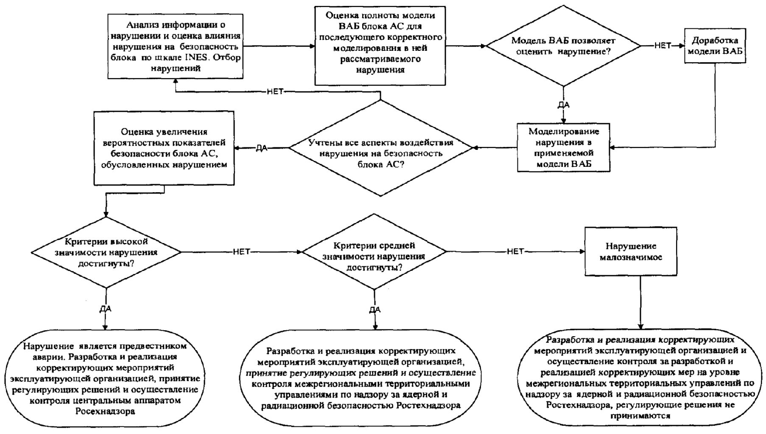

NO

NO

NO

YES

NO

YES

YES

YES

Occurrence is a precursor of accident. Development and implementation of corrective actions by the operating organization, taking of control decisions and monitoring by the Rostechnadzor Head Office

Development and implementation of corrective actions by the operator, taking of control decisions and monitoring by Rostechnadzor interregional territorial directorates for supervision over nuclear and radiation safety

Development and implementation of corrective actions by operator and monitoring development and implementation of corrective actions at the level of Rostechnadzor interregional territorial departments for supervision over nuclear and radiation safety, control decisions are not taken

Have the medium significance criteria of non-compliance been reached?

Assessment of the increase of probabilistic safety indicators of the NPP power unit caused by the occurrence

Have the high significance criteria of non-compliance been reached?

Have all the aspect of non-compliance impact on the NPP power unit safety been considered?

Simulation of non-compliance in the applied PSA model

Minor non-compliance

PSA simulation modification

Does the PSA mode allow assess non-compliance?

PSA model coverage estimation of the NPP power unit for subsequent correct simulation of the considered non-compliance in it

Analysis of information on non-compliance and impact assessment of non-compliance on safety according to INES scale. Selection of non-compliances