APPROVED BY

by order of the Federal Environmental, Industrial and Nuclear Supervision Service No.33 dated February 01, 2017

**Safety guide in the use of atomic energy**

**"Basic recommendations for development of a probabilistic safety analysis of level 1 for a nuclear power plant unit during initial events stipulated by** **the seismic impacts"**

**(RB-123-17)**

1. **General Provisions**
2. The safety guide in the use of atomic energy "Basic recommendations for development of a probabilistic safety analysis of level 1 for a nuclear power plant unit during initial events stipulated by the seismic impacts" (RB-123-17) (hereinafter – the Safety Guide) was developed in accordance with Article 6 of the Federal Law No. 170-FL "On the Use of Atomic Energy" dated of November 21, 1995, for the purpose of securing the compliance with the requirements of the Federal rules and regulations in the field of atomic energy use "General Provisions for NPP Safety Assurance" (NP-001-15) approved by the order No. 522 of the Federal Environmental, Industrial and Nuclear Supervision dated December 17, 2015, and also for the purpose of securing the compliance with the requirements of the Federal rules and regulations in the field of atomic energy use "Basic requirements for probabilistic risk assessment of a power unit of nuclear power plant" (NP-095-15), approved by the Order of the Federal Environmental, Industrial and Nuclear Supervision No.311 dated of August 12, 2015.
3. This Safety Guide contains recommendations of the Federal Service for Ecological, Technological and Atomic Supervision in the part of development of level 1 probabilistic safety analysis for nuclear power plant during initial events caused by the seismic impacts (hereinafter PSA of the seismic impacts).

The list of abbreviations used in this Safety Guide is provided in Appendix 1, terms and definitions - in Appendix 2, recommended PSA report makeup of the seismic impacts - in Appendix 3, Recommended sequence and mutual relation of PSA tasks of the seismic impacts is given in Appendix 4, the recommended approaches to the probabilistic seismic hazard analysis - in Appendix 5, the recommended approaches to the probabilistic analysis of the seismic vulnerability of the components - in Appendix 6, the recommended approaches to the systems, cumulative severe accident probability and valuating uncertainty - in Appendix 7, the examples of the criteria of the components exclusion - in Appendix 8 to this Safety Guide.

1. The Safety Guide contains recommendations that ensure acceptable PSA quality level of the seismic impacts.
2. This Safety Guide is designed for use by the design organizations, operating organizations and Rostechnadzor during construction and operation of the NPP units, carrying out safety supervision of the NPP units, development and implementation of measures for providing the safety level of the NPP units.
3. The PSA of the seismic impacts is a constituent part of the full-scale level 1 PSA, developed for all categories of IE and for all possible operation states of the designed, constructed and operated NPP units with reactors of different types.
4. The PSA of the seismic impacts may be performed using other techniques than those that are available in this Safety Guide if they are substantiated for the safety case.
5. This Safety Guide contains recommendations on the objectives, scope, composition, content, and sequence of individual tasks, as well as the content and scope of the deliverables.
6. **General information**
7. The basic objectives of the PSA of the seismic impacts are:

The assessment of probability of severe accidents for the NPP unit, caused by the seismic impacts;

The assessment of the boundary seismic resistance of the NPP unit as the characteristic of the resistance to the seismic impacts, exceeding safe shutdown earthquake;

detection of shortcomings on the NPP unit, including when the seismic impact exceeds the SSE level, and formation of recommendations on overcoming these shortcomings.

1. The basic tasks of PSA of the seismic impacts are:

accumulation of information specific for the NPP unit;

the probabilistic analysis of seismic hazards on the NPP site;

the preliminary analysis of the seismic impacts, development of a list of systems (components) for the analysis;

the probabilistic analysis of the response of buildings (constructions) to the seismic impacts;

the seismic walkdown of the unit;

the analysis of the seismic vulnerability to components under seismic impacts;

personnel reliability analysis;

simulation of accident sequences;

analysis of the systems;

the uncertainty, sensitivity, and significance analysis;

the analysis of the results of the seismic impact PSA and assessment of the safety level of the NPP unit.

1. It is recommended to perform a seismic impact analysis for constructed and operated NPP units. Recommended sequence and mutual relation of PSA tasks of the seismic impacts is given in Appendix 4 to the Safety Guide.

At the stage of construction of the NPP unit:

it is recommended to perform the task of the seismic impact analysis "Probabilistic analysis of the seismic hazard" using the simplified approach given in Appendix 5 to this Safety Guide;

it is not recommended to perform the task of the seismic impact analysis "The seismic walkdown of the unit" ;

when performing the task of the seismic impact analysis "The analysis of the seismic vulnerability to components under seismic impacts", it is recommended to use the results of the design-basis justification of seismic resistance of equipment and buildings (constructions) made for the prototypes of the NPP unit, information from generalized databases and expert assessments.

1. The PSA of the seismic impacts is recommended to develop based on information from the safety case reports of the NPP unit and PSA of the level 1 NPP unit for internal IE.
2. Recommendations of the Provision on basic recommendations for the development of level 1 probabilistic safety analysis for internal initiating events for all modes of operation of the Unit of nuclear power plant, approved by the order No. 519 of the Federal Environmental, Industrial and Nuclear Supervision Service dated 9 September 2011 (hereinafter - SG-024-11) shall be applied to the implementation of the PSA for the seismic impacts in the part not contradicting to the recommendations of this Safety Guide.

Recommendations of the safety guide "Basic recommendations for development of level 1 probabilistic safety analysis of nuclear power plant unit for initiating events, stipulated by intra-site fires and flooding" (SG-076-12), approved by order No. 496 of the Federal Environmental, Industrial and Nuclear Supervision Service dated 5 September 2012, shall be applied to the implementation of the PSA for the seismic impacts in the part not contradicting to the recommendations of this Safety Guide.

Recommendations of the safety guide in the use of atomic energy "Basic recommendations for development of a probabilistic safety analysis of level 1 for a nuclear power plant unit during initial events stipulated by external impacts of natural and man-induced origin" (SG-021-14), approved by order No. 396 of the Federal Environmental, Industrial and Nuclear Supervision Service dated of 28 August 2014, shall be applied to the implementation of the PSA for the seismic impacts in the part not contradicting to the recommendations of this Safety Guide.

1. It is recommended to establish the possibility of joint impact on the NPP unit of the seismic impacts and other external impacts caused by the seismic impacts (for example, fire, flooding, the falls of the crane, and other impacts resulting from the seismic impacts).
2. PSA of the seismic impacts is recommended to develop for the following RS:

nuclear fuel in the reactor core;

nuclear fuel in spent fuel storage places (for example, in the spent fuel pool/refueling pool, the drum of spent nuclear fuel assemblies).

1. When performing the PSA for the seismic impacts, it is recommended to justify the time interval for reaching the controlled state of the systems (components) of the NPP unit after the IE as a result of the seismic impacts.
2. **Acquisition of information specific for the NPP unit**
3. The composition and scope of information required for analysis and acquisition of information shall be made when performing this PSA task of the seismic impacts. The following information shall be acquired:

general layout of NPP site;

the results of the global seismic hazard assessment applied to the site region under consideration;

the earthquake catalogs for the site (region) of the NPP location;

the previously performed work on the analysis of the site's seismic hazard, geological, seismotectonic, and seismological characteristics of the region:

the structure and location of the areas of earthquake source origination, seismic sources, and models of attenuation rules used;

the results of the site seismicity analysis based on geodynamical data; data on the soil of foundations of buildings and constructions of the site, including geological, geotechnical, dynamic characteristics of the components of the soil foundations, test results and results of studies of the stability of the soil foundations;

the monitoring studies of records of weak earthquakes, tilts and sediments of site foundations and analysis of their effectiveness;

databases on the characteristics of seismic resistance of prototype units and the results of their seismic walkdown.

1. The following shall be recommended to use when performing PSA of the seismic impacts:

the design documentation; the operation documentation;

the operation experience for all the units of the analyzed NPP and operation experience of the prototypes including information about the seismic impacts taking place;

PSA of the seismic impacts performed for prototypes of the NPP units;

level 1 of the NPP unit PSA for internal initiating events;

existing investigations for safety case of the NPP unit during the seismic impacts;

checking calculation of equipment and building structures, including support, anchor and Foundation structures of equipment important to safety;

programs and results of testing for seismic resistance of equipment from the seismic list of equipment;

3D-models of the NPP unit buildings (if available); safety case reports of the NPP unit;

methodological recommendations corresponding to the current level

of development of science, technology and production, for example contained in IAEA documents and documents of other organizations.

1. **The probabilistic analysis of the seismic hazards on the NPP**

**site**

1. The purpose of the PSA task "Probabilistic analysis of the seismic hazard on the NPP site" is to determine the seismic hazard curves that provide information about the frequency of exceeding seismic impacts of different intensity on the NPP site.
2. To determine the frequency of exceeding seismic impacts of various intensities, it is recommended to use a seismotectonic model of the area of the NPP site developed as part of the NPP project (or as a part of other works) to determine the seismicity of the area and site, containing the results of processing geological, geophysical, geotechnical and seismological information, the results of seismic and geodynamic monitoring conducted during the design and survey work, construction and operation of the NPP.

It is recommended to include the following components in the seismotectonic model of the NPP site area:

geometric models of the sources of the seismic impacts (point, linear, areal, extensional);

earthquake recurrence interval (stochastic models) for the sources of the seismic impacts, including assessments of maximum magnitudes;

rules of attenuation of the the impact intensity depending on the distance.

1. It is recommended to perform a probabilistic analysis of the seismic hazard taking into the account the local soil conditions of the NPP site. It is recommended to take into account the impact of the dynamic characteristics of the soil foundation, including changes in the properties of watered ground layers, on the results of the seismic hazard analysis.
2. To determine the seismic hazard curves, it is recommended to determine the minimum value of the frequency of the seismic impacts (over a time interval of one year), taking into the account the total probability of severe beyond design-basis accidents calculated during the development of the level 1 PSA for the initiating event.
3. It is recommended to perform the uncertainty analysis of the assessments of the seismic hazard on the NPP site. It is recommended to consider the following uncertainty sources:

various models of the attenuation rules of the intensity parameters of the impacts from sources;

various assessments of the maximum magnitudes of the impacts;

various types of movements in the center of the seismic impact (discharge, upcast, shift, mixed impacts);

various statistical laws of events occurrence;

other sources of epistemic uncertainty.

It is recommended to perform uncertainty analysis using a logic tree that allows to obtain seismic hazard curves for various quantiles. The uncertainty, the sources of which are listed in paragraphs 2-6 of item 22 of this Safety Guide, is assessed by constructing a logic tree, a fragment of which is shown in Figure 6.2 of Appendix 5 to this Safety Guide as example.

1. It is recommended to present the results of probabilistic analysis of the seismic hazard of the NPP site in the form of seismic hazard curves for quantiles of spectral accelerations of various periods of oscillation up to the zero period.
2. It is recommended to present the results of probabilistic analysis of the seismic hazard of the NPP site in the form of seismic hazard curves for quantiles of maximal accelerations of the zero period, indicating the form of the response spectrum corresponding to each reoccurance level (annual frequency) of these curves.
3. The recommended approaches for performing a probabilistic analysis of the seismic hazard of the NPP site are given in Appendix 5 to this Safety Guide.
4. **The preliminary analysis of initial events for the seismic impacts. The development of a list of systems (components) for the analysis**
5. The preliminary IE analysis for the seismic impacts of various intensities is performed to:

reveal the initiating event caused by the seismic impacts;

develop the accident sequences’ models under the seismic impacts;

develop the preliminary list of systems (components) that are potentially subject to the seismic impacts.

The result of the preliminary analysis of the initiating event for the seismic impacts is a list of the initiating event, as well as a tree of seismic initiating event, which determines the relationship between various seismic initiating event and failures of buildings, systems and equipment. An example of the tree of seismic initiating event is provided in Appendix 7 to this Safety Guide.

1. The list of systems (components) in the PSA of the seismic impacts (hereinafter - the seismic list of components) is developed to take into the account their failures when modeling accidental sequences for the initiating event caused by the seismic impacts.
2. It is recommended to develop a seismic list of components in stages, taking into the account information from:

the results of the analysis of the site general layout of the NPP unit location;

the stability analysis of the soil foundations of the site where the NPP unit is located;

the PSA models for the internal IE;

the results of the seismic walkdown of the NPP unit;

the analysis of the seismic vulnerability to components under the seismic impact;

1. It is recommended to include into the seismic list of components:

all the components taken into the account in the PSA model for the internal IE;

passive components of the process systems are not included due to various reasons in the PSA model for the internal IE, which failure under the seismic impact can influence the performance of safety-related functions considered in the PSA (tanks, heat exchangers, tanks, components of distribution systems);

passive building structures, fastening components that ensure the retention of other components from the seismic list of components in the design position;

buildings and constructions where systems (components) included in the PSA model for internal IE are located;

hydro-technical constructions and components that are damaged due to the seismic impact may cause flooding of the NPP site or malfunctioning of the ultimate heat sink;

other components included in the list based on the results of performing a seismic walkdown of the NPP unit, damage to which due to the seismic impact may cause the seismic dimensional interference with other components from the seismic list of the components.

1. It is recommended to exclude components from the preliminary seismic list in order to form a final list of components. It is recommended to exclude components from the preliminary list:

according to the results of a seismic walkdown of the unit based on simplified assessments of the boundary seismic resistance;

based on assessments of the boundary seismic resistance of the components from the preliminary seismic list, using the calculations available in the design;

based on the similarity with components of the integrated databases, for which the lower assessment of the boundary seismic resistance of the component is known;

based on the performed assessments of the seismic vulnerability of the components from the seismic list of components.

1. It is recommended to provide the seismic list of components in tabular form with the following information:

the ordinal number of the component in the table;

the component name;

belonging to the process system;

code designation of the component in the NPP design;

the building where the component is located; the  premise, where the component is located;

the elevation;

category of seismic resistance in accordance with the Federal standards and rules in the field of nuclear energy use "Design standards for seismic-resistant nuclear power stations" (NP-031-01), approved by the resolution of State Nuclear Supervision Service of the Russian Federation No. 9 dated October 19, 2001 (hereinafter-NP-031-91);

position of the component gridline (if an gridline can be defined for the component) relative to the building's gridlines.

It is recommended to provide the list of buildings and constructions in a separate table with the following information:

the ordinal number of the building (construction) in the table;

name of the building (construction);

code designation of the building in the NPP design; the component number in the NPP general layout diagram.

1. **The probabilistic analysis of the response of buildings (constructions) to the seismic impacts**
2. The probabilistic analysis of the response of buildings (constructions) to the seismic impacts is recommended to determine the loads on components from the seismic list of components in the form of values of average and standard deviations of seismic forces and/or response spectra. For this purpose it is recommended to develop realistic mechanical models of the constructions together with the soil foundations and perform dynamic calculations that take into the account the mechanical interaction of the soil foundation and the construction under the seismic impact.
3. When analyzing the response of the constructions, it is recommended to determine the seismic impacts (for example, accelerograms) for analysis taking into the account the local properties of the soil foundations (the thickness and sequence of the soil layers and their dynamic characteristics).
4. When performing dynamic calculations of the "soil-construction" system, it is recommended to take into the account the average values and characteristics of aleatoric and epistemic uncertainty for:

the mechanical dynamic characteristics of the construction and the soil foundation (rigidity, inertial, damping);

the geometric kinematic and force parameters of the input seismic impact (input response spectra on the free surface, the phase composition of the impact).

1. Dynamic calculations of the "foundation-construction" system are recommended using one of the following methods:

the direct dynamic integration method of the associated system of differential movement equations;

the dynamic model superposition method;

the dynamic method of complex functions of integral transformations.

1. It is recommended to determine the average values of the response characteristics of a building (construction) and their standard deviations using one of the methods listed below for seismic impact with reoccurance of 10-4 1/year according to the average seismic hazard curve (for an average response spectrum equal exceedance frequency of 10-4 1/year):

statistical simulation using the "Monte Carlo" method and its options with varying parameters specified in item 34 of this Safety Guide, and performing dynamic calculations of the "soil-construction" system;

performing a deterministic analysis of the "soil-construction" response at realistic values of the model parameters, followed by an assessment of each of the factors specified in item 34 of this Safety Guide that affect the deviation from the obtained response value and the overall deviation generally;

scaling available in the NPP unit design calculation of the "soil-construction" system with the purpose to account for the differences between response characteristics from the average values and justified the appropriation of the characteristics of deviations of values obtained from experience in performing calculations on the previous two models.

It is recommended to select the method for analyzing the reaction of buildings (constructions) depending on the availability of initial data and the method chosen for assessing the parameters of vulnerability of the components specified in section VIII of this Safety Guide.

1. **The seismic walkdown of the unit**
2. It is recommended to perform a seismic walkdown of the existing NPP unit or an NPP under the commissioning stage in order to confirm the existing NPP unit in the design and obtain additional information:

about the exact location of the component on the site (building, premise, elevation, orientation in the building gridline);

about compliance of the components under the consideration to requirements of design documentation regarding sufficiency of the fastening conditions of the components at installation and operation, about the locking conditions of the designs, about the condition of the adjacent components of distribution systems (pipelines, cables, air ducts);

about the possible seismic dimensional interactions of a component with closely located equipment and engineering structures.

When performing a seismic walkdown of the NPP unit, additional information is collected to perform an analysis of vulnerability from the seismic list of components.

1. It is recommended to form groups for the unit walkdown in oder to perform the walkdown procedures of the NPP unit. It is recommended to include the following into the groups for the unit walkdown:

specialists in PSA;

specialists in the vulnerability analysis due to the seismic impacts of the components;

NPP unit personnel.

1. It is recommended to perform the procedure of the seismic walkdown in three stages:

stage 1 - analysis of technical documentation (process diagrams, PSA failure trees for the internal IE, seismic list of components, available loads calculations, response spectra, strength and seismic resistance calculations, results of seismic resistance tests, technical specifications for equipment) and preparation of the walkdown reports; it is recommended to form groups for the unit walkdown at the stage 1;

stage 2 - walkdown itself and survey of the site, buildings, constructions and premises of the NPP unit; recording the results - filling in the walkdown reports, photographing, drawing up sketches, calculation schemes;

stage 3 - creating a database of the seismic components based on the results of the walkdowns.

1. It is recommended to include the following information in the premises walkdown reports:

name and marking of the building, premise, elevation, name of the system, component, belonging to the category of the seismic resistance;

the information describing components from the seismic list about the condition of anchor, fixing components, welded joints to embedded parts, the condition of threaded connections, supports, suspensions, trays of the distribution systems;

the information describing possible component failures due to the seismic interaction with:

the components of building structures and other components due to the proximity of the location (shock impact, fall);

the distribution systems (cables, pipelines, air ducts) due to thy are unfastened insufficiently;

vessels, tanks, shell-type equipment, damage to which during the seismic impact causes the failure of the component due to flooding;

graphic materials (drawings, sketches, photos) that supplement the information included in the reports of the premises walkdown.

1. **The analysis of the seismic vulnerability to components under seismic impacts**
2. The purpose of assessing the seismic vulnerability of the components under the seismic impacts is to assess the assumed probabilities of component failure depending on the intensity of the seismic impact on the free surface of the site (maximal or spectral (for a fixed frequency range) acceleration) for different levels of confidence probability. It is recommended to select the parameter of the seismic impact intensity corresponding to the one used for presenting the results of the probabilistic analysis of the seismic hazard of the NPP site.
3. It is recommended to perform the analysis of the component seismic vulnerability in several stages:

stage 1 - selection of criteria (types) of the component failure;

stage 2 - assessment of the seismic vulnerability parameters of the component for each selected type of failure;

stage 3 - plotting of the seismic vulnerability curves for the component.

1. It is recommended to consider the following types of the component failures:

functional failures in the field of elasticity (false actuations of relays and switches, seizure of drives, elastic loss of stability of vessel walls, excessive bending of fan blades, excessive mutual displacement of supports located on a building structure);

brittle failures (shearing and tearing of anchor bolts and studs, break through a welded joint);

failures caused by reaching the critical states under the conditions of plasticity (reaching the plastic moment in the sections of pipelines, housings, plastic deformations of cable trays and racks).

1. When selecting failure criteria, it is recommended to follow the design criteria, the results of tests for seismic resistance, and failures of similar components detected after past earthquakes.
2. The recommended approaches for conducting a probabilistic analysis of the seismic vulnerability of the components are given in Appendix 6 to this Safety Guide.

For the purpose of revelation the components that make the main contribution to the seismic safety characteristics of the NPP unit, it is recommended to exclude the components which influence is insufficient. To exclude components that slightly affect the seismic safety characteristics of the unit, it is recommended to develop criteria for excluding elements in accordance with their characteristics of boundary seismic resistance. It is recommended to create a list of elements excluded in accordance with the accepted criteria. Examples of criteria for excluding components are provided in Appendix 8 to this Safety Guide.

1. Human reliability analysis (HRA)
2. The objective of human reliability analysis in PSA of the seismic impacts is aimed at determination and assessment of the impact on the personnel of different seismic impact factors when they perform accident management actions (enhanced stress level, reduced time to perform actions required, spurious actuation of fire detection system, loss of data at MCR).
3. HRA when performing the PSA of the seismic impacts shall be recommended to perform by the method similar to the method used during performance of level 1 NPP PSA for internal IE considering the seismic impacts.
4. The list designed under the level 1 NPP PSA for internal IE shall be adopted as the basic list of personnel erroneous actions. If additional emergency scenarios in the seismic impacts of the PSA are found, it is recommended to identify new personnel erroneous actions and assess their probability.
5. Factors influencing the probability of human errors during accident management, considered in the level1 NPP PSA for internal IE should be used as the basic list of factors when performing the PSA of the seismic impacts.
6. It is recommended to consider the additional factors stipulated by the seismic impacts and influencing the probability of performance of actions for accident management by the personnel when performing the HRA. It is recommended to consider the following factors for non-performance of required actions by the personnel:

enhanced stress;

reduced time to perform actions required;

impossibility of performing actions locally due to occurrence of conditions preventing the performance of action;

decrease of information support at the MCR.

1. The analysis of the systems and modeling of the accidental sequences:
2. It is recommended to develop the model of the accidental sequences of the seismic impact PSA based on available models of the accidental sequences from PSA for the internal IE. It is recommended to use event trees and failure trees from the PSA model for internal IE as the basis of the developed PSA model, including additional events and/or changes in system models related to dependent system failures due to the seismic impact, if necessary. With that, it is recommended to take into the account that the types and consequences of failures at different levels of the seismic impact may be different and for the same components differ from those considered in the PSA for the internal IE.
3. It is recommended to include the components from the final seismic list of components in the probabilistic model.
4. It is recommended to consider different levels of the seismic impact in accordance with the seismic hazard curve, which may have an impact on the total probability of severe accidents with fuel melting. It is recommended to take into the account different levels of the seismic impact by applying specific boundary conditions.
5. The use of AS models developed in level 1 NPP PSA for internal IE may be impossible when developing the seismic impact scenarios due to the requirements of considering the specifics of the seismic impact consequences (multiple failures and spurious operations). In these cases it is recommended to develop new AS models on condition that the simulation principles and basic allowances accepted under performing level 1 NPP PSA for internal IE are saved.
6. It is recommended to take into the account both failures of systems (components) caused by the seismic impacts and failures from the PSA model for the internal IE that are not caused by the seismic impacts in the models of AS and systems for the seismic impacts. With that it is recommended to take into the account failures of the passive components (for example, pipelines, air ducts, cable routes, tanks, construction components). It is recommended to justify the consideration of these passive components in probabilistic models of systems.
7. In order to identify IE caused by the seismic impact, it is recommended to develop seismic event trees at the stages of preliminary analysis of the seismic events and the AS simulating stage.
8. It is recommended to take into the account the logical cause-and-effect relation of events related to the development of the seismic impact scenario, and make the necessary changes to the PSA model of the seismic impacts. It is recommended to take into the account that when the seismic impact reaches the level stipulated by the design, the unit should be stopped by a seismic protection signal.
9. When simulating the AS, it is recommended to take into the account that the consequence of the high-intensity seismic impacts may include hindered access of the personnel to certain areas of the AS to be able to manage the accident.
10. It is recommended to take into the account the difference in the probability of components recovery of models of internal and external impacts. For seismic impacts with the intensity of SSE and higher, the possibility of recovery for the component may be reduced or absent. It is recommended to assess the possibility of systems (components) recovery taking into the account the intensity of the seismic impacts.
11. When simulating the AS, it is recommended to take into the account the dependence of component failures due to simultaneous seismic impacts on these components when they are located at the same or close elevations, construction hridlines, and orientation in the same direction. While development of a probabilistic model, these dependencies should be taken into the account by simulating the component failures due to a common cause due to the seismic impact.
12. In the analysis it is recommended that the AS is integrated to the characteristics of the seismic hazard of the site as and features conditional probabilities of failure (vulnerability) in the range of seismic impacts of varying intensity and frequency-specific probabilistic seismic hazard analysis of the NPP site.
13. To determine the average probability of severe accidents caused by the seismic impacts, it is recommended to use the average values of seismic vulnerability and the average characteristics of the seismic hazard of the site (average seismic hazard curves, average spectra of equal frequency of excess) for the components of the probabilistic model of the NPP unit. It is recommended to use the average value of the total (for all seismic impacts) probability of severe accidents for one year for a single NPP unit as a probabilistic safety indicator evaluated within the framework of the seismic impact database.
14. **Analysis of uncertainty, sensitivity and significance of the seismic impact PSA and assessment of the safety level of the NPP unit.**
15. Analysis of uncertainty, sensitivity and significance at the stage of performing individual tasks of the seismic impact PSA is recommended to be made in accordance with the recommendations from SG-024-11.
16. Analysis of the results of PSA of the seismic impacts and assessment of the safety level of NPP unit is recommended to be made in compliance with the recommendations from SG-024-11.

APPENDIX 1   
to the safety guide in the use of atomic energy "Basic recommendations for development of a probabilistic safety analysis of level 1 for a nuclear power plant unit during initial events stipulated by the seismic impacts" approved by order No. 33 of the Federal Environmental, Industrial and Nuclear Supervision Service dated  
 of February 01, 2017.

**Abbreviations**

|  |  |  |
| --- | --- | --- |
| EP | — | emergency protection |
| HRA | — | human reliability analysis (hra) |
| AS | — | accidental sequence |
| NPP | — | Nuclear Power Plant |
| MCR | — | main control room |
| PSA | — | probabilistic safety assessment |
| PES | — | potential earthquakes source |
| HEP | — | human error probability |
| RS | — | radioactive source |
| IE | — | initiating event |
| PTL | — | power transmission line |
| IAEA | — | International Atomic Energy Agency |
| SSE | — | safe shutdown earthquake |
| NO | — | normal operation |
| PE | — | personnel error |
| OSG | — | open switchgear |
| OBE | — | operating basis earthquake |
| SDGS | — | standby diesel-generator station |

APPENDIX 2   
to the safety guide in the use of atomic energy "Basic recommendations for development of a probabilistic safety analysis of level 1 for a nuclear power plant unit during initial events stipulated by the seismic impacts" approved by order No. 33 of the Federal Environmental, Industrial and Nuclear Supervision Service   
dated of February 01, 2017.

**Terms and definitions**

**Accelerogram** - the dependence of the acceleration of vibrations on time.

**Analog accelerogram (selected)** - an accelerogram registered during an actual earthquake and taken to carry out a seismic resistance calculation, taking into account its conformity to seismotectonic and soil conditions at NPP site.

**Earthquake accelerogram** - an accelerogram on the free soil surface during an earthquake.

Response accelerogram - an accelerogram of structure determined from the calculation of forced fluctuations under seismic impact.

Floor accelerogram - a response accelerogram for individual elevations of the structure on which equipment is installed.

Synthesized accelerogram - an accelerogram obtained analytically based on statistical processing and analysis of several accelerograms and/or spectra of actual earthquakes, taking into account local seismic conditions.

Aleatoric straggling (uncertainty), βR - straggling of values of the phenomenon parameter due to its random (stochastic) nature. The aleatoric straggling is taken into the account by simulating the parameter as a random variable in the probabilistic model. In most cases, the aleatoric straggling cannot be reduced by collecting additional data (conducting additional tests of the material) or obtaining additional information.

Site response analysis - determination of ground movements during an earthquake subject to local soil conditions, using the theory of flat waves propagation. The soil profile is simulated as a column of soil of the total depth with an unbounded strike in horizontal directions. Earthquake waves propagate up the soil column, determining the movement of the soil on the surface.

The analysis of the seismic vulnerability to components - a procedure for determining failure types and seismic vulnerability curves for a seismic list of components.

Probabilistic analysis of seismic hazards - a probabilistic method that combines alternative models of sources, periods of recurrence and dependence of strong motion attenuation, as well as explicit and random uncertainties in the probabilistic model of seismic hazard to obtain the probability of exceeding a specific level of soil movement.

Conditional probability (in the vulnerability analysis) - the probability of the event under consideration depending (provided) on the achievement of a fixed value of the maximal acceleration of the free soil surface a in fractions of the acceleration of gravity g - P(a). Other characteristics of the impact intensity on the free soil surface can also be used instead of acceleration a.

Interaction of the "soil-construction" system - mechanical interaction of building structures of a construction with the soil foundation of this construction under external impact subject to applying filling and reflected seismic waves or external shock impacts on the construction.

The boundary seismic resistance (HCLPF) of a component - the acceleration value (in fractions of the acceleration of gravity g) on the free soil surface, at which the conditional probability of failure of the component does not exceed 5% with a confidence probability of 95 %. For the average seismic vulnerability curve, with a combined uncertainty of 0.5, the acceleration value of the boundary seismic resistance approximately corresponds to the seismic vulnerability rate of 0.01 (1 %).

The boundary seismic resistance of the NPP unit - the acceleration value (in fractions of the acceleration of gravity g) on the free soil surface, at which the estimated average value of the conditional probability of severe damage to the core does not exceed 1 %.

Movement of the site free surface - the movement of the soil that occurs directly on the free surface or near the surface on a specific site in the absence of a construction (building structure). It is determined by analyzing the site's response to the seismic impact.

Deaggregation - calculation of the most probable earthquake magnitudes and distances from the source to the site that prevail in the probabilistic analysis of seismic hazard for a given period of recurrence and period of fluctuations.

Damping (attenuation) viscous - a type of damping that occurs when a body moves in a viscous medium. In viscous damping, the resistance force of the medium is proportional to the speed of the oscillating body.

Structural, material, and hysteresis damping - a type of damping in which energy is dissipated due to internal friction forces.

**Seismic event tree** - a graph that displays the logic of the development of a **seismic impact** of a certain intensity, used for simulating the occurrence of seismic events.

Rules of attenuation of the the impact intensity from the distance to the source -

dependence of the magnitude, maximum or spectral accelerations (for different oscillation periods) on the characteristic distance to the earthquake source. As parameters, the rule may contain characteristics of movement in the center of the soil foundation of the site.

Earthquake recurrence model - a linear dependence of the logarithm of the number of earthquakes in a certain area over a certain period of time on the magnitude.

PES area - an area of occurrence of earthquake sources.

Initiating seismic event - an initial event caused by a seismic impact.

Viscous damping coefficient - the coefficient of proportionality between the strength of the viscous resistance of the medium and the speed of movement of the body.

Damping coefficient (fraction, percentage of critical) - the ratio of the current value of the damping coefficient of an oscillator with a viscous damper to the critical value of its damping coefficient, expressed in fractions or percentages.

The seismic hazard (seismic risk) curve - a set of values of the frequency of exceeding seismic impacts of a given intensity, depending on the accepted parameter of the intensity of the seismic impact. In the probabilistic analysis of seismic hazard curves are developed for different levels of confidence.

Seismic vulnerability curve - the values of the conditional probability of component failure shown on the graph, depending on a number of values of the maximal acceleration of the free surface of the NPP site (or another intensity parameter, if the seismic hazard curves are represented using it).

**Seismic hazard curves for quantiles** - a set of seismic hazard curves that are used to perform uncertainty analysis in assessments of event frequencies and intensity that correspond to different confidence levels.

**Critical damping (attenuation)** - the value of the damping coefficient of an oscillator with a viscous damper, at which the oscillatory nature of its movement changes to an aperiodic one.

**Magnitude** - an earthquake intensity related to the energy released in the form of seismic waves. The magnitude is expressed as a numerical value in the unified scale (Richter, surface waves, moment magnitude, etc.).

**Maximal (peak) acceleration of the earth's surface** - the maximal acceleration of the accelerogram, which is realized on the free soil surface during an earthquake.

**The logical tree method** - a probabilistic method for accounting for model uncertainties in simulating. This method uses a tree structure of nodes and branches that represent decision points and alternative models, respectively. Branches from each node have a specific set weight. The sum of the branch weights of each node is equal to one. Searching by logical tree is performed by exhaustive sampling or using a probabilistic procedure to determine statistical rows.

**An earthquake source** - the volume of the geological environment where rock breaks and elastic stresses are released. The size of the source area and the magnitude of the elastic stresses released determine the energy of seismic waves and the magnitude of the earthquake. The seismic moment, which is the product of the rock displacement modulus by the fault area and the displacement amplitude, is also a measure of the size of the source. The place in the center where the fault begins is called the hypocenter (focus) of the earthquake, and its projection on the earth's surface is called the epicenter. According to the type of displacement of rocks, the source can be characterized as a shift, discharge, overthrust fault, or a more complex combination of them.

Straggling (uncertainty) combined, *βC* - an uncertainty, consisting of aleatory (random) *βR* and epistemic (model) *βU* straggling (uncertainty). The straggling measure in the form of a log-normal standard deviation is defined as 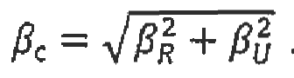

A seismic hazard (in probabilistic analysis of seismic hazard) - is represented as expected (within a given time interval) frequencies of exceeding seismic impacts of different intensity at the NPP site. The intensity of the impact is characterized by a parameter (maximal acceleration of the soil surface, spectral acceleration of the soil surface at a given frequency and damping coefficient, etc.). The time period is usually set to one year, and the assessed frequency is called the annual exposure frequency.

Seismic vulnerability to a component (construction, equipment, or their component part) under the set intensity of seismic impact - the conditional probability of failure of a component when the set level of intensity of the seismic impact is reached on the free soil surface. The level of the seismic impact can be set by the response spectrum of this impact on the free surface of the site. Seismic vulnerability does not depend on the seismic hazard of the site of the object under consideration but subject to the spectral composition of the impact on it.

Seismic source - a generic term that refers to domains (areas of the geological environment characterized by internal uniformity of physical properties and diffuse seismicity) and tectonic structures (discontinuous and folded dislocations) that can cause vibrational movements and tectonic surface deformations. In the probabilistic analysis of seismic hazard for seismic sources, the characteristics of the frequency of impacts should be set depending on the magnitude of earthquakes.

Seismic walkdown of the unit - a visual inspection performed in buildings, constructions, and on the NPP site where components of the seismic list of components are physically located in order to establish:

compliance with installation procedures and design documentation requirements, sufficient conditions for fastening components;

the exact location of the component on the site (building, premise, elevation, orientation in the building gridlines);

possible seismic dimensional interactions.

Seismic list of components - a list of comonents of the NPP and soil foundations for which it is necessary to perform a seismic vulnerability analysis.

Seismic dimensional interaction is the mechanical interaction of equipment, components of distribution systems, and building structures with a nearby component of a seismic list, which may result in the failure of this component and failure to perform its assigned function.

Response spectrum - the set of absolute values of the maximum response accelerations of a linear oscillator under the action given by the accelerogram determined depending on the natural frequency and damping parameter of the oscillator.

Response spectrum of equal exceedance frequency - the response spectrum defined in such a way that the frequency of excess (during a given time interval) of the spectral value (acceleration, speed, displacement) is the same for all values of the oscillation frequency (oscillation period) of this spectrum. The time period is usually set to one year.

Spectral acceleration - the value of the response spectrum acceleration corresponding to the specified frequency (period).

Response spectra equal to the exceedance frequency of quantiles - a set of response spectra equal to the exceedance frequency of various levels of confidence that are used to perform the analysis of uncertainty in the assessments of the frequency and intensity of events.

**Acceleration of zero period** - the spectral acceleration in asymptotic (solid) region of the spectrum, which usually is placed in the frequency range that is more than 33 Hz (the maximal acceleration of the response spectrum accelerogram).

The exceedance frequency of the set intensity of seismic impacts on the NPP site - the assessed value of the probability of exceeding the set value of the parameter of intensity of seismic impacts on the surface of the NPP site for the time period of one year.

**Epistemic straggling (uncertainty),** ***βU*** - straggling that reflects the uncertainty associated with insufficient knowledge of the phenomenon under consideration, which prevents the possibility of more accurate simulating of this phenomenon. Epistemic uncertainty is present in the range of changes in parameter values, the ability to use different models, the level of detail in simulating, various expert assessments, and in statistical confidence probability. Epistemic uncertainty can be reduced by obtaining additional information, but this is often unreasonable due to time, financial, and technical constraints.

APPENDIX 3   
to the safety guide in the use of atomic energy "Basic recommendations for development of a probabilistic safety analysis of level 1 for a nuclear power plant unit during initial events stipulated by the seismic impacts" approved by order No. 33 of the Federal Environmental, Industrial and Nuclear Supervision Service dated   
of February 01, 2017.

Recommended report contents of PSA of the seismic impacts

1. General information

Information on characteristics of radioactive sources, operation states considered, tasks set, scope of surveys and tasks, performed under the PSA of the seismic impacts are given in this chapter, and the main assumptions and limitations adopted in the analysis are stated.

The references to expert opinions confirming the quality of level 1 NPP PSA for internal IE which was used as the basis when performing the PSA of the seismic impacts are recommended in this chapter.

Recommended sequence and mutual relation of PSA tasks of the seismic impacts is given in Appendix 4 to the Safety Guide. The detailed information in the deliverables about the NPP deployment site, brief information on reactor plant, monitoring and control of the NPP unit, principal and emergency power supply systems, main equipment cooling systems and about the systems involved in the performance of safety functions is recommended to provide in the deliverables for PSA of the seismic impacts. References to the respective sources of more detailed information are recommended to be given.

It is recommended to provide brief characteristics of the procedures, manuals and software programs used for resolving all the tasks considered under the PSA of the seismic impacts in the deliverables for the PSA of the seismic impacts.

1. **Accumulation of information specific for the NPP unit**

It is recommended to provide all information about the NPP unit, which were used when performing PSA of the seismic impacts, in the deliverables for PSA of the seismic impacts. Initial data shall be provided in the scope required for assuring adequacy and completeness of the analysis.

It is required to provide references to the used information about NPP and performed analysis, results thereof were used when performing PSA of the seismic impacts when preparing initial data for PSA of the seismic impacts in the deliverables.

1. **The probabilistic analysis of seismic hazards on the NPP site**

It is recommended to provide an analysis of the seismic hazard of the NPP site, including:

catalogues of earthquakes in the region;

research data on the refinement of seismic and tectonic conditions of the construction area, which establish location and depth of sources of possible earthquakes, their magnitude, repetition and minimum distance to epicenter;

PES areas models, geometric characteristics of the seismic sources;

attuniation ratio, determining the maximum magnitude, the variations of the correlation (epistemic uncertainty);

earthquake recurrence interval for PES areas;

logical trees for seismic hazard analysis;

results of seismic hazard analysis seismic hazard curves for maximal and spectral accelerations, response spectra);

information about accounting for local soil conditions in seismic hazard characteristics.

1. **The preliminary analysis of initial events for the seismic impacts. The development of a list of systems (components) for the analysis**

It is recommended to provide a list of equipment units, construction components, and distribution system components with the following information: the component ordinal number; name;

belonging to the process system;

building;

premise;

elevation;

seismic resistance category in accordance with NP 031-01;

the location of the component gridline relative to the building gridlines.

1. **The probabilistic analysis of the response of constructions to the seismic**  **impacts;**

It is recommended to submit in the derivables of the PSA of the seismic impacts:

the results of probabilistic analysis of constructions for the probability of occurrence of the seismic impacts in the form of response spectra;

models of soil foundations that were used in the calculation of the "soil-construction" interaction;

results of calculating the site response analysis; comparison of the spectral characteristics of the impacts used in the design justifications and as a result of calculating the site response;

information about calculations performed to account for variations in rigidity and inertial characteristics.

1. **The seismic walkdown of the unit**

It is recommended to provide the following information about the seismic walkdown

of the unit:

the premises walkdown reports;

final table with the main results of the walkdown (recommendations, information about dimensional interactions, characteristics of boundary seismic resistance);

performed justifications of the boundary seismic resistance of the components by indirect methods (if available).

1. The analysis of the seismic vulnerability to components under seismic impacts

In this Chapter, it is recommended to provide the following information about the analysis of seismic vulnerability to components:

method for performing seismic vulnerability analysis;

types and criteria of failures;

exclusion criteria;

characteristics of seismic vulnerability of non-excluded At elements β*U*, β*R*, β*C*

1. Human reliability analysis (HRA)

It is recommended to present the results of human reliability analysis in the PSA deliverables of the seismic impacts, including: brief description of the HRA procedure used, the list of considered human errors and their identifiers, results of the analysis for screening of human errors, results of the analysis for determination of the HEP, results of analysis for assessing the dependences of human errors.

It is recommended to present the basic list of human actions and the list of actions obtained following the analysis of additional scenarios related to the seismic impacts in the PSA deliverables of the seismic impacts.

It is recommended to present the results of final HRA for PSA of the seismic impacts considering the influence of factors stipulated by the seismic impact on personnel actions.

It is recommended to present the assessment results of the probabilities of performing by personnel actions which are used in PSA of the seismic impacts.

It is recommended to present the analysis of dependent human errors and results of their assessment.

1. **Simulation of accident sequences**

It is recommended to present the results of AS aimulation including:

the seismic event trees;

brief characteristics of the PSA models for the internal IE;

modified and newly developed event trees and failure trees to account for various levels of seismic impacts;

seismic IE and failure frequencies for different impact ranges;

results of AS simulation, a list of minimal sections, and the probability of severe core damage for each of the considered IE.

1. **Analysis of uncertainty, sensitivity and significance**

It is recommended to provide the results of analysis of uncertainty, sensitivity and significance in the deliverable for the PSA of the seismic impacts.

1. **The analysis of the results of the seismic impact PSA and assessment of the safety level of the NPP unit**

It is recommended to provide recommendations for improving the safety level of NPP unit developed based on PSA of the seismic impacts and probabilistic assessments of their efficiency, including engineering and organizational measures in the deliverables for the PSA of the seismic impacts.

APPENDIX 4   
 to the safety guide in the use of atomic energy "Basic recommendations for development of a probabilistic safety analysis of level 1 for a nuclear power plant unit during initial events stipulated by the seismic impacts" approved by order No. 33 of the Federal Environmental, Industrial and Nuclear Supervision Service dated   
of February 01, 2017.

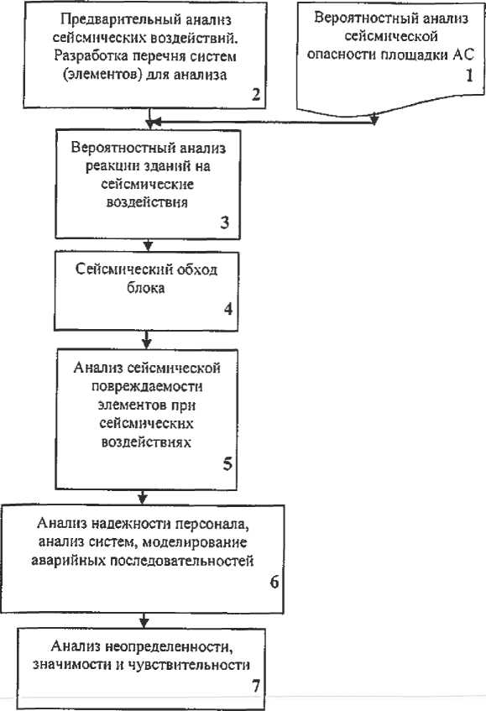**Recommended sequence and mutual relation of PSA tasks of the seismic impacts**

|  |  |
| --- | --- |
| Вероятностный анализ сейсмической опасности площадки АС | the probabilistic analysis of seismic hazards on the NPP site |
| Предварительный анализ сейсмических воздействий. Разработка перечня систем (элементов) для анализа. | the preliminary analysis of the seismic impacts, development of a list of systems (components) for the analysis |
| Вероятностный анализ реакции зданий на сейсмические воздействия | the probabilistic analysis of the buildings response to the seismic impact |
| Сейсмический обход блока | the seismic walkdown of the unit |
| Анализ сейсмической повреждаемости элементов при сейсмических воздействиях | the analysis of the seismic vulnerability to components under seismic impacts; |
| Анализ надежности персонала, анализ систем, моделирование аварийных последовательностей | Human reliability analysis, analysis of the systems, accidental sequences simulation |
| Анализ неопределенности, значимости и чувствительности | The analysis of uncertainty, significance and sensitivity |

APPENDIX 5   
 to the safety guide in the use of atomic energy "Basic recommendations for development of a probabilistic safety analysis of level 1 for a nuclear power plant unit during initial events stipulated by the seismic impacts" approved by order No. 33 of the Federal Environmental, Industrial and Nuclear Supervision Service dated   
 of February 01, 2017.

**Recommended approaches for probabilistic analysis of seismic** **hazard**

The main stages of a probabilistic analysis of seismic hazard are shown in Figure 6.1. The specified stages are supplemented by uncertainty analysis, which is performed using the logical tree method shown in Figure 6.2.

When performing PSA of the seismic impacts at the stage of construction of the NPP unit to assess the seismic hazard of the construction site, it is allowed to use a procedure based on the use of data from seismic zoning maps. The main provisions of the procedure are given in Appendix 5 of SG-006-98.

1. **The schematization of the sources**

At this stage, model simplification of source areas to simple geometric shapes (point, linear, two-dimensional and three-dimensional shapes) is performed, depending on the available information. When determining possible PES areas, it is usually assumed that earthquakes occur within any segment of the area with equal probability (uniform distribution). However, this assumption is not necessary, and if there is information about nonuniform distribution of activity within the area, a different distribution may be selected.

The result of this stage is the distribution density fR(r), which gives the distribution function of the distance to the potential source *r*, in the form of

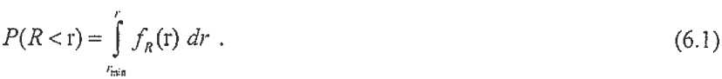

|  |  |
| --- | --- |
| Linear and point sources |  |
| Schematization of potential sources | Magnitude  Correlation for the frequency of occurrence of earthquakes |
|  |  |
| Distance  Decrease in intensity with distance (attenuation correlations) | Spectral acceleration  Movements reoccurance of the site surface (seismic hazard curves for spectral accelerations) |

Fig. 6.1. Main stages of probabilistic analysis of a site seismic hazard

|  |  |
| --- | --- |
| Площадка | Site |
| Зоны | Areas |
| Параметр движения свободной поверхности грунта | Parameter of free soil surface movement |
| Повторяемость, 1/год | Reoccurence, 1/year |

**2. Correlation for the frequency of occurrence of earthquakes**

At the second stage, the characteristics of the frequency of earthquakes in the sources are established.

The common approach are the Gutenberg-Richter relations for the frequency of earthquakes occurrence:

lg λm=а-b*m, (6.2)

where:

λm - annual average magnitude exceedance frequency m;

a and b - the parameters obtained by regression from source seismicity data.

There are various ways to determine the magnitude (local Richter ΜL,of the volume waves mb, of the surface waves (MS, MLH, ΜLV), moment МH'). When performing a probabilistic analysis of a seismic hazard, it is necessary to ensure that the magnitude indicators in the reoccurance and attenuation ratios correspond.

In the ratio (6.2), the magnitude is unlimited, which is contrary to practice, so the ratio (6.2) is corrected in the form:

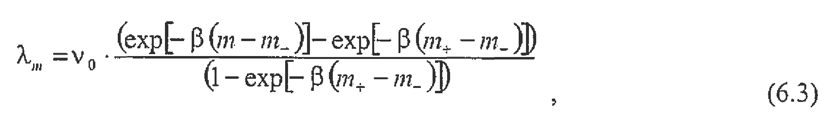

where:

ν0 = ехр(а- β*m_);

V0 - reoccurance of impacts with a lower limit of magnitude m;

α = ln(10)*a;

β = ln(10)*β;

m+ - the upper bound of the values of the magnitudes;

m_ - the lower bound of the values of the magnitudes.

Determining the lower and upper limits of magnitudes is a separate study that increases the reliability of probabilistic analysis of seismic hazard and the results of which allow us to achieve more realistic assessments. The lack of realistic values of the specified values is the reason for accounting for this epistemic uncertainty using the logical tree method.

Defining the magnitude distribution function in terms of density fM (m) as:



can be obtained from

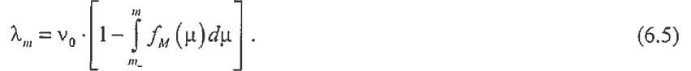

**3. Attenuation ratio**

In this case the term "attenuation" means a decrease in the seismic effect depending on the distance to the source. The seismic effect can generally be determined on the free surface of the site or on the free surface of the bedrock. Attenuation rules can generally take into account various source parameters (types of movement in the focus, type of source), site parameters (parameters that characterize the soil conditions of the site) and are usually represented as the average value of the logarithm of the motion parameter (for example, in the form of the ratio (6.6)) and standard deviation:

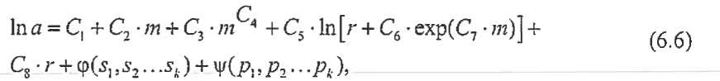

where:

C1...C8 - regression constants (may be equal to zero);

m - the magnitude;

r - distance to the source (epicentral, hypocentral);

s1...sk - parameters that characterize the source;

φ() - function for accounting for source parameters (may be equal to zero);

р1...рk -parameters that characterize the site soil conditions;

ψ() - function for consideration of the parameters that characterize the site soil condition (may be equal to zero).

The final result of this step is the conditional probability of exceeding a certain value of the motion parameter a for each source under consideration:

*Р(А > а**m,r) = 1-* Ф(ln *а,ϭ*ln *a).* (6.7)

1. **Determination and providing of the results (the hazard curves)**

The results of the previous stages for all sources are combined by a ratio that gives the annual probability (frequency) of exceeding the movement parameter:

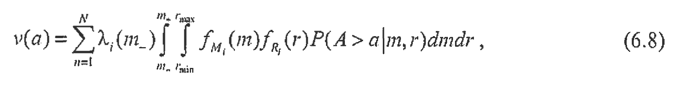

where the index i refers to the i-th source.

The uncertainty consideration, the sources of which are listed in item 22 of this Safety Guide, is performed by constructing a logic tree, a fragment of which is shown in Figure 6.2 of Appendix 5 to this Safety Guide.

The calculation of seismic hazard curves is performed for each path of the logical tree, and thus each end state of the tree corresponds to its own seismic hazard curve. In addition, for each path of the logical tree, there is a weight calculated for this path, and the sum of the weights which is equal to one. Thus, for each value of the movement parameter a, we obtain n reoccurance values, where n is the number of end states. The weighted average (subject to the corresponding weight) reoccurance value calculated for each fixed acceleration value eventually forms the average seismic hazard curve. From analogy, the median values and quantiles of the seismic hazard curves are determined taking subject to the weights.

|  |  |  |  |  |  |
| --- | --- | --- | --- | --- | --- |
| Shift in the focus |  | Assessment of the maximal magnitude |  | The rule of attuniation | |
|  | | | | | С&В 0.33  В&А 0.33  Model А 0.33 |
| С&В 0.33  В&А 0.33  Model А 0.33 |
| С&В 0.33  В&А 0.33  Model А 0.33 |
| С&В 0.33  В&А 0.33  Model А 0.33 |
| С&В 0.33  В&А 0.33  Model А 0.33 |
| С&В 0.33  В&А 0.33  Model А 0.33 |
| С&В 0.33  В&А 0.33  Model А 0.33 |
| С&В 0.33  В&А 0.33  Model А 0.33 |
| С&В 0.33  В&А 0.33  Model А 0.33 |

Fig. 6.2. Fragment of the logical tree of uncertainty analysis

|  |  |
| --- | --- |
| Взброс | upcast |
| Сброс | discharge |
| Сдвиг | shift |
| Наибольшая | The largest |
| Средняя | Average |
| Наименьшая | The least |

For the convenience of performing the selection, it is recommended to represent the seismic risk curve H(a) as:

Н(а) = КI х а-Кн, (6.9)

where ΚI and КH - are the constants defined e.g. by the least square method.

If one presents the equality of the seismic risk curve as a linear logarithm function, the result will be:

lg *Н(а)* = lg *К*I *\** *lg* *а.* (6.10)

Examples of representing seismic hazard curves for maximal and spectral accelerations are shown in Figures 6.3, 6.4, 6.5, and 6.6.

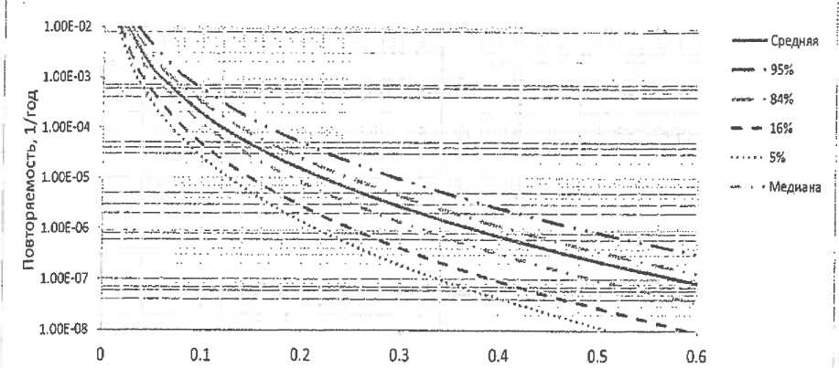

Zero period acceleration, g

Fig. 6.3. Example of seismic hazard curves for maximal accelerations (or zero period accelerations) and various confidence levels

|  |  |
| --- | --- |
| Повторяемость, 1/год | Reoccurence, 1/year |
| Средняя | Average |
| Медиана | Median value |

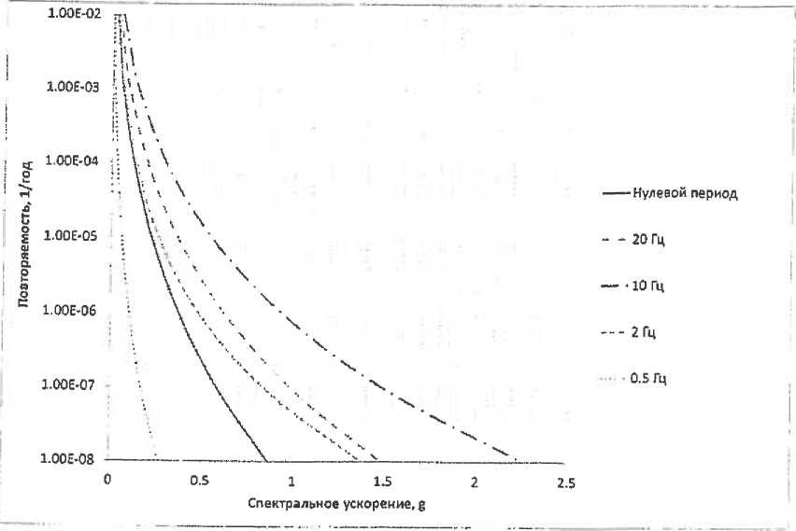

Fig. 6.4. Example of average seismic hazard curves for spectral accelerations

|  |  |
| --- | --- |
| Повторяемость, 1/год | Reoccurence, 1/year |
| Нулевой период | Zero period |
| Гц | Hz |
| Спектральное ускорение | Spectral acceleration |

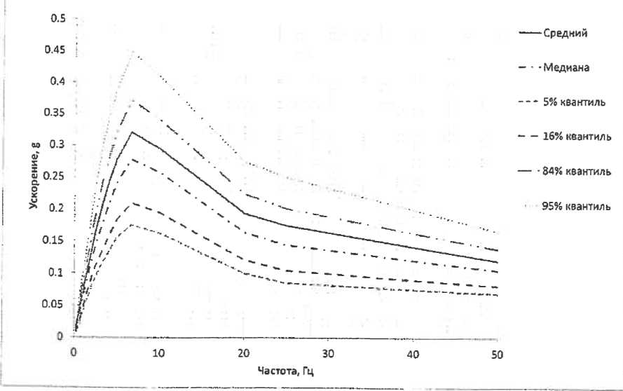

Fig. 6.5. Example of representation of the average response spectra of equal frequencies for the exceedance frequency 10-4 1/year and various quantiles (5 % of the critical damping)

|  |  |
| --- | --- |
| Ускорение | Acceleration |
| Средний | Average |
| Медиана | Median value |
| Квантиль | quintile |
| Частота, Гц | Frequency, Hz |

Fig. 6.6. Example of average response spectra of equal exceedance frequencies for frequencies from 10-3 to 10-7 1/year (5 % of critical damping)

|  |  |
| --- | --- |
| Ускорение | Acceleration |
| Частота, Гц | Frequency, Hz |

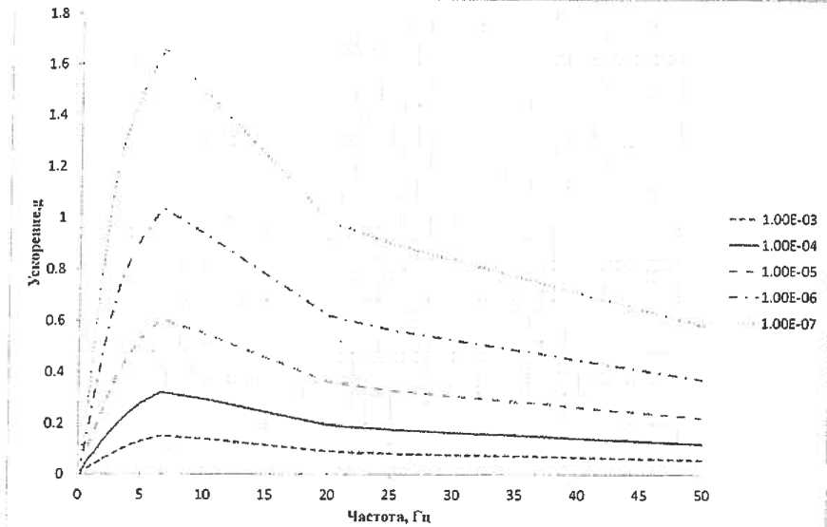If there are a large number of sources involved in the probabilistic analysis of seismic hazard, their significance can be analyzed in the form of deaggregation.

**Example 1.Point source (Cornwell model)**

Let's consider the point source model shown in Figure 6.7. It is assumed that the earthquakes occurrence from this source is a Poisson random process.

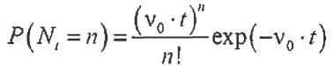 - the number of events in the considered interval (0, t).

Let us suppose to simplify the model:

the relations for reoccurance (6.3) are limited only on the left (only for low magnitudes) so m+= ∞;

the constants in the attenuation rule (6.6) are C3, Sb, C7, C8 = 0; also, the spread of the attenuation rule C9 = 0 is not considered. The functions φ(·) and ψ(·) are missing, so the attenuation rule has the form:

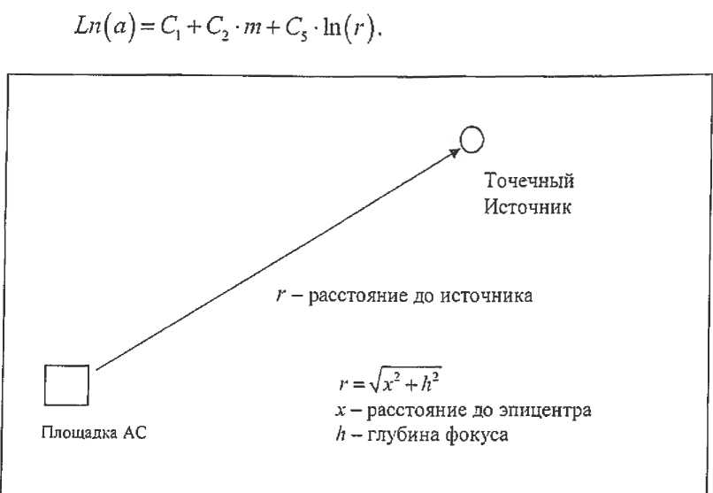

Fig. 6.7. Point source

|  |  |
| --- | --- |
| Точечный источник | Point source |
| Расстояние до источника | Distance to the source |
| Площадка АС | NPP site |
| Расстояние до эпицентра | distance to the epicenter |
| Глубина фокуса | focus depth |

The relation (6.7) has a deterministic form:

P(а > а⏐m,r)=1.

The example under consideration relates to the determination of only one seismic hazard curve (a logical tree for uncertainty analysis is not developed). In this case:

λm= ν0 * ехр[-β(m-m_)],

and the distribution function for events with magnitude m:

Fm(m) = 1 - ехр[-β(m-m_)];

fm(m) = β **\*** ехр[-β(m-m_)]**;**

fR(r) **=** δ(R-r),

where δ ( ) is the Delta (Dirac function).

The probability that the magnitude Mmax of the most intense earthquake of the year (t=1) will exceed m:

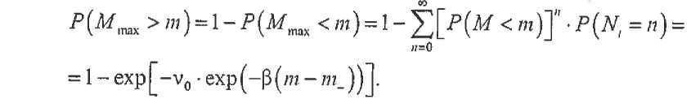

Since the straggling of the attenuation rule (C9) is not considered, so:

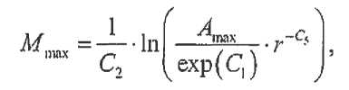

where Amax is the maximal acceleration of the free surface during an earthquake in a point source with a magnitude of Mmax.

So it is correct that:

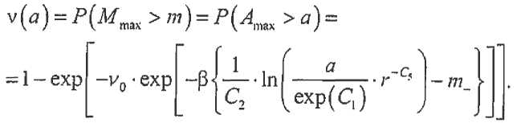

After mathematical manipulations, may be achieved:

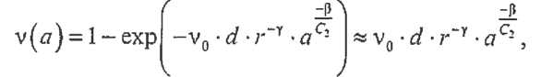

where:

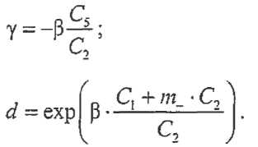

A numerical example is given below.

Let the site be located at a distance of 30 km from the hypocenter of a point source located at a depth of 10 km. According to the seismological information, it follows that impacts of magnitude greater than 4 occur once every 50 years, and the value of β is estimated to be 2.

The attenuation rule for accelerations (in cm/S2) has the following coefficients:



then:

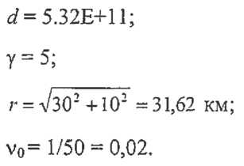



Then, for example, for the acceleration of the free surface of 0.1 g (98 cm/s2), the following

frequency will be obtained:

For a number of acceleration values, we obtain the hazard curve (Fig. 6.8) of this site with 1 point source.

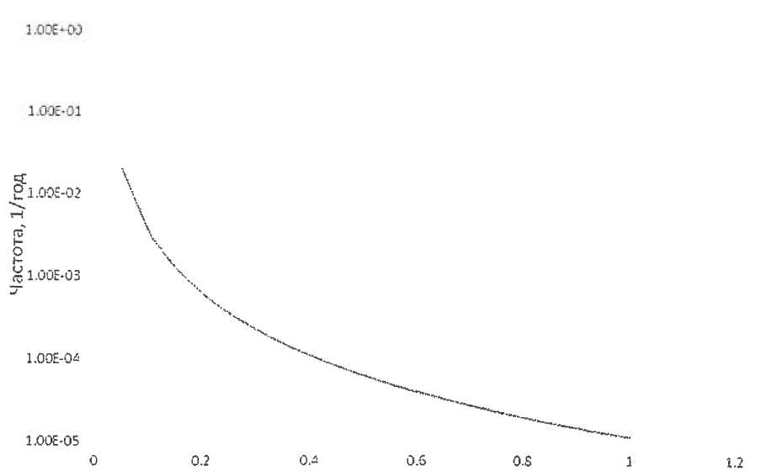

Acceleration, g

|  |  |
| --- | --- |
| Частота, 1/год | Frequency, 1/year |

Fig. 6.8. Hazard curve for the example with point source

Models that allow "hand" calculations allow to make only approximate assessments. It is difficult to consider the limitation of magnitudes on the right (maximum m+), the straggling, and modern complex forms of attenuation rules there, so numerical methods are used to calculate hazard curves.

The main principles of their application are considered below.

**Example 2. Model with a linear, rectangular, and point source**

Figure 6.9 shows the model under consideration.

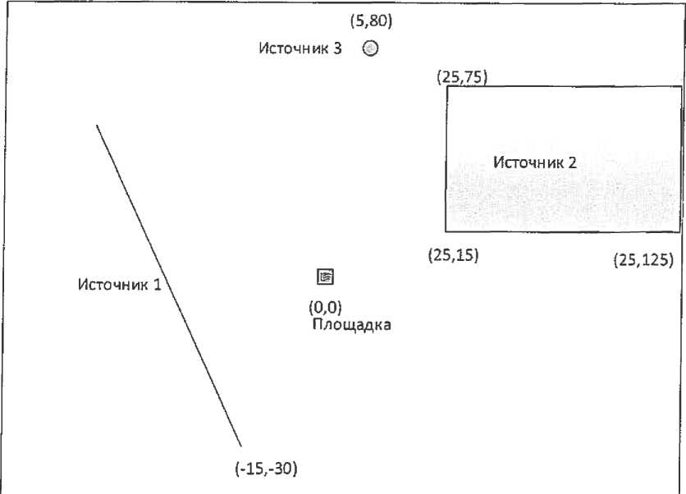

Fig. 6.9. Model with three sources

|  |  |
| --- | --- |
| Источник | Source |
| Площадка | Site |

The characteristics of the reoccurance rules (6.2) for sources are given in Table 6.1.

Table 6.1

**Characteristics of reoccurance rules**

|  |  |  |  |
| --- | --- | --- | --- |
| Source | Reoccurance rule | m- | m+ |
| Source 1 | lg λ(m) = 4-m | 4 | 7.7 |
| Source 2 | lg λ(m) = 4.5-1.2m | 4 | 5 |
| Source 3 | Ig λ(m) = 3-0.8m | 4 | 7.3 |

The attenuation rule (6.6) is given in the form proposed by Cornwell:

image23where:

a - acceleration in cm/s2;

image24r - distance to the epicenter, km.

Standard deviation:

Let's show how the functions *f*R(r) (6.1) and fM (m) (6.4) can be obtained using the example of obtaining a single summand of the expression (6.8).

Obtaining all the summands should be performed using computer technology.

Let us consider a linear source No.1.

The maximal distance from this source (point with coordinates (-50;75)) to the site rmax = 90.14 km, the minimum distance is rmin is 23.72 km. Let's divide the linear source into 1000 congruent segments by points. In addition, let's divide the difference rmax - rmin into 100 congruent segments, take the corresponding radius for each division point and calculate the number of source points that fall into the ring between the radii (ri, ri+1), ri [rmin , rmах].

The ratio of the number of points that fall in the segment to the total number of points (1000) determines the frequency of radius hits for this interval.

The histogram for source No. 1 obtained in this way is shown in Fig. 6.9.

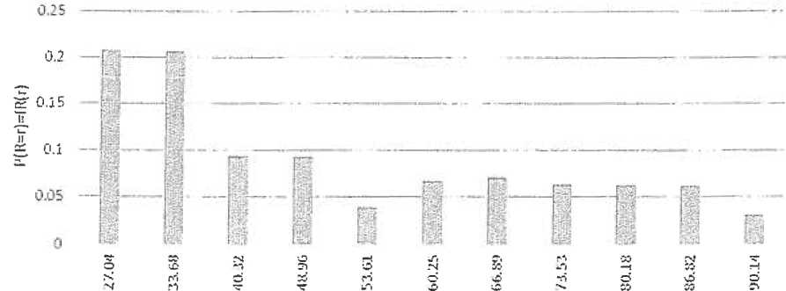

r, km

Fig. 6.9. Approximation of the fR (r) function for source No.1

For rectangular source No. 2, the minimum distance is rmin= 29.15 km, and the maximum distance is rmax = 145.78 km.

The difference between the distances rmах -rmin is divided into 100 equal parts, and for each division point we take the corresponding radius. Divide a rectangular source into 2500 identical rectangles (2x1. 2) km in size, take a point at the intersection of the diagonals of each of the rectangles, and count the number of points that fall into each of the segments.

Similarly, as for a linear source, we calculate the approximation of the function fR(r) (Fig. 6.10)

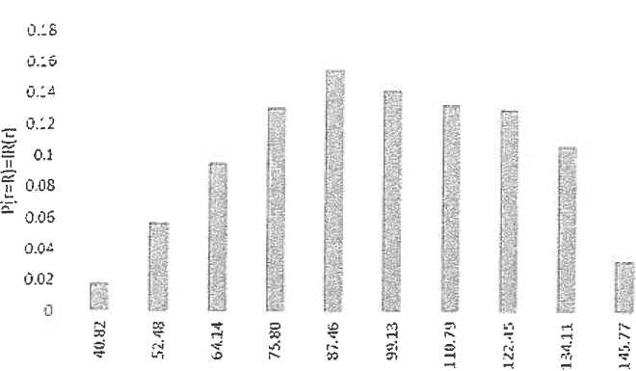

r, km

Fig. 6.10. Approximation of the fR (r) function for source No.2

For a point source, the approximation function is obvious (see example 1).

From formulas (6.3), (6.5):

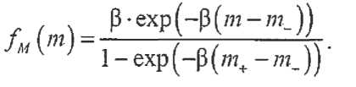

For each source in a small range of magnitudes (m1, m2):

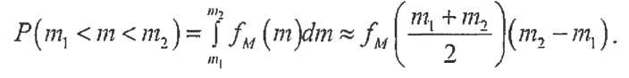

If for source No. 1 its possible range of magnitudes from m- = 4 to m+ = 7.7 is divided into 10 segments, then for the first of them

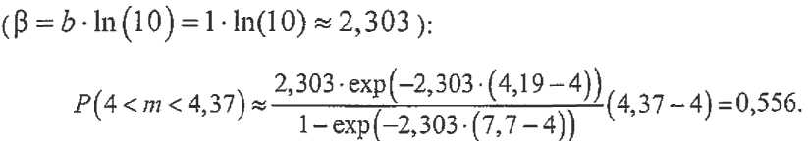

The histogram for P(m = M) constructed for 10 magnitude intervals is shown in Fig. 6.11.

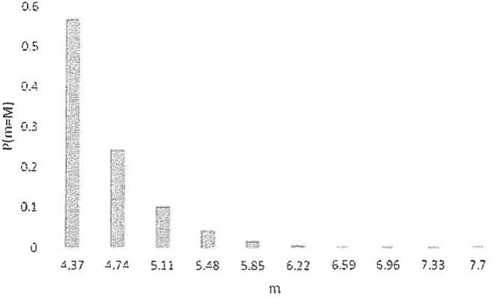

Fig. 6.11. Histogram P (m = M) for 10 magnitude intervals

Thus, for source No. 1, if the distance to the site and

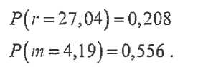the magnitude range corresponds to the minimum value, then:

For this combination of m and r, according to the accepted attenuation rule, the logarithm of the maximum acceleration of the free surface

image32

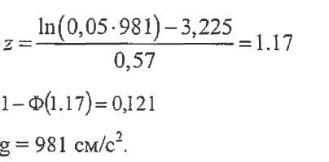Assuming that the uncertainty (C9) in the attenuation rule (the natural logarithm of acceleration on a free surface) has a normal distribution with an average value of 3.225 (for these values of m and r), we determine the frequency of occurrence of acceleration of 0.05 g on a free surface:



where Ф(·) is the standard function of normal distribution;

Let's determine the first term of the formula (6.8):

λ1(m_) = λ1(4) = 1 (the second column, the first row of Table 6.1)

ν11 (0,05g) = λ(m_)·x Ρ(Α> 0,05g|m = 4,19r = 27,04) x P(r = 27,04) x Р(т = 4,19) =

= 1 x 0,121 x 0.208 x 0,556 = 0,014 x 1/year.

To obtain the hazard curve, follow these steps: for a level of 0.05 g, sum all the frequency values for all combinations of m and r values and for all sources - this will get the frequency value for exceeding the acceleration of 0.05 g. Then follow these steps for other acceleration values and to determine the frequency values. It is recommended to perform these operations using computer technology.

APPENDIX 6   
to the safety guide in the use of atomic energy "Basic recommendations for development of a probabilistic safety analysis of level 1 for a nuclear power plant unit during initial events stipulated by the seismic impacts" approved by order No. 33 of the Federal Environmental, Industrial and Nuclear Supervision Service dated   
of February 01, 2017.

**Recommended approaches for probabilistic analysis   
of the seismic vulnerability to components**

**Main characteristics of a logarithmically-normal distribution. Double logarithmically-normal distribution**

The logarithmically-normal distribution of a random variable is determined by the density:

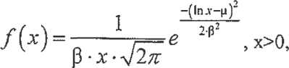

depending on two parameters of μ and β,

where:

μ is the Logarithmic Median (or median value of the random variable under consideration);

β is the standard deviation of the logarithm of a random variable.

The mathematical expectation m and standard deviation σΝ for a logarithmically-normal distribution can be defined as:

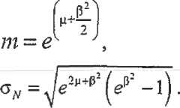

54

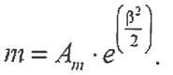Then for the median Am = eµ it is true:

At low β (for example <0.4):

m ≈ Аm ;

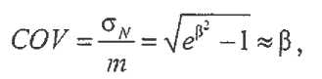

where COV - is the coefficient of variation.

Distribution function of a logarithmically-normal distribution:

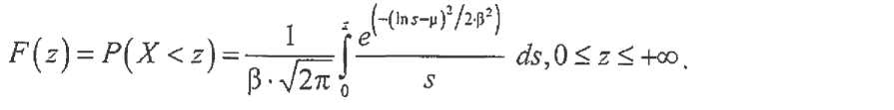

The logarithmically normal distribution of A can be represented as:

А= Аm x eβxZ , where Ζ - is a random variable with a standard normal distribution (the mean value is zero, the variance equals to one).

Consider the standard "load-strength" model (figure 7.1).

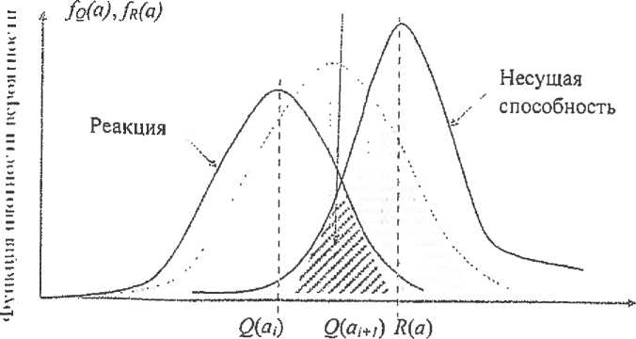

Failure area

Fig. 7.1. A combination of the response values and seismic vulnerability causing a component failure

|  |  |
| --- | --- |
| Функция … вероятности | Function…probability |
| Реакция | Response |
| Область отказа | Failure area |
| Несущая способность | Bearing capacity |

For any set level of intensity of the seismic impact aQ, the response in the component will be a random value due to a number of random factors of the system for transmitting the impact from soil surface vibrations to the element (for example, by the straggling of the properties of the soil foundation, the rigidity and mass characteristics of building structure components, damping). Thus, the load-bearing capacity of the component, i.e. the ability to perceive response forces, is also a random value due to the straggling of the strength of materials and other random parameters related to the properties of the component design. Assume that the load and the bearing capacity are independent random variables distributed according to the normal law. In general, the procedure for determining the seismic vulnerability curve of an component is reduced to determining the joint probability density of the response acting on the component and its bearing capacity. Figure 7.1 shows a graph of the distribution density of a random variable, which is conventionally called "Response", and a graph of the distribution density of another random variable - "Bearing capacity". The area formed by the intersection of the areas under these curves is the failure area. In a particular case, If all the computed values may be divided into two groups, where the first includes the characteristics related to the properties of the construction, and the second characterizes the external impacts, then in the appendix to the calculation tasks for strength the failure condition mathematically shall be expressed by the inequation:

*g = R - Q < 0,*

where Q - is the response or loading effect;

R - load bearing capacity expressed in the same units as the loading effect Q;

g - operability function or strength margin.

If the random variables R and Q are independent then the mathematical expectation and standard deviation of strength margin are respectively equal to:



where:

mR и ϭR - – mathematical expectation and distribution standard deviation of bearing capacity;

тQ и ϭq - are mathematical expectation and standard deviation of the load effect distribution.

For normal distribution of random quantities the failure probability is determined using the formula:

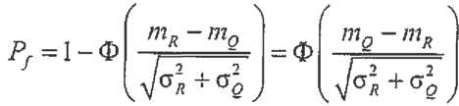

where Ф(·) is the function of the standard normal distribution.

If the functions R and *Q* are distributed logarithmically normally and independent, the above relation can be represented as:

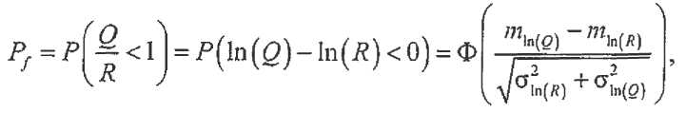

where:

Q/R- is the margin of bearing capacity (random variable);

mln (R) , σln(R) - is mathematical expectation and standard deviation of the base logarithm of the response;

mln (Q) , σln(Q)  - is mathematical expectation and standard deviation of

the base logarithm of the bearing capacity characteristics.



If Sm и Rm - are the median values of "load" Q and "strength" R, then it is true:

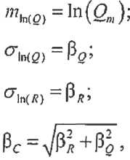

then, in an earthquake with acceleration on the free surface a, the random variable is the load on the component under consideration Q(a), and its median is Qm(а).

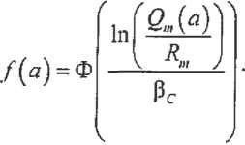Then for the component under consideration it is true:

This ratio in a generic form defines the vulnerability curve of the component with the parameters Rm and β*C*.

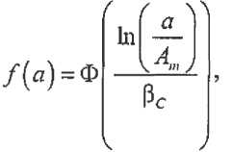Moving from loads and bearing capacity on the component (at the mark) to loads and bearing capacity on the free surface expressed in accelerations, we get the traditional form of the average seismic vulnerability curve:

where Аm - is the median value of the component bearing capacity, expressed as the value of acceleration of the free surface during an earthquake that causes the component to fail.

image48The vulnerability analysis uses a double logarithmically-normal distribution:

image49where: βU , βR - characteristics of aleatory and epistemic uncertainty;

X, Y - are random variables that have a standard normal distribution.

Such form of representation assumes that the change in the limit acceleration due to epistemic uncertainty can be simplified as a random shift of the median value of this acceleration to an area of lower and higher values, and the aleatoric uncertainty determines the shape of the "shifted" vulnerability curve (figure 7.2).

**Method of vulnerability (scaling)**

image50The seismic vulnerability of a component, expressed in terms of the maximal acceleration on the free soil surface at which the component fails, is represented as a double logarithmically normally distributed random variable

where:

Am - median value of a random variable;

- logarithmically normally distributed random variables with a unit median and logarithmic standard deviations βU, βR.

These random variables determine the straggling of the random variable  due to the influence of various factors:

-- determines the aleatoric straggling;

- determines the epistemic straggling.

The seismic vulnerability curve for confidence probability *Q* is defined by the expression:

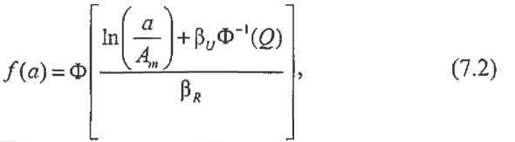

where Ф and Φ-1(·) are the direct and reverse standard functions of normal distribution.

Q - is confidence probability level.

The median curve is obtained from the expression (7.2) by substituting in (7.2) Q=0.5, taking into account that Φ-1(0.5)=0 (or take βU=0, i.e. without consideration of the epistemic uncertainty parameter βU).

The curve for 95% of the confidence probability shall be obtained by the substitution of Q=0.95 into (7.2).

image59In addition it is possible to consider vulnerability in the form of the average curve:



where 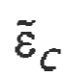с defines the total straggling.

The average (composite) curve is defined by the ratio:

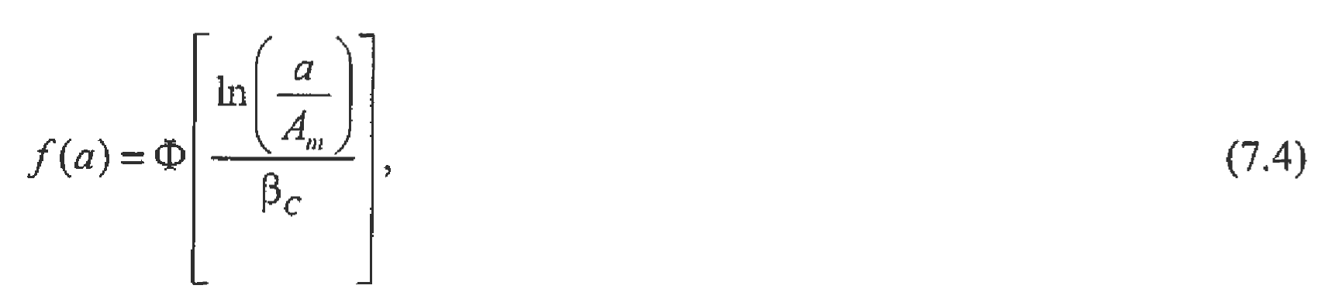

where- is the combined uncertainty.

Figure 7.2 shows the seismic vulnerability curves for different quantiles as an example. The characteristic points of the curves are: the median Аm, corresponding to the conditional probability of 0.5 on the median and average curves, and the point corresponding to the horizontal gridline of the component boundary seismic resistance (HCLPF).

The HCLPF acceleration corresponds to a probability value of 0.05 on the 95% confidence curve or 0.01 on the average (composite) curve.

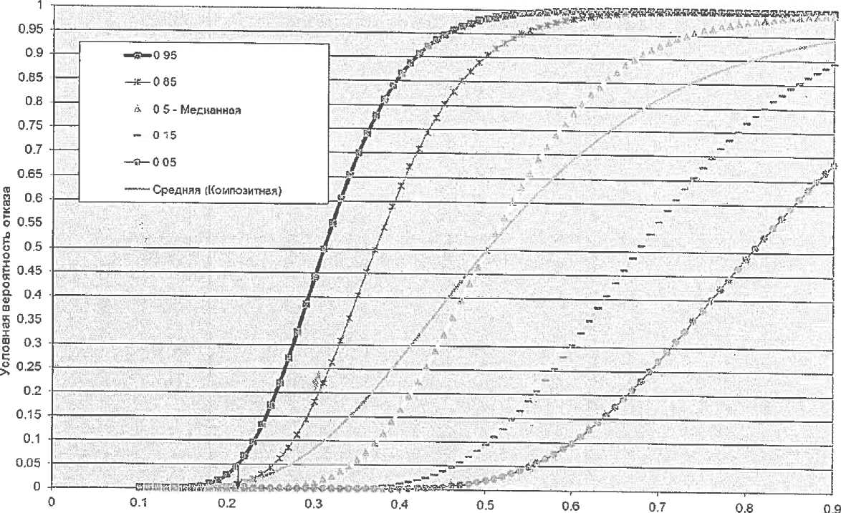

Maximal free surface acceleration (PGA), g

HCLPF=0,21g

Fig 7.2. Example of seismic vulnerability curves

|  |  |
| --- | --- |
| Условная вероятность отказа | conditional probability of failure |
| Медианная | Median |
| Средняя (композитная) | Average (composite) |

Here, in relation to vulnerability curves, the stable term "average" refers not to a characteristic of the distribution, but to a method for generalizing seismic vulnerability curves that have different confidence probability levels. The average curve is more correctly called the weighted average.

To determine the characteristics of seismic vulnerability, Αm, βU, βR the value  is recorded as a product:



where АP - is the maximal acceleration (zero period) on the free soil surface of an earthquake with a reoccurence of 10-4 1/year along the average seismic hazard curve (for an average response spectrum of equal exceedance frequency of 10-4 1/year);

it is assumed that the Ар value obtained in the probabilistic analysis of seismic hazard may differ from the acceleration of the SSE accepted in the design;

- statistical safety factor (a random variable that characterizes the margin coefficient for the bearing capacity of an component in an earthquake, corresponding to the repeatability of 10-4 on the average seismic hazard curve);

- the ratio of the limit load in the component (i.e., the load from the limit for the earthquake component) to the load (response) in the component from the impact of Ар; scaling factor (random variable), by which the calculated acceleration must be multiplied in order to get the acceleration (random variable) on the free surface at which the failure occurs.

It is common to use the method of separating variables to separately account for factors that affect the statistical safety factor.

It is assumed that a design justification for seismic resistance was previously performed for the component, and thus the following scope of justifications was performed:

the level of the strength level earthquake is set, for example, SSE;

if the component under consideration is a building structure, the loads in building structures (responses in building structures) and the strength of the component are calculated;

if the element under consideration - is equipment - determines the impact on the component from the building structure on which it is fastened (response spectra), the loads in the component from the calculated impact and the strength of the component are calculated.

The method assumes that at each of these stages for determining loads, response and strength there is a difference between the realistic approach and the conservative one required for the design justification.

The coefficient can be represented as follows: 

where:

image69- the ratio of the breaking load determined using realistic approaches to the allowable load regulated by the regulatory approach;

- the ratio of the allowable load to the load of the strength level earthquake (SSE, OBE), regulated by the regulatory approach;

- the ratio of the strength level earthquake load (SSE, OBE) determined by the normative approach to the earthquake load with the reoccurence of 10-4 1/year according to the average АP, seismic hazard curve determined by the realistic approach.

Equivalent representation:

for buildings and constructions:

for equipment:

where:

- is the safety margin for the load-bearing capacity (a random variable);

- is the coefficient of the structure response (a random variable).

- coefficient of equipment relative to constructions in which it is set (random variable) - the ratio of the response of the equipment under strength level earthquake, defined regulatory approach to a load from Ар to a certain realistic approach.

Accordingly:

for constructions

for equipment

The safety margin is represented as the product of two random variables and that allow for separate consideration of the margin in relation to the forces determined by linear calculation, and the margin associated with the operation of the component design beyond the elastic limits:



The margin factor  is the ratio of the maximum force (or displacement) that the component loses the ability to perform its functions when it reaches, to the corresponding force that occurs in the strength level earthquake:

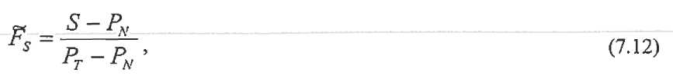

where:

S - is the critical load that the component under consideration can take in relation to the type of failure under consideration;

РN- force from the operating load (NO);

РT- total force (seismic impact + NO).

In general, these loads are random variables that have their own statistical characteristics. Then the average variable and the coefficient

deviationcan be determined by the "Monte Carlo" method or another method (for example, the first moment).

The coefficient  takes in consideration the scattering of energy beyond the elastic limit.

Methods for determining this coefficient are given in EPRI TR103959.

The structure response coefficient - is the random variable that takes into the account the fact that calculations performed in the framework of the design are based on the certain (and often conservative ones) deterministic parameters of a structure and the response in it. Depending on the need to take into the account factors that affect the design response, it can be defined as a product, for example, of the corresponding coefficients of random variables (IAEA-TECDOC-1487 Appendix 1):



where various factors can be taken into account as coefficients, for example:

difference and straggling in response due to differences in the design spectrum (for example, SSE) and the spectrum obtained as a result of the analysis of the seismic hazard of the site (in the case of scaling calculations of seismic resistance performed in the design justification in accordance with paragraph 3 of item 36 of this Safety Guide);

incoherence of seismic waves;

the difference between realistic damping and damping according to the regulatory documents;

models' uncertainty;

methods for adding nonsingular forms;

method for accounting for the combined impact of the dimensional components of the impact;

effects of the "soil-construction" interaction, including changes in the intensity of impact with depth relative to the soil surface for embedded constructions.

Each of the coefficients, as a random variable having a double logarithmically-normal distribution, can have a median and its epistemic and aleatoric straggling βU and βR, respectively. In general, they can be determined either by varying the parameters that affect each of the factors separately in order to find out its median and stragglings (the method of separating variables), or by using the experience of already completed studies.

Using the properties of the logarithmically-normal distribution, the median value of the coefficient is defined as:



where m - is the index, means the median values of the corresponding coefficients.

The coefficient for equipment can be presented in different ways, depending on the method used to justify the seismic resistance of the component.

For rigid equipment (with high natural frequencies), it is sufficient to consider the uncertainty of simulating and the joint impact of the dimensional components of the impact.

For equipment that has natural frequencies in the range of spectra of the considered impacts, differences in calculated and realistic spectral accelerations, differences in damping, errors in the validation method (at experimental justification), etc. can also be taken into the account.

The characteristics of seismic vulnerability Am, βU and βR are determined from the relations:

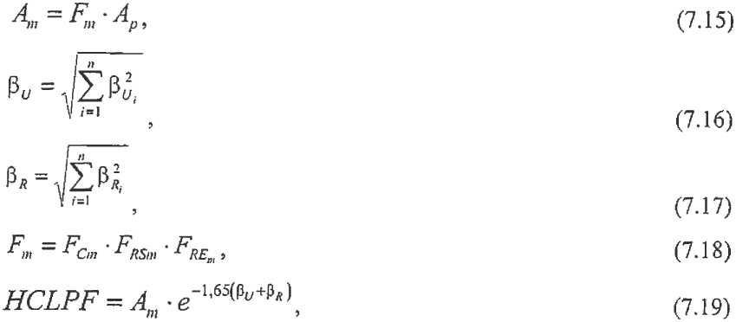

where- are the median values of the safety factor according to

bearing capacity, response of constructions and equipment, respectively.

**Simplified method for calculating seismic vulnerability (hybrid method)**

The method is based on a generalization of the results of previously performed PSA for the seismic impacts and simplifies the procedure for assessing the seismic vulnerability of components by using HCLPF characteristics, which are assessed by deterministic methods or indirect methods (IAEA-TECDOC-1333, EPRI NP-6041-SL) after performing seismic walkdown of the unit.

The method is described in the IAEA technical document IAEA-TECDOC-1487.

The hybrid method assumes the following procedure:

to assess the HCLPF for the component under consideration, or assess the value of the maximum intensity parameter on the free soil surface, at which its conditional probability is 0.01 (or 1%);

to assign logarithmic-normal deviation βC, applying the following recommendations:

for building structures and main passive mechanical equipment at low levels or at the free surface level, βC - is within the range of 0.3...0.5;

for active components located at high elevations in buildings, βC - is in the range of 0.4 ... 0.6; βC = 0.4 is used as a conservative assessment;

to calculate the median value of bearing capacity from the following ratio:



to obtain an assessment of the vulnerability curve according to the formula (7.20).

To assess HCLPF components, it is proposed to use the deterministic method (CDFM) [EPRI NP-6041-SL, EPRI 1019200, IAEA Safety Report 28] or use indirect methods to justify seismic resistance based on the results of a seismic walkdown of the NPP unit (IAEA-TECDOC-1333, EPRI NP-6041-SL).

**Example**

Vertical pump that supplies water for cooling is considered. Potential failure analysis includes various types of failures, including anchor structure failures. One of the potential types of failure is the failure of the support structure of the electric motor that transmits torque to the pump shaft, which may result in a functional failure of the pump unit. In this example, we consider obtaining the seismic vulnerability curve for this type of failure.

The electric motor (Fig. 7.3) is mounted on a support structure, which is a cylinder with two cut-out windows, resulting in two arches with angles of 120°, which work as cantilever beams when a transverse load is applied.

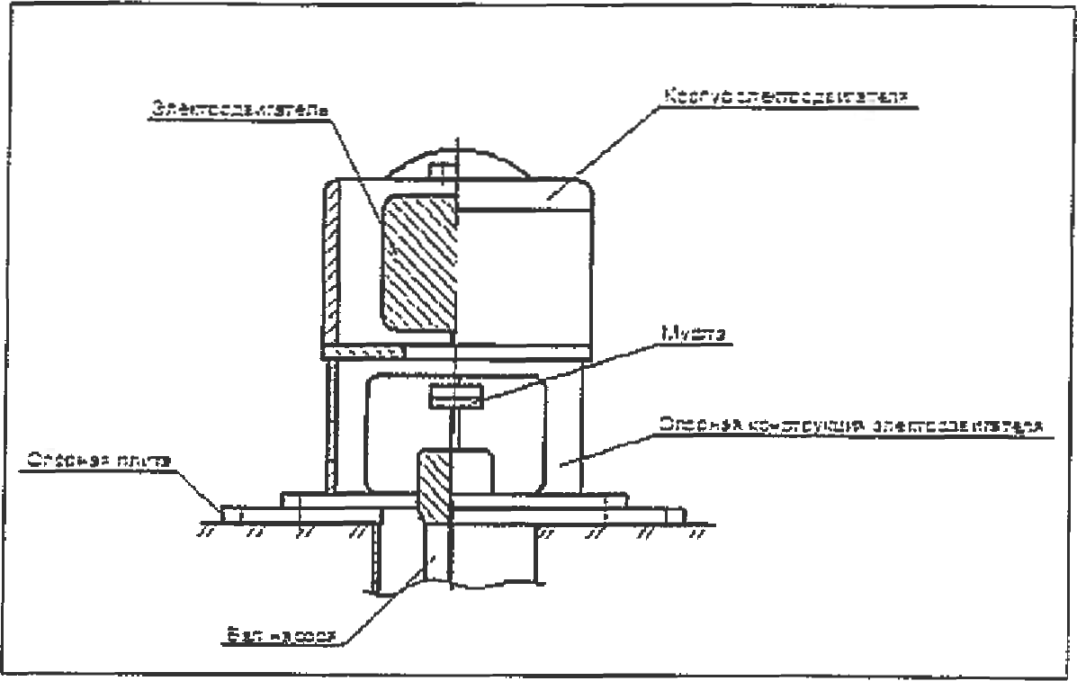

Fig. 7.3. The scheme of fastening of the pump electric motor

|  |  |
| --- | --- |
| Электродвигатель | Electric motor |
| Корпус электродвигателя | electric motor case |
| Опорная плита | Support plate |
| Муфта | Coupling |
| Опорная конструкция электродвигателя | Electric motor support structure |
| Вал насоса | Pump shaft |

The calculation scheme is shown in Fig. 7.4.

|  |  |
| --- | --- |
|  | Electric motor |
| Support brackets |
| Support plate |

Рис. 7.4. Design diagram

The coefficients in this example depend on the specifics of the calculations performed and may be different for other cases (have a different content).

**Load capacity safety factor Fc**

The support structure is made of steel with a minimum yield strength of ϭT0,2 = 250 MPa at the design temperature. We shall assume that this value is guaranteed to be 95 % exceeded. The values of the coefficient of variation for the normal distribution of the yield strength of carbon steel are approximately near the value of 0.1.

Using the properties of a logarithmically-normal distribution, we obtain that the epistemic uncertainty associated with ignorance of the actual properties of the material is - βu1 ≈ 0,1 and the median value of the material properties is ~ 300 MPa. Here we assume that the difference between the normal law and the Logarithmically-norma law in this particular case and in the area of practical application in this problem is not significant.

In the calculation, the total stress from bending and stretching (compression) from the horizontal and vertical components of the seismic impact was 50 MPa. The calculation was performed specifically for determining seismic vulnerability, so its results can be considered as having a load median assessment.

The median value of the Fs coefficient can be obtained using the formula (7.12) and ignoring the operating load (own weight):

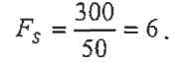

From the calculated static analysis, it follows that the plastic yielding in the cross section of the support structure (plastic hinge) is formed when the load increases 1.5 times higher than the load of the beginning of the formation of plastic deformations. From the analysis of the operational documentation, it follows that such an increase can lead to misalignment and damage to the coupling between the motor shaft and the pumping mechanism shaft, so the coefficient Fµ was assumed to be 1.5, and the coefficient of bearing capacity FC FC:



Considering the value Fμ = 1.5 as the median, and a value equal to one that has a 95% excess level, shall be obtained:



where the value 1.65 corresponds to the value of the inverse function for the standard normal distribution at a value of 0.95.

The final value of the epistemic straggling for the bearing capacity factor FC according to (7.16):

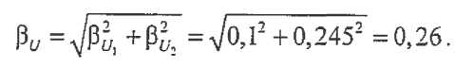

**Equipment response factor FRE**

Parameters of the response factor: calculation method, damping, simulating, summation of nonsingular forms, and combination of earthquake components.

Calculation method

The value of the natural frequency (6.81 Hz) of the considered waveform measured during the survey procedure differs slightly from the previously accepted value (4.23 Hz).

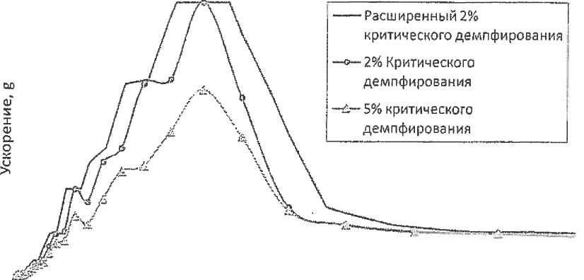

Frequency, Hz

Fig. 7.5. Spectra of response at the level of the component installation

|  |  |
| --- | --- |
| Ускорение | Acceleration |
| Расширенный 25% критического демпфирования | Extended 25% of critical damping |
| 2% критического демпфирования | 2% of critical damping |
| 5% критического демпфирования | 5% of critical damping |

Damping in the calculation was taken according to NP-031-01 equal to 2 % of the critical value. The median damping value is considered to be the value at a state close to failure, which is estimated as 5 % of the critical value.

The previously performed calculation used an extended 2% spectrum. The difference between the spectral acceleration (at a frequency of 4.23 Hz) of the calculated extended 2% spectrum and the spectral acceleration at a frequency of 6.81 Hz for 5% of the spectrum (Fig. 7.5) is estimated as:

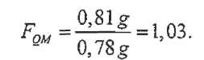

The uncertainty in spectrum processing is estimated as the difference between 2 % of the extended spectrum and 2% at the frequency of 6.81 Hz. Assuming that the extension provides a 99% probability of non-exceeding (+2.33 β), is obtained (at a frequency of 6.81 Hz) using the formulas for the properties of the lognormal distribution:

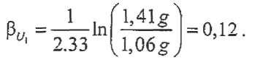

Damping

The calculated frequency of the electric motor was equal to 4.23 Hz, and the corresponding acceleration was 0.8 lg. 5% damping is considered to be the median. However, when calculating the damping factor and its

uncertainty (βU) should first be corrected for the frequency that has changed due to the update of the calculation. Damping was taken into the account when calculating the previous coefficient, so FD = 1. The frequency of 6.81 Hz is in the amplification area of the response spectra. In this area, the ratio of spectra (accelerations) with different attenuation coefficients (as a fraction of the critical one) at the selected frequency is approximately inversely proportional to the square root of the ratio of these attenuation coefficients.

It is assumed that the 2% spectrum forms the boundary corresponding to the standard deviation value - 2βU, while the 5% spectrum is the median (βU = 0) (this assumption is proposed as an expert assessment). In this case:

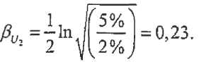

Simulation

A possible decrease in the natural frequency due to changes in damping and the development of nonlinear deformations is considered. There are various methods that allow you to account for changes in the component load due to these effects. Herein such accounting is based on an expert approach.

As noted above, the natural frequency of 6.81 Hz is in the growth zone of the spectrum. When the natural frequency decreases, the load on the support structure will also decrease in accordance with the response spectrum. It is reasonable to assume a decrease in the natural frequency by about 10 % (median value) due to the development of nonlinear deformations in the pre-failure state. At the same time (see Fig. 7.5, graph with 5% of the critical level), the possible straggling is limited to the "shelf" of 5% of the spectrum at frequencies from 4.6 to 5.6 Hz. According to these conditions, we define the accounting coefficient as the ratio of the effective load to the reduced one (the calculations use a spectrum with 5% damping in the critical fraction):

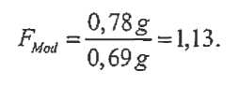

Assuming that the lower acceleration value of the "shelf" spectrum (at frequencies from 4.6 to 5.6 Hz equal to 0.6 g) provides a 99% probability of exceeding, and the initial value of 0.78 g provides a 99% probability of non-exceeding (1% probability of exceeding), we shall get:

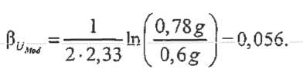

Adding nonsingular forms

The calculations were performed using dynamic analysis with nonsingular frequencise decomposition.

The first frequency was the vibrations of the vertical pump's structural column itself, and the second was the vibrations of the electric motor on the support structure. The following forms (more than 15 Hz) practically do not affect the response of the electric motor design. Therefore, there is no influence of adding nonsingular forms:

FMC =1.

The aleatoric uncertainty is assumed to be minimal at the level of:

βR = 0,05.

Combination of earthquake component

When summing components by the square root or adding components by the rule (100-40-40) is used (see table 4.1 of NP-031-01), it is assumed that the median load value is obtained:

*Fесс* =1.

According to the recommendation of EPRITR-103959, we accept βR= 0.18.

Total equipment response factor FRE



The characteristics of the straggling of the response factor of the equipment are equal to:

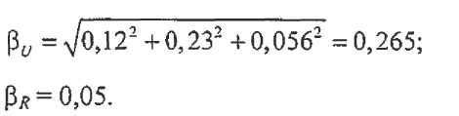

**Construction response factor**

Components of the factor: the shape of the spectrum, damping, simulation, summation by forms and consideration of the dimensional and asynchronous nature of the external impact on the construction (incoherence).

The form of the spectrum

On the frequency of 6.81 Hz the ratio of acceleration response spectrum (5 % critical damping) on the free surface used in the previously performed calculations of the acceleration spectrum, obtained after the execution of probabilistic analysis of seismic hazard and the local characteristics of the soil foundation, is equal to 1.15.

FSS = 1,15.

According to the document EPRITR-103959 to it:

βR =0,2;

βU =0,16.

Damping

When the loads are close to critical for the pump support, the building structures are in the elastic stage, so the damping equal to 4 % is considered as the median. The straggling due to uncertainty was estimated as 0.15.

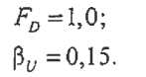

Simulation

The building model was formed and calculations based on it were carried out in accordance with the recommendations of section VI of this Safety Guide. The building model was assumed to have median characteristics. Varying the characteristics allows us to estimate the straggling over the building's natural frequencies to determine βU=0.1. The vibration forms of the pump house building did not change with changes in the input parameters of the model:

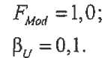

Combination of nonsingular forms

The building's response is mostly determined by its own shape. Thus, the previously obtained values have a median characteristic. The minimum value for the aleatoric straggling is accepted according to EPRI TR-103959:

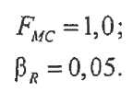

Consideration of the dimensional and asynchronous nature of the external impact on the construction (incoherency)

The pump house has a plan size of 27m x 55m.

For a frequency of 6.81 Hz, the reduction factor for adjusting the response spectrum is 1.14. Since it was not taken into the account in the design calculation, the FGMI coefficient is also 1.14.

It is recommended to select a characteristic of the epistemic straggling βU of this coefficient, so that the probability of exceeding the FGMI ≥1 value is extremely low:

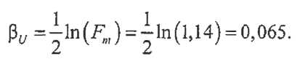

Final response factor of the construction:

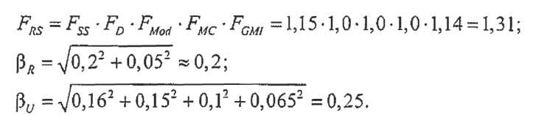

Characteristics of vulnerability of the component

The calculated impact on an open surface corresponds to the maximal horizontal acceleration on a free surface of 0.08 g.

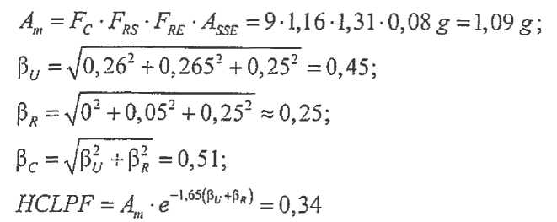

or by an approximate formula for the average (composite) curve and the conditional probability of failure 0.01:

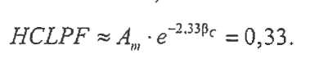

The seismic damage curves are shown in figure 7.6.

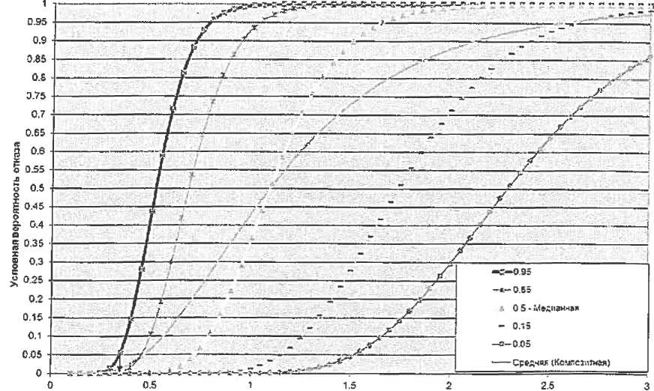

HCLPF-0.34p Maximal free surface acceleration (PGA), g

Fig. 7.6. Curves of seismic vulnerability to the supporting structure of the electric motor

|  |  |
| --- | --- |
| Условная вероятность отказа | conditional probability of failure |
| Медианная | Median |
| Средняя (композитная) | Average (composite) |

APPENDIX 7   
to the safety guide in the use of atomic energy "Basic recommendations for development of a probabilistic safety analysis of level 1 for a nuclear power plant unit during initial events stipulated by the seismic impacts" approved by order No. 33 of the Federal Environmental, Industrial and Nuclear Supervision Service dated   
of February 10, 2017.

**Recommended approaches to the system analysis, total probability  
 of severe accidents from seismic impacts, and uncertainty assessment**

The list below shows the scope of work that is recommended for performing in the process of system analysis and analysis of the total probability of severe accidents from the seismic impacts and uncertainty assessment.

1. Development based on AS models (event trees) and system models (failure trees) from the level 1 PSA for the internal IE of event trees and failure trees, taking into the account component failures due to the seismic impacts.
2. Analysis of possible seismic IE and development of a tree of seismic events. The following can be selected among these events:

events that cause IE that were considered in the PSA for the internal iniating events: leakages (failure of primary circuit equipment and adjacent systems), blackout (OSG equipment, external  PTL supports), other events that could be simulated in the PSA for the internal IE (loss of process water and other initiating events);

additional events due to the specifics of the impact: failures of constructions, foundations, fires and flooding, flying objects, tree-lenght effects due to pipeline breaks; failures of buildings and constructions that differ in their consequences can be simulated on the seismic event trees (for example, failure of the reactor building reactor pressure vessel rupture, EP failure, turbine building failure).

The example of a tree of the seismic IE is shown in figure 8.1.

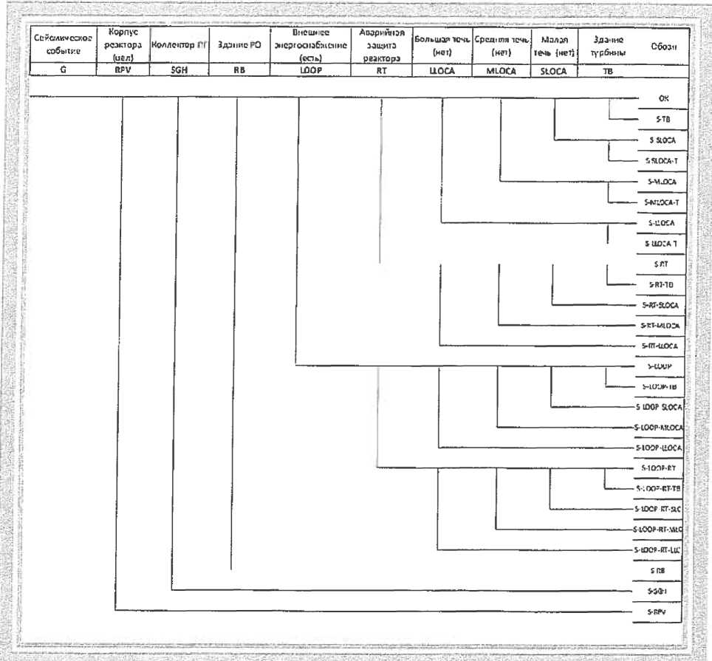

Fig. 8.1. The example of a tree of the seismic IE

|  |  |
| --- | --- |
| Сейсмическое событие | Seismic event |
| Корпус реактора | Reactor vessel |
| Коллектор | Collector |
| Здание РО | Reactor building |
| Внешнее энергоснабжение (есть) | Outer power supply (there is) |
| Аварийная защита реактора | Reactor emergency protection |
| Большая течь (нет) | Large leakage (there isn’t) |
| Средняя течь (нет) | Average leakage (there isn’t) |
| Малая течь (нет) | Small leakage (there isn’t) |
| Здание турбины | Turbine building |
| Обозначение | Designation |

3) Grouping of the events according to their consequences: for example, events related to OSG failures are grouped as causing the initiating event - a long-term blackout of the NPP unit. To determine the probabilities of functional events (headers of the seismic IE tree), additional failure trees can be developed, for example, a tree of seismic failures of reactor facility components that cause a small leakage event when exposed to an intensity of 0.2 g on a free surface, or a tree of failures of building structures of the reactor building.

1. Dividing the considered seismic hazard curve into intensity ranges in which the development of accidents is qualitatively different due, for example, to the appearance of new events which frequencies were beyond the cut-off level in the previous sub-range, as well as due to the transition of some events to the category of unconditional (for example, blackout during intense earthquakes). To obtain an average assessment of the probability of severe accidents, the average seismic hazard curve is considered.
2. Calculation of IE frequencies due to the seismic impacts for each range and seismic failure frequencies.

The IE frequencies caused by the seismic impacts are assessed considering the seismic hazard curve and the component vulnerability curve.

For the range of the seismic hazard curve (hi, аi)...(hi+1, аi+1)

the appropriate acceleration range of the seismic vulnerability curve of the component is selected (fi, аi)...(fi+1, аi+1),

where:

hi,.hi+1 - are the reoccurence values 1/year on the seismic hazard curve corresponding to the boundaries of the i-range;

ai,.ai+1 - are values of accelerations of the free ground surface corresponding to the boundaries of the i -range;

fi,.fi+1 - are values of the conditional probability of component failures (vulnerability).

The event frequency for the n-th component  is defined as:



where fi - is the reduced conditional probability for the range.

In order to determine the reduced conditional probability, the frequency range is divided into intervals, and the reduced frequency is defined as the weighted average:

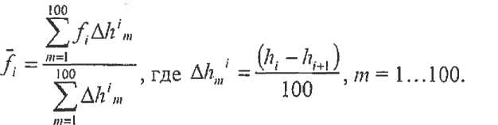

1. Failure trees that are developed for the internal IE are modified to account for the consequences of seismic failures. In a number of instances, the boundaries of the systems under consideration are revised: supporting structures and anchoring of equipment, pipelines are introduced into the system boundaries, and cabinets and panels are additionally included for electrical and control systems, which are attached to the components previously considered in PSA the internal IE, as well as components of the distribution systems.
2. Dependent failures due to a common cause at the seismic impacts are also recorded. The dependence is due to the fact that in the same type of equipment, located in such a way that the impact on it is similar (the same or slightly different response spectra: the systems are located next to each other, one or neighboring elevations, the same location in the gridlines of the building, the same conditions for fastening on the gridline, on the pipeline, etc.), similar characteristics of the response to the impact will occur. The maximal response characteristics of this equipment will coincide in time, direction, and if there is a failure of any component, then we can assume the failure of a similar one.

In the practice of previously developed PSA for seismic events, the following methods were used to account for the dependence on the response to the impact:

similar components at the same elevation that respond in the same frequency range of the response spectrum are considered absolutely dependent on the response to the impact;

similar components at the same elevation that respond in different frequency ranges of the response spectrum have a correlation factor for the response to the impact of 0.5. The difference from the previous case may be, for example, in different conditions for fastening similar components, which changes the rigidity and, accordingly, the frequency ranges of the response;

similar components at different levels of the same building, but responding in the same frequency range, have a correlation factor for the response to the impact of 0.75;

components installed near buildings are considered as if they are located on the lower level (ground surface) of the adjacent building;

similar configurations of pipe fittings (sequential or parallel) from similar components have a correlation factor for the response to the impact equal to 1;

all other configurations are considered independent.

When using the specified approach, at the stage of developing a seismic list of components and at the stage of walkdown of the NPP unit, it is recommended to identify and fix similar equipment components, as well as similar conditions for fastening, installing, and suspending.

1. The total probability of severe accidents from the seismic impacts is calculated for each range of the seismic hazard curve.

Then the results are summarized for all the ranges.

1. To perform the uncertainty analysis, combinations of data from the probabilistic analysis of seismic hazard and seismic vulnerability curves for different confidence levels are considered. Since the possible combination of hazard and vulnerability curves can be extremely large, you should use special software that allows you to perform these calculations to perform the uncertainty analysis.

APPENDIX 8   
to the safety guide in the use of atomic energy "Basic recommendations for development of a probabilistic safety analysis of level 1 for a nuclear power plant unit during initial events stipulated by the seismic impacts" approved by order No. 33 of the Federal Environmental, Industrial and Nuclear Supervision Service dated   
 February 01, 2017.

**Examples of criteria for excluding the components**

Below are the examples of criteria for excluding components that have a minor impact on the seismic safety characteristics of the NPP unit.

1. A component can be excluded if its boundary seismic resistance obtained by the indirect method, based on the results of the walkdown of the unit, exceeds the value assigned as the threshold for exclusion. The threshold value is justified taking into the account the seismic hazard characteristics of the site (section IV of this Safety Guide) and the absence of the impact of the failure of the excluded component on the average probability of a severe accident. When assessing the boundary seismic resistance, the indirect method compares the component under consideration with a category of similar components which behavior under the seismic impacts is known from experience.
2. A component may be excluded if the calculated characteristic of its boundary seismic resistance exceeds the value designated as the threshold for exclusion (see item 1 of Appendix 8 to this Safety Guide). When using this criterion, an assessment of the boundary seismic resistance is required. In this case, a preliminary assessment of the boundary seismic resistance can be performed based on the results of a previously performed calculation to justify the seismic resistance:

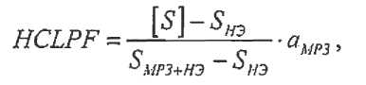

where:

SNO - is the load under normal operating conditions;

[S] - is the allowable load at SSE;

Smp3+HЭ - is the load from a combination of NO+SSE;

aМР3 - is the maximal acceleration of the free surface at SSE in fractions of the acceleration of gravity.

1. The frequency of failure of a component caused by the seismic impact the whole considered range of more than two orders of magnitude below the average value of the probability of a severe accident (requires the assessment of the vulnerability curve); may require re-assessment, if the probability of a severe accident in the development of PSA for seismic loads is less than two orders of magnitude different from the full annual frequency of failure of the component.

To determine the frequency of HYf failure caused by the seismic impacts, we recommend using the composite probability formula:

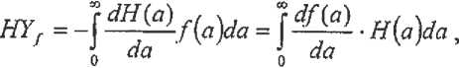

where:

Н(а) - is the average seismic hazard curve;

f(a) - is the average seismic vulnerability curve;

а - is the maximal horizontal acceleration of the free soil surface.

When performing numerical integration, the limits of zero and infinity in the given formula can be replaced with approximate values of аmin and аmах respectively. Then, if the seismic hazard curve can be represented as the ratios (6.9), (6.10) from Appendix 5 to this Safety Guide, then to

define HYf the approximating formula can be used:

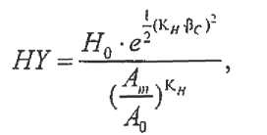

where:

(Н0, А0) - is some point with the average seismic hazard curve, for example, corresponding to the repeatability of Н0 = 10-4 1/year;

Аm - see Appendix 6 of this Safety Guide.

Formulas (6.9) and (6.10) from Appendix 5 to this Safety Guide do not always provide a good approximation of the seismic hazard curve. Therefore, the preferred option is to perform numerical integration to obtain HYf.

**Example**

Approximation of the average seismic hazard curve has indicators К1 = 2,32 10-10 и КH = 4,18, acceleration А0 = 0,12g corresponds to the frequency H0 =1.9 10-6 1/year.

Then the average seismic vulnerability curve with the parameters Am =0.53 g and βC= 0.4 corresponds to the value of the total frequency NΗΥf=1,57 10-8 1/year.

If, for example, the probability of severe accidents from seismic events is expected to be 20% of the total allowable value of 10-5 1/year for all the IE, then the resulting HYf value is more than two orders of magnitude lower and can be excluded.